Magazine Paper Bowl Workshop
This fun class will teach you how to upcycle old magazines into a useful bowl. All materials supplied.
Class held by Lynette Fairbrother

Cost: $40 per person,  Maximum group size - 8 people  Duration: 4 hour class  Venue: Art as Mania  20 – 22 Emu Bay Road, Deloraine  Dates: Thursday, Nov. 17th  Time: 10 am – 2 pm | 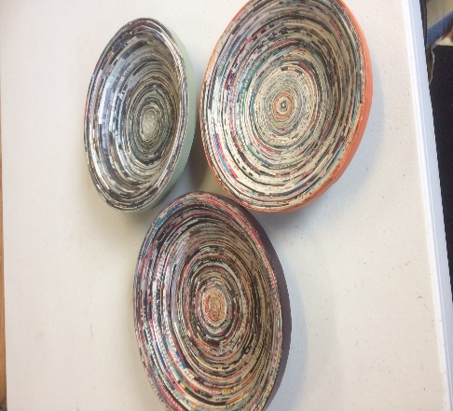
To enrol or for more information contact Art as Mania contact@artasmania.com.au or phone 0488 137 315
Workshop Fun in Deloraine
@ArtistinResidenceTrailTasmania

