Funky Felted Soft Pots
Learn how to make a simple felted soft pot. Have fun with colour at this workshop with June Hope. All materials supplied.

Cost: $95 per person,  Maximum group size - 6 people  Duration: 4 hour class  Venue: Art as Mania  20 – 22 Emu Bay Road, Deloraine  Date: Tuesday, September 13th  Time: 10 am – 2 pm | 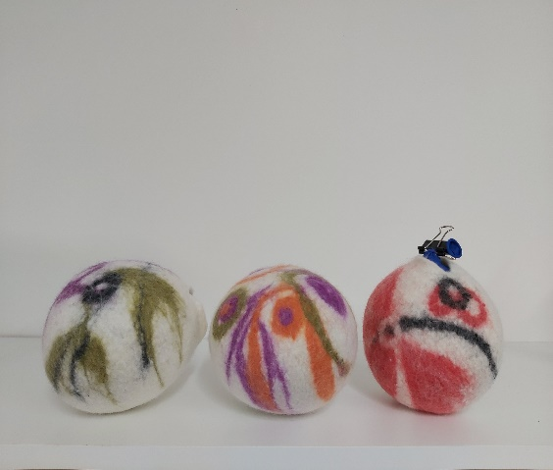
To enrol or for more information contact Art as Mania contact@artasmania.com.au or phone 0488 137 315
Workshop Fun in Deloraine
@ArtistinResidenceTrailTasmania

