Vintage Soy Wax Candle Making
Learn how to make Scented Vintage Soy Wax Candles. Have fun with Soy Wax, Essential oils, Vintage China and Glassware, with Joanne Ring from flamin’ Blue MOON. All materials supplied.

Cost: $50 per person,  Maximum group size - 8 people  Duration: 2 hour class  Venue: Art as Mania  20 – 22 Emu Bay Road, Deloraine  Dates: Friday, March 24th  Time: 10 am – 12 pm | 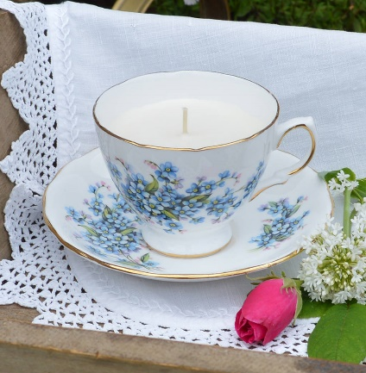
To enrol or for more information contact Art as Mania contact@artasmania.com.au or phone 0488 137 315
Workshop Fun in Deloraine
@ArtistinResidenceTrailTasmania

