Flora Pressing & Art Workshop
This is a beginner friendly introduction to flora pressing and flora art. All materials supplied. Class held by Stacey Tabert.

Cost: $55 per person,  Maximum group size: 10  Duration: 2 hour class  Venue: Art as Mania  20 – 22 Emu Bay Road, Deloraine  Dates: Thursday, January 19th  Time: 11:30 am – 1:30 pm | 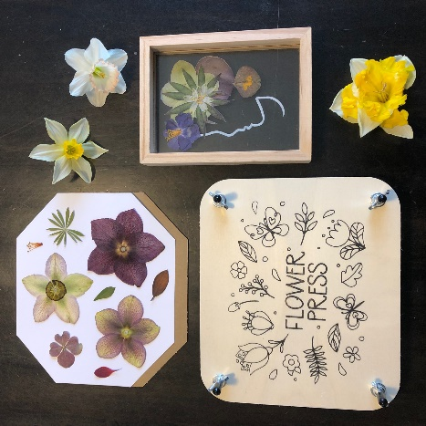
To enrol or for more information contact Art as Mania contact@artasmania.com.au or phone 0488 137 315
Workshop Fun in Deloraine
@ArtistinResidenceTrailTasmania

