Introduction to Scratchboard
In this workshop you will learn how to use the tools, transfer your image and all the techniques you need to complete a work in this subtractive art form. Class held by Julie Wickham

Cost: $85 per person,  Maximum group size: 6 people  Duration: 6.5 hour class  Venue: Art as Mania  20 – 22 Emu Bay Road, Deloraine  Dates: Saturday, May 13th  Time: 9:30 am – 4:00 pm | 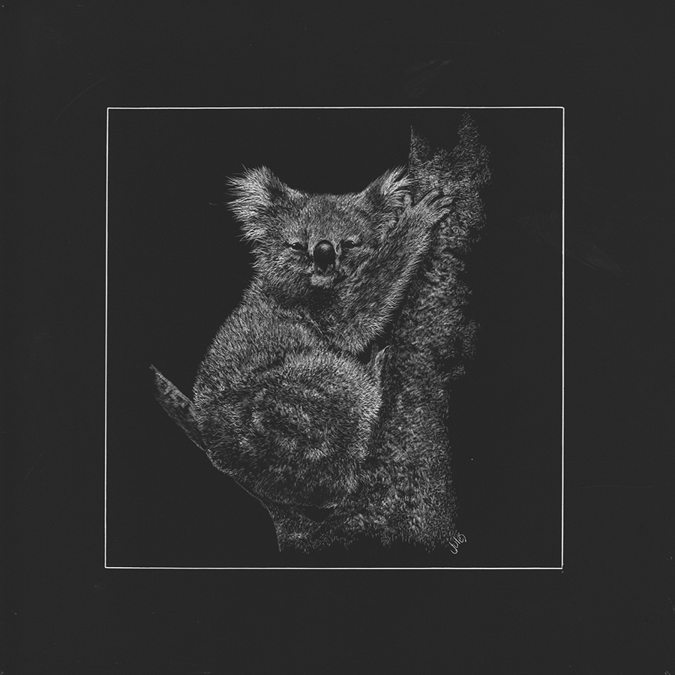
To enrol or for more information contact Art as Mania contact@artasmania.com.au or phone 0488 137 315
Workshop Fun in Deloraine
@ArtistinResidenceTrailTasmania

