Lampshade Making Workshop
Bring along your favourite piece of fabric and make a lampshade for a lampbase or ceiling lamp, with Annie Giffard.

Cost: $140 per person,  Maximum group size - 6 people  Duration: 4 hour class  Venue: Art as Mania  20 – 22 Emu Bay Road, Deloraine  Dates: Saturday, May 6th  Time: 11 am – 3 pm | 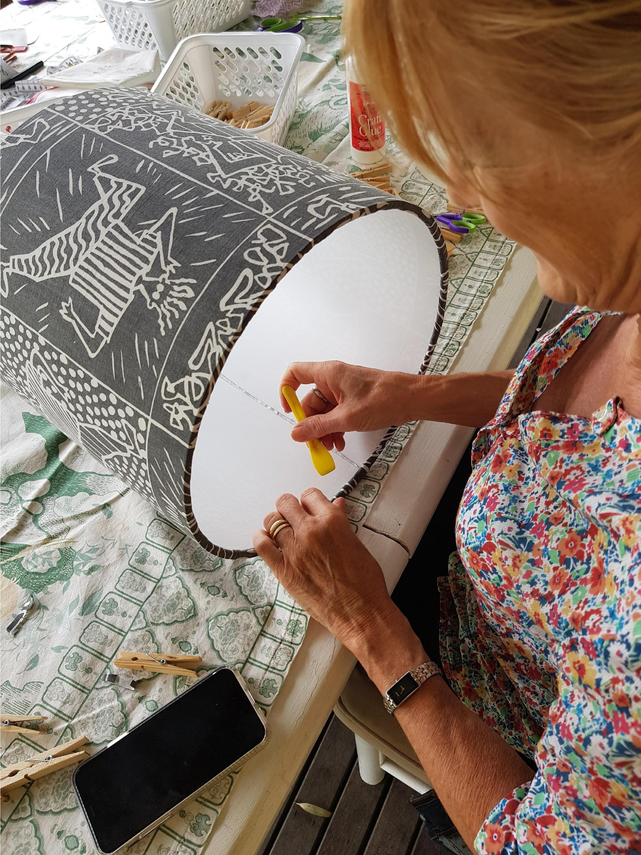
To enrol or for more information contact Art as Mania contact@artasmania.com.au or phone 0488 137 315
Workshop Fun in Deloraine
@ArtistinResidenceTrailTasmania

