Creating & Understanding Abstract Artwork Workshop
This workshop is aimed at awakening a sense of freedom of expression in artists and is for those who are curious and open-minded. Honestly, not for anyone who is opting for being an abstract artist because it is “the easy path”. All materials supplied. Class held by Linda Ireland

Cost: $130 per person,  Maximum group size - 8 people  Duration: 6 hour class  Venue: Art as Mania  20 – 22 Emu Bay Road, Deloraine  Dates: Wednesday, May 17th  Time: 10 am – 4 pm | 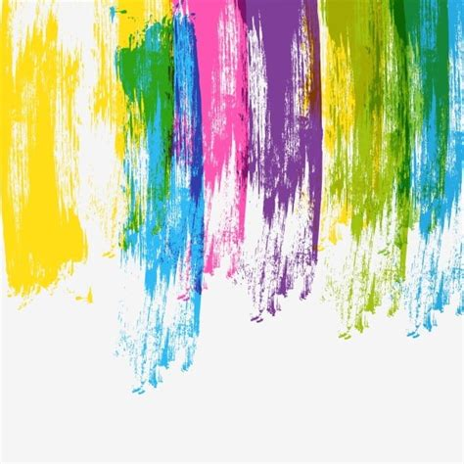
To enrol or for more information contact Art as Mania contact@artasmania.com.au or phone 0488 137 315
Workshop Fun in Deloraine
@ArtistinResidenceTrailTasmania

