Pottery Cottage Workshop
This fun, guided workshop teaches you basic Hand Building techniques and is suitable for beginners. Make & decorate a cottage. All materials supplied. Approximately 2 weeks turnaround due to drying and kiln firing.
Class held by Trish Richers.

Cost: $85 per person,  Maximum group size - 5 people  Duration: 3.5 hour class  Venue: Art as Mania  20 – 22 Emu Bay Road, Deloraine  Dates: Friday, September 8th  Time: 11 am – 2:30 pm | 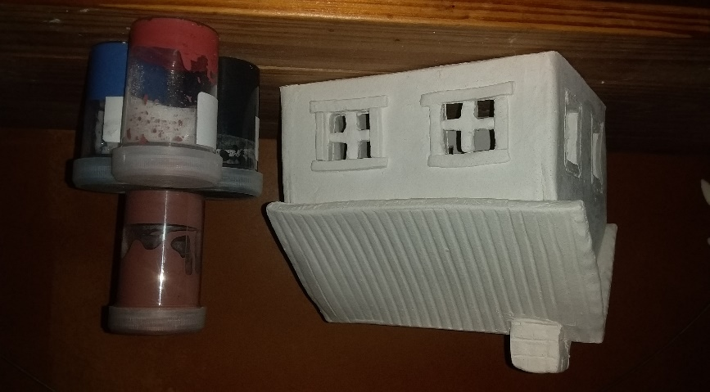
To enrol or for more information contact Art as Mania contact@artasmania.com.au or phone 0488 137 315
Workshop Fun in Deloraine
@ArtistinResidenceTrailTasmania

