Learn to Crochet Workshop
This fun, guided workshop teaches you the basic crochet techniques and is suitable for beginners.
All materials supplied. Class held by Lisa Yeates

Cost: $50 per person,  Maximum group size - 8 people  Duration: 3 hour class  Venue: Art as Mania  20 – 22 Emu Bay Road, Deloraine  Dates: Thursday, September 14th  Time: 1:00 – 4:00 pm | 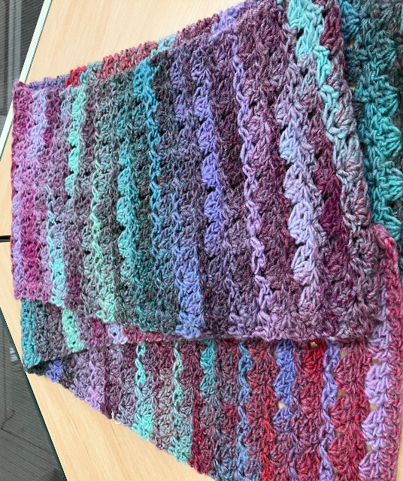
To enrol or for more information contact Art as Mania contact@artasmania.com.au or phone 0488 137 315
Workshop Fun in Deloraine
@Art Trails Tasmania

