Learn to Knit Workshop
This fun, guided workshop teaches you basic knitting techniques ~ cast on, cast off, knit, purl and some simple stitch combinations. The session is suitable for absolute beginners. All materials supplied. Class held by local textile artist/activist
Tara Ulbrich (i:taraintheforest)

Cost: $35 per person,  Maximum group size - 8 people  Duration: 2 hour class  Venue: Art as Mania  20 – 22 Emu Bay Road, Deloraine  Dates: Thursday, May 9th  Time: 10:30 – 12:30 pm | 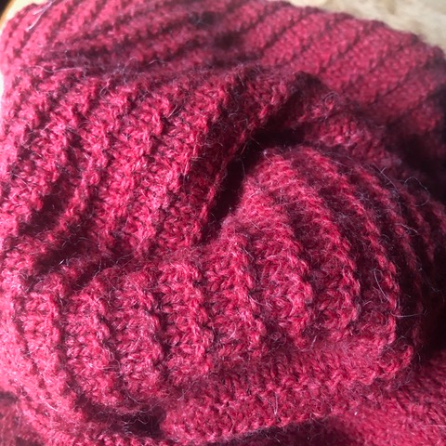
To enrol or for more information contact Art as Mania contact@artasmania.com.au or phone 0488 137 315
Bookings Essential

