Kintsugi Traditional Workshop
Kintsugi is the ancient Japanese art of repairing broken pottery by mending the areas of breakage with urushi lacquer then sprinkle gold on top. All materials supplied. Class held by Jun Morooka

Cost: $385 per person,  Maximum group size - 8 people  Duration: 3 Lessons  Venue: Empire Hotel, 19 Emu Bay Road, Deloraine  Dates: Saturday, March 16th  Lesson 1 – 12:45 – 2:30  Lesson 2 – 2:45 – 4:15  Sunday, March 17th  Lesson 3 – 12:45 – 2:30 | 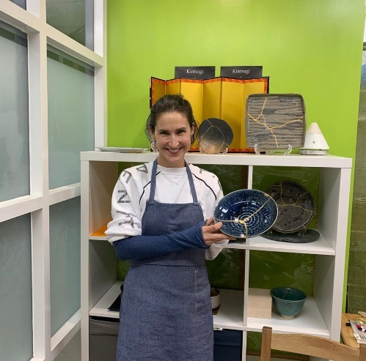
To enrol or for more information contact Art as Mania contact@artasmania.com.au or phone 0488 137 315
Bookings Essential

