Kintsugi Beginners Workshop
Kintsugi is the ancient Japanese art of repairing broken pottery by mending the areas of breakage with urushi lacquer, then sprinkle gold on top. This beginners Kintsugi class uses an original technique designed by Kintsugi Australia to make it easy for anyone to use the Modern Kintsugi technique. In this class you will learn the basic techniques using modern material such as epoxy glue and putty. All materials supplied. Class held by Jun Morooka

Cost: $120 per person,  Maximum group size - 15 people  Duration: 2 hour class  Venue: Empire Hotel, 19 Emu Bay Road, Deloraine  Dates: Saturday, March 16th or  Sunday, March 17th  Time: 9:30 am – 11:30 am | 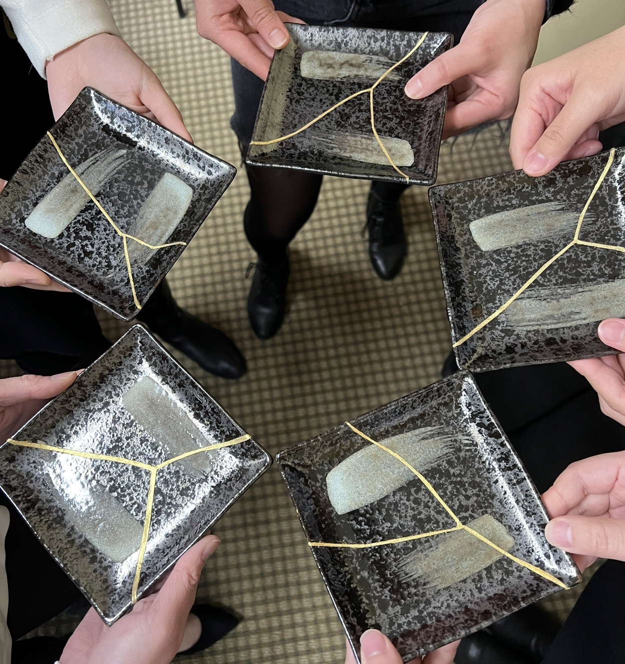
To enrol or for more information contact Art as Mania contact@artasmania.com.au or phone 0488 137 315
Bookings Essential

