Knitted Wire Bracelet Workshop
Join us for a creative journey where you’ll learn the art of knitting wire into beautiful jewellery! Basic knitting skills are required. In this workshop, you’ll craft a stunning bracelet adorned with beads, guided by talented textile artist Noelene Hammond.

Cost: $35 per person  Maximum group size - 8 people  Duration: 2.5 hour class  Venue: Art as Mania  20 – 22 Emu Bay Road, Deloraine  Dates: Saturday, October 11th  Time: 11:00 am – 1:30 pm | 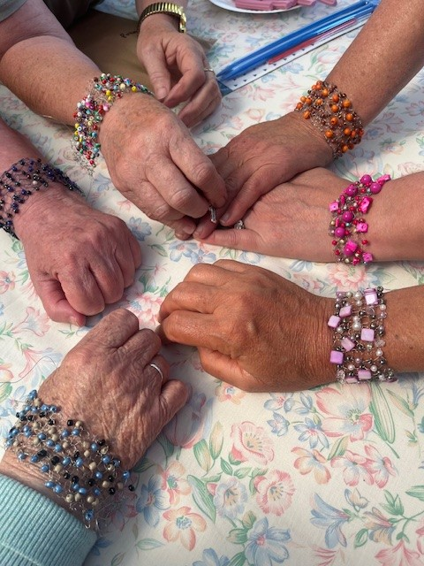
To enrol or for more information contact Art as Mania contact@artasmania.com.au or phone 0488 137 315
Bookings essential

