Felt Embellished Christmas Hat
Join the fun and unleash your creativity in a unique hat making class led by talented textile artist Noelene Hammond.

Cost: $40 per person  Maximum group size - 8 people  Duration: 2 hour class  Venue: Art as Mania  20 – 22 Emu Bay Road, Deloraine  Dates: Saturday, October 25th  Time: 11:00 am – 1:00 pm | 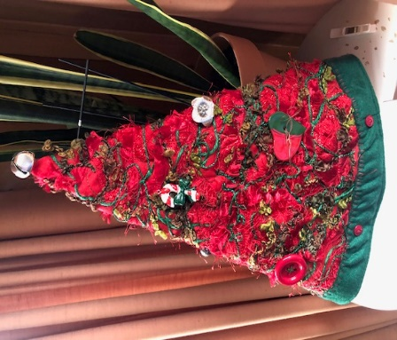
To enrol or for more information contact Art as Mania contact@artasmania.com.au or phone 0488 137 315
Bookings essential

