Christmas Wire Bracelet Workshop
Get ready for Christmas being a gift or for yourself. This bracelet consists of wire, charms, beads using 5 stitches only. Kits are threaded up ready to go. Just pick which one suits you.
A fun day of laughter. Proudly wear home your unique Christmas bracelet.

Cost: $40 per person  Maximum group size - 8 people  Duration: 2.0 hour class  Venue: Art as Mania  20 – 22 Emu Bay Road, Deloraine  Dates: Saturday, November 29th  Time: 11:00 am – 1:00 pm | 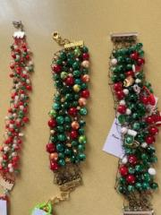
To enrol or for more information contact Art as Mania contact@artasmania.com.au or phone 0488 137 315
Bookings essential

