Lampshade Making Workshop
Bring along your favourite piece of fabric and make a lampshade for a lampbase or ceiling lamp, with Annie Giffard.

Cost: $135 per person,  Maximum group size - 6 people  Duration: 2 hour class  Venue: Art as Mania  20 – 22 Emu Bay Road, Deloraine  Dates: Sunday, May 3rd  Time: 10 am – 12 pm | 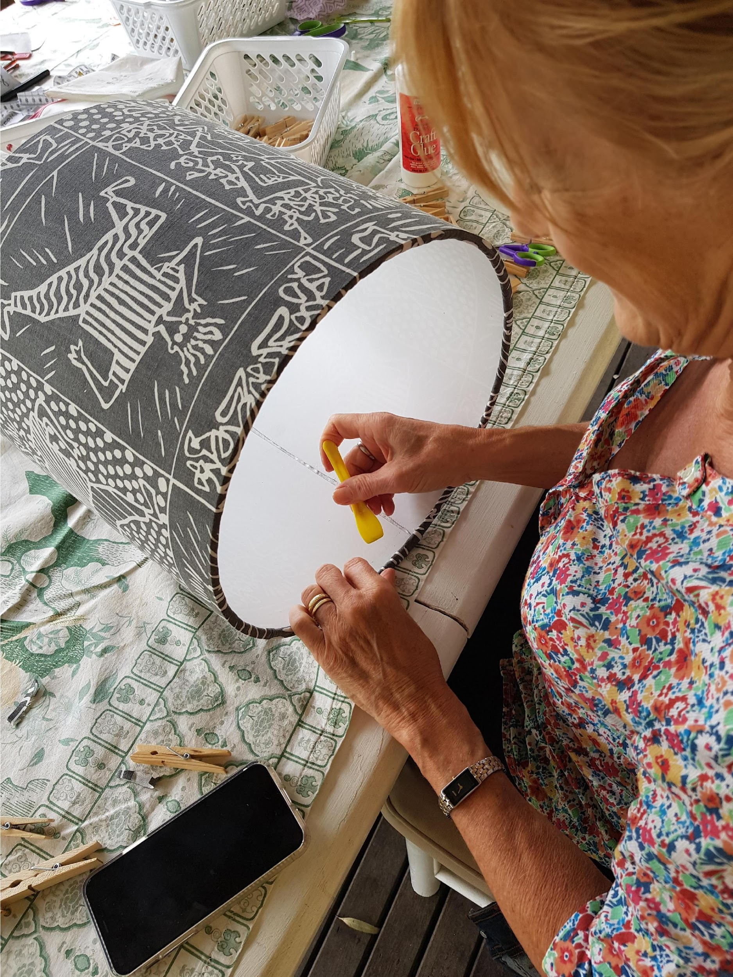
To enrol or for more information contact Art as Mania contact@artasmania.com.au or phone 0488 137 315
Workshop Fun in Deloraine
Bookings Essential

