Cat Mat Workshop
Using old bed sheets, you’ll make a cat mat in this workshop with
Jo Wild. Please bring a crochet hook, knitting needles or needle and strong thread, scissors and old bed sheets.

Cost: $70 per person  Maximum group size - 6 people  Duration: 4 hour class  Venue: Art as Mania  20 – 22 Emu Bay Road, Deloraine  Dates: Saturday, July 11th  Time: 10:00 – 2:00 | 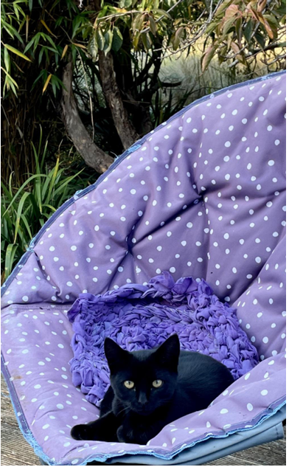

To enrol or for more information contact Art as Mania contact@artasmania.com.au or phone 0488 137 315
Bookings essential

