York/Adams Chapter of PIAA-
Registered Track & Field Officials

Meeting #5 Minutes– April 22, 2024 (7:00 PM)

I. Call to Order by Steve Stough(K) at 7:00.

II. Announcements
A. Sign in
B. Happy Earth Day and Vote Tomorrow
C. Comments on York High Jr High Meet. Chaos but managed by Bill Sterner. No help at throws. Nobody dedicated to help. Additional comments on Arctic Blast, Pan-Ram (crowded, went well, tablets used) Shippensburg.

C. Golf at South Hills on Wednesday, May 15 before the picnic at Sterners. 12:30 ish. Let Lynn VH know if you want to play. Bill Blank, Dan & Lynn VanHouwe, Wick?, Gingrichs?,
All officials and families are welcome to the Picnic @ Sterner’s Picnic Grove. Social hour @ 5:00. Covered Dish dinner @ 6:00. Wednesday, May 15. Meeting #7 at 7:00. Sign-up sheet for picnic.

D. Email from Bill McHale, PIAA District 3 Male Officials Representative and Cathy Wreski, PIAA District 3 Female Officials Representative regarding Official’s Symposium – June 22, 2024 at CD.

E. Reimbursement checks for obtaining officials. Carolyn Tritt, Theresa Whye. $35 for PIAA membership.

F. League Meet officials are set with ALL of our own officials.

III. Motion to forego reading of April 8, 2024, minutes. Question- any additions/corrections. Motion to accept April 8, 2024, minutes.

IV. Treasurer’s Report - $5,853.12.

V. Nominations for officers and executive committee members for the 2025 YAIAA Track and Field Officials Chapter. This was forwarded to members with the Agenda.

Chapter By-Laws Addendum 2 - Officers and Duties: Chapter Officers may be elected to serve a second, consecutive one-year term provided the current officer is nominated to serve a second term, the current officer accepts the nomination, and this nomination is approved by the vote of the majority of the chapter membership at the annual Nominations Meeting. If an officer is not elected to a second term by this process, nominations and voting will be conducted as described in Article VII - Chapter By-Laws Addendum 1.

A. Nominations for Rules Interpreter- Jon Seitz,
B. Nominations for Treasurer- Dave Rizzuto,
C. Nominations for Secretary- Lynn VanHouwe,
D. Nominations for Vice-President- Dave Wickenheiser,
E. Nominations for President- Steven Stough,

Chapter By-Laws Addendum 3 - The Executive Committee shall consist of the immediate past-president and two at-large members who shall be elected at the annual voting meeting of the chapter.

A. Nominations for Executive Committee At-Large Member #1- Bill Blank,
B. Nominations for Executive Committee At-Large Member #2- Mike Eisenhart,

V. Old Business

A. Ray Geesey Officials assigned:

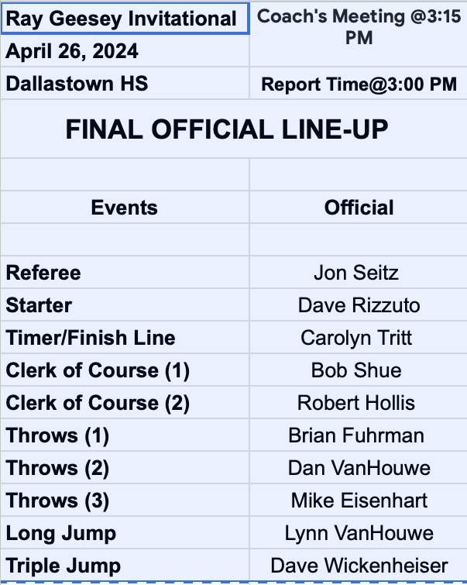
Call Wick if unforeseen circumstances arise and you cannot work.

B. Any reports back regarding equipment to purchase- high jump measuring device (long stand that extends, $339 and $690) (plastic case that extends our in meter and inches for $189), Brad Ream found $44.99 and $39.99 from Amazon, And headset radio/intercom, (Walmart $29.88, $50.00, Corsnair $100 and $180 like what was used at the HS Relays) Radio Shack like $25 - $75, set of 7 in a kit. RESEARCH SOME MORE. Ask the timing people from the Relays.
- buy the Amazon high jump measuring device.

VI. New Business

A. May 2 meet at the Spring Grove. 5 meets at 1 time. Double pay. William Penn with no track facility. Many, many rainouts. No more than 3 teams for twice the pay. Please be sure that you are being properly paid for double duals. Please notify Steve Stough if that does not happen. Steve Stough is trying to straighten things out with Chuck Abbott. Issue with amount of pay if an official works a meet that is really three or more dual meets. How should this be approached? I am not sure we can get this completely solved this year.

B. Tshirts – 240 ordered. $6. Per shirt profit.

VII. Rules Interpretation Portion- Jon Seitz
- Quad meet guidance – from Mike Eisenhart
- Uniform Rant – No hats, no clothing not a uniform or school clothing
- Uniform Rule – school issued or approved (Ok with head coach?) Relays and XC teams need to be clearly identified as consistent and similar.
- Fairfield kids thanked Jeff Halterman for working their meet.
- Pole vault run back. To check the correct setting at the pit. OK!! The runback rule is for WARM UPS.
- Continuous rain – PV coaches want to stop the event. Brad says when kids slide down the pole it is not ok. Now it is blowing wind 20+mph cross wind. NO NO NO in finishing the event. No points were awarded. Consider limiting the number of competitors IF the weather conditions look bad.

VIII. Adjournment at 8:05 pm by Steve Stough(k).

Respectfully submitted by Lynn VanHouwe.

Next Meeting- May 6, 7-8 PM, Room 1011, YCST
May 15, (7:00) Future last meeting of the year is at the Sternic Picnic Pavilion after the covered dish dinner (6:00) of fried chicken from Weis Markets.
All families are invited as well as past and retired officials.
Happy Hour at 5:00.

Bring your $15 insurance cash payment or check payable to:
York County Chapter PIAA Track and Field Officials

