ABB Substation Transformers
Executive Summary — Three (3) Surplus ABB 7.85 MVA Transformers Available for Immediate Sale
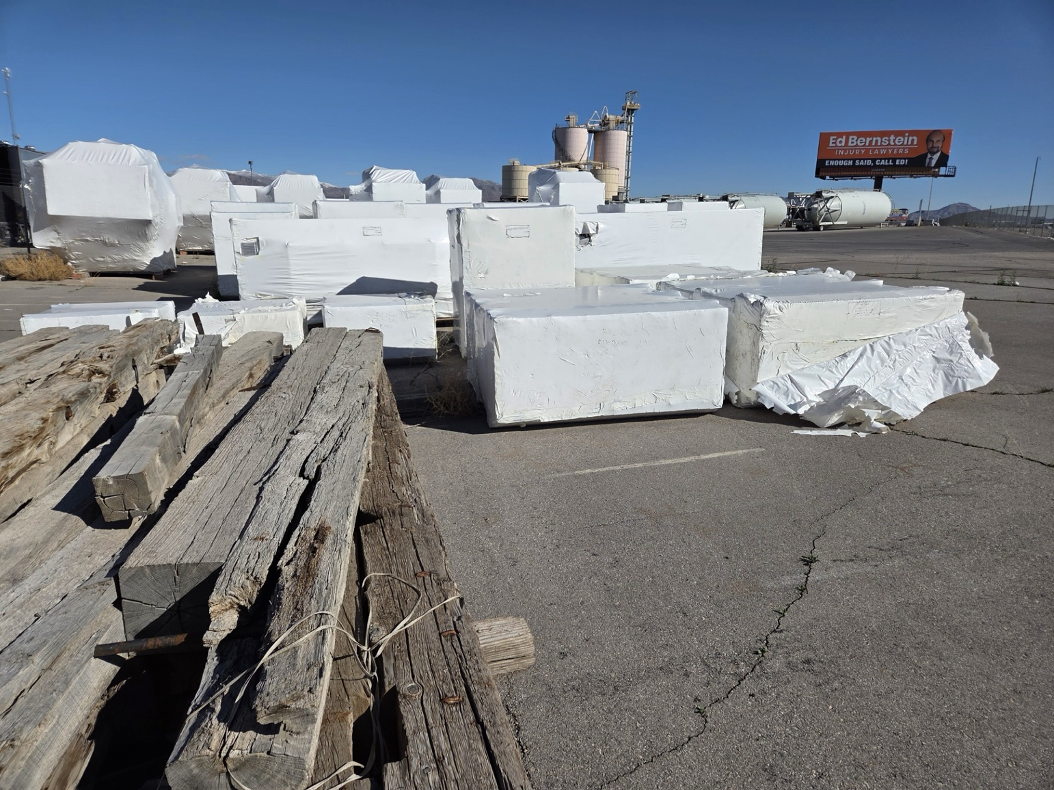
Figure 1: Solar substation facility with transformer and switchgear equipment
Three (3) surplus ABB 7,850 kVA (7.85 MVA) three-phase substation transformers are available for immediate acquisition. Manufactured in 2013, each unit is rated 60 Hz with KNAN cooling and filled with Envirotemp FR3 dielectric fluid. Nameplate data indicates 8.333 kV high-voltage (with five tap positions) and 2.8 kV low-voltage, with Yy0 vector group. The package includes Menk radiators in multiple labeled shipping crates.
Total combined capacity: 23.55 MVA (3 × 7.85 MVA)
Availability: In stock — ready for immediate shipment
Why This Opportunity Stands Out
- Immediate availability — no manufacturing lead time
- ABB-built equipment — robust, substation-class transformer construction
- FR3 dielectric fluid — strong option for projects with environmental and fire-safety considerations
- HV tap flexibility — five tap positions for voltage adjustment
- Cooling equipment included — Menk radiators packaged and labeled (see packaging summary)
Equipment Inventory Summary
Item No. | Item Description | Specification | Manufacturer | Qty
STT-06-0030 | Substation Power Transformer | 7,850 kVA (7.85 MVA), 8.333 kV HV (tapped) / 2.8 kV LV, 3-phase, Yy0, 60 Hz, KNAN, FR3 fluid | ABB | 3
CTG-RAD-MENK | Radiators (Crated) | Menk radiator packages (see crate list below) | Menk | Multiple

Technical Highlights
Each ABB transformer is nameplate-rated 7,850 kVA, 3-phase, 60 Hz, KNAN, Yy0.
Voltage and taps (per diagram/nameplate photos):
- HV nominal: 8,333 V
- Tap positions (HV): 8716 / 8525 / 8333 / 8141 / 7950 V
- LV: 2,800 V
Insulation levels (nameplate):
- HV: LI 150 / AC 50
- LV: LI 60 / AC 20
Losses (nameplate):
- No-load loss: 6.21 kW
- No-load power: 12.73 kVA
Weights (nameplate, per unit):
- Total weight: 23,200 kg
- Oil weight: 6,530 kg
- Active parts: 7,000 kg
- Transport weight with oil: 19,300 kg
Transformer identifiers (diagram plate):
- Transformers No.: 1LFI4270754712, 1LFI4270754717, 1LFI4270754720
(Tags shown as 30-BM-021-TF1 / TF2 / TF3 on the diagram plate.)
Cooling Equipment / Packaging Summary (Menk Radiators)
Package No. | Dimensions (L x W x H) | Gross | Net
F13-2832 | 6’9” × 6’1” × 6’7” |  | 1556 kg (3430 lb)
  1750 kg (3858 lb)
F13-2833 | 6’9” × 6’1” × 6’7” |  | 1556 kg (3430 lb)
  1750 kg (3858 lb)
F13-2892 | 6’9” × 6’1” × 6’7” |  | 1556 kg (3430 lb)
  1750 kg (3858 lb)
F13-2893 | 6’9” × 6’1” × 6’7” |  | 1556 kg (3430 lb)
  1750 kg (3858 lb)
F13-2834 | 6’9” × 6’1” × 2’11” |  | 519 kg (1144 lb)
  650 kg (1433 lb)
F13-2894 | 6’9” × 6’1” × 2’11” |  | 519 kg (1144 lb)
  650 kg (1433 lb)
• Offered as-is, where-is unless otherwise agreed in writing.
• Nameplate, tap/diagram plate, and packaging label photos available upon request.
• CTG can support freight coordination and export documentation.

Contact and Acquisition
CTG Power Systems Intnl., LLC
401 East Jackson St., Ste. 2340-F12
Tampa, Florida 33602 USA Corp. Tel.:
(813) 920-3500
Direct: (813) 535-7771
WhatsApp: (813) 918-0762
Fax: (941) 220-6612
Email: Sales@CTGPowerSystems.com
Website: www.CTGPowerSystems.com

