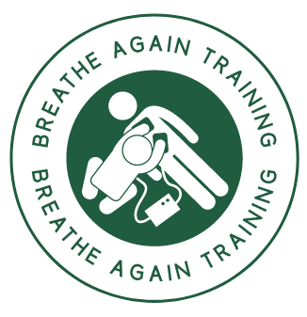 **Complaints and Appeals**

**Complaints Policy**

Breathe Again Training, views complaints as an opportunity to learn and improve for the future, as well as a chance to put things right for the person or organisation that has made the complaint.

**Our policy is**:

To provide a fair complaints procedure which is clear and easy to use for anyone wishing to make a complaint.

To publicise the existence of our complaints procedure so that people know how to contact us to make a complaint.

To make sure everyone at Breathe Again Training knows what to do if a complaint is received.

To make sure all complaints are investigated fairly and in a timely way.

To make sure that complaints are, wherever possible, resolved and that relationships are repaired.

To gather information which helps us to improve what we do.

**Definition of a Complaint**

A complaint is any expression of dissatisfaction, whether justified or not, about any aspect of Breathe Again Training.

**Where Complaints Come From**

Complaints may come from customers, and other persons connected to our activities.

A complaint can be received verbally, by phone, by email or in writing.

Breathe Again Training, 2 Spillarsford Cottages, Lonmay, Fraserburgh AB43 8UQ

Tel: 07970 126 727 Email: [alastair@breatheagaintraining.com](mailto:alastair@breatheagaintraining.com) Website www.breatheagaintraining.com

**Confidentiality**

All complaint information will be handled sensitively, telling only those who need to know and following any relevant data protection requirements.

**Responsibility**

Overall responsibility for this policy and its implementation lies with Mr Alastair Greig.

Breathe Again Training, 2 Spillarsford Cottages, Lonmay, Fraserburgh AB43 8UQ

Tel: 07970 126 727 Email: [alastair@breatheagaintraining.com](mailto:alastair@breatheagaintraining.com) Website www.breatheagaintraining.com