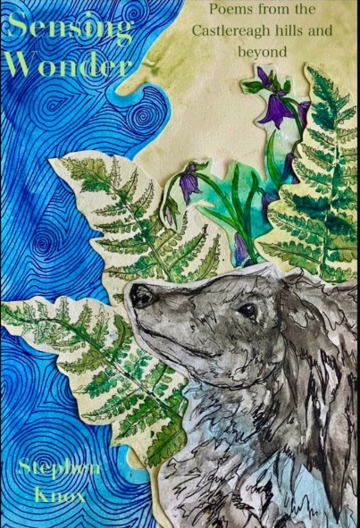Yellow House Publishing are delighted to publish Stephen Knox’s debut poetry collection.

I first met Stephen at the open mic poetry event that my wife and I run in Belfast. We had been living in East Belfast for a couple of years at that stage, having moved from the south of the city. On finding out that we were based near the Cregagh Road, Stephen asked us if we had ever taken a walk up Cregagh Glen.   
This was news to us. We didn't even know of its existence.  
  
Through Stephen, we learnt that there was a National Trust site, just half a mile up the road from us! The entrance to the Glen is modest; driving by it and not paying much attention, you might mistake it for someone's narrow driveway. However, once you enter, you've firmly stepped over that line marking city from countryside, travelling gently up a thin ravine towards the fields shortly beyond.  
  
On reading Stephen's poems about the Glen, I re-experience those first feelings of discovery and connection: the celebration of the pastoral, the appreciation of its proximity, the simple splendour it offers the visitor. The writing transports one right into the ganglion of the area, finding affinity with Stephen (and his faithful dog!), as if we are almost walking beside him.  
  
Having the pleasure over many months to listen to Stephen read at our poetry nights, I am always struck by his genteel delivery, his playful use of rhyme, and how his faith permeates throughout his every action. Perhaps part of being close to nature is to also feel close to God, as these poems affirm. Read them with joy, and afterwards, take yourself outside for a walk – canine companion optional.

Yellow House Publishing Ltd

85 Great Portland Street

London W1W7LT UK

www.yellowhousepublishing .com

publishingyellowhouse.com

Ph: 07592507105

SENSING WONDER by Stephen Knox

Order Directly from Publisher

Cost £12

35% discount to trade

Editor: Colin Dardis

ISBN 978-1-7393125-4-1

Available from 1st Oct 2024

Colin Dardis Poet