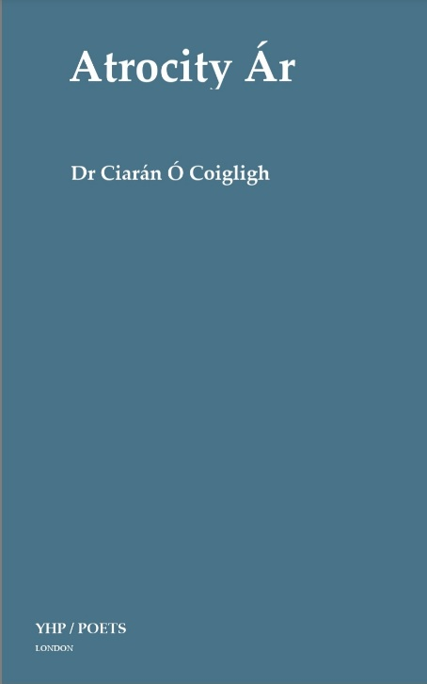 Atrocity Ár

Yellow House Publishing Ltd

85 Great Portland Street

London W1W7LT UK

www.yellowhousepublishing .com

publishingyellowhouse.com

Ph: 07592507105

Atrocity Ár

Author: Dr Ciarán O’Coigligh

Order Directly from Publisher

Cost £18

Editor: Hanna Nielson

ISBN 9781-7393125-8-9

Paperback

Size: 155mm 230mm

Available from 1st May 2025

**Dr Ciarán**  Ó Coigligh’s Atrocity Ár is a haunting poetic chronicle of lives lost to violence. Each victim’s story is distilled into a Haiku, blending historical documentation with minimalist lyricism. The result is a stark yet deeply moving tribute, where the brevity of the form intensifies the weight of each loss.

By using Irish bilingual Haiku, it has been a personal journey for Ciarán; ensuring that no life is reduced to a statistic. Each poem captures a moment, an essence, a tragedy inviting reflection. Victims of atrocities such as the **Dublin and Monaghan bombings (1974)** and the **Enniskillen bombing (1987)** are memorialized with striking simplicity capturing the humanity of the individual victim.

The accumulation of loss also makes for an emotionally heavy read. Yet, these very qualities reinforce the book’s impact, ensuring each life lost during the “*Troubles*” is given human value at a time when history of political violence in Ireland is being rewritten for political expediency.

Atrocity Ár is both a literary achievement and a profound personal memorial. Through precision and restraint, Ciarán crafts a lasting tribute, making this an essential and deeply affecting historical work.

All author royalties are being donated to Southeast Fermanagh Foundation (SEFF). Charity that supports innocent victims of the “*Troubles*”

Publisher: Christoph Thackaberry