Yellow House Publishing Ltd

85 Great Portland Street

London W1W7LT UK

www.yellowhousepublishing .com

[publishingyellowhouse.com](https://www.yellowhousepublishing.com/news/anything-strange-or-startling)

Ph: 07592507105

Anything Strange or Startling

Author: Tony Black

Order UK: Gardeners book Wholesale

R.O.I Directly from Publisher

Cost £18

Editor: Hanna Nielson

Cover Art: Joel Simon

<https://www.joelsimon.art/>

Contributors

Author: Wendy Erskine

Author: Michael Magee

ISBN 978-1-7393125-7-2

Paperback

Size: 155mm 230mm

Available from 23rd Oct 2025

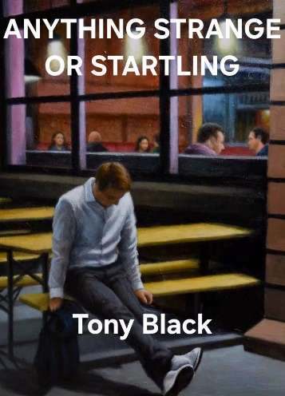**Tony Black’s Debut Short Story Collection Arrives October 2025**

**Belfast, Northern Ireland**  
Yellow House Publishing is proud to announce the upcoming release of *Anything Strange or Startling*, the debut short story collection by Northern Irish writer Tony Black, arriving **29th October 2025**.

Originally from Carnlough, County Antrim and now based in West Belfast, Tony Black has been a vital voice in short fiction for over fifteen years. His work has appeared in *The Belfast Review*, *Púca*, *The Bangor Literary Journal*, *The Martello*, [*New Isles Press*](https://www.yellowhousepublishing.com/shop/new-isles-press-border-teorainn-mairch), and numerous international journals. His stories have been translated, featured in *The Irish Times*, and broadcast on BBC Radio Ulster. Twice runner-up in the Colm Tóibín International Short Story Award, his writing is also archived in the National Library of Ireland and The Linen Hall Library.

Currently completing an MA in Creative Writing at the Seamus Heaney Centre at Queen’s University Belfast, Tony brings a sharp wit, lyrical voice, and deep compassion to stories that span decades and geographies from 1950s Belfast jazz clubs to medieval villages and 1980s misadventures.

*Anything Strange or Startling* offers a curated selection of his finest work to date: a mix of full-length short stories and punchy micro fictions that explore themes of love, loss, family, faith, and art with a healthy dose of the unexpected.

For press inquiries or advance review copies please contact YHP [(Link)](https://www.yellowhousepublishing.com/contact)

Christoph Thackaberry

Publisher