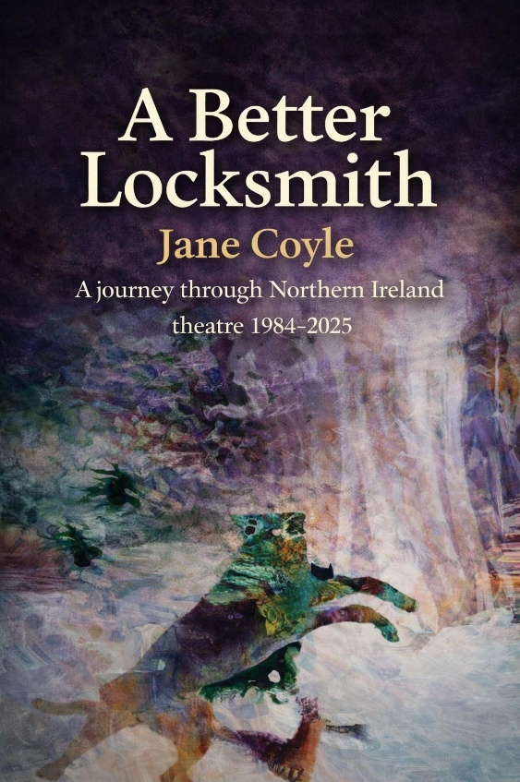
A Better Locksmith (2026) is a landmark anthology by the respected, Belfast-based arts journalist and critic Jane Coyle, which represents her coverage of Northern Ireland theatre over a period of four decades.

This wide-ranging selection of previews and reviews, news features and personal profiles begins in 1984 and ends in 2025. It charts the evolution and development of the theatre sector in Northern Ireland during more than forty years of conflict, social and political change and financial pressures. Events, festivals, international partnerships and individual career paths are recorded with clarity, insight and humanity, from the viewpoint of a self-confessed ‘objective observer’.

As a freelance writer, Coyle’s work has been published on many media platforms, some of which are now difficult to access The pieces reproduced here were originally published in The Irish News, The Irish Times, The Stage, The Sunday Tribune, The Sunday Times, Irish Theatre Magazine, Theatre Ireland and Culture Northern Ireland.

Much more than a historical record, A Better Locksmith captures, from the inside track, the lived experience of Northern Ireland’s theatre sector. With a foreword by theatre director and former Queen’s University Belfast drama lecturer David Grant, and edited by Hanna Nielson and Dr. Connal Parr, it stands as a vital chronicle of an imaginative, resilient and forward-looking creative community.

As Grant writes in his foreword:

“What stands out overall is the sheer diversity of the work … reflecting the way in which theatre in this period has been continually breaking the bounds of conventional performance spaces and traditional forms … At its heart are the hundreds of actors, writers, directors and other theatre artists who populate this wide-ranging anthology.”


85 Great Portland Street London W1W7LT England

BUSINESS INFORMATION
Title: A Better Locksmith
Author: Jane Coyle
ISBN:
Release Date: 14th June 2026
Distribution: Directly from the publisher
Cost:
Trade Discount:
Paperback
Size: 155-230
Cover Art:
Cover Design: Sparks in Colour

