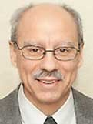 A Note from Deacon Mark
I would like to share this reflection on the Lamb of God from Fr. Tommy Lane, an Irish priest that I like to follow on the web. Fr. Lane writes: “John the Baptist introduces Jesus as the Lamb of God who takes away the sins of the world (John 1:29). It is a most unusual description. A lamb suggests gentleness. It suggests Jesus will not condemn us when we sin but will gently encourage us to get up again. We see this in the Gospels. Just a short while after today’s Gospel passage, the evangelist says, “God did not send his Son into the world to condemn the world, but that the world might be saved through him.” (John 3:17) Jesus said to the sinner woman brought to him by the Pharisees, “Neither do I condemn you. Go, and from now on do not sin anymore.” (John 8:11) Later again in the Gospel, Jesus said, “I did not come to condemn the world but to save the world.” (John 12:47)”
“Jesus does not lock people into their past but frees them to live a new life in union with him. Jesus is always waiting to lead us into his light out of whatever darkness we are in. Jesus wants the best for you, and the best for you is his light, not darkness. Let no prejudice of any kind prevent us from going to Jesus for his forgiveness, mercy, and healing. He is the gentle lamb who offered himself in sacrifice for us once for all time, and he is always ready to make us new and take away our sins.”
Upon Further Reflection
The pastor was working in his office one day when the church secretary came scurrying through the door, out of breath. “Pastor, Pastor, I have news!” she said, trying to regain her composure. “Well, what’s the news?” asked the perplexed pastor. “Jesus is coming. He’s back, and he’s coming here right now. What should we do?” The pastor smiled, turned back to his computer and answered, “Look busy.”
MASS SCHEDULE &
INTENTIONS
01/17-5:00 pm……………Anthony & Diane Roskopf
01/18-9:00 am……………Lowell “Chopper”
Waupoose
01/19……………………….No Mass
01/20-8:00 am……………Souls in Purgatory
01/21-8:00 am……………Catholic Faith Formation
01/22-8:00 am……………Those who have no one
to pray for them
01/23-8:00 am……………Gary Gwidt
01/24-5:00 pm……………Josephine Dodge &
Arthur Chapman
01/25-9:00 am……………Richard & Sylvia Dodge

We are in need of weekday Mass intentions. Mass intentions are $20.00 per Mass.
Financial Blessings
Envelope/Contributors | $1287.00
Loose Collection | $232.00
January 10th & 11th

Thank you for supporting our Parish!

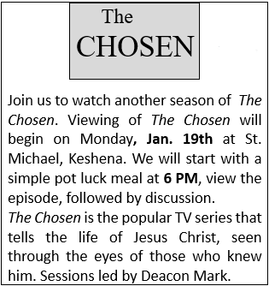

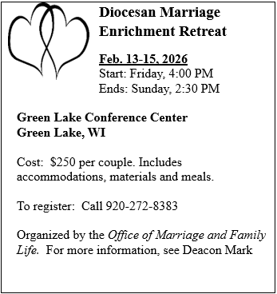

Thank you to those that volunteered their time to take down the Christmas decorations.
EXTRAORDINARY MINISTER
OF HOLY COMMUNION & LECTOR SCHEDULE

Saturday, January 17th, 5:00 p.m.
Lector: Muffy Culhane
Eucharistic Minister: Kevin Culhane
Sunday, January 18th, 9:00 a.m.
Lector: Ellie Sokoly
Eucharistic Minister: Anne Sulskis
Saturday, January 24th, 5:00 p.m.
Lector: Mary Lewellin
Eucharistic Minister: Jim Gilane
Sunday, January 25th, 9:00 a.m.
Lector: Jacquie Braun
Eucharistic Minister: Vicki Hermsen
Saturday, January 31st, 5:00 p.m.
Lector: Kevin Culhane
Eucharistic Minister: Muffy Culhane
Sunday February 1st, 9:00 a.m.
Lector: Ellie Sokoly
Eucharistic Minister: Anne Sulskis
Saturday, February 7th, 5:00 p.m.
Lector: Terri Glauser
Eucharistic Minister: Deacon Mark Fuller
Sunday, February 8th, 9:00 a.m.
Lector: Jacquie Braun
Eucharistic Minister: Deacon Mark Fuller
Upcoming Events:
- Tuesday, January 27th,1st Presbyterian Church Community Dinner. Sponsored by St. Michael @ 5:30 pm. We are looking for volunteers to help that evening with set up, serving, and clean up. Be there by 4:00 pm and we are usually done by 7:30 pm. We also need dessert donations. Please call Cookie at 920-216-9240 if you have any questions.
- Sunday February 15th, Please join us for our Valentines Day Breakfast after 9:00 am Mass.
- Wednesday February 18th, Ash Wednesday.

St. Michael Parish
St. Michael’s Calendar
01/19/2026 The Chose Viewing 6:00 pm
01/20/2026 Thrift N Gift 11:00 am – 3:00 pm
01/20/2026 Food Pantry/Book Share 12:30 - 3:00 pm
01/20/2026 Knights of Colombus meeting 7:00 pm
01/20/2026 Confirmation Class 7:00 – 8:30 pm
01/21/2026 Faith Formation Class 6:00 – 7:00 pm
01/23/2026 Holy Hour after 8:00 am Mass
01/24/2026 FP 2nd Collection at 5:00 pm Mass
01/25/2026 FP 2nd Collection at 9:00 am Mass
01/26/2026 Pastoral Parish Council meeting 6:00 pm

MASS TIMES
St. Michael – Saturday: 5:00 pm., Sunday: 9:00 am.
Monday – No Mass, Tuesday - Friday: 8:00 am
St. Anthony – Sunday: 10:30 am

Book Share
Will be open Tuesday, January 20th from 12:30 – 3:00 pm. We have books for all ages! We will accept books in good shape, just no old magazines, text books or encyclopedias.

Food Pantry
Will be open Tuesday, January 20th from 12:30 - 3:00 pm. There will be drive up service only and food will be placed in your trunk. Please do not get out of your vehicle. Please save brown paper bags & plastic bags and please drop them off at the Parish office.

Thrift N Gift
Will be open Tuesday, January 20th from 11:00 am - 3:00 pm. We have an abundance of household items, clothes, and great gift items. Please reach out to Cookie if you need to, 920-216-9240.

We the Knights
We always ask God to bless our community members. If you or a family member need assistance to get to a doctor appointment, we may be able to help. Call Paul at 715-853-2414 or Todd 715-584-5885.

Kateri Prayer Circle
Never underestimate the power of prayer. Just one small prayer can change your life. If you or your family members need prayers for any reason, please call one of our Kateri Prayer Circle members, who will in turn call members of their group. Soon, many prayers will be offered for your specific prayer request. Please call:

Fay Waupochick: 715-799-3437
Jacqueline Braun: 715-701-4552

You can also call the Parish Office to leave a request.

Religious Education Calendar Up Coming Events:
Wednesday, November 30th –Classes Resume
Wednesday December 7th
Wednesday December 14th
Wednesday December 21st Birthday Party- Parents
Guardians invited
Wednesday December 28th No Class
Wednesday January 4th No Class
Wednesday January 11 Classes resume
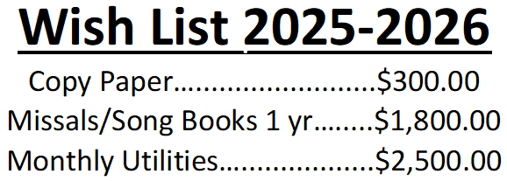
We are so close to reaching our goal for the 2025-2026 Wishlist completion. Please consider making a donation, even if it is just a partial payment. Thank you to those who have already contributed. Your support is greatly appreciated!!



14109 County VV, Gillett, WI 54124


SUNDAY BRUNCH 9-12 PM.
CHICKEN DINNER ALL DAY.

Please pick up your pans, cookie sheets, and miscellaneous items left over from funerals and other church events in the Fr. Barrett Hall.
There will not be a Mass at St. Michael on Holy Saturday, March 26. Easter Vigil will be held at St. Francis in Gresham at 7 pm. Easter Sunday Mass will be at St. Michael and St. Anthony at 10:30 am.

Maintenance. Michael Catholic Parish in Keshena is seeking a part-time maintenance person. Responsible for light maintenance, cleaning the church, etc. Contact the parish office at telephone number 715-799-3811 for an application, and job.

Please pick up your pans, cookie sheets, and miscellaneous items left over from funerals and other church events in the Fr. Barrett Hall.
There will not be a Mass at St. Michael on Holy Saturday, March 26. Easter Vigil will be held at St. Francis in Gresham at 7 pm. Easter Sunday Mass will be at St. Michael and St. Anthony at 10:30 am.
PARISH STAFF
FR. HANZ CHRISTIAN BORBOR
Parish Administrator
Parish Office (715) 799-3811
xtian.borbor@gmail.com

DEACON MARK FULLER
(715) 201-2961
mpfull7@gmail.com

Parish Secretary
RICKIE DODGE
Parish Office (715) 799-3811
stmichaels@livingwaterslivingfaith.org

Faith Formation
JACKIE LANGHANS
Parish Office (715) 799-3811
jlanghans@att.net

PARISH TRUSTEES
KAREN SMART, Treasurer
VICKI HERMSEN, Secretary

Parish Council Chair
MARY LEWELLIN

Finance Council Chair
THERESE GLAUSER

Thrift N Gift Coordinator
COOKIE VIGUE

Food Pantry Coordinator

MASS SCHEDULE
Saturday: 5:00 pm Mass
4:30 pm Rosary & Confession
Sunday: 9:00 am Mass
8:30 am Rosary
Monday – No Mass
Tuesday - Friday: 8:00 am

PARISH OFFICE HOURS
Regular hours: Monday-Wednesday
8:15 am – 2:00 pm
Hours may vary, please call before coming to the office.
SATURDAY MASS: 5:00 pm
SUNDAY MASS: 9:00 am
CONFESSION: Saturday 4:30 - 4:45pm
ROSARY: Saturday 3:40 pm Sunday 8:35 am
DAILY MASS: Chapel Southside of Church

P Parish Administrator, Fr. Nonito Barra - 715-799-3811 - pastor@livingwaterslivingfaith.org
Rectory – 715-994-1337
Parochial Vicar Fr. Joel Jores - 715-787-3377 frj@livingwaterslivingfaith.org
Deacon Mark Fuller 715-201-2961- deaconmark@livingwaterslivingfaith.org
Parish Secretary, Vicki Hermsen - 715-799-3811 - vicki@livingwaterslivingfaith.org
Religious Education Kathy King-Tucker - 715-799-3927 – ltucker@frontiernet.netmailto:maczuzak@frontiernet.net
Wednesday 6 – 7:30 pm September – May
Parish Administrator, Fr. Nonito Barra - 715-799-3811 - pastor@livingwaterslivingfaith.org
Rectory – 715-994-1337
Parochial Vicar Fr. Joel Jores - 715-787-3377 frj@livingwaterslivingfaith.org
Deacon Mark Fuller 715-201-2961- deaconmark@livingwaterslivingfaith.org
Parish Secretary, Vicki Hermsen - 715-799-3811 - vicki@livingwaterslivingfaith.org
Religious Education Kathy King-Tucker - 715-799-3927 – ltucker@frontiernet.netmailto:maczuzak@frontiernet.net
Wednesday 6 – 7:30 pm September – May
Parish Administrator, Fr. Nonito Barra - 715-799-3811 - pastor@livingwaterslivingfaith.org
Rectory – 715-994-1337
Parochial Vicar Fr. Joel Jores - 715-787-3377 frj@livingwaterslivingfaith.org
Deacon Mark Fuller 715-201-2961- deaconmark@livingwaterslivingfaith.org
Parish Secretary, Vicki Hermsen - 715-799-3811 - vicki@livingwaterslivingfaith.org
Religious Education Kathy King-Tucker - 715-799-3927 – ltucker@frontiernet.netmailto:maczuzak@frontiernet.net
Wednesday 6 – 7:30 pm September – May

January 18, 2026
Second Sunday in Ordinary Time
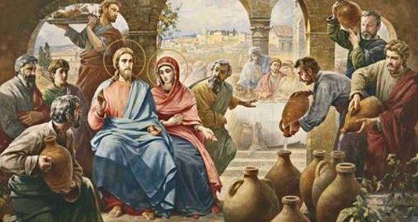
Anamehawikamek Welcome
ST. MICHAEL CATHOLIC CHURCH
PO Box 610, N816 State Highway 47-55,
Keshena, WI 54135 - Phone: 715-799-3811
Email: stmichaels@livingwaterslivingfaith.org
Website: stmichaelkeshena.com
Find us on Facebook: St. Michael’s Church

MISSION STATEMENT: St. Michael’s Christian Community, located on the Menominee Indian Reservation, is a diverse Christian community reaching out to all residents, learning, loving, sharing, and communicating with one another through the teachings and practices celebrated in the Mass & the Holy Sacraments of the Catholic Church by integrating sacred symbols and spiritual practices of the Menominee.
KNIGHTS OF COLUMBUS: Contact Grand Knight Paul Marroquin 715-853-2414.
HOLY HOUR: Every Friday in January after 8:00 am Mass.
ANOINTING OF THE SICK: Individual arrangements can be made through the Parish Office.
BAPTISM: Kindly contact parish office.
MARRIAGE: Make arrangements with the Priest, six months prior to desired date.
CONFIRMATION: Contact Deacon Mark Fuller for information via email mpfull7@gmail.com.

