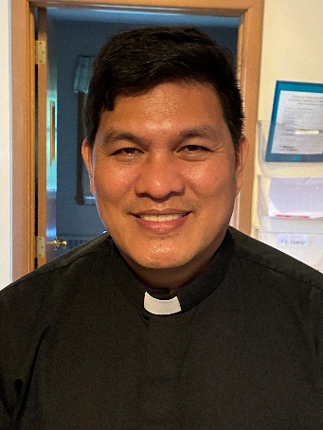 A Note from Father Hanz
Our Gospel for this Fourth Sunday in Ordinary Time is about the Beatitudes. The Beatitudes remind us that true happiness does not come from comfort, power, or success, but from living close to the heart of God. Jesus calls blessed those whom the world often overlooks—the poor in spirit, the meek, the merciful, and those who suffer for doing what is right. In them, God sees faith, humility, and love.
Each Beatitude invites us to trust God more deeply: to depend on Him in our weakness, to choose mercy over revenge, to seek peace instead of division. They assure us that even in pain, loss, or persecution, God is present and His promises are sure.
The Beatitudes challenge us to live differently—to love generously, to forgive freely, and to hope firmly. When we live them, we discover that the path of the Gospel, though demanding, leads to the deepest and lasting joy.

Please return your palms from last year. Baskets are located at every Parish entrance for you to put them in.

MASS SCHEDULE &
INTENTIONS
01/31-5:00 pm…………….Jim Kaquatosh
02/01-9:00 am…………….David Hawpetoss
02/02………………….…….No Mass
02/03-8:00 am…………….Tribal Elders
02/04-8:00 am…………….Parish Volunteers
02/05-8:00 am…………….Improved health for
my many relatives/friends dealing with problems
02/06-8:00 am…………….John Fenelon
02/07-5:00 pm…………….The Brath/Rehman
Families
02/08-9:00 am…………….Olga Doran

We are in need of weekday Mass intentions. Mass intentions are $20.00 per Mass.
Financial Blessings
Envelope/Contributors | $2452.00
Loose Collection | $198.00
January 24th & 25th

Thank you for supporting our Parish!

Please Join Us!
St. Michael will be hosting their annual Family Lenten Fish Dinner on Friday February 27th from 4:30 pm – 6:30 pm in the Father David Barrett Hall. Dine-In OR Carry-Out. Baked Battered or Unbattered Cod, Mac N Cheese, Vegetarian Baked Beans, Cole Slaw, Buttered Marbled Rye Bread, Dessert. Full Meal $13.00. Kids any 3 items $6.00. Water $1.00.

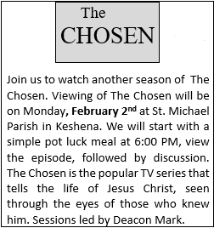



2026 Bishop’s Appeal is fast approaching, please consider making a donation. Thank you.
EXTRAORDINARY MINISTER
OF HOLY COMMUNION & LECTOR SCHEDULE

Saturday, January 31st, 5:00 p.m.
Lector: Kevin Culhane
Eucharistic Minister: Muffy Culhane
Sunday February 1st, 9:00 a.m.
Lector: Ellie Sokoly
Eucharistic Minister: Anne Sulskis
Saturday, February 7th, 5:00 p.m.
Lector: Terri Glauser
Eucharistic Minister: Deacon Mark Fuller
Sunday, February 8th, 9:00 a.m.
Lector: Jacquie Braun
Eucharistic Minister: Deacon Mark Fuller
Saturday, February 14th, 5:00 p.m.
Lector: Kevin Culhane
Eucharistic Minister: Muffy Culhane
Sunday, February 15th, 9:00 a.m.
Lector: Anne Sulskis
Eucharistic Minister: Gloria Gierach
Wednesday February, 18th, 6:00 pm
Lector: Ellie Sokoly
Eucharistic Minister: Anne Sulskis
Saturday, February 21st, 5:00 p.m.
Lector: Rod Glauser
Eucharistic Minister: Kevin Culhane
Sunday, February 22nd, 9:00 a.m.
Lector: Jacquie Braun
Eucharistic Minister: Anne Sulskis

Upcoming Events:
- Sunday February, 15th please join us for our Valentine’s Day Breakfast after 9:00 am Mass.
- Wednesday, February 18th Ash Wednesday 6:00 pm Mass.
- Friday February, 27th please join us for our Annual Lenten Fish Dinner from 4:30 – 6:30 pm in the Father David Barrett Hall. See bulletin ad for more details.

St. Michael Parish
St. Michael’s Calendar
02/02/2026 The Chosen Viewing 6:00 pm
02/03/2026 Thrift N Gift 11:00 am – 3:00 pm
02/03/2026 Food Pantry/Book Share 12:30 - 3:00 pm
02/03/2026 Confirmation Class 7:00 – 8:30 pm
02/04/2026 Faith Formation Class 6:00 – 7:00 pm
02/06/2026 Holy Hour after 8:00 am Mass
02/07/2026 Bishop’s Appeal 2nd Collection at 5:00 pm
Mass
02/07/2026 Prayer Ministry after Mass
02/08/2026 Bishop’s Appeal 2nd Collection at 9:00 am
Mass
02/08/2026 Prayer Ministry after Mass
MASS TIMES
St. Michael – Saturday: 5:00 pm., Sunday: 9:00 am.
Monday – No Mass, Tuesday - Friday: 8:00 am
Ash Wednesday February 18th: 6:00 pm
St. Anthony – Sunday: 10:30 am

Book Share
Will be open Tuesday, February 3rd from 12:30 – 3:00 pm. We have books for all ages! We will accept books in good shape, just no old magazines, text books or encyclopedias.

Food Pantry
Will be open Tuesday, February 3rd from 12:30 - 3:00 pm. There will be drive up service only and food will be placed in your trunk. Please do not get out of your vehicle. Please save brown paper bags & plastic bags and please drop them off at the Parish office.

Thrift N Gift
Will be open Tuesday, February 3rd from 11:00 am - 3:00 pm. We have an abundance of household items, clothes, and great gift items. Please reach out to Cookie if you need to, 920-216-9240.

We the Knights
We always ask God to bless our community members. If you or a family member need assistance to get to a doctor appointment, we may be able to help. Call Paul at 715-853-2414 or Todd 715-584-5885.

Kateri Prayer Circle
Never underestimate the power of prayer. Just one small prayer can change your life. If you or your family members need prayers for any reason, please call one of our Kateri Prayer Circle members, who will in turn call members of their group. Soon, many prayers will be offered for your specific prayer request. Please call:
Fay Waupochick: 715-799-3437
Jacqueline Braun: 715-701-4552
You can also call the Parish Office to leave a request.

Religious Education Calendar Up Coming Events:
Wednesday, November 30th –Classes Resume
Wednesday December 7th
Wednesday December 14th
Wednesday December 21st Birthday Party- Parents
Guardians invited
Wednesday December 28th No Class
Wednesday January 4th No Class
Wednesday January 11 Classes resume
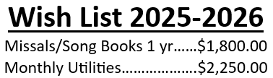
We are so close to reaching our goal for the 2025-2026 Wishlist completion. Please consider making a donation, even if it is just a partial payment. A partial payment has been made to the Utilities. Thank you to those who have already contributed. Your support is greatly appreciated!!



14109 County VV, Gillett, WI 54124


SUNDAY BRUNCH 9-12 PM.
CHICKEN DINNER ALL DAY.

Please pick up your pans, cookie sheets, and miscellaneous items left over from funerals and other church events in the Fr. Barrett Hall.
There will not be a Mass at St. Michael on Holy Saturday, March 26. Easter Vigil will be held at St. Francis in Gresham at 7 pm. Easter Sunday Mass will be at St. Michael and St. Anthony at 10:30 am.

Maintenance. Michael Catholic Parish in Keshena is seeking a part-time maintenance person. Responsible for light maintenance, cleaning the church, etc. Contact the parish office at telephone number 715-799-3811 for an application, and job.

Please pick up your pans, cookie sheets, and miscellaneous items left over from funerals and other church events in the Fr. Barrett Hall.
There will not be a Mass at St. Michael on Holy Saturday, March 26. Easter Vigil will be held at St. Francis in Gresham at 7 pm. Easter Sunday Mass will be at St. Michael and St. Anthony at 10:30 am.
PARISH STAFF
FR. HANZ CHRISTIAN BORBOR
Parish Administrator
Parish Office (715) 799-3811
xtian.borbor@gmail.com

DEACON MARK FULLER
(715) 201-2961
mpfull7@gmail.com

Parish Secretary
RICKIE DODGE
Parish Office (715) 799-3811
stmichaels@livingwaterslivingfaith.org

Faith Formation
JACKIE LANGHANS
Parish Office (715) 799-3811
jlanghans@att.net

PARISH TRUSTEES
KAREN SMART, Treasurer
VICKI HERMSEN, Secretary

Parish Council Chair
MARY LEWELLIN

Finance Council Chair
THERESE GLAUSER

Thrift N Gift Coordinator
COOKIE VIGUE

Food Pantry Coordinator

MASS SCHEDULE
Saturday: 5:00 pm Mass
4:30 pm Rosary & Confession
Sunday: 9:00 am Mass
8:30 am Rosary
Monday – No Mass
Tuesday - Friday: 8:00 am
Ash Wednesday February 18th: 6:00 pm

PARISH OFFICE HOURS
Regular hours: Monday-Wednesday
8:15 am – 2:00 pm
Hours may vary, please call before coming to the office.
SATURDAY MASS: 5:00 pm
SUNDAY MASS: 9:00 am
CONFESSION: Saturday 4:30 - 4:45pm
ROSARY: Saturday 3:40 pm Sunday 8:35 am
DAILY MASS: Chapel Southside of Church

P Parish Administrator, Fr. Nonito Barra - 715-799-3811 - pastor@livingwaterslivingfaith.org
Rectory – 715-994-1337
Parochial Vicar Fr. Joel Jores - 715-787-3377 frj@livingwaterslivingfaith.org
Deacon Mark Fuller 715-201-2961- deaconmark@livingwaterslivingfaith.org
Parish Secretary, Vicki Hermsen - 715-799-3811 - vicki@livingwaterslivingfaith.org
Religious Education Kathy King-Tucker - 715-799-3927 – ltucker@frontiernet.netmailto:maczuzak@frontiernet.net
Wednesday 6 – 7:30 pm September – May
Parish Administrator, Fr. Nonito Barra - 715-799-3811 - pastor@livingwaterslivingfaith.org
Rectory – 715-994-1337
Parochial Vicar Fr. Joel Jores - 715-787-3377 frj@livingwaterslivingfaith.org
Deacon Mark Fuller 715-201-2961- deaconmark@livingwaterslivingfaith.org
Parish Secretary, Vicki Hermsen - 715-799-3811 - vicki@livingwaterslivingfaith.org
Religious Education Kathy King-Tucker - 715-799-3927 – ltucker@frontiernet.netmailto:maczuzak@frontiernet.net
Wednesday 6 – 7:30 pm September – May
Parish Administrator, Fr. Nonito Barra - 715-799-3811 - pastor@livingwaterslivingfaith.org
Rectory – 715-994-1337
Parochial Vicar Fr. Joel Jores - 715-787-3377 frj@livingwaterslivingfaith.org
Deacon Mark Fuller 715-201-2961- deaconmark@livingwaterslivingfaith.org
Parish Secretary, Vicki Hermsen - 715-799-3811 - vicki@livingwaterslivingfaith.org
Religious Education Kathy King-Tucker - 715-799-3927 – ltucker@frontiernet.netmailto:maczuzak@frontiernet.net
Wednesday 6 – 7:30 pm September – May

February 1st, 2026
Fourth Sunday in Ordinary Time
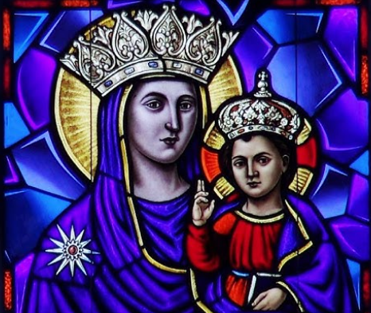
Anamehawikamek Welcome
ST. MICHAEL CATHOLIC CHURCH
PO Box 610, N816 State Highway 47-55,
Keshena, WI 54135 - Phone: 715-799-3811
Email: stmichaels@livingwaterslivingfaith.org
Website: stmichaelkeshena.com
Find us on Facebook: St. Michael’s Church

MISSION STATEMENT: St. Michael’s Christian Community, located on the Menominee Indian Reservation, is a diverse Christian community reaching out to all residents, learning, loving, sharing, and communicating with one another through the teachings and practices celebrated in the Mass & the Holy Sacraments of the Catholic Church by integrating sacred symbols and spiritual practices of the Menominee.
KNIGHTS OF COLUMBUS: Contact Grand Knight Paul Marroquin 715-853-2414.
HOLY HOUR: Every Friday after 8:00 am Mass.
ANOINTING OF THE SICK: Individual arrangements can be made through the Parish Office.
BAPTISM: Kindly contact parish office.
MARRIAGE: Make arrangements with the Priest, six months prior to desired date.
CONFIRMATION: Contact Deacon Mark Fuller for information via email mpfull7@gmail.com.

