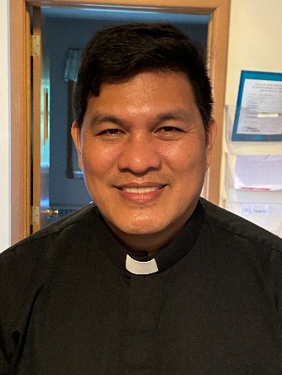 A Note from Father Hanz
Saint Thomas Aquinas explains that believers become light in three ways:
1. By truth: Light reveals. A Christian enlightens others by teaching truth and living in truth. Falsehood belongs to darkness; truth belongs to light.
2. By good example: He stresses that light is not hidden. A holy life should be visible—not for vanity, but so that others may be drawn to God. Our works are meant to point beyond us to the Father.
3. By charity: Light gives warmth as well as visibility. Aquinas links light with love: a Christian life that lacks charity may shine outwardly but is spiritually dim.
He also added on the “city set on a hill”:
The Church and the life of the saints cannot be concealed, because their purpose is to guide others to God.
And on letting the light shine:
Good works are shown not for human glory, but so that God may be glorified in His servants.
So, for St. Thomas Aquinas, the verse is both a gift and a responsibility. We are not the source of the light — Christ is — but we are called to reflect Him so clearly that others see God through our lives.
Be the Light for Our Community
“You are the light of the world. A city set on a mountain cannot be hidden. Nor do they light a lamp and then put it under a bushel basket; it is set on a lampstand, where it gives light to all in the house. Just so, your light must shine before others, that they may see your good deeds and glorify your heavenly Father. – Matthew 5:14-16
Dear Friends, Jesus calls us to Be the Light—a light that brings hope and healing to those around us. The Bishop’s Appeal helps make this possible through Catholic Charities, faith formation at St. Michael Parish, and even more ministries that support people across our Diocese.
If you have already given, thank you. If you have never given before, I invite you to consider making your first gift this year. Every gift makes a difference.
Those who are able may join the Crozier Society with a gift of $500 or more, helping these ministries reach even more people.
Please prayerfully consider supporting the 2026 Bishop’s Appeal by using your pledge card or visiting www.catholicfoundation.org/give.
Thank you for helping St. Michael Parish and our Diocese share the light of Christ.
Financial Blessings
January 31st & February 1st
Envelope/Contributors | $1288.00
Loose Collection | $296.00
We are in need of Mass intentions. Mass intentions are $20.00 per Mass.
Thank you for supporting our Parish!
MASS SCHEDULE &
INTENTIONS
02/07-5:00 pm…………….The Brath/Rehman
Families
02/08-9:00 am…………….Olga Doran
02/09………………………..No Mass
02/10-8:00 am…………….The homeless
02/11-8:00 am…………….For peace in holy land
02/12-8:00 am…………….Janet’s successful
shoulder surgery
02/13-8:00 am…………….For all expectant
parents
02/14-5:00 pm…………….John Fenelon
02/15-9:00 am…………….Richard A Moses Sr.
Please return your palms from last year. Baskets are located at every Parish entrance for you to put them in.
Please Join Us!
St. Michael will be hosting their annual Family Lenten Fish Dinner on Friday February 27th from 4:30 pm – 6:30 pm in the Father David Barrett Hall. Dine-In OR Carry-Out. Baked Battered or Unbattered Cod, Mac N Cheese, Vegetarian Baked Beans, Cole Slaw, Buttered Marbled Rye Bread, Dessert. Full Meal $13.00. Kids any 3 items $6.00. Water $1.00. Cookie needs 20 volunteers.
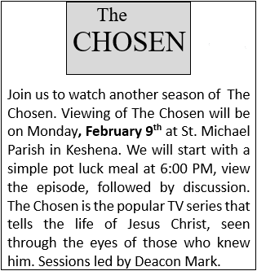
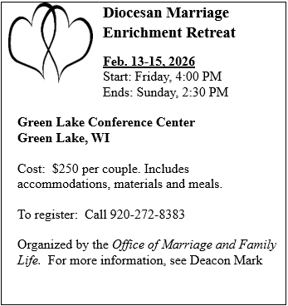
Food Pantry News:
Recently, St. Michael’s Food Pantry was awarded a grant from the Augustine Stewardship Fund. In addition to purchasing food, the grant will fund a spring container vegetable gardening project for our recipients. This project was inspired by the late Pat Gwidt. Thank you Augustine Stewardship Fund.
EXTRAORDINARY MINISTER
OF HOLY COMMUNION &
LECTOR SCHEDULE

Saturday, February 7th, 5:00 p.m.
Lector: Terri Glauser
Eucharistic Minister: Deacon Mark Fuller
Sunday, February 8th, 9:00 a.m.
Lector: Jacquie Braun
Eucharistic Minister: Deacon Mark Fuller
Saturday, February 14th, 5:00 p.m.
Lector: Kevin Culhane
Eucharistic Minister: Muffy Culhane
Sunday, February 15th, 9:00 a.m.
Lector: Anne Sulskis
Eucharistic Minister: Gloria Gierach
Wednesday February, 18th, 6:00 pm
Lector: Ellie Sokoly
Eucharistic Minister: Anne Sulskis
Saturday, February 21st, 5:00 p.m.
Lector: Rod Glauser
Eucharistic Minister: Kevin Culhane
Sunday, February 22nd, 9:00 a.m.
Lector: Jacquie Braun
Eucharistic Minister: Anne Sulskis
Saturday, February 28th, 5:00 p.m.
Lector: Larry Sikowski/Mary Lewellin
Eucharistic Minister: Deacon Mark
Sunday March 1st, 9:00 a.m.
Lector: Ellie Sokoly/Jacquie Braun
Eucharistic Minister: Deacon Mark
Upcoming Events:
- Sunday February, 15th please join us for our Valentine’s Day Breakfast after 9:00 am Mass. Cookie is in need of egg bakes, fruit, desserts, chocolate milk & cheesy potatoes. Please contact her at 920-216-9240.
- Wednesday, February 18th Ash Wednesday 8:00 am & 6:00 pm Mass.
- Friday February, 27th please join us for our Annual Lenten Fish Dinner from 4:30 – 6:30 pm in the Father David Barrett Hall. See bulletin ad for more details.

St. Michael Parish
St. Michael’s Calendar
02/07/2026 Bishop’s Appeal 2nd Collection at 5:00 pm
Mass
02/07/2026 Prayer Ministry after Mass
02/08/2026 Bishop’s Appeal 2nd Collection at 9:00 am
Mass
02/08/2026 Prayer Ministry after Mass
02/09/2026 The Chosen Viewing 6:00 pm
02/11/2026 Faith Formation Class 6:00 – 7:00 pm
02/12/2026 Parish Finance Council meeting 9:00 am
02/13/2026 Holy Hour after 8:00 am Mass
02/14/2026 Valentine’s Day
02/15/2026 Valentine’s Day Breakfast after Mass
MASS TIMES
St. Michael – Saturday: 5:00 pm., Sunday: 9:00 am.
Monday – No Mass, Tuesday - Friday: 8:00 am
Ash Wednesday February 18th: 8:00 am & 6:00 pm
St. Anthony – Sunday: 10:30 am

Book Share
Will be open Tuesday, February 17th from 12:30 – 3:00 pm. We have books for all ages! We will accept books in good shape, just no old magazines, text books or encyclopedias.

Food Pantry
Will be open Tuesday, February 17th from 12:30 - 3:00 pm. There will be drive up service only and food will be placed in your trunk. Please do not get out of your vehicle. Please save brown paper bags & plastic bags and please drop them off at the Parish office.

Thrift N Gift
Will be open Tuesday, February 17th from 11:00 am - 3:00 pm. We have an abundance of household items, clothes, and great gift items. Please reach out to Cookie if you need to, 920-216-9240.

We the Knights
We always ask God to bless our community members. If you or a family member need assistance to get to a doctor appointment, we may be able to help. Call Paul at 715-853-2414 or Todd 715-584-5885.

Kateri Prayer Circle
Never underestimate the power of prayer. Just one small prayer can change your life. If you or your family members need prayers for any reason, please call one of our Kateri Prayer Circle members, who will in turn call members of their group. Soon, many prayers will be offered for your specific prayer request. Please call:
Fay Waupochick: 715-799-3437
Jacqueline Braun: 715-701-4552
You can also call the Parish Office to leave a request.

Religious Education Calendar Up Coming Events:
Wednesday, November 30th –Classes Resume
Wednesday December 7th
Wednesday December 14th
Wednesday December 21st Birthday Party- Parents
Guardians invited
Wednesday December 28th No Class
Wednesday January 4th No Class
Wednesday January 11 Classes resume

What is the Bishop's Appeal?
The Bishop's Appeal is a stewardship opportunity for each of us to reach out to thousands of people in search of Jesus' love. Each gift given supports the ministries of the Diocese of Green Bay which serve our parishes, Catholic schools, and communities. Your gift truly helps bring the heart and hands of Christ to our children, young adults, families, and neighbors here in northeastern Wisconsin.
To make a gift today, contact your parish, make a gift online at www.catholicfoundationgb.org/give, or call Tammy at 920-272-8123.
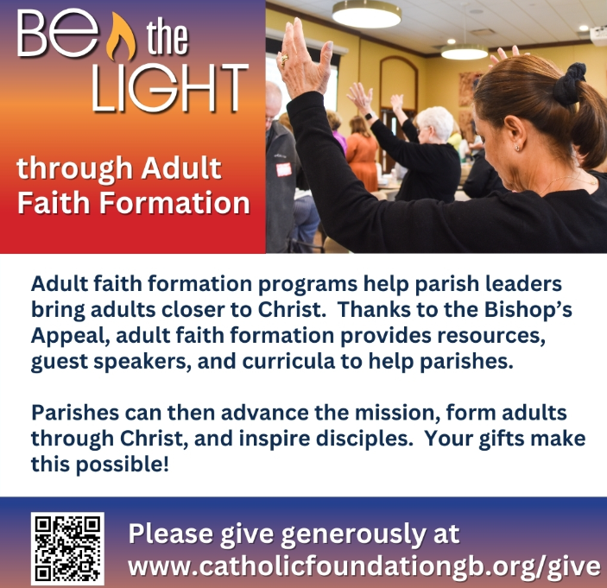


14109 County VV, Gillett, WI 54124


SUNDAY BRUNCH 9-12 PM.
CHICKEN DINNER ALL DAY.

Please pick up your pans, cookie sheets, and miscellaneous items left over from funerals and other church events in the Fr. Barrett Hall.
There will not be a Mass at St. Michael on Holy Saturday, March 26. Easter Vigil will be held at St. Francis in Gresham at 7 pm. Easter Sunday Mass will be at St. Michael and St. Anthony at 10:30 am.

Maintenance. Michael Catholic Parish in Keshena is seeking a part-time maintenance person. Responsible for light maintenance, cleaning the church, etc. Contact the parish office at telephone number 715-799-3811 for an application, and job.

Please pick up your pans, cookie sheets, and miscellaneous items left over from funerals and other church events in the Fr. Barrett Hall.
There will not be a Mass at St. Michael on Holy Saturday, March 26. Easter Vigil will be held at St. Francis in Gresham at 7 pm. Easter Sunday Mass will be at St. Michael and St. Anthony at 10:30 am.
PARISH STAFF
FR. HANZ CHRISTIAN BORBOR
Parish Administrator
Parish Office (715) 799-3811
xtian.borbor@gmail.com

DEACON MARK FULLER
(715) 201-2961
mpfull7@gmail.com

Parish Secretary
RICKIE DODGE
Parish Office (715) 799-3811
stmichaels@livingwaterslivingfaith.org

Faith Formation
JACKIE LANGHANS
Parish Office (715) 799-3811
jlanghans@att.net

PARISH TRUSTEES
KAREN SMART, Treasurer
VICKI HERMSEN, Secretary

Parish Council Chair
MARY LEWELLIN

Finance Council Chair
THERESE GLAUSER

Thrift N Gift Coordinator
COOKIE VIGUE

Food Pantry Coordinator

MASS SCHEDULE
Saturday: 5:00 pm Mass
4:30 pm Rosary & Confession
Sunday: 9:00 am Mass
8:30 am Rosary
Monday – No Mass
Tuesday - Friday: 8:00 am
Ash Wednesday February 18th: 8:00 am & 6:00 pm Masses

PARISH OFFICE HOURS
Regular hours: Monday-Thursday
8:15 am – 2:00 pm
Hours may vary, please call before coming to the office.
SATURDAY MASS: 5:00 pm
SUNDAY MASS: 9:00 am
CONFESSION: Saturday 4:30 - 4:45pm
ROSARY: Saturday 3:40 pm Sunday 8:35 am
DAILY MASS: Chapel Southside of Church

P Parish Administrator, Fr. Nonito Barra - 715-799-3811 - pastor@livingwaterslivingfaith.org
Rectory – 715-994-1337
Parochial Vicar Fr. Joel Jores - 715-787-3377 frj@livingwaterslivingfaith.org
Deacon Mark Fuller 715-201-2961- deaconmark@livingwaterslivingfaith.org
Parish Secretary, Vicki Hermsen - 715-799-3811 - vicki@livingwaterslivingfaith.org
Religious Education Kathy King-Tucker - 715-799-3927 – ltucker@frontiernet.netmailto:maczuzak@frontiernet.net
Wednesday 6 – 7:30 pm September – May
Parish Administrator, Fr. Nonito Barra - 715-799-3811 - pastor@livingwaterslivingfaith.org
Rectory – 715-994-1337
Parochial Vicar Fr. Joel Jores - 715-787-3377 frj@livingwaterslivingfaith.org
Deacon Mark Fuller 715-201-2961- deaconmark@livingwaterslivingfaith.org
Parish Secretary, Vicki Hermsen - 715-799-3811 - vicki@livingwaterslivingfaith.org
Religious Education Kathy King-Tucker - 715-799-3927 – ltucker@frontiernet.netmailto:maczuzak@frontiernet.net
Wednesday 6 – 7:30 pm September – May
Parish Administrator, Fr. Nonito Barra - 715-799-3811 - pastor@livingwaterslivingfaith.org
Rectory – 715-994-1337
Parochial Vicar Fr. Joel Jores - 715-787-3377 frj@livingwaterslivingfaith.org
Deacon Mark Fuller 715-201-2961- deaconmark@livingwaterslivingfaith.org
Parish Secretary, Vicki Hermsen - 715-799-3811 - vicki@livingwaterslivingfaith.org
Religious Education Kathy King-Tucker - 715-799-3927 – ltucker@frontiernet.netmailto:maczuzak@frontiernet.net
Wednesday 6 – 7:30 pm September – May

February 8th, 2026
Fifth Sunday in Ordinary Time
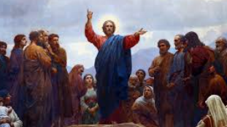
Anamehawikamek Welcome
ST. MICHAEL CATHOLIC CHURCH
PO Box 610, N816 State Highway 47-55,
Keshena, WI 54135 - Phone: 715-799-3811
Email: stmichaels@livingwaterslivingfaith.org
Website: stmichaelkeshena.com
Find us on Facebook: St. Michael’s Church

MISSION STATEMENT: St. Michael’s Christian Community, located on the Menominee Indian Reservation, is a diverse Christian community reaching out to all residents, learning, loving, sharing, and communicating with one another through the teachings and practices celebrated in the Mass & the Holy Sacraments of the Catholic Church by integrating sacred symbols and spiritual practices of the Menominee.
KNIGHTS OF COLUMBUS: Contact Grand Knight Paul Marroquin 715-853-2414.
HOLY HOUR: Every Friday after 8:00 am Mass.
ANOINTING OF THE SICK: Individual arrangements can be made through the Parish Office.
BAPTISM: Kindly contact parish office.
MARRIAGE: Make arrangements with the Priest, six months prior to desired date.
CONFIRMATION: Contact Deacon Mark Fuller for information via email mpfull7@gmail.com.

