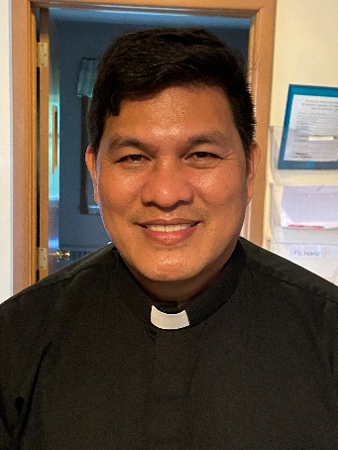 A Note from Father Hanz
St. Augustine on the Gospel for this Sunday.
Jesus teaches that being good is not only about what we do on the outside, but about what is in our hearts.
1. Greater righteousness (v. 20)
Augustine says the Pharisees followed rules outwardly, but Jesus asks for something deeper. A Christian must not only avoid sin but learn to love what is good. True righteousness comes from charity — love of God and neighbor.
2. Anger (v. 21–22)
Anger that leads to hatred or contempt is already a kind of spiritual harm. Augustine teaches that when we reject or despise another person, we damage love. Christians are called to correct others with love, not with pride or revenge.
3. Lust (v. 27–28)
Sin begins in the heart when we choose to welcome wrong desires. Augustine explains that temptation itself is not sin — sin happens when the will agrees with it. Purity means learning to see others with respect and dignity.
4. Truthfulness (v. 33–37)
A Christian should be so honest that oaths are unnecessary. Augustine says our words should be simple and true. A faithful heart speaks plainly: yes means yes, and no means no.
According to St. Augustine, Jesus is teaching that holiness starts inside. God wants to transform our hearts, not just our behavior. When love fills the heart, actions naturally follow.

Faith That Shines: Living God’s Commandments
“But whoever obeys and teaches these commandments will be called greatest in the kingdom
of heaven.” – Luke 5:19
Dear Friends,
To Be the Light means to live our faith and allow Christ’s love to shine through us. We see this light in action right here at St. Michael Parish in our faith formation program, where 9 children are introduced to Jesus and begin a lifelong journey of friendship with Him. This is just one of the many ways your gift makes a difference.
If you have already given, thank you. If you have never given before, please consider making your first gift this year to support these important ministries.
For those who are able, a gift of $500 or more enrolls you in the Crozier Society, a growing community of generous supporters who help the Church reach even more people with the love
of Jesus.
To give to the Appeal, contact our parish office, use the pledge card you received at home, or visit the Bishop’s Appeal website at www.catholicfoundation.com/give to make your gift.
Thank you for your faith, your generosity, and for being the light that helps others encounter Jesus at St. Michael Parish.
2026 Bishop’s Appeal Goal
This year’s goal is $7,664.00.
We have already received $5,200.00 in donations. Thank you!
Financial Blessings
February 7th & 8th
Envelope/Contributors | $2511.00
Loose Collection | $311.00
We are in need of Mass intentions. Mass intentions are $20.00 per Mass.
Thank you for supporting our Parish!
MASS SCHEDULE &
INTENTIONS
02/14-5:00 pm…………….John Fenelon
02/15-9:00 am…………….Richard A Moses Sr. 02/16………….……………..No Mass
02/17-8:00 am……………..For all who are grieving
02/18-8:00 am……………..Jim & Pauline Rolfes
02/19-8:00 am……………..Katie Culhane
02/20-8:00 am……………..John Fenelon
02/21-5:00 pm……………..Bernard Sanapaw
02/22-9:00 am……………..Roger Sananaw
Please Join Us!
St. Michael will be hosting their annual Family Lenten Fish Dinner on Friday February 27th from 4:30 pm – 6:30 pm in the Father David Barrett Hall. Dine-In OR Carry-Out. Baked Battered or Unbattered Cod, Mac N Cheese, Vegetarian Baked Beans, Cole Slaw, Buttered Marbled Rye Bread, Dessert. Full Meal $13.00. Kids any 3 items $6.00. Water $1.00. Cookie needs 20 volunteers.
Faith Formation News
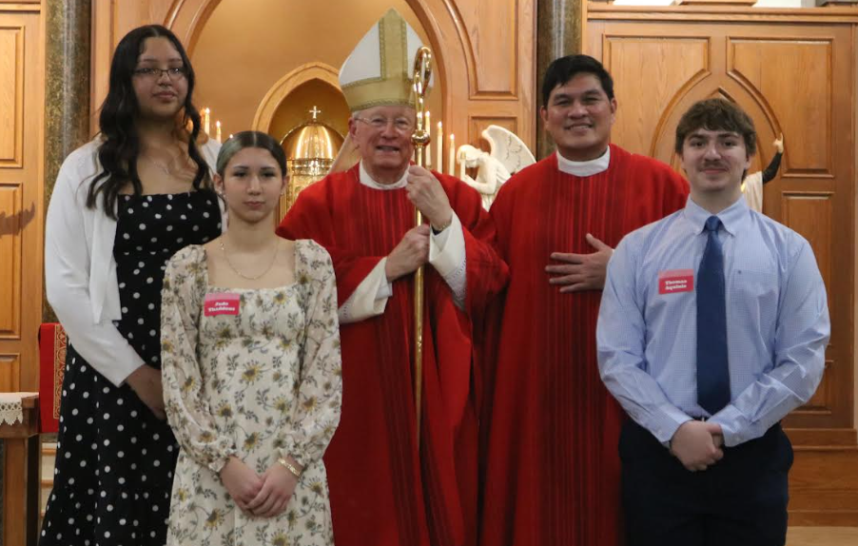
Congratulations to Dru, Nekah and Carter on your Confirmation!

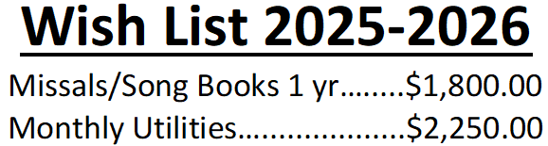
Please consider making a donation, even if it is just a partial payment. Thank you!!!
EXTRAORDINARY MINISTER
OF HOLY COMMUNION &
LECTOR SCHEDULE

Saturday, February 14th, 5:00 p.m.
Lector: Kevin Culhane
Eucharistic Minister: Muffy Culhane
Sunday, February 15th, 9:00 a.m.
Lector: Anne Sulskis
Eucharistic Minister: Gloria Gierach
Wednesday February, 18th, 6:00 pm
Lector: Ellie Sokoly
Eucharistic Minister: Anne Sulskis
Saturday, February 21st, 5:00 p.m.
Lector: Rod Glauser
Eucharistic Minister: Kevin Culhane
Sunday, February 22nd, 9:00 a.m.
Lector: Jacquie Braun
Eucharistic Minister: Anne Sulskis
Saturday, February 28th, 5:00 p.m.
Lector: Larry Sikowski
Eucharistic Minister: Jim Gilane
Sunday March 1st, 9:00 a.m.
Lector: Ellie Sokoly
Eucharistic Minister: Gloria Gierach
Saturday, March 7th, 5:00 p.m.
Lector: Terri Glauser
Eucharistic Minister: Deacon Mark Fuller
Sunday, March 8th, 9:00 a.m.
Lector: Jacquie Braun
Eucharistic Minister: Deacon Mark Fuller
Upcoming Events:
- Sunday, February 14th Valentine’s Breakfast after 9:00 am Mass.
- Wednesday, February 18th Ash Wednesday 8:00 am & 6:00 pm Mass.
- Friday, February 27th please join us for our Annual Lenten Fish Dinner from 4:30 – 6:30 pm in the Father David Barrett Hall. See bulletin ad for more details.
- Sunday, March 29th please join us for our Palm Sunday Breakfast after Mass. Faith Formation will be hosting this event.

St. Michael Parish

Why Give to the Bishop’s Appeal?
And the king will say to them in reply, “Amen, I say to you, whatever you did for one of these least brothers of mine, you did for me.” -Matthew 25:40. Your gift to the Bishop’s Appeal will help in countless ways. Children and families are able to attend lively, interactive education programs learning the Word of God. A young woman in an abusive relationship is able, through counseling with Catholic Charities, to stand on her own feet. Married couples struggling with infertility are able to become parents through Adoption Services. Your gift to the Bishop’s Appeal makes such a difference. Make a tremendous difference, and give to the Bishop’s Appeal. How much you give is less important than the spirit in which you give. Even small donations add up to large gifts. To make a gift today, contact your parish, make a gift online at www.catholicfoundationgb.org/give, or call Tammy at 920-272-8123.
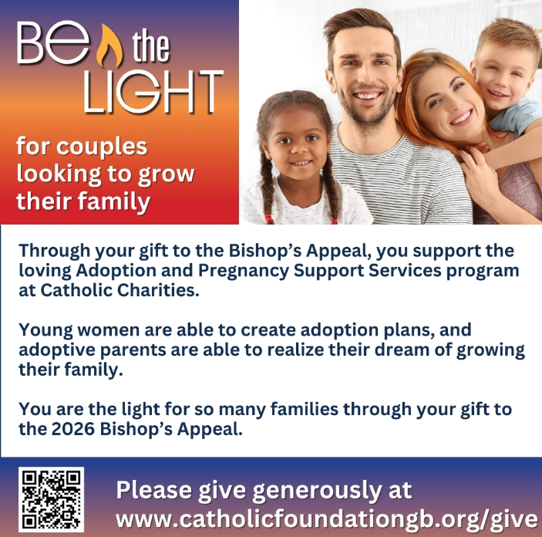


14109 County VV, Gillett, WI 54124


SUNDAY BRUNCH 9-12 PM.
CHICKEN DINNER ALL DAY.

Please pick up your pans, cookie sheets, and miscellaneous items left over from funerals and other church events in the Fr. Barrett Hall.
There will not be a Mass at St. Michael on Holy Saturday, March 26. Easter Vigil will be held at St. Francis in Gresham at 7 pm. Easter Sunday Mass will be at St. Michael and St. Anthony at 10:30 am.

Maintenance. Michael Catholic Parish in Keshena is seeking a part-time maintenance person. Responsible for light maintenance, cleaning the church, etc. Contact the parish office at telephone number 715-799-3811 for an application, and job.

Please pick up your pans, cookie sheets, and miscellaneous items left over from funerals and other church events in the Fr. Barrett Hall.
There will not be a Mass at St. Michael on Holy Saturday, March 26. Easter Vigil will be held at St. Francis in Gresham at 7 pm. Easter Sunday Mass will be at St. Michael and St. Anthony at 10:30 am.
St. Michael’s Calendar
02/14/2026 Valentine’s Day
02/15/2026 Valentine’s Day Breakfast after Mass
02/16/2026 The Chosen Viewing 6:00 pm
02/17/2026 Thrift N Gift 11:00 am – 3:00 pm
02/17/2026 Food Pantry/Book Share 12:30 - 3:00 pm
02/17/2026 Knights of Colombus meeting 7:00 pm
02/18/2026 CRS Rice Bowl 2nd Collection at Mass
02/18/2026 Ash Wednesday Mass 8:00 am & 6:00 pm
02/18/2026 Faith Formation Children’s Mass 6:00 pm
02/20/2026 Stations of the Cross 5:00 pm
02/20/2026 Holy Hour after Mass
MASS TIMES
St. Michael – Saturday: 5:00 pm., Sunday: 9:00 am.
Monday – No Mass, Tuesday - Friday: 8:00 am
Ash Wednesday February 18th: 8:00 am & 6:00 pm
St. Anthony – Sunday: 10:30 am

Book Share
Will be open Tuesday, February 17th from 12:30 – 3:00 pm. We have books for all ages! We will accept books in good shape, just no old magazines, text books or encyclopedias.

Food Pantry
Will be open Tuesday, February 17th from 12:30 - 3:00 pm. There will be drive up service only and food will be placed in your trunk. Please do not get out of your vehicle. Please save brown paper bags & plastic bags and please drop them off at the Parish office.

Thrift N Gift
Will be open Tuesday, February 17th from 11:00 am - 3:00 pm. We have an abundance of household items, clothes, and great gift items. Please reach out to Cookie if you need to, 920-216-9240.

We the Knights
We always ask God to bless our community members. If you or a family member need assistance to get to a doctor appointment, we may be able to help. Call Paul at 715-853-2414 or Todd 715-584-5885.

Kateri Prayer Circle
Never underestimate the power of prayer. Just one small prayer can change your life. If you or your family members need prayers for any reason, please call one of our Kateri Prayer Circle members, who will in turn call members of their group. Soon, many prayers will be offered for your specific prayer request. Please call:

Fay Waupochick: 715-799-3437
Jacqueline Braun: 715-701-4552
You can also call the Parish Office to leave a request.

Religious Education Calendar Up Coming Events:
Wednesday, November 30th –Classes Resume
Wednesday December 7th
Wednesday December 14th
Wednesday December 21st Birthday Party- Parents
Guardians invited
Wednesday December 28th No Class
Wednesday January 4th No Class
Wednesday January 11 Classes resume
PARISH STAFF
FR. HANZ CHRISTIAN BORBOR
Parish Administrator
Parish Office (715) 799-3811
xtian.borbor@gmail.com

DEACON MARK FULLER
(715) 201-2961
mpfull7@gmail.com

Parish Secretary
RICKIE DODGE
Parish Office (715) 799-3811
stmichaels@livingwaterslivingfaith.org

Faith Formation
JACKIE LANGHANS
Parish Office (715) 799-3811
jlanghans@att.net

PARISH TRUSTEES
KAREN SMART, Treasurer
VICKI HERMSEN, Secretary

Parish Council Chair
MARY LEWELLIN

Finance Council Chair
THERESE GLAUSER

Thrift N Gift Coordinator
COOKIE VIGUE

Food Pantry Coordinator

MASS SCHEDULE
Saturday: 5:00 pm Mass
4:30 pm Rosary & Confession
Sunday: 9:00 am Mass
8:30 am Rosary
Monday – No Mass
Tuesday - Friday: 8:00 am
Ash Wednesday February 18th: 8:00 am & 6:00 pm Masses

PARISH OFFICE HOURS
Regular hours: Monday-Thursday
8:15 am – 2:00 pm
Hours may vary, please call before coming to the office.
SATURDAY MASS: 5:00 pm
SUNDAY MASS: 9:00 am
CONFESSION: Saturday 4:30 - 4:45pm
ROSARY: Saturday 3:40 pm Sunday 8:35 am
DAILY MASS: Chapel Southside of Church

P Parish Administrator, Fr. Nonito Barra - 715-799-3811 - pastor@livingwaterslivingfaith.org
Rectory – 715-994-1337
Parochial Vicar Fr. Joel Jores - 715-787-3377 frj@livingwaterslivingfaith.org
Deacon Mark Fuller 715-201-2961- deaconmark@livingwaterslivingfaith.org
Parish Secretary, Vicki Hermsen - 715-799-3811 - vicki@livingwaterslivingfaith.org
Religious Education Kathy King-Tucker - 715-799-3927 – ltucker@frontiernet.netmailto:maczuzak@frontiernet.net
Wednesday 6 – 7:30 pm September – May
Parish Administrator, Fr. Nonito Barra - 715-799-3811 - pastor@livingwaterslivingfaith.org
Rectory – 715-994-1337
Parochial Vicar Fr. Joel Jores - 715-787-3377 frj@livingwaterslivingfaith.org
Deacon Mark Fuller 715-201-2961- deaconmark@livingwaterslivingfaith.org
Parish Secretary, Vicki Hermsen - 715-799-3811 - vicki@livingwaterslivingfaith.org
Religious Education Kathy King-Tucker - 715-799-3927 – ltucker@frontiernet.netmailto:maczuzak@frontiernet.net
Wednesday 6 – 7:30 pm September – May
Parish Administrator, Fr. Nonito Barra - 715-799-3811 - pastor@livingwaterslivingfaith.org
Rectory – 715-994-1337
Parochial Vicar Fr. Joel Jores - 715-787-3377 frj@livingwaterslivingfaith.org
Deacon Mark Fuller 715-201-2961- deaconmark@livingwaterslivingfaith.org
Parish Secretary, Vicki Hermsen - 715-799-3811 - vicki@livingwaterslivingfaith.org
Religious Education Kathy King-Tucker - 715-799-3927 – ltucker@frontiernet.netmailto:maczuzak@frontiernet.net
Wednesday 6 – 7:30 pm September – May

February 15th, 2026
Sixth Sunday in Ordinary Time
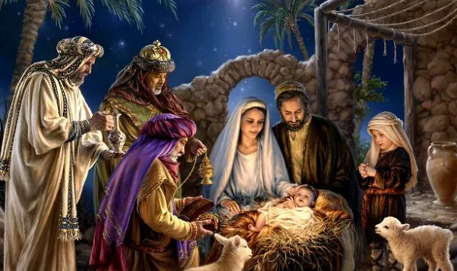
Anamehawikamek Welcome
ST. MICHAEL CATHOLIC CHURCH
PO Box 610, N816 State Highway 47-55,
Keshena, WI 54135 - Phone: 715-799-3811
Email: stmichaels@livingwaterslivingfaith.org
Website: stmichaelkeshena.com
Find us on Facebook: St. Michael’s Church

MISSION STATEMENT: St. Michael’s Christian Community, located on the Menominee Indian Reservation, is a diverse Christian community reaching out to all residents, learning, loving, sharing, and communicating with one another through the teachings and practices celebrated in the Mass & the Holy Sacraments of the Catholic Church by integrating sacred symbols and spiritual practices of the Menominee.
KNIGHTS OF COLUMBUS: Contact Grand Knight Paul Marroquin 715-853-2414.
HOLY HOUR: Every Friday after 8:00 am Mass.
ANOINTING OF THE SICK: Individual arrangements can be made through the Parish Office.
BAPTISM: Kindly contact parish office.
MARRIAGE: Make arrangements with the Priest, six months prior to desired date.
CONFIRMATION: Contact Deacon Mark Fuller for information via email mpfull7@gmail.com.

