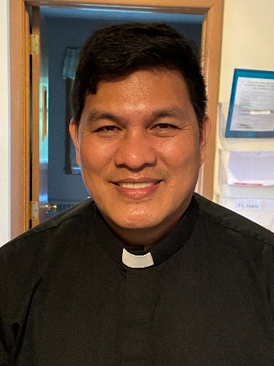 A Note from Father Hanz
St. Francis of Assisi spoke about temptation in a very practical, earthy way. He didn’t see temptation as a sign of failure, but as a battlefield where humility,
vigilance, and trust in God are strengthened.
Here are key themes from his teaching:
1. Temptation is not sin — consent is St. Francis taught that being tempted is part of the human condition. The struggle itself can be meritorious:
“Blessed is the servant who does not consider himself better when he is praised than when he is despised… for a man is only what he is before God.”
Temptation reveals the truth about our hearts. The danger is not the temptation, but pride or discouragement. The remedy: humility and patience with yourself.
2. The enemy is weakened by humility
Francis believed demons are confused by humility and self-knowledge. When tempted:
• Admit weakness
• Call on God immediately
• Refuse to argue with the temptation
He advised his brothers to say in spirit: “I am nothing, God is everything.”
Humility cuts temptation at the root because most temptations grow from pride, fear, or self-reliance.
3. Replace temptation with love
Francis didn’t recommend obsessing over sin.
Instead, he urged filling the heart with something stronger:
• prayer
• service to others
• gratitude
• praise
A famous Franciscan principle: darkness is not pushed out by staring at it, but by lighting a candle.
4. Perseverance is victory
He once encouraged a friar tormented by temptation:
As long as you resist, you are crowned.”
For St. Francis, the struggle itself is already a kind of triumph. Heaven measures fidelity, not emotional comfort.

Called to Radiate His Light
“It is written: The Lord, your God, shall you worship, and Him alone shall you serve.”
– Matthew 4:10
Dear Friends, On this First Sunday of Lent, Jesus leads us into the desert and reminds us to turn our hearts back to God. Lent begins quietly, but it leads us to the light and hope of Easter: a hope we are called to share with others.
We see this hope in Pam, who came to Catholic Charities after losing her husband, recovering from cancer, and facing financial hardship. With Christ-centered guidance, she found healing and stability. “Without Catholic Charities, I would still be in that despair,” she shared.
Your gift to the Bishop’s Appeal makes stories like Pam’s possible and supports faith formation, Catholic schools, deacon formation, and even more ministries throughout our Diocese.
If you’ve never given before, I invite you to consider making your first gift this year. Even a small gift makes an impact and helps us bring Christ’s light to others.
To support the 2026 Bishop’s Appeal, use the pledge card mailed to your home, contact the parish office, or visit www.catholicfoundation.com/give.
Thank you for your generosity and for helping St. Michael Parish shine Christ’s light this Lent.
2026 Bishop’s Appeal Goal
This year’s goal is $7,664.00.
We have already received $6,330.00 in donations. Thank you!
Financial Blessings
February 14th & 15th
Envelope/Contributors | $1028.00
Loose Collection | $475.00
We are in need of Mass intentions. Mass intentions are $20.00 per Mass.
Thank you for supporting our Parish!

MASS SCHEDULE &
INTENTIONS
02/21-5:00 pm……………..Bernard Sanapaw
02/22-9:00 am……………..Roger Sananaw
02/23………………………...No Mass
02/24-8:00 am……………..For those who dwell
in darkness
02/25-8:00 am……………..For families dealing
with cancer
02/26-8:00 am……………..Retired Religious
02/27-8:00 am……………..John Fenelon
02/28-5:00 pm……………..David Hawpetoss
03/01-9:00 am……………..Richard & Sylvia Dodge
Please Join Us!
St. Michael will be hosting their annual Family Lenten Fish Dinner on Friday February 27th from 4:30 pm – 6:30 pm in the Father David Barrett Hall. Dine-In OR Carry-Out. Baked Battered or Unbattered Cod, Mac N Cheese, Vegetarian Baked Beans, Cole Slaw, Buttered Marbled Rye Bread, Dessert. Full Meal $13.00. Kids any 3 items $6.00. Water $1.00. Cookie needs 20 volunteers.
Faith Formation News
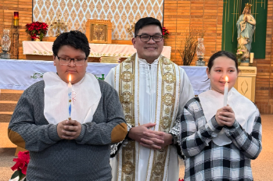
Congratulations to Keaton & Lindaya on their baptism on February 11th.
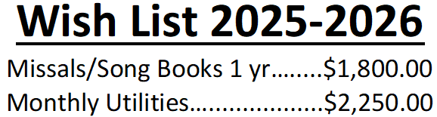
Please consider making a donation, even if it is just a partial payment. Thank you!!!
EXTRAORDINARY MINISTER
OF HOLY COMMUNION &
LECTOR SCHEDULE

Saturday, February 21st, 5:00 p.m.
Lector: Rod Glauser
Eucharistic Minister: Kevin Culhane
Sunday, February 22nd, 9:00 a.m.
Lector: Jacquie Braun
Eucharistic Minister: Anne Sulskis
Saturday, February 28th, 5:00 p.m.
Lector: Larry Sikowski
Eucharistic Minister: Jim Gilane
Sunday March 1st, 9:00 a.m.
Lector: Ellie Sokoly
Eucharistic Minister: Gloria Gierach
Saturday, March 7th, 5:00 p.m.
Lector: Terri Glauser
Eucharistic Minister: Deacon Mark Fuller
Sunday, March 8th, 9:00 a.m.
Lector: Jacquie Braun
Eucharistic Minister: Deacon Mark Fuller
Saturday, March 14th, 5:00 p.m.
Lector: Mary Lewellin
Eucharistic Minister: Karen Smart
Sunday, March 15th, 9:00 a.m.
Lector: Ellie Sokoly
Eucharistic Minister: Anne Sulskis
Saturday, March 21st, 5:00 p.m.
Lector: Muffy Culhane
Eucharistic Minister: Kevin Culhane
Sunday, March 22nd, 9:00 a.m.
Lector: Jacquie Braun
Eucharistic Minister: Anne Sulskis
Upcoming Events:
- Friday, February 27th Stations of the Cross 5:00 pm.
- Friday, February 27th please join us for our Annual Lenten Fish Dinner from 4:30 – 6:30 pm in the Father David Barrett Hall. See bulletin ad for more details.
- Sunday, March 29th please join us for our Palm Sunday Breakfast after Mass. Faith Formation will be hosting this event.

St. Michael Parish

Does the Bishop's Appeal Pay the
Bishop's Salary or Any Legal Settlements?
The Bishop's Appeal is an annual campaign that supports the ministries of the Diocese. It does not pay the Bishop's salary and has never been used to pay any legal settlements. The Bishop’s Appeal provides support to diocesan ministries reaching out to thousands of people each year. These ministries include Catholic Charities, Catholic schools, and On Mission, to name a few. It is our continuing pledge to you to use all the funds received during the Bishop's Appeal to provide these services and meet the needs described on our website at www.catholicfoundationgb.org/appeal. Thank you for your generous support.
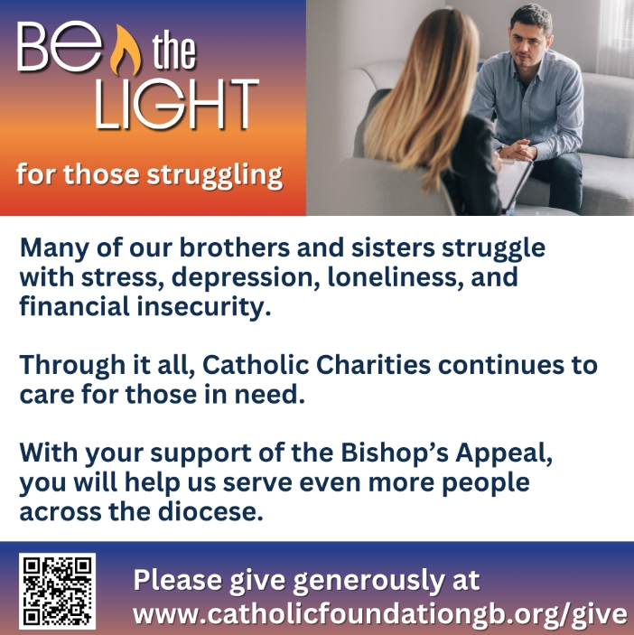


14109 County VV, Gillett, WI 54124


SUNDAY BRUNCH 9-12 PM.
CHICKEN DINNER ALL DAY.

Please pick up your pans, cookie sheets, and miscellaneous items left over from funerals and other church events in the Fr. Barrett Hall.
There will not be a Mass at St. Michael on Holy Saturday, March 26. Easter Vigil will be held at St. Francis in Gresham at 7 pm. Easter Sunday Mass will be at St. Michael and St. Anthony at 10:30 am.

Maintenance. Michael Catholic Parish in Keshena is seeking a part-time maintenance person. Responsible for light maintenance, cleaning the church, etc. Contact the parish office at telephone number 715-799-3811 for an application, and job.

Please pick up your pans, cookie sheets, and miscellaneous items left over from funerals and other church events in the Fr. Barrett Hall.
There will not be a Mass at St. Michael on Holy Saturday, March 26. Easter Vigil will be held at St. Francis in Gresham at 7 pm. Easter Sunday Mass will be at St. Michael and St. Anthony at 10:30 am.
PARISH STAFF
FR. HANZ CHRISTIAN BORBOR
Parish Administrator
Parish Office (715) 799-3811
xtian.borbor@gmail.com

DEACON MARK FULLER
(715) 201-2961
mpfull7@gmail.com

Parish Secretary
RICKIE DODGE
Parish Office (715) 799-3811
stmichaels@livingwaterslivingfaith.org

Faith Formation
JACKIE LANGHANS
Parish Office (715) 799-3811
jlanghans@att.net

PARISH TRUSTEES
KAREN SMART, Treasurer
VICKI HERMSEN, Secretary

Parish Council Chair
MARY LEWELLIN

Finance Council Chair
THERESE GLAUSER

Thrift N Gift Coordinator
COOKIE VIGUE

Food Pantry Coordinator

MASS SCHEDULE
Saturday: 5:00 pm Mass
4:30 pm Rosary & Confession
Sunday: 9:00 am Mass
8:30 am Rosary
Monday – No Mass
Tuesday - Friday: 8:00 am

PARISH OFFICE HOURS
Regular hours: Monday-Thursday
8:15 am – 2:00 pm
Hours may vary, please call before coming to the office.
SATURDAY MASS: 5:00 pm
SUNDAY MASS: 9:00 am
CONFESSION: Saturday 4:30 - 4:45pm
ROSARY: Saturday 3:40 pm Sunday 8:35 am
DAILY MASS: Chapel Southside of Church

P Parish Administrator, Fr. Nonito Barra - 715-799-3811 - pastor@livingwaterslivingfaith.org
Rectory – 715-994-1337
Parochial Vicar Fr. Joel Jores - 715-787-3377 frj@livingwaterslivingfaith.org
Deacon Mark Fuller 715-201-2961- deaconmark@livingwaterslivingfaith.org
Parish Secretary, Vicki Hermsen - 715-799-3811 - vicki@livingwaterslivingfaith.org
Religious Education Kathy King-Tucker - 715-799-3927 – ltucker@frontiernet.netmailto:maczuzak@frontiernet.net
Wednesday 6 – 7:30 pm September – May
Parish Administrator, Fr. Nonito Barra - 715-799-3811 - pastor@livingwaterslivingfaith.org
Rectory – 715-994-1337
Parochial Vicar Fr. Joel Jores - 715-787-3377 frj@livingwaterslivingfaith.org
Deacon Mark Fuller 715-201-2961- deaconmark@livingwaterslivingfaith.org
Parish Secretary, Vicki Hermsen - 715-799-3811 - vicki@livingwaterslivingfaith.org
Religious Education Kathy King-Tucker - 715-799-3927 – ltucker@frontiernet.netmailto:maczuzak@frontiernet.net
Wednesday 6 – 7:30 pm September – May
Parish Administrator, Fr. Nonito Barra - 715-799-3811 - pastor@livingwaterslivingfaith.org
Rectory – 715-994-1337
Parochial Vicar Fr. Joel Jores - 715-787-3377 frj@livingwaterslivingfaith.org
Deacon Mark Fuller 715-201-2961- deaconmark@livingwaterslivingfaith.org
Parish Secretary, Vicki Hermsen - 715-799-3811 - vicki@livingwaterslivingfaith.org
Religious Education Kathy King-Tucker - 715-799-3927 – ltucker@frontiernet.netmailto:maczuzak@frontiernet.net
Wednesday 6 – 7:30 pm September – May

St. Michael’s Calendar
02/21/2026 Food Pantry 2nd Collection
02/22/2026 Food Pantry 2nd Collection
02/23/2026 The Chosen Viewing 6:00 pm
02/24/2026 1st Presbyterian Church Community
Dinner 5:30 pm
02/25/2026 Faith Formation 6:00 – 7:00 pm
02/27/2026 Stations of the Cross 5:00 pm
02/27/2026 Annual Lenten Fish fry 4:30 – 6:30 pm
02/28/2026 Faith Formation Retreat First
Reconciliation 9:00 – 11:30 am

MASS TIMES
St. Michael – Saturday: 5:00 pm., Sunday: 9:00 am.
Monday – No Mass, Tuesday - Friday: 8:00 am
St. Anthony – Sunday: 10:30 am

Book Share
Will be open Tuesday, March 17th from 12:30 – 3:00 pm. We have books for all ages! We will accept books in good shape, just no old magazines, text books or encyclopedias.

Food Pantry
Will be open Tuesday, March 3rd from 12:30 - 3:00 pm. There will be drive up service only and food will be placed in your trunk. Please do not get out of your vehicle. Please save brown paper bags & plastic bags and please drop them off at the Parish office.

Thrift N Gift
Will be open Tuesday, March 3rd from 11:00 am - 3:00 pm. We have an abundance of household items, clothes, and great gift items. Please reach out to Cookie if you need to, 920-216-9240.

We the Knights
We always ask God to bless our community members. If you or a family member need assistance to get to a doctor appointment, we may be able to help. Call Paul at 715-853-2414 or Todd 715-584-5885.

Kateri Prayer Circle
Never underestimate the power of prayer. Just one small prayer can change your life. If you or your family members need prayers for any reason, please call one of our Kateri Prayer Circle members, who will in turn call members of their group. Soon, many prayers will be offered for your specific prayer request. Please call:

Fay Waupochick: 715-799-3437
Jacqueline Braun: 715-701-4552

You can also call the Parish Office to leave a request.

Religious Education Calendar Up Coming Events:
Wednesday, November 30th –Classes Resume
Wednesday December 7th
Wednesday December 14th
Wednesday December 21st Birthday Party- Parents
Guardians invited
Wednesday December 28th No Class
Wednesday January 4th No Class
Wednesday January 11 Classes resume
February 22nd, 2026
First Sunday of Lent

Anamehawikamek Welcome
ST. MICHAEL CATHOLIC CHURCH
PO Box 610, N816 State Highway 47-55,
Keshena, WI 54135 - Phone: 715-799-3811
Email: stmichaels@livingwaterslivingfaith.org
Website: stmichaelkeshena.com
Find us on Facebook: St. Michael’s Church

MISSION STATEMENT: St. Michael’s Christian Community, located on the Menominee Indian Reservation, is a diverse Christian community reaching out to all residents, learning, loving, sharing, and communicating with one another through the teachings and practices celebrated in the Mass & the Holy Sacraments of the Catholic Church by integrating sacred symbols and spiritual practices of the Menominee.
KNIGHTS OF COLUMBUS: Contact Grand Knight Paul Marroquin 715-853-2414.
HOLY HOUR: Every Friday after 8:00 am Mass.
ANOINTING OF THE SICK: Individual arrangements can be made through the Parish Office.
BAPTISM: Kindly contact parish office.
MARRIAGE: Make arrangements with the Priest, six months prior to desired date.
CONFIRMATION: Contact Deacon Mark Fuller for information via email mpfull7@gmail.com.

