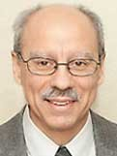 A Note from Deacon Mark
As we journey through Lent, I thought it might be helpful for Lent this year to share some inspiring thoughts from Pope Leo, as he himself journeys through his first Lent as the Holy Father. I will share his thoughts given from each week’s Angelus Address at St. Peter’s Square. Today, Pope Leo instructs us that “In this time of grace, let us therefore practice penance generously, alongside prayer and works of mercy. Let us create space for silence by turning off televisions, radios and cell phones for a while. Let us meditate on the Word of God, approach the Sacraments, and listen to the voice of the Holy Spirit who speaks to us in our heart. Let us also listen to one another — in our families, workplaces and communities. Let us dedicate time to those who are alone, especially the elderly, the poor and the sick. By giving up what is superfluous, we can share what we save with those in need. Then, as Saint Augustine taught, our prayer offered in this way — “in humility and charity, by fasting and giving, by restraining ourselves and pardoning, by paying out good deeds and not paying back bad ones, by turning away from evil and doing good” (Sermons, 206, 3) — will reach heaven and give us peace.”

Upon Further Reflection

A bartender notices that every evening, without fail, one of his patrons ordered three beers. After several weeks of noticing this pattern, the bartender asks the man why he always orders three beers. The man says, “I have two brothers who have moved away to different countries. We promised each other that we would always order an extra two beers whenever we drank as a way of keeping up the family bond.” Several weeks later, noticing that the man only ordered two beers, the bartender said, “Please accept my condolences on the death of one of your brothers. You know, the two beers and all…” The man replied, “You’ll be happy to hear that my two brothers are alive and well…It’s just that I, myself, have decided to give up drinking for Lent.”

In HIs Mercy, Deacon Mark
From the Mountain to the Mission: Reflecting Jesus’ Light
“And He [Jesus] was transfigured before them; His face shone like the sun, and His clothes became white as light.” – Matthew 17:2
Dear Friends,
On this Second Sunday of Lent, we remember the Transfiguration when Jesus revealed His glory and filled Peter, James, and John with awe and hope. That same light guides us today and calls us to share His love with others.
We see Christ’s light reflected in the ministries supported by the Bishop’s Appeal: marriage preparation that strengthens couples, deacons who walk with parishioners in moments of joy and sorrow, and Catholic Charities counselors who provide Christ-centered care to more than 13,000 people each year.
Your support makes this life-changing work possible. If you’ve already given, thank you. If you’ve never given before, I invite you to consider making your first gift today to help bring the light of Jesus to more people.
For those who are able, a gift of $500 or more enrolls you in the Crozier Society, a special community of more than 3,700 supporters who help the Church reach even further with
the Gospel.
To give, use the pledge card mailed to your home, contact the parish office, or visit www.catholicfoundation.com/give.
Thank you for your generosity and for helping St. Michael Parish share Christ’s light this Lent.
2026 Bishop’s Appeal Goal
This year’s goal is $7,664.00.
We have already received $7,080.00 in donations. Thank you!
Financial Blessings
February 21st & 22nd
Envelope/Contributors | $1233.00
Loose Collection | $353.00
We are in need of Weekday Mass intentions. Mass intentions are $20.00 per Mass.
Thank you for supporting our Parish!
MASS SCHEDULE &
INTENTIONS
02/28-5:00 pm……………..David Hawpetoss
03/01-9:00 am……………..Richard & Sylvia Dodge
03/02………………………...No Mass
03/03-8:00 am……………..For those who travel
during winter months
03/04-6:00 pm……………..For leaders in this
community
03/05-8:00 am……………..For those who suffer
from temptation
03/06-8:00 am……………..John Fenelon
03/07-5:00 pm……………..For animals during
winter months
03/08-9:00 am……………..Retired Religious
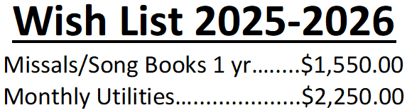
We are slowly chipping away at our wish list. Please consider making a donation, even if it is just a partial payment. Thank you!!!

CHURCH REGULATIONS
REGARDING
FAST & ABSTINENCE
Abstinence from meat (beast or fowl) is to be observed by all Catholics fourteen years old and older on Ash Wednesday and on all the Fridays of Lent. This obligation prohibits the eating of meat, but not eggs, milk products, or condiments of any kind, even though made from animal fat.
Fasting means limiting oneself to one full meal on a given fast day. Catholics who are eighteen years of age but not yet fifty-nine are obliged to fast on Ash Wednesday and Good Friday. On fast days, two additional smaller meals are permitted if necessary to maintain strength. However, the two smaller meals together may not equal one full meal. Moreover, eating solid foods between meals on fast days is not permitted.
EXTRAORDINARY MINISTER
OF HOLY COMMUNION &
LECTOR SCHEDULE

Saturday, February 28th, 5:00 p.m.
Lector: Larry Sikowski
Eucharistic Minister: Jim Gilane
Sunday March 1st, 9:00 a.m.
Lector: Ellie Sokoly
Eucharistic Minister: Gloria Gierach
Saturday, March 7th, 5:00 p.m.
Lector: Terri Glauser
Eucharistic Minister: Deacon Mark Fuller
Sunday, March 8th, 9:00 a.m.
Lector: Jacquie Braun
Eucharistic Minister: Deacon Mark Fuller
Saturday, March 14th, 5:00 p.m.
Lector: Mary Lewellin
Eucharistic Minister: Karen Smart
Sunday, March 15th, 9:00 a.m.
Lector: Ellie Sokoly
Eucharistic Minister: Anne Sulskis
Saturday, March 21st, 5:00 p.m.
Lector: Muffy Culhane
Eucharistic Minister: Kevin Culhane
Sunday, March 22nd, 9:00 a.m.
Lector: Jacquie Braun
Eucharistic Minister: Anne Sulskis
Saturday, March 28th, 5:00 p.m.
Lector: Larry Sikowski & Mary Lewellin
Eucharistic Minister: Deacon Mark
Sunday, April 1st, 9:00 a.m.
Lector: Ellie Sokoly & Jacquie Braun
Eucharistic Minister: Deacon Mark
Upcoming Events:
- Friday, March 6th, 13th & 20th Stations of the Cross at 5:00 pm.
- Friday, March 20th Confession at 6:00 pm.
- Friday, March 27th Fish Fry @ Primal Eats in the Pine Hall from 4:00 – 7:00 pm.
- Saturday, March 28th Eve of Palm Sunday Mass @ 5:00 pm.
- Sunday, March 29th Palm Sunday Mass @ 8:45 am. Breakfast after Mass, hosted by Faith
Formation.

St. Michael Parish

On Mission Magazine Fuels Faith
Thousands of fellow Catholics fuel their faith by reading the Diocese’s official online and print magazine, On Mission. They’re reading the publication because it guides them on their faith journey. Inspirational stories from On Mission Magazine bring Christ right into their hearts
and minds.

With help from the Bishop’s Appeal, On Mission Magazine provides readers with reliable news, information, and inspiration. Bimonthly print stories reveal our Catholic faith. You can sign up for a weekly email that will deliver articles directly to your inbox. These stories challenge readers to explore and absorb Christian values in the world today.
On Mission Magazine is supported by the Bishop’s Appeal; please prayerfully consider a gift today. Make a gift online at www.catholicfoundationgb.org/give, or call Tammy at
920-272-8123.
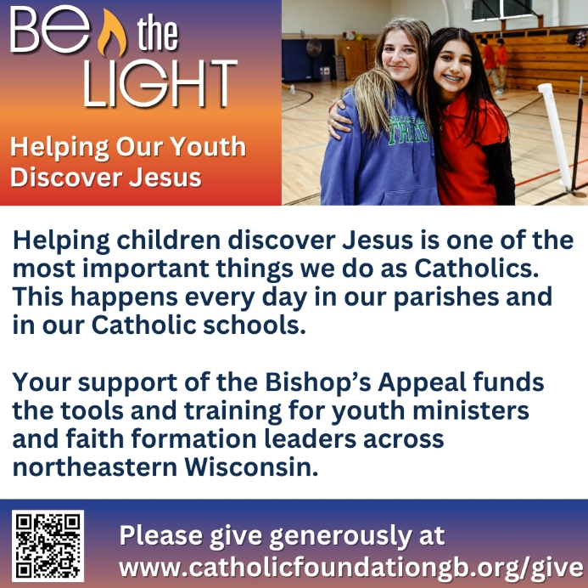


14109 County VV, Gillett, WI 54124


SUNDAY BRUNCH 9-12 PM.
CHICKEN DINNER ALL DAY.

Please pick up your pans, cookie sheets, and miscellaneous items left over from funerals and other church events in the Fr. Barrett Hall.
There will not be a Mass at St. Michael on Holy Saturday, March 26. Easter Vigil will be held at St. Francis in Gresham at 7 pm. Easter Sunday Mass will be at St. Michael and St. Anthony at 10:30 am.

Maintenance. Michael Catholic Parish in Keshena is seeking a part-time maintenance person. Responsible for light maintenance, cleaning the church, etc. Contact the parish office at telephone number 715-799-3811 for an application, and job.

Please pick up your pans, cookie sheets, and miscellaneous items left over from funerals and other church events in the Fr. Barrett Hall.
There will not be a Mass at St. Michael on Holy Saturday, March 26. Easter Vigil will be held at St. Francis in Gresham at 7 pm. Easter Sunday Mass will be at St. Michael and St. Anthony at 10:30 am.
PARISH STAFF
FR. HANZ CHRISTIAN BORBOR
Parish Administrator
Parish Office (715) 799-3811
xtian.borbor@gmail.com

DEACON MARK FULLER
(715) 201-2961
mpfull7@gmail.com

Parish Secretary
RICKIE DODGE
Parish Office (715) 799-3811
stmichaels@livingwaterslivingfaith.org

Faith Formation
JACKIE LANGHANS
Parish Office (715) 799-3811
jlanghans@att.net

PARISH TRUSTEES
KAREN SMART, Treasurer
VICKI HERMSEN, Secretary

Parish Council Chair
MARY LEWELLIN

Finance Council Chair
THERESE GLAUSER

Thrift N Gift Coordinator
COOKIE VIGUE

Food Pantry Coordinator

MASS SCHEDULE
Saturday: 5:00 pm Mass
4:30 pm Rosary & Confession
Sunday: 9:00 am Mass
8:30 am Rosary
Monday – No Mass
Tuesday, Thursday & Friday: 8:00 am
Wednesday: 6:00 pm

PARISH OFFICE HOURS
Regular hours: Monday-Thursday
8:15 am – 2:00 pm
Hours may vary, please call before coming to the office.
SATURDAY MASS: 5:00 pm
SUNDAY MASS: 9:00 am
CONFESSION: Saturday 4:30 - 4:45pm
ROSARY: Saturday 3:40 pm Sunday 8:35 am
DAILY MASS: Chapel Southside of Church

P Parish Administrator, Fr. Nonito Barra - 715-799-3811 - pastor@livingwaterslivingfaith.org
Rectory – 715-994-1337
Parochial Vicar Fr. Joel Jores - 715-787-3377 frj@livingwaterslivingfaith.org
Deacon Mark Fuller 715-201-2961- deaconmark@livingwaterslivingfaith.org
Parish Secretary, Vicki Hermsen - 715-799-3811 - vicki@livingwaterslivingfaith.org
Religious Education Kathy King-Tucker - 715-799-3927 – ltucker@frontiernet.netmailto:maczuzak@frontiernet.net
Wednesday 6 – 7:30 pm September – May
Parish Administrator, Fr. Nonito Barra - 715-799-3811 - pastor@livingwaterslivingfaith.org
Rectory – 715-994-1337
Parochial Vicar Fr. Joel Jores - 715-787-3377 frj@livingwaterslivingfaith.org
Deacon Mark Fuller 715-201-2961- deaconmark@livingwaterslivingfaith.org
Parish Secretary, Vicki Hermsen - 715-799-3811 - vicki@livingwaterslivingfaith.org
Religious Education Kathy King-Tucker - 715-799-3927 – ltucker@frontiernet.netmailto:maczuzak@frontiernet.net
Wednesday 6 – 7:30 pm September – May
Parish Administrator, Fr. Nonito Barra - 715-799-3811 - pastor@livingwaterslivingfaith.org
Rectory – 715-994-1337
Parochial Vicar Fr. Joel Jores - 715-787-3377 frj@livingwaterslivingfaith.org
Deacon Mark Fuller 715-201-2961- deaconmark@livingwaterslivingfaith.org
Parish Secretary, Vicki Hermsen - 715-799-3811 - vicki@livingwaterslivingfaith.org
Religious Education Kathy King-Tucker - 715-799-3927 – ltucker@frontiernet.netmailto:maczuzak@frontiernet.net
Wednesday 6 – 7:30 pm September – May

St. Michael’s Calendar
02/28/2026 Faith Formation Retreat First
Reconciliation 9:00 – 11:30 am
03/02/2026 The Chosen Viewing 6:00 pm
03/03/2026 Thrift N Gift 11:00 am – 3:00 pm
03/03/2026 Food Pantry 12:30 - 3:00 pm
03/04/2026 Faith Formation Children’s Mass
6:00 – 7:00 pm
03/06/2026 Holy Hour after Mass
03/06/2026 Stations of the Cross 5:00 pm
03/07/2026 Prayer Ministry after Mass
03/08/2026 Prayer Ministry after Mass
MASS TIMES
St. Michael – Saturday: 5:00 pm, Sunday: 9:00 am,
Monday: No Mass, Tuesday, Thursday & Friday: 8:00 am Wednesday: 6:00 pm
St. Anthony – Sunday: 10:30 am

Book Share
Will be open Tuesday, March 17th from 12:30 – 3:00 pm. We have books for all ages! We will accept books in good shape, just no old magazines, text books or encyclopedias.

Food Pantry
Will be open Tuesday, March 3rd from 12:30 - 3:00 pm. There will be drive up service only and food will be placed in your trunk. Please do not get out of your vehicle. Please save brown paper bags & plastic bags and please drop them off at the Parish office.

Thrift N Gift
Will be open Tuesday, March 3rd from 11:00 am - 3:00 pm. We have an abundance of household items, clothes, and great gift items. Please reach out to Cookie if you need to, 920-216-9240.

We the Knights
We always ask God to bless our community members. If you or a family member need assistance to get to a doctor appointment, we may be able to help. Call Paul at 715-853-2414 or Todd 715-584-5885.

Kateri Prayer Circle
Never underestimate the power of prayer. Just one small prayer can change your life. If you or your family members need prayers for any reason, please call one of our Kateri Prayer Circle members, who will in turn call members of their group. Soon, many prayers will be offered for your specific prayer request. Please call:

Fay Waupochick: 715-799-3437
Jacqueline Braun: 715-701-4552
You can also call the Parish Office to leave a request.

Religious Education Calendar Up Coming Events:
Wednesday, November 30th –Classes Resume
Wednesday December 7th
Wednesday December 14th
Wednesday December 21st Birthday Party- Parents
Guardians invited
Wednesday December 28th No Class
Wednesday January 4th No Class
Wednesday January 11 Classes resume
March 1st, 2026
Second Sunday of Lent
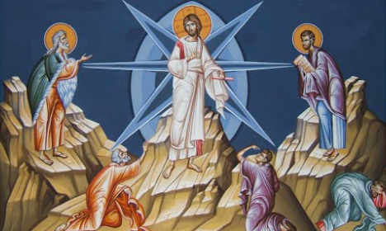
Anamehawikamek Welcome
ST. MICHAEL CATHOLIC CHURCH
PO Box 610, N816 State Highway 47-55,
Keshena, WI 54135 - Phone: 715-799-3811
Email: stmichaels@livingwaterslivingfaith.org
Website: stmichaelkeshena.com
Find us on Facebook: St. Michael’s Church

MISSION STATEMENT: St. Michael’s Christian Community, located on the Menominee Indian Reservation, is a diverse Christian community reaching out to all residents, learning, loving, sharing, and communicating with one another through the teachings and practices celebrated in the Mass & the Holy Sacraments of the Catholic Church by integrating sacred symbols and spiritual practices of the Menominee.
KNIGHTS OF COLUMBUS: Contact Grand Knight Paul Marroquin 715-853-2414.
HOLY HOUR: Every Friday after 8:00 am Mass.
ANOINTING OF THE SICK: Individual arrangements can be made through the Parish Office.
BAPTISM: Kindly contact parish office.
MARRIAGE: Make arrangements with the Priest, six months prior to desired date.
CONFIRMATION: Contact Deacon Mark Fuller for information via email mpfull7@gmail.com.

