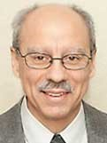 A Note from Deacon Mark
This week I would like to share with you a reflection by S. James Meyer, a deacon from our own Diocese of Green Bay. This reflection is found in the wonderful monthly periodical, Living with Christ (Bayard Press), which contains the daily readings from Mass and other tools for praying and living the Eucharist. I highly recommend getting a subscription! I had wanted to share a Lenten reflection from Pope Leo but an unforeseen timing issue between the Pope’s reflection and when I needed to submit this note soon became apparent. Instead, Deacon Meyer shares with us:
“Rachel stopped by our Streetlights Outreach outpost one night and opened up about her history of abuse, drugs, prostitution, and prison dating back to when she was only five years-old. Now, at age thirty-two, she was homeless but determined to stay sober and start life over. Suddenly, she stopped and said, “I’ve never done this before. I’ve never had a conversation with men that wasn’t about sex and drugs. I’ve never talked to men who were interested in who I am, and not in what they could get from me.” In today’s gospel, Jesus sits with a Samaritan woman at a well, a woman who, like Rachel, yearned to have her own human dignity valued and affirmed. People like the Samaritan woman and Rachel are all around us all the time. Like us, they are images and likenesses of God’s own self, and they hunger for the dignity that comes with having it acknowledged. Can we give them that gift? What holds us back?”
Upon Further Reflection
A Catholic priest working in an inner city was walking down an alley one evening on his way home when a young man came down the alley behind him and poked a knife against his back. “Give me your money,” the young man said. The priest opened his jacket and reached into an inner pocket to remove his wallet, exposing his clerical collar. “Oh, I’m sorry, Father,” said the young man, “I didn’t see your collar. I don’t want YOUR money.” Trembling from the scare, the priest removed a cigarette from his shirt pocket and offered it to the young man. “Here,” he said. “Have a smoke” “Oh, no, I can’t do that,” the young man replied, “I gave them up for Lent!”
In His Mercy, Deacon Mark.

Financial Blessings
February 28th & March 1st
Envelope/Contributors | $889.00
Loose Collection | $413.90
We are in need of Weekday Mass intentions. Mass intentions are $20.00 per Mass.
Thank you for supporting our Parish!
MASS SCHEDULE &
INTENTIONS
03/07-5:00 pm……………..Bob & Jackie Drexler
03/08-9:00 am……………..The Williams/Forsberg,
Brath Families
03/09………………………...No Mass
03/10-8:00 am……………..For animals during
winter months
03/11-8:00 am……………..Retired Religious
03/12-8:00 am……………..For those who dwell in
darkness
03/13-8:00 am……………..For all expectant
parents
03/14-5:00 pm……………..Ann Wychesit Spencer
03/15-9:00 am……………..The Brath/Keller
Families
2025-2026 Wishlist
We have reached our goal! Thank you everyone for your generous donations! With all of your support, we can ensure our Parish operations continue to run smoothly.

Thank you!!!
I want to thank everyone for the outstanding response to my request for desserts for our fish fry.
-Karen, the bakery beggar.

Food Pantry News:
Our Food Pantry thanks The Shawano Area United Way for a generous grant to purchase hygiene items for our recipients.

Support St. Michael Parish

Easter Flower Envelopes are located in the pews; these are for your loved ones living or deceased. Please place in the Collection Basket.

Faith Formation News:
Congratulations to Reyniah on her baptism on Saturday, February 28th!
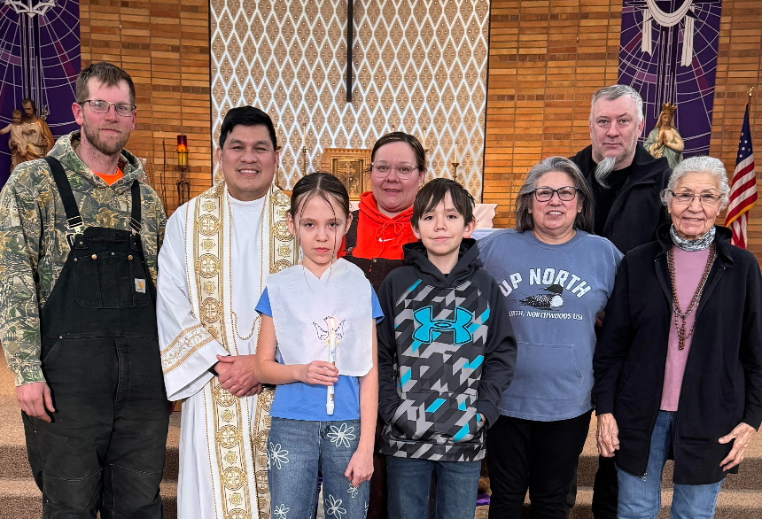
Lenten Fish Dinner Thank You!
Thank you for your Time, Talent and Treasure for supporting St. Michael’s Annual Fish Dinner.

Lenten Fish Fry Fundraiser
Location: Primal Eats Friday, March 27th in the Pine Hall from 4:00 – 7:00 pm.

Pre-Buy tickets can be purchased before & after weekend Masses, March 7th-8th, 14th-15th, 21st-22nd. They can also be purchased at the Parish office.

Price: $15.00 for a 3 pc. Lake Perch Basket OR Cheese Pizza.

Entertainment provided by Fr. Hanz from 5:00–7:00 pm.

Parish Picnic Raffle Tickets
Raffle Tickets for the Parish Picnic on Sunday, June 28th 2026 will be sold before & after Mass starting the weekend of March 29th. Tickets are $5.00 each or 3 for $10.00. Jacquie needs help selling Raffle Tickets. There will be a sign-up sheet located by the main entrance. Please call Jacquie at 715-701-4552 if you are interested.

St. Anthony Fish Fry Dinner:
Please join St. Anthony for their Annual Lenten Fish Fry Dinner, located at the Neopit Community Center on Friday March 13th from 4:30 – 7:00 pm (or until they run out).
EXTRAORDINARY MINISTER
OF HOLY COMMUNION &
LECTOR SCHEDULE

Saturday, March 7th, 5:00 p.m.
Lector: Terri Glauser
Eucharistic Minister: Deacon Mark Fuller
Sunday, March 8th, 9:00 a.m.
Lector: Jacquie Braun
Eucharistic Minister: Deacon Mark Fuller
Saturday, March 14th, 5:00 p.m.
Lector: Mary Lewellin
Eucharistic Minister: Karen Smart
Sunday, March 15th, 9:00 a.m.
Lector: Ellie Sokoly
Eucharistic Minister: Anne Sulskis
Saturday, March 21st, 5:00 p.m.
Lector: Muffy Culhane
Eucharistic Minister: Kevin Culhane
Sunday, March 22nd, 9:00 a.m.
Lector: Jacquie Braun
Eucharistic Minister: Anne Sulskis
Saturday, March 28th, 5:00 p.m.
Lector: Larry Sikowski & Mary Lewellin
Eucharistic Minister: Deacon Mark
Sunday, April 1st, 9:00 a.m.
Lector: Ellie Sokoly & Jacquie Braun
Eucharistic Minister: Deacon Mark
Upcoming Events:
- The Office will be closed Wednesday, March 11th through Tuesday, March 17th. If you need help please call to leave a voicemail & somebody will reach back out to you.

- Friday, March 6th, 13th & 20th Stations of the Cross at 5:00 pm.

- Friday, March 20th Confession at 6:00 pm.

- Friday, March 27th Fish Fry @ Primal Eats in the Pine Hall from 4:00 – 7:00 pm.

- Saturday, March 28th Eve of Palm Sunday Mass @ 5:00 pm.

- Sunday, March 29th Palm Sunday Mass @ 8:45 am. Breakfast after Mass, hosted by Faith
Formation.

St. Michael Parish

2026 Bishop’s Appeal Goal
This year’s goal is $7,664.00.
We have already received $7,270.00 in donations. Thank you!
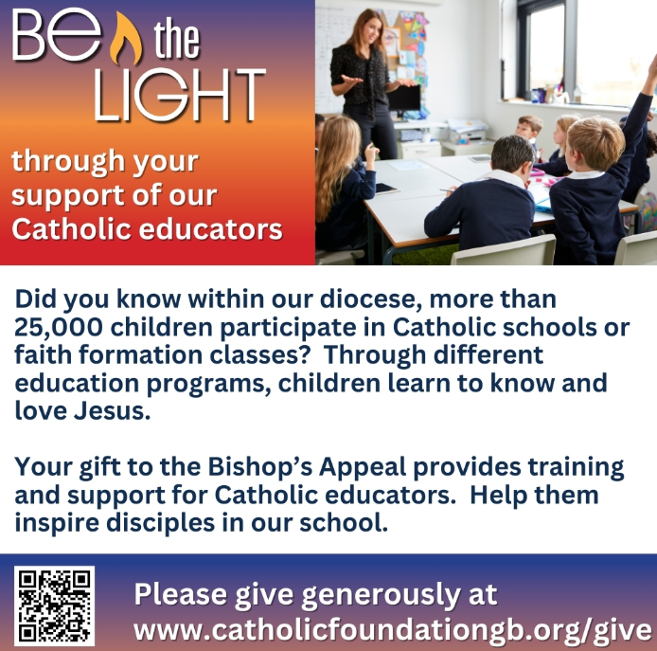


14109 County VV, Gillett, WI 54124


SUNDAY BRUNCH 9-12 PM.
CHICKEN DINNER ALL DAY.

Please pick up your pans, cookie sheets, and miscellaneous items left over from funerals and other church events in the Fr. Barrett Hall.
There will not be a Mass at St. Michael on Holy Saturday, March 26. Easter Vigil will be held at St. Francis in Gresham at 7 pm. Easter Sunday Mass will be at St. Michael and St. Anthony at 10:30 am.

Maintenance. Michael Catholic Parish in Keshena is seeking a part-time maintenance person. Responsible for light maintenance, cleaning the church, etc. Contact the parish office at telephone number 715-799-3811 for an application, and job.

Please pick up your pans, cookie sheets, and miscellaneous items left over from funerals and other church events in the Fr. Barrett Hall.
There will not be a Mass at St. Michael on Holy Saturday, March 26. Easter Vigil will be held at St. Francis in Gresham at 7 pm. Easter Sunday Mass will be at St. Michael and St. Anthony at 10:30 am.
PARISH STAFF
FR. HANZ CHRISTIAN BORBOR
Parish Administrator
Parish Office (715) 799-3811
xtian.borbor@gmail.com

DEACON MARK FULLER
(715) 201-2961
mpfull7@gmail.com

Parish Secretary
RICKIE DODGE
Parish Office (715) 799-3811
stmichaels@livingwaterslivingfaith.org

Faith Formation
JACKIE LANGHANS
Parish Office (715) 799-3811
jlanghans@att.net

PARISH TRUSTEES
KAREN SMART, Treasurer
VICKI HERMSEN, Secretary

Parish Council Chair
MARY LEWELLIN

Finance Council Chair
THERESE GLAUSER

Thrift N Gift Coordinator
COOKIE VIGUE

Food Pantry Coordinator

MASS SCHEDULE
Saturday: 5:00 pm Mass
4:30 pm Rosary & Confession
Sunday: 9:00 am Mass
8:30 am Rosary
Monday – No Mass
Tuesday, Thursday & Friday: 8:00 am
Wednesday: 6:00 pm

PARISH OFFICE HOURS
Regular hours: Monday-Thursday
8:15 am – 2:00 pm
The Office will be closed March 11th through the 17th.
Hours may vary, please call before coming to the office.
SATURDAY MASS: 5:00 pm
SUNDAY MASS: 9:00 am
CONFESSION: Saturday 4:30 - 4:45pm
ROSARY: Saturday 3:40 pm Sunday 8:35 am
DAILY MASS: Chapel Southside of Church

P Parish Administrator, Fr. Nonito Barra - 715-799-3811 - pastor@livingwaterslivingfaith.org
Rectory – 715-994-1337
Parochial Vicar Fr. Joel Jores - 715-787-3377 frj@livingwaterslivingfaith.org
Deacon Mark Fuller 715-201-2961- deaconmark@livingwaterslivingfaith.org
Parish Secretary, Vicki Hermsen - 715-799-3811 - vicki@livingwaterslivingfaith.org
Religious Education Kathy King-Tucker - 715-799-3927 – ltucker@frontiernet.netmailto:maczuzak@frontiernet.net
Wednesday 6 – 7:30 pm September – May
Parish Administrator, Fr. Nonito Barra - 715-799-3811 - pastor@livingwaterslivingfaith.org
Rectory – 715-994-1337
Parochial Vicar Fr. Joel Jores - 715-787-3377 frj@livingwaterslivingfaith.org
Deacon Mark Fuller 715-201-2961- deaconmark@livingwaterslivingfaith.org
Parish Secretary, Vicki Hermsen - 715-799-3811 - vicki@livingwaterslivingfaith.org
Religious Education Kathy King-Tucker - 715-799-3927 – ltucker@frontiernet.netmailto:maczuzak@frontiernet.net
Wednesday 6 – 7:30 pm September – May
Parish Administrator, Fr. Nonito Barra - 715-799-3811 - pastor@livingwaterslivingfaith.org
Rectory – 715-994-1337
Parochial Vicar Fr. Joel Jores - 715-787-3377 frj@livingwaterslivingfaith.org
Deacon Mark Fuller 715-201-2961- deaconmark@livingwaterslivingfaith.org
Parish Secretary, Vicki Hermsen - 715-799-3811 - vicki@livingwaterslivingfaith.org
Religious Education Kathy King-Tucker - 715-799-3927 – ltucker@frontiernet.netmailto:maczuzak@frontiernet.net
Wednesday 6 – 7:30 pm September – May

St. Michael’s Calendar
03/07/2026 Prayer Ministry after Mass
03/08/2026 Prayer Ministry after Mass
03/09/2026 The Chosen Viewing 6:00 pm
03/11/2026 Faith Formation 6:00 – 7:00 pm
03/12/2026 Parish Finance Council meeting 9:00 am
03/13/2026 Holy Hour after Mass
03/13/2026 Stations of the Cross 5:00 pm
03/14/2026 World’s Poor 2nd Collection at 5:00 pm Mass
03/15/2026 World’s Poor 2nd Collection at 5:00 pm Mass

MASS TIMES
St. Michael – Saturday: 5:00 pm, Sunday: 9:00 am,
Monday: No Mass, Tuesday, Thursday & Friday: 8:00 am Wednesday: 6:00 pm
St. Anthony – Sunday: 10:30 am

Book Share
Will be open Tuesday, March 17th from 12:30 – 3:00 pm. We have books for all ages! We will accept books in good shape, just no old magazines, text books or encyclopedias.

Food Pantry
Will be open Tuesday, March 17th from 12:30 - 3:00 pm. There will be drive up service only and food will be placed in your trunk. Please do not get out of your vehicle. Please save brown paper bags & plastic bags and please drop them off at the Parish office.

Thrift N Gift
Will be open Tuesday, March 17th from 11:00 am - 3:00 pm. We have an abundance of household items, clothes, and great gift items. Please reach out to Cookie if you need to, 920-216-9240.

We the Knights
We always ask God to bless our community members. If you or a family member need assistance to get to a doctor appointment, we may be able to help. Call Paul at 715-853-2414 or Todd 715-584-5885.

Kateri Prayer Circle
Never underestimate the power of prayer. Just one small prayer can change your life. If you or your family members need prayers for any reason, please call one of our Kateri Prayer Circle members, who will in turn call members of their group. Soon, many prayers will be offered for your specific prayer request. Please call:

Fay Waupochick: 715-799-3437
Jacqueline Braun: 715-701-4552

You can also call the Parish Office to leave a request.

Religious Education Calendar Up Coming Events:
Wednesday, November 30th –Classes Resume
Wednesday December 7th
Wednesday December 14th
Wednesday December 21st Birthday Party- Parents
Guardians invited
Wednesday December 28th No Class
Wednesday January 4th No Class
Wednesday January 11 Classes resume
March 8th, 2026
Third Sunday of Lent
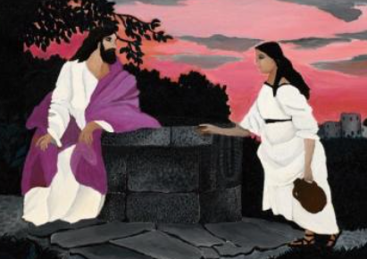
Anamehawikamek Welcome
ST. MICHAEL CATHOLIC CHURCH
PO Box 610, N816 State Highway 47-55,
Keshena, WI 54135 - Phone: 715-799-3811
Email: stmichaels@livingwaterslivingfaith.org
Website: stmichaelkeshena.com
Find us on Facebook: St. Michael’s Church

MISSION STATEMENT: St. Michael’s Christian Community, located on the Menominee Indian Reservation, is a diverse Christian community reaching out to all residents, learning, loving, sharing, and communicating with one another through the teachings and practices celebrated in the Mass & the Holy Sacraments of the Catholic Church by integrating sacred symbols and spiritual practices of the Menominee.
KNIGHTS OF COLUMBUS: Contact Grand Knight Paul Marroquin 715-853-2414.
HOLY HOUR: Every Friday after 8:00 am Mass.
ANOINTING OF THE SICK: Individual arrangements can be made through the Parish Office.
BAPTISM: Kindly contact parish office.
MARRIAGE: Make arrangements with the Priest, six months prior to desired date.
CONFIRMATION: Contact Deacon Mark Fuller for information via email mpfull7@gmail.com.

