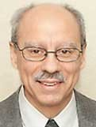 A Note from Deacon Mark
On this Laetare Sunday, I offer this gospel reflection from Fr. George Smiga, from his website, “Building on the Word.”
The man who was blind from birth receives his sight in the first few verses of today’s gospel. But that is not the end of his story. The gospel goes on to recount his conversations with neighbors, the Pharisees, and Jesus himself. This is because today’s gospel is not about seeing. It is about seeing more. You and I can see. We see trees, our computer screens, and the members of our families. But that does not mean that we see all that is necessary. This is why we are called to follow the example of the man born blind, living our lives with eyes open, seeing more and more until we finally see Jesus’s face to face. But all too often, we take the stance that the Pharisees adopt at the end of today’s gospel. “We see,” we say, “and what we see today is enough.” Jesus warns us that whenever proudly we say “we see,” we are only revealing our own blindness. It is only by our willingness to see more that we will be able to arrive at the place where God wants us to be.
We can only grow if we are willing to see more. That is why we can never say that what we see today is complete. But it is good news that our God is willing to lead us in the journey to greater sight. Our God is willing to use our abilities and our experiences, as God used the abilities and experiences of the man born blind, to lead us to a deeper truth. Our stance then must be one of humility and trust. We pray, “Lord, I can see, but help me to see more. I place my life in your hands.” Seeing begins with trust. That is why before we can open our eyes, we must be willing to open our hearts.
Upon Further Reflection
Ode to M y o p i a
My face in the mirror is not wrinkled or drawn;
my house isn’t dirty- the cobwebs are gone!
My garden looks lovely and so does my lawn;
I think I might never put my glasses back on!
In His mercy, Deacon Mark.
Financial Blessings
March 7th & 8th
Envelope/Contributors | $2050.00
Loose Collection | $292.00
We are in need of Weekday Mass intentions. Mass intentions are $20.00 per Mass.
Thank you for supporting our Parish!
MASS SCHEDULE &
INTENTIONS
03/14-5:00 pm……………..Ann Wychesit Spencer
03/15-9:00 am……………..The Brath/Keller
Families
03/16…………….…………..No Mass
03/17-8:00 am……………..Jack Rolfes
03/18-8:00 am……………..For all who are grieving
03/19-8:00 am……………..For the poor
03/20-8:00 am……………..For peace in this world
03/21-5:00 pm……………..Bernard Sanapaw
03/22-9:00 am……………..Eugene & Ann Degroot

Support St. Michael Parish

Easter Flower Envelopes are located in the main entrance; these are for your loved ones living or deceased. Please place in the Collection Basket.

Lenten Fish Fry Fundraiser
Location: Primal Eats Friday, March 27th in the Pine Hall from 4:00 – 7:00 pm.

Pre-Buy tickets can be purchased before & after weekend Masses, March 14th-15th & 21st-22nd. They can also be purchased at the Parish office.

Price: $15.00 for a 3 pc. Lake Perch Basket OR Cheese Pizza.

Entertainment provided by Fr. Hanz from 5:00–7:00 pm.

More Information will be available in the main Church entrance. Come on out for a fun evening & to support St. Michael Parish!!

Parish Picnic Raffle Tickets
Raffle Tickets for the Parish Picnic on Sunday, June 28th 2026 will be sold before & after Mass starting the weekend of March 29th. Tickets are $5.00 each or 3 for $10.00. Jacquie needs help selling Raffle Tickets. There will be a sign-up sheet located by the main entrance. Please call Jacquie at 715-701-4552 if you are interested.

Faith Formation News
Faith Formation will be hosting a Fellowship Breakfast on Sunday March 29th in the Father David Barrett Hall after the 9:00 am Mass. Please join us for Breakfast and Easter activities. Jackie is in need of: 2 fruit salads, 1 gallon of whole milk, 1 gallon of chocolate milk, 3 bottles of maple syrup, 2 dozen donuts, 2 coffee cakes & 2 quarts of fruit juice. She is also in need of volunteers to help with clean up. Please email Jackie at jlanghans@att.net to let her know if you can donate or help. Thank you!

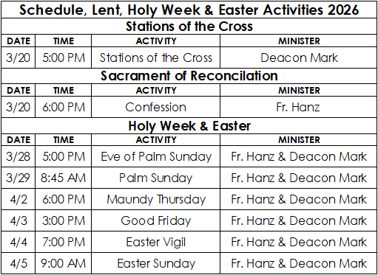

Estate Planning
When doing your estate planning, please remember St. Michael Parish. If you have questions, please contact the Parish office at 715-799-3811.

EXTRAORDINARY MINISTER
OF HOLY COMMUNION &
LECTOR SCHEDULE

Saturday, March 14th, 5:00 p.m.
Lector: Mary Lewellin
Eucharistic Minister: Karen Smart
Sunday, March 15th, 9:00 a.m.
Lector: Ellie Sokoly
Eucharistic Minister: Anne Sulskis
Saturday, March 21st, 5:00 p.m.
Lector: Muffy Culhane
Eucharistic Minister: Kevin Culhane
Sunday, March 22nd, 9:00 a.m.
Lector: Jacquie Braun
Eucharistic Minister: Anne Sulskis
Saturday, March 28th, 5:00 p.m.
Lector: Larry Sikowski & Mary Lewellin
Eucharistic Minister: Deacon Mark
Sunday, March 29th, 9:00 a.m.
Lector: Ellie Sokoly & Jacquie Braun
Eucharistic Minister: Deacon Mark
Thursday April 2nd, 6:00 p.m.
Lector: UNKNOWN
Eucharistic Minister: UNKNOWN
Friday April 3rd, 3:00 p.m.
Lector: UNKNOWN
Eucharistic Minister: UNKNOWN
Saturday, April 4th, 7:00 p.m.
Lector: UNKNOWN
Eucharistic Minister: UNKNOWN
Sunday, April 5th, 9:00 a.m.
Lector: UNKNOWN
Eucharistic Minister: UNKNOWN
Upcoming Events:
- The Office will be closed Monday, March 16th & Tuesday, March 17th. If you need help please call 715-799-3811 to leave a voicemail & somebody will reach back out to you.
- Friday, March 20th Stations of the Cross 5:00 pm. Confession at 6:00 pm.
- Friday, March 27th Fish Fry @ Primal Eats in the Pine Hall from 4:00 – 7:00 pm.
- Saturday, March 28th Eve of Palm Sunday Mass @ 5:00 pm.
- Sunday, March 29th Palm Sunday Mass @ 8:45 am. Breakfast after Mass, hosted by Faith
Formation.

St. Michael Parish

2026 Bishop’s Appeal Goal
This year’s goal is $7,664.00.
We have already received $7870.00 in donations. Thank you!
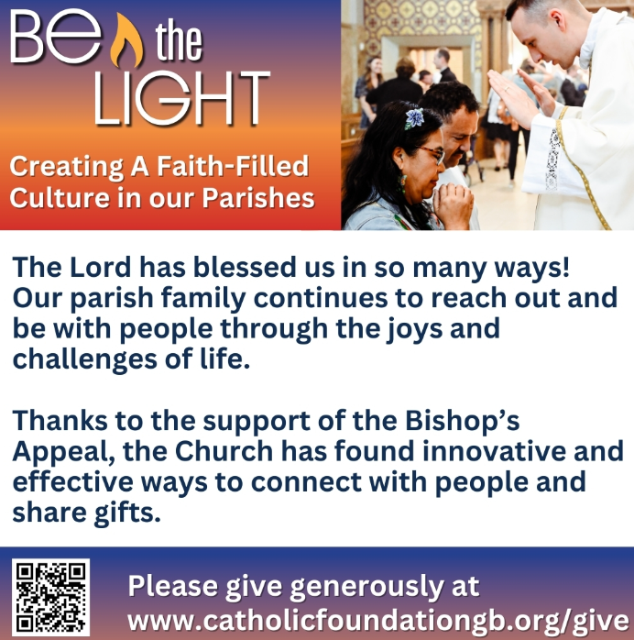


14109 County VV, Gillett, WI 54124


SUNDAY BRUNCH 9-12 PM.
CHICKEN DINNER ALL DAY.

Please pick up your pans, cookie sheets, and miscellaneous items left over from funerals and other church events in the Fr. Barrett Hall.
There will not be a Mass at St. Michael on Holy Saturday, March 26. Easter Vigil will be held at St. Francis in Gresham at 7 pm. Easter Sunday Mass will be at St. Michael and St. Anthony at 10:30 am.

Maintenance. Michael Catholic Parish in Keshena is seeking a part-time maintenance person. Responsible for light maintenance, cleaning the church, etc. Contact the parish office at telephone number 715-799-3811 for an application, and job.

Please pick up your pans, cookie sheets, and miscellaneous items left over from funerals and other church events in the Fr. Barrett Hall.
There will not be a Mass at St. Michael on Holy Saturday, March 26. Easter Vigil will be held at St. Francis in Gresham at 7 pm. Easter Sunday Mass will be at St. Michael and St. Anthony at 10:30 am.
PARISH STAFF
FR. HANZ CHRISTIAN BORBOR
Parish Administrator
Parish Office (715) 799-3811
xtian.borbor@gmail.com

DEACON MARK FULLER
(715) 201-2961
mpfull7@gmail.com

Parish Secretary
RICKIE DODGE
Parish Office (715) 799-3811
stmichaels@livingwaterslivingfaith.org

Faith Formation
JACKIE LANGHANS
Parish Office (715) 799-3811
jlanghans@att.net

PARISH TRUSTEES
KAREN SMART, Treasurer
VICKI HERMSEN, Secretary

Parish Council Chair
MARY LEWELLIN

Finance Council Chair
THERESE GLAUSER

Thrift N Gift Coordinator
COOKIE VIGUE

Food Pantry Coordinator

MASS SCHEDULE
Saturday: 5:00 pm Mass
4:30 pm Rosary & Confession
Sunday: 9:00 am Mass
8:30 am Rosary
Monday – No Mass
Tuesday - Friday: 8:00 am

PARISH OFFICE HOURS
Regular hours: Wednesday & Thursday
8:15 am – 2:00 pm
The Office will be closed Monday March 16th & Tuesday March 17th.
Hours may vary, please call before coming to the office.
SATURDAY MASS: 5:00 pm
SUNDAY MASS: 9:00 am
CONFESSION: Saturday 4:30 - 4:45pm
ROSARY: Saturday 3:40 pm Sunday 8:35 am
DAILY MASS: Chapel Southside of Church

P Parish Administrator, Fr. Nonito Barra - 715-799-3811 - pastor@livingwaterslivingfaith.org
Rectory – 715-994-1337
Parochial Vicar Fr. Joel Jores - 715-787-3377 frj@livingwaterslivingfaith.org
Deacon Mark Fuller 715-201-2961- deaconmark@livingwaterslivingfaith.org
Parish Secretary, Vicki Hermsen - 715-799-3811 - vicki@livingwaterslivingfaith.org
Religious Education Kathy King-Tucker - 715-799-3927 – ltucker@frontiernet.netmailto:maczuzak@frontiernet.net
Wednesday 6 – 7:30 pm September – May
Parish Administrator, Fr. Nonito Barra - 715-799-3811 - pastor@livingwaterslivingfaith.org
Rectory – 715-994-1337
Parochial Vicar Fr. Joel Jores - 715-787-3377 frj@livingwaterslivingfaith.org
Deacon Mark Fuller 715-201-2961- deaconmark@livingwaterslivingfaith.org
Parish Secretary, Vicki Hermsen - 715-799-3811 - vicki@livingwaterslivingfaith.org
Religious Education Kathy King-Tucker - 715-799-3927 – ltucker@frontiernet.netmailto:maczuzak@frontiernet.net
Wednesday 6 – 7:30 pm September – May
Parish Administrator, Fr. Nonito Barra - 715-799-3811 - pastor@livingwaterslivingfaith.org
Rectory – 715-994-1337
Parochial Vicar Fr. Joel Jores - 715-787-3377 frj@livingwaterslivingfaith.org
Deacon Mark Fuller 715-201-2961- deaconmark@livingwaterslivingfaith.org
Parish Secretary, Vicki Hermsen - 715-799-3811 - vicki@livingwaterslivingfaith.org
Religious Education Kathy King-Tucker - 715-799-3927 – ltucker@frontiernet.netmailto:maczuzak@frontiernet.net
Wednesday 6 – 7:30 pm September – May

St. Michael’s Calendar
03/14/2026 World’s Poor 2nd Collection at 5:00 pm Mass
03/15/2026 World’s Poor 2nd Collection at 5:00 pm Mass
03/17/2026 Thrift N Gift 11:00 am – 3:00 pm
03/17/2026 Food Pantry/Book Share 12:30 - 3:00 pm
03/17/2026 Knights of Colombus meeting 7:00 pm
03/18/2026 Faith Formation 6:00 – 7:00 pm
03/20/2026 Holy Hour after Mass
03/20/2026 Stations of the Cross 5:00 pm
03/20/2026 Confession 6:00 pm
03/27/2026 Primal Eats Fish Fry Dinner 4:00 - 7:00 pm

MASS TIMES
St. Michael – Saturday: 5:00 pm, Sunday: 9:00 am,
Monday: No Mass, Tuesday-Friday: 8:00 am
St. Anthony – Sunday: 10:30 am

Book Share
Will be open Tuesday, March 17th from 12:30 – 3:00 pm. We have books for all ages! We will accept books in good shape, just no old magazines, text books or encyclopedias.

Food Pantry
Will be open Tuesday, March 17th from 12:30 - 3:00 pm. There will be drive up service only and food will be placed in your trunk. Please do not get out of your vehicle. Please save brown paper bags & plastic bags and please drop them off at the Parish office.

Thrift N Gift
Will be open Tuesday, March 17th from 11:00 am - 3:00 pm. We have an abundance of household items, clothes, and great gift items. Please reach out to Cookie if you need to, 920-216-9240.

We the Knights
We always ask God to bless our community members. If you or a family member need assistance to get to a doctor appointment, we may be able to help. Call Paul at 715-853-2414 or Todd 715-584-5885.

Kateri Prayer Circle
Never underestimate the power of prayer. Just one small prayer can change your life. If you or your family members need prayers for any reason, please call one of our Kateri Prayer Circle members, who will in turn call members of their group. Soon, many prayers will be offered for your specific prayer request. Please call:

Fay Waupochick: 715-799-3437
Jacqueline Braun: 715-701-4552

You can also call the Parish Office to leave a request.

Religious Education Calendar Up Coming Events:
Wednesday, November 30th –Classes Resume
Wednesday December 7th
Wednesday December 14th
Wednesday December 21st Birthday Party- Parents
Guardians invited
Wednesday December 28th No Class
Wednesday January 4th No Class
Wednesday January 11 Classes resume
March 15th, 2026
Fourth Sunday of Lent
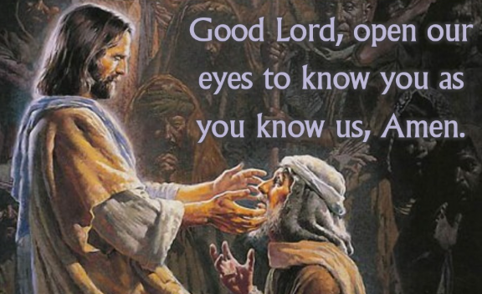
Anamehawikamek Welcome
ST. MICHAEL CATHOLIC CHURCH
PO Box 610, N816 State Highway 47-55,
Keshena, WI 54135 - Phone: 715-799-3811
Email: stmichaels@livingwaterslivingfaith.org
Website: stmichaelkeshena.com
Find us on Facebook: St. Michael’s Church

MISSION STATEMENT: St. Michael’s Christian Community, located on the Menominee Indian Reservation, is a diverse Christian community reaching out to all residents, learning, loving, sharing, and communicating with one another through the teachings and practices celebrated in the Mass & the Holy Sacraments of the Catholic Church by integrating sacred symbols and spiritual practices of the Menominee.
KNIGHTS OF COLUMBUS: Contact Grand Knight Paul Marroquin 715-853-2414.
HOLY HOUR: Every Friday after 8:00 am Mass.
ANOINTING OF THE SICK: Individual arrangements can be made through the Parish Office.
BAPTISM: Kindly contact parish office.
MARRIAGE: Make arrangements with the Priest, six months prior to desired date.
CONFIRMATION: Contact Deacon Mark Fuller for information via email mpfull7@gmail.com.

