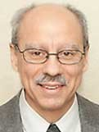 A Note from Deacon Mark
The Church celebrates this sixth Sunday of Lent as both Palm Sunday and Passion Sunday. This is the point in the Liturgical year when the Church stops us so that we can remember and relive the events which brought about our redemption and salvation. What we commemorate and relive during this week is not just Jesus’ dying and rising, but our own dying to sin and selfishness and rising in Jesus, which will result in our healing, reconciliation, and redemption. Attentive participation in the Holy Week liturgy will deepen our relationship with God, increase our faith, and strengthen our lives as disciples of Jesus. Today’s liturgy combines contrasting moments, one of glory, the other of suffering: the royal welcome of Jesus entering Jerusalem, and the rigged trial, culminating in the crucifixion, death, and burial of the Christ. May we all receive needed grace during this special time of Holy Week, so we may experience the height and depth of Jesus’ great love and mercy for us and know that by His wounds we are healed!

Upon Further Reflection

Little Johnny was sick on Palm Sunday and stayed home from Church with his mother. His father returned from Church holding a palm branch. The little boy was curious and asked, “Why do you have that palm branch, Dad?” His father explained, “You see, when Jesus came into town, everyone waved palm branches to honor Him; so, we got palm branches today.” “Aw, shucks,” grumbled Little Johnny. “The one Sunday I can’t go to Church, and Jesus shows up!”

In His mercy, Deacon Mark

Financial Blessings
March 21st & 22nd
Envelope/Contributors | $3798.00
Loose Collection | $298.00
We are in need of Weekday Mass intentions. Mass intentions are $20.00 per Mass.
Thank you for supporting our Parish!
MASS SCHEDULE &
INTENTIONS
03/28-5:00 pm……………. Roger Sanapaw
03/29-8:45 am……………. Jim & Joleen
Kaquatosh & Kinsey
03/30……………………. …. No Mass
03/31-8:00 am……………. For peace in Holy Land
04/01-8:00 am……………. Souls in purgatory
04/02-6:00 pm……………. Tribal elders
04/03-3:00 pm……………. Those who have no
one to pray for them
04/04-7:00 pm……………. Mary, Fred & Bob
Drexler
04/05-8:45 am……………. Richard A Moses Sr.

Support St. Michael Parish
Easter Flower Envelopes are located in the main entrance; these are for your loved ones living or deceased. This will be the last weekend to submit. Please place in the Collection Basket.
Lenten Fish Fry Fundraiser
Thank you to those who attended our Lenten Fish Fry Dinner at Primal eats. We appreciate all of your support.

Parish Picnic Raffle Tickets
Raffle Tickets for the Parish Picnic on Sunday, June 28th 2026 will be sold before & after Mass starting the weekend of March 29th. Tickets are $5.00 each or 3 for $10.00. Jacquie needs help selling Raffle Tickets. There will be a sign-up sheet located by the main entrance. Please call Jacquie at 715-701-4552 if you are interested.

Faith Formation News
Faith Formation will be hosting the Palm Sunday Fellowship Breakfast this Sunday March 29th in the Father David Barrett Hall after the 8:45 am Mass. Please join us for Breakfast and Easter activities. Thank you!

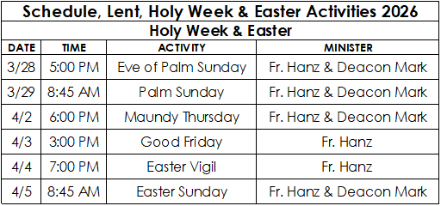

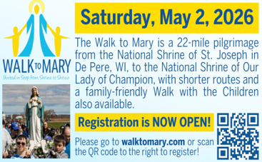

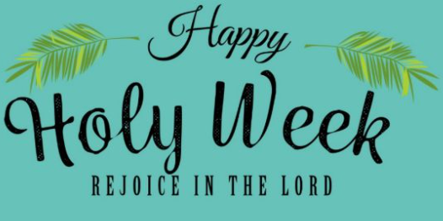
EXTRAORDINARY MINISTER
OF HOLY COMMUNION &
LECTOR SCHEDULE

Saturday, March 28th, 5:00 p.m.
Lector: Larry Sikowski & Mary Lewellin
Eucharistic Minister: Deacon Mark
Sunday, March 29th, 8:45 a.m.
Lector: Ellie Sokoly & Jacquie Braun
Eucharistic Minister: Deacon Mark
Thursday April 2nd, 6:00 p.m.
Lector: Ellie Sokoly
Eucharistic Minister: Deacon Mark, Karen
Smart & Anne Sulskis
Friday April 3rd, 3:00 p.m.
Lector: Larry Sikowski
Eucharistic Minister: Jim Gilane
Saturday, April 4th, 7:00 p.m.
Lector: Muffy Culhane & Anne Sulskis
Eucharistic Minister: Kevin Culhane, Karen
Smart & Muffy Culhane
Sunday, April 5th, 8:45 a.m.
Lector: Jacquie Braun
Eucharistic Minister: Gloria Gierach
Saturday, April 11th, 5:00 p.m.
Lector: Mary Lewellin
Eucharistic Minister: Karen Smart
Sunday, April 12th, 9:00 a.m.
Lector: Ellie Sokoly
Eucharistic Minister: Anne Sulskis
Saturday, April 18th, 5:00 p.m.
Lector: Kevin Culhane
Eucharistic Minister: Muffy Culhane
Sunday, April 19th, 9:00 a.m.
Lector: Jacquie Braun
Eucharistic Minister: Gloria Gierach
Save the Dates:

- Sunday, June 28th St. Michael’s Church Picnic 10:00 am.

- Monday, Tuesday & Wednesday, July 27th – 29th Charlie’s Red Barn Fundraiser 9:00 am – 5:00 pm.

St. Michael Parish

2026 Bishop’s Appeal Goal
This year’s goal is $7,664.00.
We have already received $7870 in
donations. Thank you!
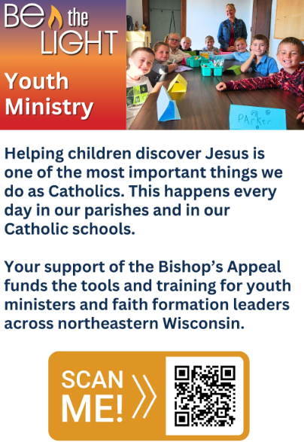


14109 County VV, Gillett, WI 54124


SUNDAY BRUNCH 9-12 PM.
CHICKEN DINNER ALL DAY.

Please pick up your pans, cookie sheets, and miscellaneous items left over from funerals and other church events in the Fr. Barrett Hall.
There will not be a Mass at St. Michael on Holy Saturday, March 26. Easter Vigil will be held at St. Francis in Gresham at 7 pm. Easter Sunday Mass will be at St. Michael and St. Anthony at 10:30 am.

Maintenance. Michael Catholic Parish in Keshena is seeking a part-time maintenance person. Responsible for light maintenance, cleaning the church, etc. Contact the parish office at telephone number 715-799-3811 for an application, and job.

Please pick up your pans, cookie sheets, and miscellaneous items left over from funerals and other church events in the Fr. Barrett Hall.
There will not be a Mass at St. Michael on Holy Saturday, March 26. Easter Vigil will be held at St. Francis in Gresham at 7 pm. Easter Sunday Mass will be at St. Michael and St. Anthony at 10:30 am.
PARISH STAFF
FR. HANZ CHRISTIAN BORBOR
Parish Administrator
Parish Office (715) 799-3811
xtian.borbor@gmail.com

DEACON MARK FULLER
(715) 201-2961
mpfull7@gmail.com

Parish Secretary
RICKIE DODGE
Parish Office (715) 799-3811
stmichaels@livingwaterslivingfaith.org

Faith Formation
JACKIE LANGHANS
Parish Office (715) 799-3811
jlanghans@att.net

PARISH TRUSTEES
KAREN SMART, Treasurer
VICKI HERMSEN, Secretary

Parish Council Chair
MARY LEWELLIN

Finance Council Chair
THERESE GLAUSER

Thrift N Gift Coordinator
COOKIE VIGUE

Food Pantry Coordinator

MASS SCHEDULE
Saturday: 5:00 pm Mass
4:30 pm Rosary & Confession
Sunday: 9:00 am Mass
8:30 am Rosary
Monday – No Mass
Tuesday - Friday: 8:00 am

PARISH OFFICE HOURS
Regular hours: Monday - Thursday
9:00 am – 2:00 pm
Hours may vary, please call before coming to the office.
SATURDAY MASS: 5:00 pm
SUNDAY MASS: 9:00 am
CONFESSION: Saturday 4:30 - 4:45pm
ROSARY: Saturday 3:40 pm Sunday 8:35 am
DAILY MASS: Chapel Southside of Church

P Parish Administrator, Fr. Nonito Barra - 715-799-3811 - pastor@livingwaterslivingfaith.org
Rectory – 715-994-1337
Parochial Vicar Fr. Joel Jores - 715-787-3377 frj@livingwaterslivingfaith.org
Deacon Mark Fuller 715-201-2961- deaconmark@livingwaterslivingfaith.org
Parish Secretary, Vicki Hermsen - 715-799-3811 - vicki@livingwaterslivingfaith.org
Religious Education Kathy King-Tucker - 715-799-3927 – ltucker@frontiernet.netmailto:maczuzak@frontiernet.net
Wednesday 6 – 7:30 pm September – May
Parish Administrator, Fr. Nonito Barra - 715-799-3811 - pastor@livingwaterslivingfaith.org
Rectory – 715-994-1337
Parochial Vicar Fr. Joel Jores - 715-787-3377 frj@livingwaterslivingfaith.org
Deacon Mark Fuller 715-201-2961- deaconmark@livingwaterslivingfaith.org
Parish Secretary, Vicki Hermsen - 715-799-3811 - vicki@livingwaterslivingfaith.org
Religious Education Kathy King-Tucker - 715-799-3927 – ltucker@frontiernet.netmailto:maczuzak@frontiernet.net
Wednesday 6 – 7:30 pm September – May
Parish Administrator, Fr. Nonito Barra - 715-799-3811 - pastor@livingwaterslivingfaith.org
Rectory – 715-994-1337
Parochial Vicar Fr. Joel Jores - 715-787-3377 frj@livingwaterslivingfaith.org
Deacon Mark Fuller 715-201-2961- deaconmark@livingwaterslivingfaith.org
Parish Secretary, Vicki Hermsen - 715-799-3811 - vicki@livingwaterslivingfaith.org
Religious Education Kathy King-Tucker - 715-799-3927 – ltucker@frontiernet.netmailto:maczuzak@frontiernet.net
Wednesday 6 – 7:30 pm September – May

St. Michael’s Calendar
03/28/2026 Eve of Palm Sunday Mass 5:00 pm
03/28/2026 FP 2nd Collection at 5:00 pm Mass
03/29/2026 Palm Sunday Mass 8:45 am
03/29/2026 FP 2nd Collection at 8:45 am Mass
03/29/2026 Faith Formation hosts Breakfast/Easter
activities after 8:45 am Mass
04/01/2026 Faith Formation 6:00 – 7:00 pm
04/02/2026 Maundy Thursday Mass 6:00 pm
04/03/2026 Good Friday adoration of the Cross/
Communion 3:00 pm
04/03/2026 Holy Land collection at 3:00 pm adoration
of the Cross/Communion

MASS TIMES
St. Michael – Saturday: 5:00 pm, Sunday: 9:00 am
Monday: No Mass Tuesday - Friday: 8:00 am
St. Anthony – Sunday: 10:30 am

Book Share
Will be open Tuesday, April 7th from 12:30 – 3:00 pm. We have books for all ages! We will accept books in good shape, just no old magazines, text books or encyclopedias.

Food Pantry
Will be open Tuesday, April 7th from 12:30 - 3:00 pm. There will be drive up service only and food will be placed in your trunk. Please do not get out of your vehicle. Please save brown paper bags & plastic bags and please drop them off at the Parish office.

Thrift N Gift
Will be open Tuesday, April 7th from 11:00 am - 3:00 pm. We have an abundance of household items, clothes, and great gift items. Please reach out to Cookie if you need to, 920-216-9240.

We the Knights
We always ask God to bless our community members. If you or a family member need assistance to get to a doctor appointment, we may be able to help. Call Paul at 715-853-2414 or Todd 715-584-5885.

Kateri Prayer Circle
Never underestimate the power of prayer. Just one small prayer can change your life. If you or your family members need prayers for any reason, please call one of our Kateri Prayer Circle members, who will in turn call members of their group. Soon, many prayers will be offered for your specific prayer request. Please call:
Fay Waupochick: 715-799-3437
Jacqueline Braun: 715-701-4552
You can also call the Parish Office to leave a request.

Religious Education Calendar Up Coming Events:
Wednesday, November 30th –Classes Resume
Wednesday December 7th
Wednesday December 14th
Wednesday December 21st Birthday Party- Parents
Guardians invited
Wednesday December 28th No Class
Wednesday January 4th No Class
Wednesday January 11 Classes resume
March 29th, 2026
Palm Sunday of the
Lord’s Passion
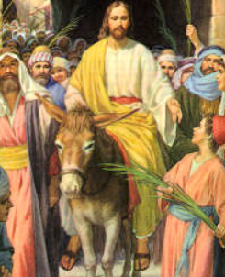
Anamehawikamek Welcome
ST. MICHAEL CATHOLIC CHURCH
PO Box 610, N816 State Highway 47-55,
Keshena, WI 54135 - Phone: 715-799-3811
Email: stmichaels@livingwaterslivingfaith.org
Website: stmichaelkeshena.com
Find us on Facebook: St. Michael’s Church

MISSION STATEMENT: St. Michael’s Christian Community, located on the Menominee Indian Reservation, is a diverse Christian community reaching out to all residents, learning, loving, sharing, and communicating with one another through the teachings and practices celebrated in the Mass & the Holy Sacraments of the Catholic Church by integrating sacred symbols and spiritual practices of the Menominee.
KNIGHTS OF COLUMBUS: Contact Grand Knight Paul Marroquin 715-853-2414.
HOLY HOUR: Every Friday after 8:00 am Mass.
ANOINTING OF THE SICK: Individual arrangements can be made through the Parish Office.
BAPTISM: Kindly contact parish office.
MARRIAGE: Make arrangements with the Priest, six months prior to desired date.
CONFIRMATION: Contact Deacon Mark Fuller for information via email mpfull7@gmail.com.

