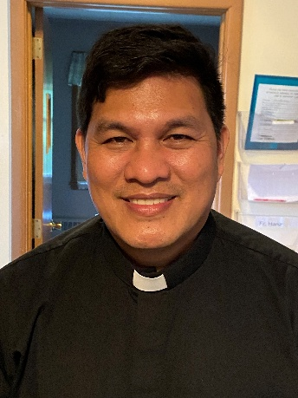 A Note from Father Hanz
Easter Sunday is the most important day in the Christian faith—the day on which our Lord Jesus Christ triumphed over sin and death. He fulfilled His mission, and through His suffering and death on the cross, He gave our lives new meaning.
If Jesus had not risen from the dead, our faith would be incomplete. His teachings would be no different from those of others who founded their own religious practices. But because He truly rose, all of Christendom has reason to celebrate and rejoice. Our Savior is faithful to His word: He died to give us life, and He rose again to make us worthy sharers in His Kingdom, so that we may be called adopted sons and daughters of God the Father through His Son, Jesus Christ.
May the Resurrection of Jesus inspire us each day to keep our faith alive—a living faith that we are willing to share and to live out.
Happy Easter Sunday, everyone!

MASS SCHEDULE &
INTENTIONS
04/04-7:00 pm…………….Mary, Fred & Bob Drexler
04/05-8:45 am…………….Richard A Moses Sr.
04/06 ……………………….No Mass
04/07………………………..No Mass
04/08………………………..No Mass
04/09………………………..No Mass
04/10………………………..No Mass
04/11-5:00 pm…………….Jim & Joleen
Kaquatosh & Kinsey
04/12-9:00 am…………….The Suess/Staehler
Families
Lenten Fish Fry Fundraiser
Thank you to everyone who supported the March 27 fish fry at Primal Eats. A special thank you to Primal Eats and the Follett family for this opportunity to have an enjoyable evening of Lenten fellowship in the Pine Hall. Thank you Fr. Hanz, Dr. Heather and Stephanie for your gift of music for the evening. We could not do this wit out our wonderful volunteers: Kathryn Geimer Chojnacki, Muffy and Kevin Culhane, Ellie and Jim Sokoly, Patty Fuller, Larry Sikowski, Carla Wilber, Kristi and Jim Kirk, Jackie and John Langhans, Karen Lynch, Jay Peerenboom, Anne Suslkis, Jacquie Braun and Mary Lewellin. Thank you for a great evening of food, music and fellowship.
Parish Picnic Raffle Tickets
Raffle Tickets for the Parish Picnic on Sunday, June 28th 2026 will be sold before & after Mass starting the weekend of March 29th. Tickets are $5.00 each or 3 for $10.00. Jacquie needs help selling Raffle Tickets. There will be a sign-up sheet located by the main entrance. Please call Jacquie at 715-701-4552 if you are interested.

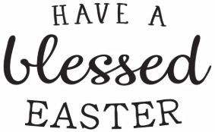

Faith Formation News
Thanks to all of you who attended the Palm Sunday Faith Formation Breakfast! Pancakes, fruit and desserts were enjoyed, Easter eggs were colored (Mary Lewellin) and palms were braided (Patty Fuller). Many thanks to all who donated items, helped to decorate before and then clean up afterwards. We could not have done it without you!
Since many had asked, here is the recipe for the sheet pan pancakes that were made.
Per Allrecipes website:
2 cups of Bisquick baking mix
2 eggs
1 cup of milk
I added - 3 tablespoons of sugar
2 teaspoons of baking powder
1 teaspoon of vanilla
Mix the above, let rest for 5 minutes. Generously spray a 9x12 sheet pan with cooking spray and pour the batter into the pan. Top with one of the following: 1 cup - sliced strawberries, whole blueberries, chocolate chips or precooked pork sausage.
Bake at 425 for approximately 15 minutes.
Slice and enjoy.
Financial Blessings
March 28th & 29th
We are in need of Weekday Mass intentions. Mass intentions are $20.00 per Mass.
Envelope/Contributors | $1928.00
Loose Collection | $629.00
Thank you for supporting our Parish!
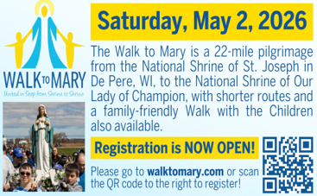

EXTRAORDINARY MINISTER
OF HOLY COMMUNION &
LECTOR SCHEDULE

Saturday, April 4th, 7:00 p.m.
Lector: Muffy Culhane & Anne Sulskis
Eucharistic Minister: Kevin Culhane, Karen
Smart & Muffy Culhane
Sunday, April 5th, 8:45 a.m.
Lector: Jacquie Braun
Eucharistic Minister: Gloria Gierach
Saturday, April 11th, 5:00 p.m.
Lector: Mary Lewellin
Eucharistic Minister: Karen Smart
Sunday, April 12th, 9:00 a.m.
Lector: Ellie Sokoly
Eucharistic Minister: Anne Sulskis
Saturday, April 18th, 5:00 p.m.
Lector: Kevin Culhane
Eucharistic Minister: Muffy Culhane
Sunday, April 19th, 9:00 a.m.
Lector: Jacquie Braun
Eucharistic Minister: Gloria Gierach
Saturday, April 25th, 5:00 p.m.
Lector: Rod Glauser
Eucharistic Minister: Deacon Mark
Sunday, April 26th, 9:00 a.m.
Lector: Jacquie Braun
Eucharistic Minister: Deacon Mark
Save the Dates:

- Saturday, May 2nd 11:00 am Memorial Mass and lunch to follow for Patricia Gwidt.

- Sunday, June 28th St. Michael’s Church Picnic 10:00 am.

- Monday, Tuesday & Wednesday, July 27th – 29th Charlie’s Red Barn Fundraiser 9:00 am – 5:00 pm.

St. Michael Parish

2026 Bishop’s Appeal Goal
This year’s goal is $7,664.00.
We have already received $7,970 in
donations. Thank you!
Pastoral Parish Council & Trustee Election
The Pastoral Parish Council has three terms opening in May. We are in need of a candidate for the Council to serve three-year term. There is one Church Trustee opening, a two-year term. There is also a Finance chair open for a three-year term. Please consider volunteering for one of these positions. Contact the Parish office if interested or want to learn more about these opportunities to serve St. Michael’s Parish.
Religious Education Coordinator
St. Michael’s is seeking an individual interested in being the Faith Formation/Religious Education Coordinator for 2026-27. This is a part time, salaried position for 8-15 hours per week from September through May. Job description and application are available in the Parish Office.


14109 County VV, Gillett, WI 54124


SUNDAY BRUNCH 9-12 PM.
CHICKEN DINNER ALL DAY.

Please pick up your pans, cookie sheets, and miscellaneous items left over from funerals and other church events in the Fr. Barrett Hall.
There will not be a Mass at St. Michael on Holy Saturday, March 26. Easter Vigil will be held at St. Francis in Gresham at 7 pm. Easter Sunday Mass will be at St. Michael and St. Anthony at 10:30 am.

Maintenance. Michael Catholic Parish in Keshena is seeking a part-time maintenance person. Responsible for light maintenance, cleaning the church, etc. Contact the parish office at telephone number 715-799-3811 for an application, and job.

Please pick up your pans, cookie sheets, and miscellaneous items left over from funerals and other church events in the Fr. Barrett Hall.
There will not be a Mass at St. Michael on Holy Saturday, March 26. Easter Vigil will be held at St. Francis in Gresham at 7 pm. Easter Sunday Mass will be at St. Michael and St. Anthony at 10:30 am.
PARISH STAFF
FR. HANZ CHRISTIAN BORBOR
Parish Administrator
Parish Office (715) 799-3811
xtian.borbor@gmail.com

DEACON MARK FULLER
(715) 201-2961
mpfull7@gmail.com

Parish Secretary
RICKIE DODGE
Parish Office (715) 799-3811
stmichaels@livingwaterslivingfaith.org

Faith Formation
JACKIE LANGHANS
Parish Office (715) 799-3811
jlanghans@att.net

PARISH TRUSTEES
KAREN SMART, Treasurer
VICKI HERMSEN, Secretary

Parish Council Chair
MARY LEWELLIN

Finance Council Chair
THERESE GLAUSER

Thrift N Gift Coordinator
COOKIE VIGUE

Food Pantry Coordinator

MASS SCHEDULE
Saturday: 5:00 pm Mass
4:30 pm Rosary & Confession
Sunday: 9:00 am Mass
8:30 am Rosary
Monday – Friday: No Mass

PARISH OFFICE HOURS
Regular hours: Tuesday - Thursday
9:00 am – 2:00 pm
Hours may vary, please call before coming to the office.
SATURDAY MASS: 5:00 pm
SUNDAY MASS: 9:00 am
CONFESSION: Saturday 4:30 - 4:45pm
ROSARY: Saturday 3:40 pm Sunday 8:35 am
DAILY MASS: Chapel Southside of Church

P Parish Administrator, Fr. Nonito Barra - 715-799-3811 - pastor@livingwaterslivingfaith.org
Rectory – 715-994-1337
Parochial Vicar Fr. Joel Jores - 715-787-3377 frj@livingwaterslivingfaith.org
Deacon Mark Fuller 715-201-2961- deaconmark@livingwaterslivingfaith.org
Parish Secretary, Vicki Hermsen - 715-799-3811 - vicki@livingwaterslivingfaith.org
Religious Education Kathy King-Tucker - 715-799-3927 – ltucker@frontiernet.netmailto:maczuzak@frontiernet.net
Wednesday 6 – 7:30 pm September – May
Parish Administrator, Fr. Nonito Barra - 715-799-3811 - pastor@livingwaterslivingfaith.org
Rectory – 715-994-1337
Parochial Vicar Fr. Joel Jores - 715-787-3377 frj@livingwaterslivingfaith.org
Deacon Mark Fuller 715-201-2961- deaconmark@livingwaterslivingfaith.org
Parish Secretary, Vicki Hermsen - 715-799-3811 - vicki@livingwaterslivingfaith.org
Religious Education Kathy King-Tucker - 715-799-3927 – ltucker@frontiernet.netmailto:maczuzak@frontiernet.net
Wednesday 6 – 7:30 pm September – May
Parish Administrator, Fr. Nonito Barra - 715-799-3811 - pastor@livingwaterslivingfaith.org
Rectory – 715-994-1337
Parochial Vicar Fr. Joel Jores - 715-787-3377 frj@livingwaterslivingfaith.org
Deacon Mark Fuller 715-201-2961- deaconmark@livingwaterslivingfaith.org
Parish Secretary, Vicki Hermsen - 715-799-3811 - vicki@livingwaterslivingfaith.org
Religious Education Kathy King-Tucker - 715-799-3927 – ltucker@frontiernet.netmailto:maczuzak@frontiernet.net
Wednesday 6 – 7:30 pm September – May

St. Michael’s Calendar
04/04/2026 Easter Vigil 7:00 pm
04/05/2026 Easter Sunday 8:45 am
04/06/2026 Office closed for Easter Monday Holiday
04/07/2026 Thrift N Gift 11:00 am – 3:00 pm
04/07/2026 Food Pantry 12:30 – 3:00 pm
04/07/2026 Book Share 12:30 -3:00 pm
04/08/2026 Faith Formation 6:00 – 7:00 pm
04/07/2026 - 04/10/2026: Reminder, No Mass this week

MASS TIMES
St. Michael – Saturday: 7:00 pm, Sunday: 8:45 am
Monday - Friday: No Mass
St. Anthony – Sunday: 10:30 am

Book Share
Will be open Tuesday, April 7th from 12:30 – 3:00 pm. We have books for all ages! We will accept books in good shape, just no old magazines, text books or encyclopedias.

Food Pantry
Will be open Tuesday, April 7th from 12:30 - 3:00 pm. There will be drive up service only and food will be placed in your trunk. Please do not get out of your vehicle. Please save brown paper bags & plastic bags and please drop them off at the Parish office.

Thrift N Gift
Will be open Tuesday, April 7th from 11:00 am - 3:00 pm. We have an abundance of household items, clothes, and great gift items. Please reach out to Cookie if you need to, 920-216-9240.

We the Knights
We always ask God to bless our community members. If you or a family member need assistance to get to a doctor appointment, we may be able to help. Call Paul at 715-853-2414 or Todd 715-584-5885.

Kateri Prayer Circle
Never underestimate the power of prayer. Just one small prayer can change your life. If you or your family members need prayers for any reason, please call one of our Kateri Prayer Circle members, who will in turn call members of their group. Soon, many prayers will be offered for your specific prayer request. Please call:
Fay Waupochick: 715-799-3437
Jacqueline Braun: 715-701-4552

You can also call the Parish Office to leave a request.

Religious Education Calendar Up Coming Events:
Wednesday, November 30th –Classes Resume
Wednesday December 7th
Wednesday December 14th
Wednesday December 21st Birthday Party- Parents
Guardians invited
Wednesday December 28th No Class
Wednesday January 4th No Class
Wednesday January 11 Classes resume
April 5, 2026
Easter Sunday of the
Lord’s Resurrection
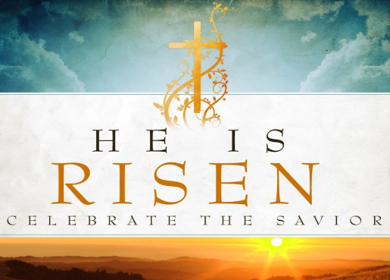
Anamehawikamek Welcome
ST. MICHAEL CATHOLIC CHURCH
PO Box 610, N816 State Highway 47-55,
Keshena, WI 54135 - Phone: 715-799-3811
Email: stmichaels@livingwaterslivingfaith.org
Website: stmichaelkeshena.com
Find us on Facebook: St. Michael’s Church

MISSION STATEMENT: St. Michael’s Christian Community, located on the Menominee Indian Reservation, is a diverse Christian community reaching out to all residents, learning, loving, sharing, and communicating with one another through the teachings and practices celebrated in the Mass & the Holy Sacraments of the Catholic Church by integrating sacred symbols and spiritual practices of the Menominee.
KNIGHTS OF COLUMBUS: Contact Grand Knight Paul Marroquin 715-853-2414.
HOLY HOUR: Every Friday after 8:00 am Mass.
ANOINTING OF THE SICK: Individual arrangements can be made through the Parish Office.
BAPTISM: Kindly contact parish office.
MARRIAGE: Make arrangements with the Priest, six months prior to desired date.
CONFIRMATION: Contact Deacon Mark Fuller for information via email mpfull7@gmail.com.

