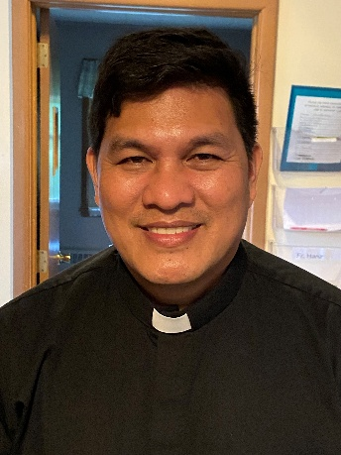 A Note from Father Hanz
As the disciples walked in sadness, the Risen Lord came beside them, though they did not recognize Him at first. He opened the Scriptures to them, helping them understand how His suffering, death, and resurrection fulfilled God’s plan. Their hearts began to burn with hope, yet it was only in the breaking of the bread that their eyes were fully opened and they recognized Him.
This moment reminds us that the Eucharist is not merely a ritual, but a real encounter with the living Christ. Just as the disciples recognized Jesus in the breaking of the bread, we too encounter Him in the Mass—when the Word is proclaimed and the Bread is broken. In every Eucharist, Jesus walks with us, opens our hearts to His Word, and reveals Himself as our hope, our nourishment, and our peace.
The journey to Emmaus shows that even in our confusion and sorrow, Christ is present—leading us, teaching us, and feeding us with Himself. Through the Eucharist, He turns our despair into hope and sends us forth, just like the disciples, to proclaim the joy of the Resurrection.

MASS SCHEDULE &
INTENTIONS
04/18-5:00 pm…………….Ann Wychesit
Spencer
04/19-9:00 am…………….Olga Doran
04/20………………………..No Mass
04/21………………………..No Mass
04/22………………………..No Mass
04/23………………………..No Mass
04/24………………………..No Mass
04/25-5:00 pm…………….Maria Escalante
04/26-9:00 am…………….Josephine Dodge

Parish Picnic Raffle Tickets
Raffle Tickets for the Parish Picnic on Sunday, June 28th 2026 will be sold before & after Mass. Tickets are $5.00 each or 3 for $10.00. Jacquie needs help selling Raffle Tickets. There will be a sign-up sheet located by the main entrance. Please call Jacquie at 715-701-4552 if you are interested.

Financial Blessings
April 11th & 12th
We are in need of Weekday Mass intentions. Mass intentions are $20.00 per Mass.
Envelope/Contributors | $2556.00
Loose Collection | $407.00
Thank you for supporting our Parish!
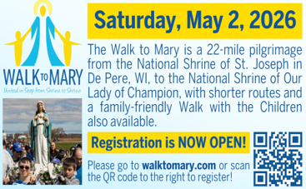

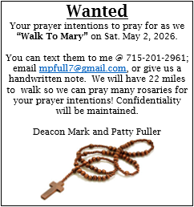
New Appointment:

Dear Parishioners of St. Michael,

God’s blessings to you this Easter Season!

Out of gratitude for the service that Father Hanz Borbor has provided to the Diocese of Green Bay and the communities of St. Anthony & St. Michael, I extend my heartfelt thanks and prayers as his ministry at St. Michael & St. Anthony concludes on June 30. I ask you to join me in expressing our thanks and keeping Father Hanz in your prayers.

It is Bishop Ricken’s intention to appoint Fr. Juan Tejerero Jr. to replace Father Hanz. Fr. Juan comes from the Diocese of Vicar, Philippines. He will begin serving at your parish on July 1, 2026.

Please know of my prayers for your parishes during this time of transition.

May the Holy Spirit bless and guide you and your families.

Sincerely in Christ,
Fr. Tom Long
Chair, Priest Personnel Board
EXTRAORDINARY MINISTER
OF HOLY COMMUNION &
LECTOR SCHEDULE

Saturday, April 18th, 5:00 p.m.
Lector: Kevin Culhane
Eucharistic Minister: Muffy Culhane
Sunday, April 19th, 9:00 a.m.
Lector: Jacquie Braun
Eucharistic Minister: Gloria Gierach
Saturday, April 25th, 5:00 p.m.
Lector: Rod Glauser
Eucharistic Minister: Deacon Mark
Sunday, April 26th, 9:00 a.m.
Lector: Jacquie Braun
Eucharistic Minister: Deacon Mark
Saturday, May 2nd, 5:00 p.m.
Lector: Terri Glauser
Eucharistic Minister: Karen Smart
Sunday, May 3rd, 9:00 a.m.
Lector: Ellie Sokoly
Eucharistic Minister: Anne Sulskis
Saturday, May 9th, 5:00 p.m.
Lector: Mary Lewellin
Eucharistic Minister: Jim Gilane
Sunday, May 10th, 9:00 a.m.
Lector: Ellie Sokoly
Eucharistic Minister: Anne Sulskis
Save the Dates:
- Saturday, April 25th 9:00 am – 12:00 pm Cemetery clean up, meet in church parking lot.
- Saturday, May 2nd 11:00 am Memorial Mass and lunch to follow for Patricia Gwidt.
- Sunday May 10th, Faith Formation hosts Mother’s Day coffee and donuts after Mass.
- Thursday, June 11th 5:00 pm Mass/22nd Anniversary of Father Hanz Ordination. Potluck dinner will follow Mass.
- Sunday, June 28th St. Michael’s Church Picnic 10:00 am.
- Monday, Tuesday & Wednesday, July 27th – 29th Charlie’s Red Barn Fundraiser 9:00 am – 5:00 pm.

St. Michael Parish

2026 Bishop’s Appeal Goal
This year’s goal is $7,664.00.
We have already received $8,150.00 in
donations. Thank you!
Pastoral Parish Council & Trustee Election
The Pastoral Parish Council has three terms opening in May. We are in need of a candidate for the Council to serve three-year term. There is one Church Trustee opening, a two-year term. There is also a Finance chair open for a three-year term. Please consider volunteering for one of these positions. Contact the Parish office if interested or want to learn more about these opportunities to serve St. Michael’s Parish.
Religious Education Coordinator
St. Michael’s is seeking an individual interested in being the Faith Formation/Religious Education Coordinator for 2026-27. This is a part time, salaried position for 8-15 hours per week from September through May. Job description and application are available in the Parish Office.


14109 County VV, Gillett, WI 54124


SUNDAY BRUNCH 9-12 PM.
CHICKEN DINNER ALL DAY.

Please pick up your pans, cookie sheets, and miscellaneous items left over from funerals and other church events in the Fr. Barrett Hall.
There will not be a Mass at St. Michael on Holy Saturday, March 26. Easter Vigil will be held at St. Francis in Gresham at 7 pm. Easter Sunday Mass will be at St. Michael and St. Anthony at 10:30 am.

Maintenance. Michael Catholic Parish in Keshena is seeking a part-time maintenance person. Responsible for light maintenance, cleaning the church, etc. Contact the parish office at telephone number 715-799-3811 for an application, and job.

Please pick up your pans, cookie sheets, and miscellaneous items left over from funerals and other church events in the Fr. Barrett Hall.
There will not be a Mass at St. Michael on Holy Saturday, March 26. Easter Vigil will be held at St. Francis in Gresham at 7 pm. Easter Sunday Mass will be at St. Michael and St. Anthony at 10:30 am.
PARISH STAFF
FR. HANZ CHRISTIAN BORBOR
Parish Administrator
Parish Office (715) 799-3811
xtian.borbor@gmail.com

DEACON MARK FULLER
(715) 201-2961
mpfull7@gmail.com

Parish Secretary
RICKIE DODGE
Parish Office (715) 799-3811
stmichaels@livingwaterslivingfaith.org

Faith Formation
JACKIE LANGHANS
Parish Office (715) 799-3811
jlanghans@att.net

PARISH TRUSTEES
KAREN SMART, Treasurer
VICKI HERMSEN, Secretary

Parish Council Chair
MARY LEWELLIN

Finance Council Chair
THERESE GLAUSER

Thrift N Gift Coordinator
COOKIE VIGUE

Food Pantry Coordinator

MASS SCHEDULE
Saturday: 5:00 pm Mass
4:30 pm Rosary & Confession
Sunday: 9:00 am Mass
8:30 am Rosary
Monday – Friday: No Mass

PARISH OFFICE HOURS
Regular hours: Wednesday - Thursday
9:00 am – 2:00 pm
Hours may vary, please call before coming to the office.
SATURDAY MASS: 5:00 pm
SUNDAY MASS: 9:00 am
CONFESSION: Saturday 4:30 - 4:45pm
ROSARY: Saturday 3:40 pm Sunday 8:35 am
DAILY MASS: Chapel Southside of Church

P Parish Administrator, Fr. Nonito Barra - 715-799-3811 - pastor@livingwaterslivingfaith.org
Rectory – 715-994-1337
Parochial Vicar Fr. Joel Jores - 715-787-3377 frj@livingwaterslivingfaith.org
Deacon Mark Fuller 715-201-2961- deaconmark@livingwaterslivingfaith.org
Parish Secretary, Vicki Hermsen - 715-799-3811 - vicki@livingwaterslivingfaith.org
Religious Education Kathy King-Tucker - 715-799-3927 – ltucker@frontiernet.netmailto:maczuzak@frontiernet.net
Wednesday 6 – 7:30 pm September – May
Parish Administrator, Fr. Nonito Barra - 715-799-3811 - pastor@livingwaterslivingfaith.org
Rectory – 715-994-1337
Parochial Vicar Fr. Joel Jores - 715-787-3377 frj@livingwaterslivingfaith.org
Deacon Mark Fuller 715-201-2961- deaconmark@livingwaterslivingfaith.org
Parish Secretary, Vicki Hermsen - 715-799-3811 - vicki@livingwaterslivingfaith.org
Religious Education Kathy King-Tucker - 715-799-3927 – ltucker@frontiernet.netmailto:maczuzak@frontiernet.net
Wednesday 6 – 7:30 pm September – May
Parish Administrator, Fr. Nonito Barra - 715-799-3811 - pastor@livingwaterslivingfaith.org
Rectory – 715-994-1337
Parochial Vicar Fr. Joel Jores - 715-787-3377 frj@livingwaterslivingfaith.org
Deacon Mark Fuller 715-201-2961- deaconmark@livingwaterslivingfaith.org
Parish Secretary, Vicki Hermsen - 715-799-3811 - vicki@livingwaterslivingfaith.org
Religious Education Kathy King-Tucker - 715-799-3927 – ltucker@frontiernet.netmailto:maczuzak@frontiernet.net
Wednesday 6 – 7:30 pm September – May

St. Michael’s Calendar
04/18/2026 Faith Formation 1st Communion
Retreat 9:00 – 11:30 am
04/20/2026 Office Closed
04/21/2026 Office Closed
04/21/2026 Thrift N Gift 11:00 am – 3:00 pm
04/21/2026 Food Pantry & Boos Share 12:30 - 3:00 pm
04/21/2026 Knights of Colombus meeting 7:00 pm
04/22/2026 Faith Formation & 1st Communion
Practice 6:00 – 7:00 pm
04/25/2026 Cemetery Clean up 9:00 am – 12:00 pm
MASS TIMES
St. Michael – Saturday: 5:00 pm, Sunday: 9:00 am
Monday - Friday: No Mass
St. Anthony – Sunday: 10:30 am

Book Share
Will be open Tuesday, April 21st from 12:30 – 3:00 pm. We have books for all ages! We will accept books in good shape, just no old magazines, text books or encyclopedias.

Food Pantry
Will be open Tuesday, April 21st from 12:30 - 3:00 pm. There will be drive up service only and food will be placed in your trunk. Please do not get out of your vehicle. Please save brown paper bags & plastic bags and please drop them off at the Parish office.

Thrift N Gift
Will be open Tuesday, April 21st from 11:00 am - 3:00 pm. We have an abundance of household items, clothes, and great gift items. Please reach out to Cookie if you need to, 920-216-9240.

We the Knights
We always ask God to bless our community members. If you or a family member need assistance to get to a doctor appointment, we may be able to help. Call Paul at 715-853-2414 or Todd 715-584-5885.

Kateri Prayer Circle
Never underestimate the power of prayer. Just one small prayer can change your life. If you or your family members need prayers for any reason, please call one of our Kateri Prayer Circle members, who will in turn call members of their group. Soon, many prayers will be offered for your specific prayer request. Please call:
Fay Waupochick: 715-799-3437
Jacqueline Braun: 715-701-4552
You can also call the Parish Office to leave a request.

Religious Education Calendar Up Coming Events:
Wednesday, November 30th –Classes Resume
Wednesday December 7th
Wednesday December 14th
Wednesday December 21st Birthday Party- Parents
Guardians invited
Wednesday December 28th No Class
Wednesday January 4th No Class
Wednesday January 11 Classes resume
April 19, 2026
3rd Sunday of Easter
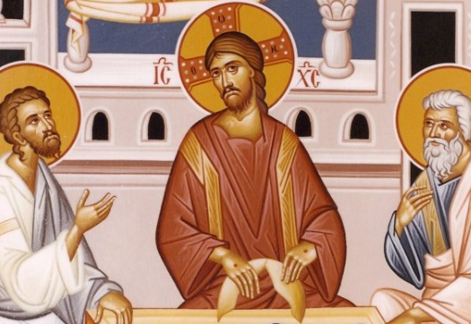
Anamehawikamek Welcome
ST. MICHAEL CATHOLIC CHURCH
PO Box 610, N816 State Highway 47-55,
Keshena, WI 54135 - Phone: 715-799-3811
Email: stmichaels@livingwaterslivingfaith.org
Website: stmichaelkeshena.com
Find us on Facebook: St. Michael’s Church

MISSION STATEMENT: St. Michael’s Christian Community, located on the Menominee Indian Reservation, is a diverse Christian community reaching out to all residents, learning, loving, sharing, and communicating with one another through the teachings and practices celebrated in the Mass & the Holy Sacraments of the Catholic Church by integrating sacred symbols and spiritual practices of the Menominee.
KNIGHTS OF COLUMBUS: Contact Grand Knight Paul Marroquin 715-853-2414.
HOLY HOUR: Every Friday after 8:00 am Mass.
ANOINTING OF THE SICK: Individual arrangements can be made through the Parish Office.
BAPTISM: Kindly contact parish office.
MARRIAGE: Make arrangements with the Priest, six months prior to desired date.
CONFIRMATION: Contact Deacon Mark Fuller for information via email mpfull7@gmail.com.

