Bulletin Note
Fr. John Muir Gospel Reflection (6.28.26)
I still remember the first homily I ever preached as a new deacon. It was at the seminary, and the Gospel was this one: “Whoever loves father or mother more than me is not worthy of me.” (Matthew 10:37-38) Standing before more than 200 classmates and professors, I stumbled awkwardly through my words and realized how strange — almost insane — this teaching sounded. If anyone else said it, we would call it narcissistic or cultish. And that is the point. I felt the weight of those words in my own heart then, as I still do today. Am I willing to live as though Christ’s claim on my love is absolute? Are you? Over the years, I’ve learned that the more I do, the more everything else makes sense. Family, friendships, vocation, even my very self: all of it falls into place when my love for Jesus comes first. That is why he dares to speak this way. Our Lord is not a cult leader hungry for control. He is the Son of God, the source of life and love itself. To put him before everything else is not to lose, but to find…everything, and everyone, in him. This week, name one thing or one person you are tempted to place before the Lord. Then consciously offer it back to him in prayer.
— Father John Muir

MASS SCHEDULE &
INTENTIONS
06/27-5:00 pm…………….Katie Culhane
06/28-9:00 am…………….Phyllis & Dewayne
Stiefvater
06/29……………….……….No Mass
06/30……………….……….No Mass
07/01……………….……….No Mass
07/02……………….……….No Mass
07/03……………….……….No Mass
Financial Blessings
June 20th & 21st
We are in need of Weekday Mass intentions. Mass intentions are $20.00 per Mass.
Envelope/Contributors | $2048.00
Loose Collection | $710.00
Thank you for supporting our Parish!
Adult Confirmation News:
Deacon Mark is in the planning stages for an Adult Confirmation Class at St. Michael's starting this Fall. If you are interested in registering or just want some general information about the class, please contact Deacon Mark at the office number 715-799-3811 or by email mpfull7@gmail.com.
St. Michael Food Pantry
News:
Each month we hold a second collection for our Food Pantry. We continue to see a rising need in the community for food. Our pantry is funded through those donations, grants, and memorials. We are open twice monthly with clients allowed one visit per month. In 2025 our monthly average served 86 households with 351 individuals in these homes. We average serving 56 seniors, 156 adults and 140 children each month. 2026 continues to see an increasing need for food with rising food and fuel prices. Your donations help us purchase food for distribution and help sustain the mission of our St. Michael Food Pantry. The pantry is staffed totally by volunteers from the parish and community. Thank you for your generosity.
Before her passing, Pat Gwidt, our food pantry coordinator, worked on an Augustine Fellowship Fund grant for the purpose of a container gardening project for our food pantry recipients. We were awarded the grant which enabled us to provide 94 households with all the supplies needed, including plants and seeds, to container garden 5 different vegetables. Our recipients were excited and grateful for this project.



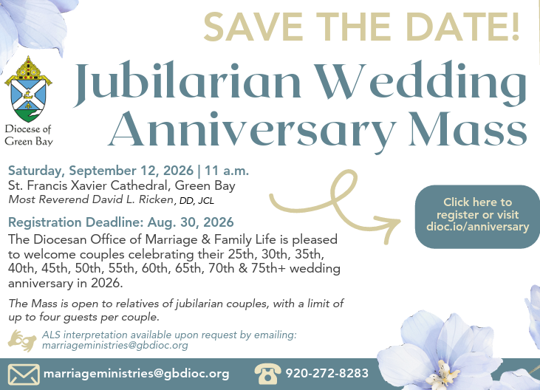

EXTRAORDINARY MINISTER
OF HOLY COMMUNION &
LECTOR SCHEDULE

Saturday, June 27th, 5:00 p.m.
Lector: Muffy Culhane
Eucharistic Minister: Kevin Culhane
Sunday, June 28th, 9:00 a.m.
Lector: Ellie Sokoly
Eucharistic Minister: Ellie Sokoly
Saturday, July 4th, 5:00 p.m.
Lector: Mary Lewellin
Eucharistic Minister: Deacon Mark
Sunday, July 5th, 9:00 a.m.
Lector: Jacquie Braun
Eucharistic Minister: Deacon Mark
Saturday, July 11th, 5:00 p.m.
Lector: Rod Glauser
Eucharistic Minister: Karen Smart
Sunday, July 12th, 9:00 a.m.
Lector: Ellie Sokoly
Eucharistic Minister: Gloria Gierach
Saturday, July 18th, 5:00 p.m.
Lector: Terri Glauser
Eucharistic Minister: Deacon Mark
Sunday, July 19th, 9:00 a.m.
Lector: Jacquie Braun
Eucharistic Minister: Deacon Mark
Saturday, July 25th, 5:00 p.m.
Lector: Larry Sikowski
Eucharistic Minister: Jim Gilane
Sunday, July 26th, 9:00 a.m.
Lector: Ellie Sokoly
Eucharistic Minister: Anne Sulskis
Save the Dates:
- Monday, Tuesday & Wednesday, July 27th – 29th Charlie’s Red Barn Fundraiser 9:00 am – 5:00 pm.

St. Michael Parish
God’s Garden
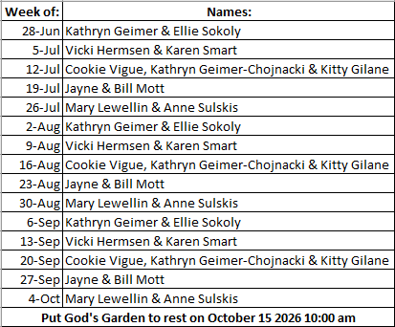



14109 County VV, Gillett, WI 54124


SUNDAY BRUNCH 9-12 PM.
CHICKEN DINNER ALL DAY.

Please pick up your pans, cookie sheets, and miscellaneous items left over from funerals and other church events in the Fr. Barrett Hall.
There will not be a Mass at St. Michael on Holy Saturday, March 26. Easter Vigil will be held at St. Francis in Gresham at 7 pm. Easter Sunday Mass will be at St. Michael and St. Anthony at 10:30 am.

Maintenance. Michael Catholic Parish in Keshena is seeking a part-time maintenance person. Responsible for light maintenance, cleaning the church, etc. Contact the parish office at telephone number 715-799-3811 for an application, and job.

Please pick up your pans, cookie sheets, and miscellaneous items left over from funerals and other church events in the Fr. Barrett Hall.
There will not be a Mass at St. Michael on Holy Saturday, March 26. Easter Vigil will be held at St. Francis in Gresham at 7 pm. Easter Sunday Mass will be at St. Michael and St. Anthony at 10:30 am.
PARISH STAFF
DEACON MARK FULLER
(715) 201-2961
mpfull7@gmail.com

Parish Secretary
RICKIE DODGE
Parish Office (715) 799-3811
office@stmichaelkeshena.org

Faith Formation
Parish Office (715) 799-3811


PARISH TRUSTEES
KAREN SMART, Treasurer
VICKI HERMSEN, Secretary

Parish Council Chair
MARY LEWELLIN

Finance Council Chair
THERESE GLAUSER

Thrift N Gift Coordinator
COOKIE VIGUE

Food Pantry Coordinator

MASS SCHEDULE
Saturday: 5:00 pm Mass
4:30 pm Rosary & Confession
Sunday: 9:00 am Mass
8:30 am Rosary
Monday – Friday: No Mass

PARISH OFFICE HOURS
Regular hours: Monday - Thursday
9:00 am – 2:00 pm
Hours may vary, please call before coming to the office.
SATURDAY MASS: 5:00 pm
SUNDAY MASS: 9:00 am
CONFESSION: Saturday 4:30 - 4:45pm
ROSARY: Saturday 3:40 pm Sunday 8:35 am
DAILY MASS: Chapel Southside of Church

P Parish Administrator, Fr. Nonito Barra - 715-799-3811 - pastor@livingwaterslivingfaith.org
Rectory – 715-994-1337
Parochial Vicar Fr. Joel Jores - 715-787-3377 frj@livingwaterslivingfaith.org
Deacon Mark Fuller 715-201-2961- deaconmark@livingwaterslivingfaith.org
Parish Secretary, Vicki Hermsen - 715-799-3811 - vicki@livingwaterslivingfaith.org
Religious Education Kathy King-Tucker - 715-799-3927 – ltucker@frontiernet.netmailto:maczuzak@frontiernet.net
Wednesday 6 – 7:30 pm September – May
Parish Administrator, Fr. Nonito Barra - 715-799-3811 - pastor@livingwaterslivingfaith.org
Rectory – 715-994-1337
Parochial Vicar Fr. Joel Jores - 715-787-3377 frj@livingwaterslivingfaith.org
Deacon Mark Fuller 715-201-2961- deaconmark@livingwaterslivingfaith.org
Parish Secretary, Vicki Hermsen - 715-799-3811 - vicki@livingwaterslivingfaith.org
Religious Education Kathy King-Tucker - 715-799-3927 – ltucker@frontiernet.netmailto:maczuzak@frontiernet.net
Wednesday 6 – 7:30 pm September – May
Parish Administrator, Fr. Nonito Barra - 715-799-3811 - pastor@livingwaterslivingfaith.org
Rectory – 715-994-1337
Parochial Vicar Fr. Joel Jores - 715-787-3377 frj@livingwaterslivingfaith.org
Deacon Mark Fuller 715-201-2961- deaconmark@livingwaterslivingfaith.org
Parish Secretary, Vicki Hermsen - 715-799-3811 - vicki@livingwaterslivingfaith.org
Religious Education Kathy King-Tucker - 715-799-3927 – ltucker@frontiernet.netmailto:maczuzak@frontiernet.net
Wednesday 6 – 7:30 pm September – May

St. Michael’s Calendar
06/27/2026 MCP Appeal 2nd Collection
06/28/2026 MCP Appeal 2nd Collection
06/28/2026 Parish Annual Picnic 10:00 am - 3:00 pm
07/02/2026 Office Closed (Independence Day Holiday)
07/04/2026 Prayer Ministry after Mass
07/05/2026 Prayer Ministry after Mass

MASS TIMES
St. Michael – Saturday: 5:00 pm, Sunday: 9:00 am
Monday - Friday: No Mass
St. Anthony – Sunday: 10:30 am

Book Share
Will be open Tuesday July 7th from 12:30 – 3:00 pm. We have books for all ages! We will accept books in good shape, just no old magazines, text books or encyclopedias.

Food Pantry
Will be open Tuesday, July 7th from 12:30 - 3:00 pm. There will be drive up service only and food will be placed in your trunk. Please do not get out of your vehicle. Please save brown paper bags & plastic bags and please drop them off at the Parish office.

Thrift N Gift
Will be open Tuesday, July 7th from 11:00 am - 3:00 pm. We have an abundance of household items, clothes, and great gift items. Please reach out to Cookie if you need to, 920-216-9240.

We the Knights
We always ask God to bless our community members. If you or a family member need assistance to get to a doctor appointment, we may be able to help. Call Paul at 715-853-2414 or Todd 715-584-5885.

Kateri Prayer Circle
Never underestimate the power of prayer. Just one small prayer can change your life. If you or your family members need prayers for any reason, please call one of our Kateri Prayer Circle members, who will in turn call members of their group. Soon, many prayers will be offered for your specific prayer request. Please call:

Fay Waupochick: 715-799-3437
Jacqueline Braun: 715-701-4552

You can also call the Parish Office to leave a request.

Religious Education Calendar Up Coming Events:
Wednesday, November 30th –Classes Resume
Wednesday December 7th
Wednesday December 14th
Wednesday December 21st Birthday Party- Parents
Guardians invited
Wednesday December 28th No Class
Wednesday January 4th No Class
Wednesday January 11 Classes resume
June 28th, 2026
13th Sunday in Ordinary Time
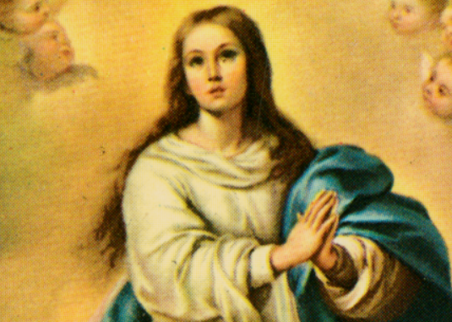
Anamehawikamek Welcome
ST. MICHAEL CATHOLIC CHURCH
PO Box 610, N816 State Highway 47-55,
Keshena, WI 54135 - Phone: 715-799-3811
Email: office@stmichaelkeshena.org
Website: stmichaelkeshena.com
Find us on Facebook: St. Michael’s Church

MISSION STATEMENT: St. Michael’s Christian Community, located on the Menominee Indian Reservation, is a diverse Christian community reaching out to all residents, learning, loving, sharing, and communicating with one another through the teachings and practices celebrated in the Mass & the Holy Sacraments of the Catholic Church by integrating sacred symbols and spiritual practices of the Menominee.
KNIGHTS OF COLUMBUS: Contact Grand Knight Paul Marroquin 715-853-2414.
HOLY HOUR: Every Friday after 8:00 am Mass.
ANOINTING OF THE SICK: Individual arrangements can be made through the Parish Office.
BAPTISM: Kindly contact parish office.
MARRIAGE: Make arrangements with the Priest, six months prior to desired date.
CONFIRMATION: Contact Deacon Mark Fuller for information via email mpfull7@gmail.com.

