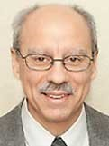 A Note from Deacon Mark
Last Sunday, my wife and I, along with another friend, traveled to Our Lady of Champion Shrine to view the exhibit, “Catholic Saints of America,” an exhibit honoring the holy men and women who helped shape America. The exhibit brought awareness to the Saints, Blesseds, Venerables, and Servants of God who lived and served in the USA. In addition to the exhibits, there were also information tables staffed by men and women who are actively promoting the cause of an individual to someday be recognized as a saint. Yes, we read about great missionaries and martyrs but ordinary people were also on the same path to sainthood. One such ordinary person was a 12-year-old girl named Charlene Richard. A Catholic Cajun girl from Louisiana, whose acceptance of suffering and reported miracles after her death earned her the title “Little Cajun Saint.” Diagnosed with leukemia at 12 in 1959, she embraced redemptive suffering, praying for others until her death. Now a Servant of God, her cause for canonization is underway, and her grave draws thousands who seek her intercession. Just an ordinary kid who learned how to love in an extraordinary way. Everyone in this exhibit of “Catholic Saints of America” were those seeds that grew in good soil. They heard the word of God, understood it, and bore fruit. We are all called to become saints and bear fruit that gives glory to God. We don’t have to live in a convent or monastery to do this or travel across the sea. Just love God and love one’s neighbor with all one’s heart, wherever we find ourselves. I think the other part of holiness is trusting God in all things. That all things will one day work to the good even if we do not see it now. I encourage you to pick a saint, blessed, venerable or servant of God, asking them to pray for you and your intentions, and let yourself be inspired by their lives. For a list of who these holy men and women are, Google “Saints of America, Our Lady of Champion Shrine.”
In His mercy, Deacon Mark
MASS SCHEDULE &
INTENTIONS
07/11-5:00 pm…………….Jim & Joleen
Kaquatosh & Kinsey
07/12-9:00 am…………….Richard A Moses Sr.
07/13………………………..No Mass
07/14-8:00 am…………….For families dealing
with cancer
07/15-8:00 am…………….Retired Religious
07/16-8:00 am…………….For leaders in this
community
07/17-8:00 am…………….For those who suffer
with temptation
07/18-5:00 pm…………….Roger Dodge &
Sandra Dodge King
07/19-9:00 am…………….Lewellin Vigue
Families

Financial Blessings
July 4th & 5th

We are in need of Weekday Mass intentions. Mass intentions are $20.00 per Mass.

Envelope/Contributors | $2111.00
Loose Collection | $1025.00
Thank you for supporting our Parish!

Adult Confirmation News:
Deacon Mark is in the planning stages for an Adult Confirmation Class at St. Michael's starting this Fall. If you are interested in registering or just want some general information about the class, please contact Deacon Mark at the office number 715-799-3811 or by email mpfull7@gmail.com.

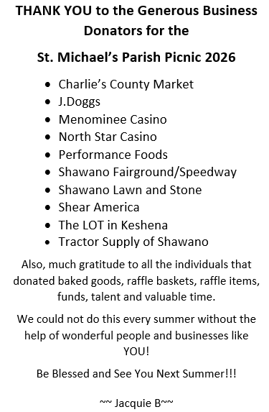

Charlies Red Barn Fundraiser:
Now to focus on our Charlie’s Red Barn Days! We will be serving up brats, hot dogs, cheddar wurst, and hamburgers along with soda and water at the Red Barn on July 27th, July 28th and July 29th! We need volunteers to sell and grill, between 9 AM when we will get everything ready to start selling by 10:00 AM till 4:30 or 5:00 PM depending on the weather. Find the sign-up sheets for all three days at the main entrance to church. Kids 12 and over are welcome to help with an adult.

EXTRAORDINARY MINISTER
OF HOLY COMMUNION &
LECTOR SCHEDULE

Saturday, July 11th, 5:00 p.m.
Lector: Rod Glauser
Eucharistic Minister: Jim Gilane
Sunday, July 12th, 9:00 a.m.
Lector: Ellie Sokoly
Eucharistic Minister: Gloria Gierach
Saturday, July 18th, 5:00 p.m.
Lector: Terri Glauser
Eucharistic Minister: Deacon Mark
Sunday, July 19th, 9:00 a.m.
Lector: Jacquie Braun
Eucharistic Minister: Deacon Mark
Saturday, July 25th, 5:00 p.m.
Lector: Larry Sikowski
Eucharistic Minister: Jim Gilane
Sunday, July 26th, 9:00 a.m.
Lector: Ellie Sokoly
Eucharistic Minister: Anne Sulskis
Save the Dates:
- Monday, Tuesday & Wednesday, July 27th – 29th Charlie’s Red Barn Fundraiser 9:00 am – 5:00 pm.

Please welcome our new priest Father Juan who comes to us from the Philippines.

St. Michael Parish
God’s Garden
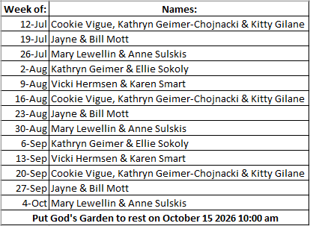



14109 County VV, Gillett, WI 54124


SUNDAY BRUNCH 9-12 PM.
CHICKEN DINNER ALL DAY.

Please pick up your pans, cookie sheets, and miscellaneous items left over from funerals and other church events in the Fr. Barrett Hall.
There will not be a Mass at St. Michael on Holy Saturday, March 26. Easter Vigil will be held at St. Francis in Gresham at 7 pm. Easter Sunday Mass will be at St. Michael and St. Anthony at 10:30 am.

Maintenance. Michael Catholic Parish in Keshena is seeking a part-time maintenance person. Responsible for light maintenance, cleaning the church, etc. Contact the parish office at telephone number 715-799-3811 for an application, and job.

Please pick up your pans, cookie sheets, and miscellaneous items left over from funerals and other church events in the Fr. Barrett Hall.
There will not be a Mass at St. Michael on Holy Saturday, March 26. Easter Vigil will be held at St. Francis in Gresham at 7 pm. Easter Sunday Mass will be at St. Michael and St. Anthony at 10:30 am.
PARISH STAFF
Parish Administrator
FR. JUAN TEJERERO JR.
Parish Office (715) 799-3811
father@stmichaelkeshena.org

DEACON MARK FULLER
(715) 201-2961
mpfull7@gmail.com

Parish Secretary
RICKIE DODGE
Parish Office (715) 799-3811
office@stmichaelkeshena.org

Faith Formation
PATTI FULLER
Parish Office (715) 799-3811
Mpfull7@gmail.com


PARISH TRUSTEES
KAREN SMART, Treasurer
VICKI HERMSEN, Secretary

Parish Council Chair
MARY LEWELLIN

Finance Council Chair
THERESE GLAUSER

Thrift N Gift Coordinator
COOKIE VIGUE

Food Pantry Coordinator

MASS SCHEDULE
Saturday: 5:00 pm Mass
4:30 pm Rosary & Confession
Sunday: 9:00 am Mass
8:30 am Rosary
Monday: No Mass Tuesday – Friday: 8:00 am Mass

PARISH OFFICE HOURS
Regular hours: Monday - Thursday
9:00 am – 2:00 pm
Hours may vary, please call before coming to the office.
SATURDAY MASS: 5:00 pm
SUNDAY MASS: 9:00 am
CONFESSION: Saturday 4:30 - 4:45pm
ROSARY: Saturday 3:40 pm Sunday 8:35 am
DAILY MASS: Chapel Southside of Church

P Parish Administrator, Fr. Nonito Barra - 715-799-3811 - pastor@livingwaterslivingfaith.org
Rectory – 715-994-1337
Parochial Vicar Fr. Joel Jores - 715-787-3377 frj@livingwaterslivingfaith.org
Deacon Mark Fuller 715-201-2961- deaconmark@livingwaterslivingfaith.org
Parish Secretary, Vicki Hermsen - 715-799-3811 - vicki@livingwaterslivingfaith.org
Religious Education Kathy King-Tucker - 715-799-3927 – ltucker@frontiernet.netmailto:maczuzak@frontiernet.net
Wednesday 6 – 7:30 pm September – May
Parish Administrator, Fr. Nonito Barra - 715-799-3811 - pastor@livingwaterslivingfaith.org
Rectory – 715-994-1337
Parochial Vicar Fr. Joel Jores - 715-787-3377 frj@livingwaterslivingfaith.org
Deacon Mark Fuller 715-201-2961- deaconmark@livingwaterslivingfaith.org
Parish Secretary, Vicki Hermsen - 715-799-3811 - vicki@livingwaterslivingfaith.org
Religious Education Kathy King-Tucker - 715-799-3927 – ltucker@frontiernet.netmailto:maczuzak@frontiernet.net
Wednesday 6 – 7:30 pm September – May
Parish Administrator, Fr. Nonito Barra - 715-799-3811 - pastor@livingwaterslivingfaith.org
Rectory – 715-994-1337
Parochial Vicar Fr. Joel Jores - 715-787-3377 frj@livingwaterslivingfaith.org
Deacon Mark Fuller 715-201-2961- deaconmark@livingwaterslivingfaith.org
Parish Secretary, Vicki Hermsen - 715-799-3811 - vicki@livingwaterslivingfaith.org
Religious Education Kathy King-Tucker - 715-799-3927 – ltucker@frontiernet.netmailto:maczuzak@frontiernet.net
Wednesday 6 – 7:30 pm September – May

St. Michael’s Calendar
07/11/2026 FP 2nd Collection
07/12/2026 FP 2nd Collection
07/17/2026 Holy Hour after Mass
07/18/2026 Prayer Ministry after Mass
07/19/2026 Prayer Ministry after Mass
07/27/2026 Charlies Red Barn 9:00 am – 5:00 pm
07/28/2026 Charlies Red Barn 9:00 am – 5:00 pm
07/29/2026 Charlies Red Barn 9:00 am – 5:00 pm
MASS TIMES
St. Michael – Saturday: 5:00 pm, Sunday: 9:00 am
Monday: No Mass Tuesday - Friday: 8:00 am Mass
St. Anthony – Sunday: 10:30 am

Book Share
Will be open Tuesday July 21st from 12:30 – 3:00 pm. We have books for all ages! We will accept books in good shape, just no old magazines, text books or encyclopedias.

Food Pantry
Will be open Tuesday, July 21st from 12:30 - 3:00 pm. There will be drive up service only and food will be placed in your trunk. Please do not get out of your vehicle. Please save brown paper bags & plastic bags and please drop them off at the Parish office.

Thrift N Gift
Will be open Tuesday, July 21st from 11:00 am - 3:00 pm. We have an abundance of household items, clothes, and great gift items. Please reach out to Cookie if you need to, 920-216-9240.

We the Knights
We always ask God to bless our community members. If you or a family member need assistance to get to a doctor appointment, we may be able to help. Call Paul at 715-853-2414 or Todd 715-584-5885.

Kateri Prayer Circle
Never underestimate the power of prayer. Just one small prayer can change your life. If you or your family members need prayers for any reason, please call one of our Kateri Prayer Circle members, who will in turn call members of their group. Soon, many prayers will be offered for your specific prayer request. Please call:

Fay Waupochick: 715-799-3437
Jacqueline Braun: 715-701-4552

You can also call the Parish Office to leave a request.

Religious Education Calendar Up Coming Events:
Wednesday, November 30th –Classes Resume
Wednesday December 7th
Wednesday December 14th
Wednesday December 21st Birthday Party- Parents
Guardians invited
Wednesday December 28th No Class
Wednesday January 4th No Class
Wednesday January 11 Classes resume
July 12th, 2026
15th Sunday in Ordinary Time
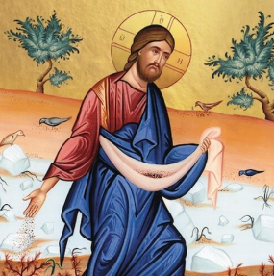
Anamehawikamek Welcome
ST. MICHAEL CATHOLIC CHURCH
PO Box 610, N816 State Highway 47-55,
Keshena, WI 54135 - Phone: 715-799-3811
Email: office@stmichaelkeshena.org
Website: stmichaelkeshena.com
Find us on Facebook: St. Michael’s Church

MISSION STATEMENT: St. Michael’s Christian Community, located on the Menominee Indian Reservation, is a diverse Christian community reaching out to all residents, learning, loving, sharing, and communicating with one another through the teachings and practices celebrated in the Mass & the Holy Sacraments of the Catholic Church by integrating sacred symbols and spiritual practices of the Menominee.
KNIGHTS OF COLUMBUS: Contact Grand Knight Paul Marroquin 715-853-2414.
HOLY HOUR: Every Friday after 8:00 am Mass.
ANOINTING OF THE SICK: Individual arrangements can be made through the Parish Office.
BAPTISM: Kindly contact parish office.
MARRIAGE: Make arrangements with the Priest, six months prior to desired date.
CONFIRMATION: Contact Deacon Mark Fuller for information via email mpfull7@gmail.com.

