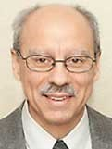 A Note from Deacon Mark
Fr. John Muir’s Gospel Reflection (7.26.26)
Around the time that the gold rushes ended in the nineteenth-century West, a curious phenomenon arose in New England known as money diggers. These were men who roamed the countryside with shovels, divining rods, and superstitious hope, convinced that treasure lay buried beneath their feet. Surely there must be gold under our feet. But there was not. The craze of these wild goose chases caused many to lose farms, families, and sanity. In this week’s Gospel, Jesus inaugurates a new era of spiritual money digging. He announces, “The kingdom of heaven is like a treasure buried in a field.” He invites us to become treasure seekers who search in the right place. What is of greatest value is not money beneath our feet, but the infinite treasure hidden deep in the humanity of Jesus himself, God’s own blessed life. The glory of heaven lies veiled in his ordinary life, his teaching, his suffering, his Church. This teaching about the Kingdom changes things. Now we see the Church’s doctrinal and moral teachings are not arbitrary rules. They are a treasure map. Follow them, and we will uncover divine happiness. Ignore them, and we will wander aimlessly, spade in hand, digging in empty fields, discouraged. Where have we wasted energy seeking treasure in the wrong places? How have we given up on seeking the treasure of truly finding God’s love for us? If so, let us repent of both. Then let us dust off our shovels and get back to digging deep into the field of Christ Jesus and his Church. After all, He never ceases seeking his treasure in us.
Upon Further Reflection:
Our first reading today tells us about Solomon’s desire for wisdom. I thought it might be worthwhile to share some wisdom from children.
Patrick, age 10, said, “Never trust a dog to watch your food.”
Michael, 14, said, “When your dad is mad and asks you, "Do I look stupid?" don’t answer him.”
Michael said, “Never tell your mom her diet’s not working.”
Susie, age 9, said, “Never hold a dust buster and a cat at the same time.”
Naomi, 15 said, “If you want a kitten, start out by asking for a horse.”
Lauren, age 9 said, “Felt markers are not good to use as lipstick.”
Joel, 10 years old, said, “Don’t pick on your sister when she’s holding a baseball bat.”
Eileen, age 8 said, “Never try to baptize a cat.”
In His Mercy, Deacon Mark
MASS SCHEDULE &
INTENTIONS
07/25-5:00 pm…………….Kim Nacotee
07/26-9:00 am…………….Sandy Powers
07/27………………………..No Mass
07/28-8:00 am…………….The homeless
07/29-8:00 am…………….For peace in holy
land
07/30-8:00 am…………….For all expectant
parents
07/31-8:00 am…………….Tribal Elders
08/01-5:00 pm…………….Judy Blochowicz
08/02-9:00 am…………….Mary Kuester
Kemmeter
Financial Blessings
July 18th & 19th

We are in need of Weekday Mass intentions. Mass intentions are $20.00 per Mass.

Envelope/Contributors | $1233.00
Loose Collection | $538.00
Thank you for supporting our Parish!

Adult Confirmation News:
Deacon Mark is in the planning stages for an Adult Confirmation Class at St. Michael's starting this Fall. If you are interested in registering or just want some general information about the class, please contact Deacon Mark at the office number 715-799-3811 or by email mpfull7@gmail.com.

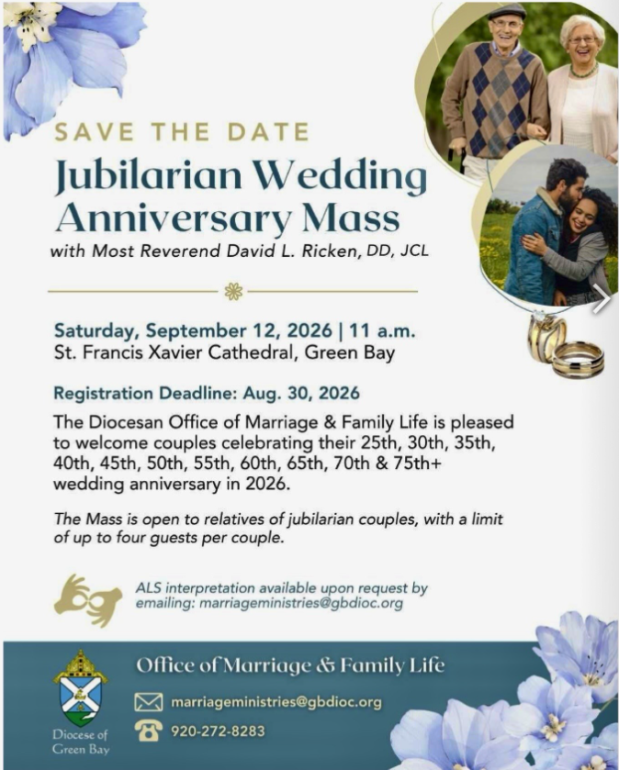

Charlies Red Barn Fundraiser:
Help Needed! We are still in need of several Grillers as well as mainly late afternoon shift volunteers! Please consider signing up one of the three days! We can't make this successful without volunteers. The late shift time finishing will vary as to business along with weather so we could be finished by 4:30, 5:00 one or more of the days.
EXTRAORDINARY MINISTER
OF HOLY COMMUNION &
LECTOR SCHEDULE

Saturday, July 25th, 5:00 p.m.
Lector: Larry Sikowski
Eucharistic Minister: Jim Gilane
Sunday, July 26th, 9:00 a.m.
Lector: Ellie Sokoly
Eucharistic Minister: Anne Sulskis
Saturday, August 1st, 5:00 p.m.
Lector: Kevin Culhane
Eucharistic Minister: Deacon Mark
Sunday, August 2nd, 9:00 a.m.
Lector: Ellie Sokoly
Eucharistic Minister: Deacon Mark
Saturday, August 8th, 5:00 p.m.
Lector: Muffy Culhane
Eucharistic Minister: Kevin Culhane
Sunday, August 9th, 9:00 a.m.
Lector: Anne Sulskis
Eucharistic Minister: Vicki Hermsen
Saturday, August 15th, 5:00 p.m.
Lector: Rod Glauser
Eucharistic Minister: Karen Smart
Sunday, August 16th, 9:00 a.m.
Lector: Jacquie Braun
Eucharistic Minister: Anne Sulskis
Saturday, August 22nd, 5:00 p.m.
Lector: Mary Lewellin
Eucharistic Minister: Deacon Mark
Sunday, August 23rd, 9:00 a.m.
Lector: Ellie Sokoly
Eucharistic Minister: Deacon Mark
Save the Dates:
- Monday, Tuesday & Wednesday, July 27th – 29th Charlie’s Red Barn Fundraiser 9:00 am – 5:00 pm.

St. Michael Parish
July Food Pantry Report
We served 91 families with 399 members in their households this month. The food pantry is in need of plastic and paper grocery bags. Donations of shampoo, body wash, bar soap and paper towel are greatly appreciated. The container is located in the main entrance of church.
God’s Garden
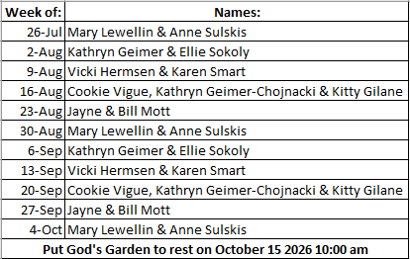



14109 County VV, Gillett, WI 54124


SUNDAY BRUNCH 9-12 PM.
CHICKEN DINNER ALL DAY.

Please pick up your pans, cookie sheets, and miscellaneous items left over from funerals and other church events in the Fr. Barrett Hall.
There will not be a Mass at St. Michael on Holy Saturday, March 26. Easter Vigil will be held at St. Francis in Gresham at 7 pm. Easter Sunday Mass will be at St. Michael and St. Anthony at 10:30 am.

Maintenance. Michael Catholic Parish in Keshena is seeking a part-time maintenance person. Responsible for light maintenance, cleaning the church, etc. Contact the parish office at telephone number 715-799-3811 for an application, and job.

Please pick up your pans, cookie sheets, and miscellaneous items left over from funerals and other church events in the Fr. Barrett Hall.
There will not be a Mass at St. Michael on Holy Saturday, March 26. Easter Vigil will be held at St. Francis in Gresham at 7 pm. Easter Sunday Mass will be at St. Michael and St. Anthony at 10:30 am.
PARISH STAFF
Parish Administrator
FR. JUAN TEJERERO JR.
Parish Office (715) 799-3811
father@stmichaelkeshena.org

DEACON MARK FULLER
(715) 201-2961
mpfull7@gmail.com

Parish Secretary
RICKIE DODGE
Parish Office (715) 799-3811
office@stmichaelkeshena.org

Faith Formation
PATTI FULLER
Parish Office (715) 799-3811
Mpfull7@gmail.com


PARISH TRUSTEES
KAREN SMART, Treasurer
VICKI HERMSEN, Secretary

Parish Council Chair
MARY LEWELLIN

Finance Council Chair
THERESE GLAUSER

Thrift N Gift Coordinator
COOKIE VIGUE

Food Pantry Coordinator

MASS SCHEDULE
Saturday: 5:00 pm Mass
4:30 pm Rosary & Confession
Sunday: 9:00 am Mass
8:30 am Rosary
Monday: No Mass Tuesday – Friday: 8:00 am Mass

PARISH OFFICE HOURS
Regular hours: Monday - Thursday
9:00 am – 2:00 pm
Hours may vary, please call before coming to the office.
SATURDAY MASS: 5:00 pm
SUNDAY MASS: 9:00 am
CONFESSION: Saturday 4:30 - 4:45pm
ROSARY: Saturday 3:40 pm Sunday 8:35 am
DAILY MASS: Chapel Southside of Church

P Parish Administrator, Fr. Nonito Barra - 715-799-3811 - pastor@livingwaterslivingfaith.org
Rectory – 715-994-1337
Parochial Vicar Fr. Joel Jores - 715-787-3377 frj@livingwaterslivingfaith.org
Deacon Mark Fuller 715-201-2961- deaconmark@livingwaterslivingfaith.org
Parish Secretary, Vicki Hermsen - 715-799-3811 - vicki@livingwaterslivingfaith.org
Religious Education Kathy King-Tucker - 715-799-3927 – ltucker@frontiernet.netmailto:maczuzak@frontiernet.net
Wednesday 6 – 7:30 pm September – May
Parish Administrator, Fr. Nonito Barra - 715-799-3811 - pastor@livingwaterslivingfaith.org
Rectory – 715-994-1337
Parochial Vicar Fr. Joel Jores - 715-787-3377 frj@livingwaterslivingfaith.org
Deacon Mark Fuller 715-201-2961- deaconmark@livingwaterslivingfaith.org
Parish Secretary, Vicki Hermsen - 715-799-3811 - vicki@livingwaterslivingfaith.org
Religious Education Kathy King-Tucker - 715-799-3927 – ltucker@frontiernet.netmailto:maczuzak@frontiernet.net
Wednesday 6 – 7:30 pm September – May
Parish Administrator, Fr. Nonito Barra - 715-799-3811 - pastor@livingwaterslivingfaith.org
Rectory – 715-994-1337
Parochial Vicar Fr. Joel Jores - 715-787-3377 frj@livingwaterslivingfaith.org
Deacon Mark Fuller 715-201-2961- deaconmark@livingwaterslivingfaith.org
Parish Secretary, Vicki Hermsen - 715-799-3811 - vicki@livingwaterslivingfaith.org
Religious Education Kathy King-Tucker - 715-799-3927 – ltucker@frontiernet.netmailto:maczuzak@frontiernet.net
Wednesday 6 – 7:30 pm September – May

St. Michael’s Calendar
07/25/2026 Building & Grounds 2nd Collection
07/26/2026 Building & Grounds 2nd Collection
07/27/2026 Charlies Red Barn 9:00 am – 5:00 pm
07/28/2026 Charlies Red Barn 9:00 am – 5:00 pm
07/28/2026 Shawano United Way Dinner 5:30 pm
07/28/2026 Pastoral Parish Council meeting 6:00 pm
07/29/2026 Charlies Red Barn 9:00 am – 5:00 pm
07/31/2026 Holy Hour after Mass
MASS TIMES
St. Michael – Saturday: 5:00 pm, Sunday: 9:00 am
Monday: No Mass Tuesday - Friday: 8:00 am Mass
St. Anthony – Sunday: 10:30 am

Book Share
Will be open Tuesday August 4th from 12:30 – 3:00 pm. We have books for all ages! We will accept books in good shape, just no old magazines, text books or encyclopedias.

Food Pantry
Will be open Tuesday, August 4th from 12:30 - 3:00 pm. There will be drive up service only and food will be placed in your trunk. Please do not get out of your vehicle. Please save brown paper bags & plastic bags and please drop them off at the Parish office.

Thrift N Gift
Will be open Tuesday, August 4th from 11:00 am - 3:00 pm. We have an abundance of household items, clothes, and great gift items. Please reach out to Cookie if you need to, 920-216-9240.

We the Knights
We always ask God to bless our community members. If you or a family member need assistance to get to a doctor appointment, we may be able to help. Call Paul at 715-853-2414 or Todd 715-584-5885.

Kateri Prayer Circle
Never underestimate the power of prayer. Just one small prayer can change your life. If you or your family members need prayers for any reason, please call one of our Kateri Prayer Circle members, who will in turn call members of their group. Soon, many prayers will be offered for your specific prayer request. Please call:
Fay Waupochick: 715-799-3437
Jacqueline Braun: 715-701-4552

You can also call the Parish Office to leave a request.

Religious Education Calendar Up Coming Events:
Wednesday, November 30th –Classes Resume
Wednesday December 7th
Wednesday December 14th
Wednesday December 21st Birthday Party- Parents
Guardians invited
Wednesday December 28th No Class
Wednesday January 4th No Class
Wednesday January 11 Classes resume
July 26th, 2026
17th Sunday in Ordinary Time
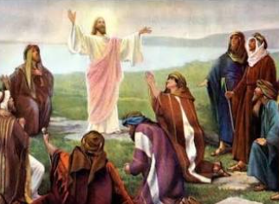
Anamehawikamek Welcome
ST. MICHAEL CATHOLIC CHURCH
PO Box 610, N816 State Highway 47-55,
Keshena, WI 54135 - Phone: 715-799-3811
Email: office@stmichaelkeshena.org
Website: stmichaelkeshena.com
Find us on Facebook: St. Michael’s Church

MISSION STATEMENT: St. Michael’s Christian Community, located on the Menominee Indian Reservation, is a diverse Christian community reaching out to all residents, learning, loving, sharing, and communicating with one another through the teachings and practices celebrated in the Mass & the Holy Sacraments of the Catholic Church by integrating sacred symbols and spiritual practices of the Menominee.
KNIGHTS OF COLUMBUS: Contact Grand Knight Paul Marroquin 715-853-2414.
HOLY HOUR: Every Friday after 8:00 am Mass.
ANOINTING OF THE SICK: Individual arrangements can be made through the Parish Office.
BAPTISM: Kindly contact parish office.
MARRIAGE: Make arrangements with the Priest, six months prior to desired date.
CONFIRMATION: Contact Deacon Mark Fuller for information via email mpfull7@gmail.com.

