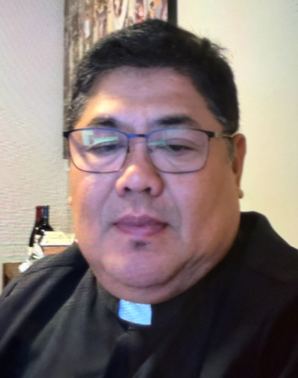 A Note from Father Juan
18th Sunday ordinary time reflection yr. A.
SHARING GOD’S BOUNTIFUL BLESSINGS.
The feeding of five thousand.
The Gospel of the 18th Sunday in ordinary Time reminds us that Jesus is moved by compassion. When saw the large crowd following Him, He did not send them away. Instead, He healed the sick, thought them, and finally fed them with only five loaves of bread and two fish. What seemed impossible in human eyes became more than enough in the hands of Jesus.
Often, we focus on what we lack: not enough money, time, talent, or strength. We may think our efforts are too small to make a difference. But Jesus asks us to offer what we have. When we place our lives, our talents. Even our weaknesses into his hands, He multiplies them for the good of others. In our living out of the Gospel when we share our blessings to others e.g. Food pantries, we give food and drinks to our brothers and sisters we participate in the miracle of our Lord Jesus Christ. He continues to do this today, especially in the Holy Eucharist, where He offers Himself as a Bread of Life. Every celebration of the Eucharist is an invitation to receive His grace and to become bread broken for others through love and service.
Riches that we possess are not our own, but theirs as well “The Holy Father wishes that the Jubilee 2025 might usher hope especially for the poor. “Echoing the age-old message of the prophets, reminds us that the goods of the earth are not destined for a privilege few, but rather for everyone. The rich much be generous not avert their eyes the faces of their brothers and sisters in need. Here I think especially of those who lack water and food: hunger is a scandal, an open wound on the body of our humanity, and it summons all of us to serious examination of conscience. I renew my appeal that the money spent on weapons and other military expenditures, let us establish a global fund that can finally put an end to hunger and favor development in the most impoverished countries, so that their citizens will not resort to violent or illusory situations, or have to leave their countries and families in order to seek more dignified life (Spes Non Confundit 16). Amen.
Reflection Questions
1. What “Five loaves and two fish” can I offer today?
2. Do I trust Jesus to provide even when my resources seem insufficient?
3. How I become a source of hope and nourishment for those around me?
PRAYER
LORD JESUS, you are the bread of life who never leaves Your People hungry.
Help me to trust in Your loving providence, especially when I feel that I have is not enough. Take my gifts, bless them and use them for your glory. Teach me to be generous, compassionate, and willing to share with those in need. May I always find my deepest satisfaction in you Amen.
In Christ, Fr. Juan C Tejerero Jr.
MASS SCHEDULE &
INTENTIONS
08/01-5:00 pm…………….Judy Blochowicz
08/02-9:00 am…………….Mary Kuester
Kemmeter
08/03………………………..No Mass
08/04-8:00 am…………….The homeless
08/05-8:00 am…………….For peace in
Holy Land
08/06-8:00 am…………….For all expectant
parents
08/07-8:00 am…………….Tribal Elders
08/08-5:00 pm…………….Jim & Joleen
Kaquatosh &
Kinsey
08/09-9:00 am…………….Tucker/Vigue
Families
Financial Blessings
July 25th & 26th

We are in need of Weekday Mass intentions. Mass intentions are $20.00 per Mass.

Envelope/Contributors | $718.00
Loose Collection | $619.00
Thank you for supporting our Parish!
School Supplies Drive:
We are collecting school supplies for children in need in our community through the month of August. Donation bin is in the Church entrance. Suggested items include; pencils, crayons, Crayola markers, erasers, glue sticks, folders, scissors, pencil boxes/pouches, loose leaf paper, backpacks. Further items may be added as we get lists from the schools. Thank you for your generosity.

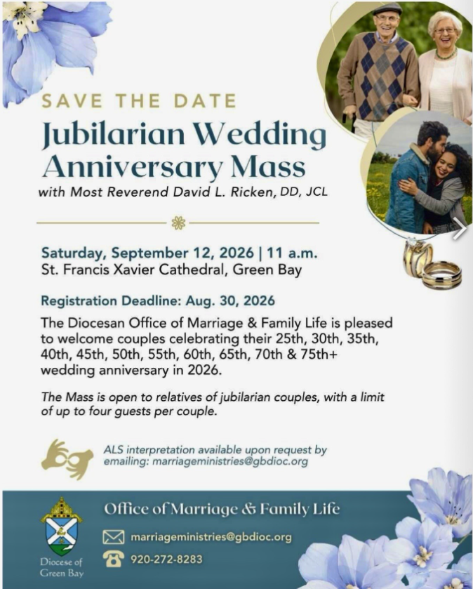

EXTRAORDINARY MINISTER
OF HOLY COMMUNION &
LECTOR SCHEDULE

Saturday, August 1st, 5:00 p.m.
Lector: Kevin Culhane
Eucharistic Minister: Deacon Mark
Sunday, August 2nd, 9:00 a.m.
Lector: Ellie Sokoly
Eucharistic Minister: Deacon Mark
Saturday, August 8th, 5:00 p.m.
Lector: Muffy Culhane
Eucharistic Minister: Kevin Culhane
Sunday, August 9th, 9:00 a.m.
Lector: Anne Sulskis
Eucharistic Minister: Vicki Hermsen
Saturday, August 15th, 5:00 p.m.
Lector: Rod Glauser
Eucharistic Minister: Karen Smart
Sunday, August 16th, 9:00 a.m.
Lector: Jacquie Braun
Eucharistic Minister: Anne Sulskis
Saturday, August 22nd, 5:00 p.m.
Lector: Mary Lewellin
Eucharistic Minister: Deacon Mark
Sunday, August 23rd, 9:00 a.m.
Lector: Ellie Sokoly
Eucharistic Minister: Deacon Mark
Save the Date:
Sat. August 15, Lake Faire at Legend Lake Lodge from 10:00-3:00. St. Michael's will have a booth, come support it.
Welcome Fr. Juan Dinner:
Please join us on Saturday, August 22 following the 5:00 PM Mass to welcome Fr. Juan to our Parish and community. This will give Fr. Juan and our members an opportunity to enjoy a meal together and visit with one another. This will be a potluck dinner so we will provide the main menu items. We look forward to seeing everyone.

St. Michael Parish
Adult Confirmation News:
Deacon Mark is in the planning stages for an Adult Confirmation Class at St. Michael's starting this Fall. If you are interested in registering or just want some general information about the class, please contact Deacon Mark at the office number 715-799-3811 or by email mpfull7@gmail.com.
God’s Garden
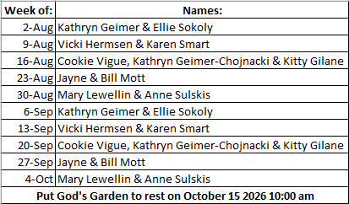



14109 County VV, Gillett, WI 54124


SUNDAY BRUNCH 9-12 PM.
CHICKEN DINNER ALL DAY.

Please pick up your pans, cookie sheets, and miscellaneous items left over from funerals and other church events in the Fr. Barrett Hall.
There will not be a Mass at St. Michael on Holy Saturday, March 26. Easter Vigil will be held at St. Francis in Gresham at 7 pm. Easter Sunday Mass will be at St. Michael and St. Anthony at 10:30 am.

Maintenance. Michael Catholic Parish in Keshena is seeking a part-time maintenance person. Responsible for light maintenance, cleaning the church, etc. Contact the parish office at telephone number 715-799-3811 for an application, and job.

Please pick up your pans, cookie sheets, and miscellaneous items left over from funerals and other church events in the Fr. Barrett Hall.
There will not be a Mass at St. Michael on Holy Saturday, March 26. Easter Vigil will be held at St. Francis in Gresham at 7 pm. Easter Sunday Mass will be at St. Michael and St. Anthony at 10:30 am.
PARISH STAFF
Parish Administrator
FR. JUAN TEJERERO JR.
Parish Office (715) 799-3811
father@stmichaelkeshena.org

DEACON MARK FULLER
(715) 201-2961
mpfull7@gmail.com

Parish Secretary
RICKIE DODGE
Parish Office (715) 799-3811
office@stmichaelkeshena.org

Faith Formation
PATTI FULLER
Parish Office (715) 799-3811
Mpfull7@gmail.com


PARISH TRUSTEES
KAREN SMART, Treasurer
VICKI HERMSEN, Secretary

Parish Council Chair
MARY LEWELLIN

Finance Council Chair
THERESE GLAUSER

Thrift N Gift Coordinator
COOKIE VIGUE

Food Pantry Coordinator

MASS SCHEDULE
Saturday: 5:00 pm Mass
4:30 pm Rosary & Confession
Sunday: 9:00 am Mass
8:30 am Rosary
Monday: No Mass Tuesday – Friday: 8:00 am Mass

PARISH OFFICE HOURS
Regular hours: Monday - Thursday
9:00 am – 2:00 pm
Hours may vary, please call before coming to the office.
SATURDAY MASS: 5:00 pm
SUNDAY MASS: 9:00 am
CONFESSION: Saturday 4:30 - 4:45pm
ROSARY: Saturday 3:40 pm Sunday 8:35 am
DAILY MASS: Chapel Southside of Church

P Parish Administrator, Fr. Nonito Barra - 715-799-3811 - pastor@livingwaterslivingfaith.org
Rectory – 715-994-1337
Parochial Vicar Fr. Joel Jores - 715-787-3377 frj@livingwaterslivingfaith.org
Deacon Mark Fuller 715-201-2961- deaconmark@livingwaterslivingfaith.org
Parish Secretary, Vicki Hermsen - 715-799-3811 - vicki@livingwaterslivingfaith.org
Religious Education Kathy King-Tucker - 715-799-3927 – ltucker@frontiernet.netmailto:maczuzak@frontiernet.net
Wednesday 6 – 7:30 pm September – May
Parish Administrator, Fr. Nonito Barra - 715-799-3811 - pastor@livingwaterslivingfaith.org
Rectory – 715-994-1337
Parochial Vicar Fr. Joel Jores - 715-787-3377 frj@livingwaterslivingfaith.org
Deacon Mark Fuller 715-201-2961- deaconmark@livingwaterslivingfaith.org
Parish Secretary, Vicki Hermsen - 715-799-3811 - vicki@livingwaterslivingfaith.org
Religious Education Kathy King-Tucker - 715-799-3927 – ltucker@frontiernet.netmailto:maczuzak@frontiernet.net
Wednesday 6 – 7:30 pm September – May
Parish Administrator, Fr. Nonito Barra - 715-799-3811 - pastor@livingwaterslivingfaith.org
Rectory – 715-994-1337
Parochial Vicar Fr. Joel Jores - 715-787-3377 frj@livingwaterslivingfaith.org
Deacon Mark Fuller 715-201-2961- deaconmark@livingwaterslivingfaith.org
Parish Secretary, Vicki Hermsen - 715-799-3811 - vicki@livingwaterslivingfaith.org
Religious Education Kathy King-Tucker - 715-799-3927 – ltucker@frontiernet.netmailto:maczuzak@frontiernet.net
Wednesday 6 – 7:30 pm September – May

St. Michael’s Calendar
08/01/2026 Raising Vocations 2nd Collection
08/02/2026 Raising Vocations 2nd Collection
08/04/2026 Thrift N Gift 11:00 am – 3:00 pm
08/04/2026 Food Pantry 12:30 – 3:00 pm
08/04/2026 Book Share 12:30 -3:00 pm
08/07/2026 Holy Hour after Mass
MASS TIMES
St. Michael – Saturday: 5:00 pm, Sunday: 9:00 am
Monday: No Mass Tuesday - Friday: 8:00 am Mass
St. Anthony – Sunday: 10:30 am

Book Share
Will be open Tuesday August 4th from 12:30 – 3:00 pm. We have books for all ages! We will accept books in good shape, just no old magazines, text books or encyclopedias.

Food Pantry
Will be open Tuesday, August 4th from 12:30 - 3:00 pm. There will be drive up service only and food will be placed in your trunk. Please do not get out of your vehicle. Please save brown paper bags & plastic bags and please drop them off at the Parish office.

Thrift N Gift
Will be open Tuesday, August 4th from 11:00 am - 3:00 pm. We have an abundance of household items, clothes, and great gift items. Please reach out to Cookie if you need to, 920-216-9240.

We the Knights
We always ask God to bless our community members. If you or a family member need assistance to get to a doctor appointment, we may be able to help. Call Paul at 715-853-2414 or Todd 715-584-5885.

Kateri Prayer Circle
Never underestimate the power of prayer. Just one small prayer can change your life. If you or your family members need prayers for any reason, please call one of our Kateri Prayer Circle members, who will in turn call members of their group. Soon, many prayers will be offered for your specific prayer request. Please call:

Fay Waupochick: 715-799-3437
Jacqueline Braun: 715-701-4552

You can also call the Parish Office to leave a request.

Religious Education Calendar Up Coming Events:
Wednesday, November 30th –Classes Resume
Wednesday December 7th
Wednesday December 14th
Wednesday December 21st Birthday Party- Parents
Guardians invited
Wednesday December 28th No Class
Wednesday January 4th No Class
Wednesday January 11 Classes resume
August 2, 2026
18th Sunday in Ordinary Time
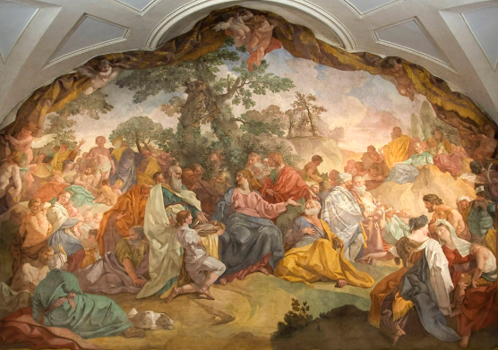
Anamehawikamek Welcome
ST. MICHAEL CATHOLIC CHURCH
PO Box 610, N816 State Highway 47-55,
Keshena, WI 54135 - Phone: 715-799-3811
Email: office@stmichaelkeshena.org
Website: stmichaelkeshena.com
Find us on Facebook: St. Michael’s Church

MISSION STATEMENT: St. Michael’s Christian Community, located on the Menominee Indian Reservation, is a diverse Christian community reaching out to all residents, learning, loving, sharing, and communicating with one another through the teachings and practices celebrated in the Mass & the Holy Sacraments of the Catholic Church by integrating sacred symbols and spiritual practices of the Menominee.
KNIGHTS OF COLUMBUS: Contact Grand Knight Paul Marroquin 715-853-2414.
HOLY HOUR: Every Friday after 8:00 am Mass.
ANOINTING OF THE SICK: Individual arrangements can be made through the Parish Office.
BAPTISM: Kindly contact parish office.
MARRIAGE: Make arrangements with the Priest, six months prior to desired date.
CONFIRMATION: Contact Deacon Mark Fuller for information via email mpfull7@gmail.com.

