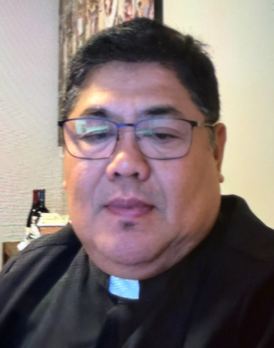 A Note from Father Juan
Reflections on Sundays Gospel 19th Sunday ordinary time year A
The Encounter between Jesus and the Canaanite woman is one of most striking conversation in the Gospel. At first Jesus seems distant He remains silent and his words seems harsh yet the woman refuses to give up she approach him with courage, humility, strong faith pleading words LORD HELP ME.
The Gospel reminds us that faith is not simply believing when everything goes well. Genuine faith perseveres in the silence delay, and disappointments.
There are moments when our prayers seem unanswered when God speaks distant, like the Canaanite woman we are invited to keep praying, trusting, God hears every cry and works in his own time.
The first reading also reminds us that the vision of God’s love invites us to reflect that heaven and eternal life is not only limited to one nation or race, but it is offered to everyone who seeks Him with sincere hearts. Our faith must express our universal mission to live the gospel witnessing that God’s love is without boundaries
This Sunday’s readings challenge us to examine our hearts to persevere in prayers when answers do not come quickly. Are we willing to trust God’s wisdom even when we do not understand His way’s.
May we learn to pray with humility persistence and confidence. Her example assures us that no sincere prayers ignored and that God’s Christ mercy is always greater than our expectation. We pray to our Lord Jesus that he may give us an open heart to trust Him wholeheartedly and deeply and to follow Him closely. Amen

In Christ,
Fr. Juan C. Tejerero

MASS SCHEDULE &
INTENTIONS
08/08-5:00 pm…………….Jim & Joleen
Kaquatosh &
Kinsey
08/09-9:00 am…………….Tucker/Vigue
Families
08/10………………………..No Mass
08/11-8:00 am…………….Judy Blochowicz
08/12-8:00 am…………….The Soul of Anna
Donnermeyer
08/13-8:00 am…………….For the poor
08/14-8:00 am…………….For those who dwell
in darkness
08/15-5:00 pm…………….Parish Volunteers
08/16-9:00 am…………….Richard & Slyvia
Dodge

Financial Blessings
August 1st & 2nd

We are in need of Weekday Mass intentions. Mass intentions are $20.00 per Mass.

Envelope/Contributors | $1851.00
Loose Collection | $510.00
Thank you for supporting our Parish!
School Supplies Drive:
We are collecting school supplies for children in need in our community through the month of August. Donation bin is in the Church entrance. Suggested items include; pencils, crayons, Crayola markers, erasers, glue sticks, folders, scissors, pencil boxes/pouches, loose leaf paper, backpacks. Further items may be added as we get lists from the schools. Thank you for your generosity.

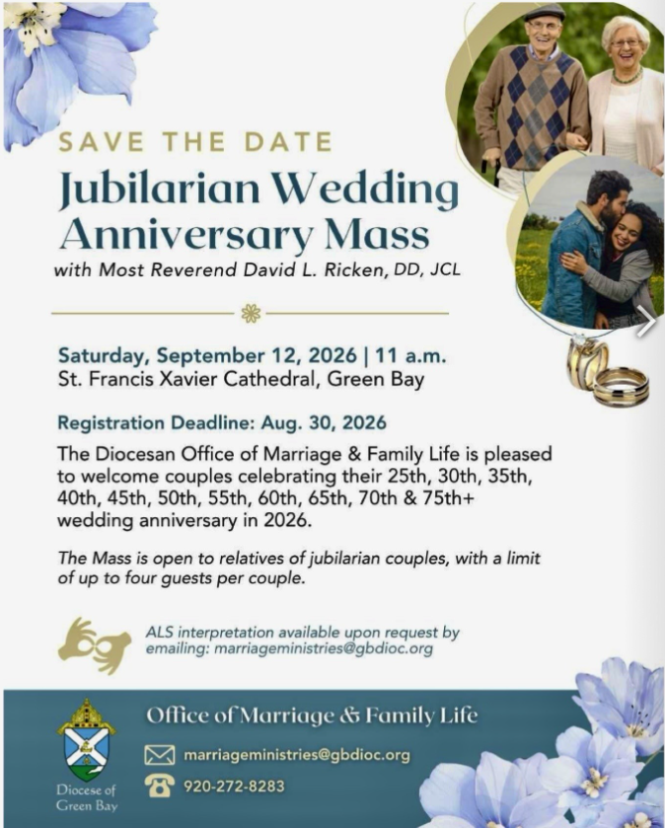
Food Pantry News:
The food pantry is in need of plastic and paper grocery bags. Donations of shampoo, body wash, bar soap and paper towel are greatly appreciated. The container is located in the main entrance of church.
Thank you!!!
A big Thank You to our Red Barn Volunteers!
Greg Wilber
Jim & Ellie Sokoly
Tina & Eric Ready
Tonia Wilber & Mahwassa
Kathryn Geimer Chojnacki
Jean & Ralph Mueller
Larry Sikowski
Maureen Shively
Mary Lewellen
Tory Gladue
David Blonegin and his sister, Mary
Cookie Vigue
Karen Smart
Nancy Hundt
Vicki Hermsen
Guy & Kathleen DeGroot
Terri & Rod Glauser
Colleen Pyne
Patty Fuller
Despite not doing the best on Monday due to the storm, we made $2436.00.

EXTRAORDINARY MINISTER
OF HOLY COMMUNION &
LECTOR SCHEDULE

Saturday, August 8th, 5:00 p.m.
Lector: Muffy Culhane
Eucharistic Minister: Kevin Culhane
Sunday, August 9th, 9:00 a.m.
Lector: Anne Sulskis
Eucharistic Minister: Vicki Hermsen
Saturday, August 15th, 5:00 p.m.
Lector: Rod Glauser
Eucharistic Minister: Karen Smart
Sunday, August 16th, 9:00 a.m.
Lector: Jacquie Braun
Eucharistic Minister: Anne Sulskis
Saturday, August 22nd, 5:00 p.m.
Lector: Mary Lewellin
Eucharistic Minister: Deacon Mark
Sunday, August 23rd, 9:00 a.m.
Lector: Ellie Sokoly
Eucharistic Minister: Deacon Mark
Saturday, August 29th, 5:00 p.m.
Lector: Larry Sikowski
Eucharistic Minister: Kevin Culhane
Sunday, August 30th, 9:00 a.m.
Lector: Jacquie Braun
Eucharistic Minister: Ellie Sokoly
Save the Date:
Sat. August 15, Lake Faire at Legend Lake Lodge from 10:00-3:00. St. Michael's will have a booth, come support it.
Welcome Fr. Juan Dinner:
Please join us on Saturday, August 22 following the 5:00 PM Mass to welcome Fr. Juan to our Parish and community. This will give Fr. Juan and our members an opportunity to enjoy a meal together and visit with one another. This will be a potluck dinner so we will provide the main menu items. We look forward to seeing everyone.

St. Michael Parish
Adult Confirmation News:
Deacon Mark is in the planning stages for an Adult Confirmation Class at St. Michael's starting this Fall. If you are interested in registering or just want some general information about the class, please contact Deacon Mark at the office number 715-799-3811 or by email mpfull7@gmail.com.
God’s Garden
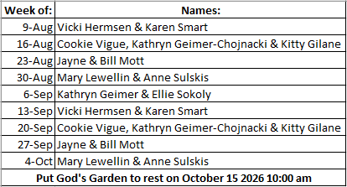



14109 County VV, Gillett, WI 54124


SUNDAY BRUNCH 9-12 PM.
CHICKEN DINNER ALL DAY.

Please pick up your pans, cookie sheets, and miscellaneous items left over from funerals and other church events in the Fr. Barrett Hall.
There will not be a Mass at St. Michael on Holy Saturday, March 26. Easter Vigil will be held at St. Francis in Gresham at 7 pm. Easter Sunday Mass will be at St. Michael and St. Anthony at 10:30 am.

Maintenance. Michael Catholic Parish in Keshena is seeking a part-time maintenance person. Responsible for light maintenance, cleaning the church, etc. Contact the parish office at telephone number 715-799-3811 for an application, and job.

Please pick up your pans, cookie sheets, and miscellaneous items left over from funerals and other church events in the Fr. Barrett Hall.
There will not be a Mass at St. Michael on Holy Saturday, March 26. Easter Vigil will be held at St. Francis in Gresham at 7 pm. Easter Sunday Mass will be at St. Michael and St. Anthony at 10:30 am.
PARISH STAFF
Parish Administrator
FR. JUAN TEJERERO JR.
Parish Office (715) 799-3811
father@stmichaelkeshena.org

DEACON MARK FULLER
(715) 201-2961
mpfull7@gmail.com

Parish Secretary
RICKIE DODGE
Parish Office (715) 799-3811
office@stmichaelkeshena.org

Faith Formation
PATTI FULLER
Parish Office (715) 799-3811
faithformation@stmichaelkeshena.org


PARISH TRUSTEES
KAREN SMART, Treasurer
VICKI HERMSEN, Secretary

Parish Council Chair
MARY LEWELLIN

Finance Council Chair
THERESE GLAUSER

Thrift N Gift Coordinator
COOKIE VIGUE

Food Pantry Coordinator

MASS SCHEDULE
Saturday: 5:00 pm Mass
4:30 pm Rosary & Confession
Sunday: 9:00 am Mass
8:30 am Rosary
Monday: No Mass Tuesday – Friday: 8:00 am Mass

PARISH OFFICE HOURS
Regular hours: Monday - Thursday
9:00 am – 2:00 pm
Hours may vary, please call before coming to the office.
SATURDAY MASS: 5:00 pm
SUNDAY MASS: 9:00 am
CONFESSION: Saturday 4:30 - 4:45pm
ROSARY: Saturday 3:40 pm Sunday 8:35 am
DAILY MASS: Chapel Southside of Church

P Parish Administrator, Fr. Nonito Barra - 715-799-3811 - pastor@livingwaterslivingfaith.org
Rectory – 715-994-1337
Parochial Vicar Fr. Joel Jores - 715-787-3377 frj@livingwaterslivingfaith.org
Deacon Mark Fuller 715-201-2961- deaconmark@livingwaterslivingfaith.org
Parish Secretary, Vicki Hermsen - 715-799-3811 - vicki@livingwaterslivingfaith.org
Religious Education Kathy King-Tucker - 715-799-3927 – ltucker@frontiernet.netmailto:maczuzak@frontiernet.net
Wednesday 6 – 7:30 pm September – May
Parish Administrator, Fr. Nonito Barra - 715-799-3811 - pastor@livingwaterslivingfaith.org
Rectory – 715-994-1337
Parochial Vicar Fr. Joel Jores - 715-787-3377 frj@livingwaterslivingfaith.org
Deacon Mark Fuller 715-201-2961- deaconmark@livingwaterslivingfaith.org
Parish Secretary, Vicki Hermsen - 715-799-3811 - vicki@livingwaterslivingfaith.org
Religious Education Kathy King-Tucker - 715-799-3927 – ltucker@frontiernet.netmailto:maczuzak@frontiernet.net
Wednesday 6 – 7:30 pm September – May
Parish Administrator, Fr. Nonito Barra - 715-799-3811 - pastor@livingwaterslivingfaith.org
Rectory – 715-994-1337
Parochial Vicar Fr. Joel Jores - 715-787-3377 frj@livingwaterslivingfaith.org
Deacon Mark Fuller 715-201-2961- deaconmark@livingwaterslivingfaith.org
Parish Secretary, Vicki Hermsen - 715-799-3811 - vicki@livingwaterslivingfaith.org
Religious Education Kathy King-Tucker - 715-799-3927 – ltucker@frontiernet.netmailto:maczuzak@frontiernet.net
Wednesday 6 – 7:30 pm September – May

St. Michael’s Calendar
08/13/2026 Parish Finance Council meeting 9:30 am
08/14/2026 Holy Hour after Mass
08/15/2026 Legend Lake Faire 10:00 am – 3:00 pm
08/18/2026 Thrift N Gift 11:00 am – 3:00 pm
08/18/2026 Food Pantry 12:30 – 3:00 pm
08/18/2026 Book Share 12:30 -3:00 pm

MASS TIMES
St. Michael – Saturday: 5:00 pm, Sunday: 9:00 am
Monday: No Mass Tuesday - Friday: 8:00 am Mass
St. Anthony – Sunday: 10:30 am

Book Share
Will be open Tuesday August 18th from 12:30 – 3:00 pm. We have books for all ages! We will accept books in good shape, just no old magazines, text books or encyclopedias.

Food Pantry
Will be open Tuesday, August 18th from 12:30 - 3:00 pm. There will be drive up service only and food will be placed in your trunk. Please do not get out of your vehicle. Please save brown paper bags & plastic bags and please drop them off at the Parish office.

Thrift N Gift
Will be open Tuesday, August 18th from 11:00 am - 3:00 pm. We have an abundance of household items, clothes, and great gift items. Please reach out to Cookie if you need to, 920-216-9240.

We the Knights
We always ask God to bless our community members. If you or a family member need assistance to get to a doctor appointment, we may be able to help. Call Paul at 715-853-2414 or Todd 715-584-5885.

Kateri Prayer Circle
Never underestimate the power of prayer. Just one small prayer can change your life. If you or your family members need prayers for any reason, please call one of our Kateri Prayer Circle members, who will in turn call members of their group. Soon, many prayers will be offered for your specific prayer request. Please call:

Fay Waupochick: 715-799-3437
Jacqueline Braun: 715-701-4552

You can also call the Parish Office to leave a request.

Religious Education Calendar Up Coming Events:
Wednesday, November 30th –Classes Resume
Wednesday December 7th
Wednesday December 14th
Wednesday December 21st Birthday Party- Parents
Guardians invited
Wednesday December 28th No Class
Wednesday January 4th No Class
Wednesday January 11 Classes resume
August 9, 2026
19th Sunday in Ordinary Time
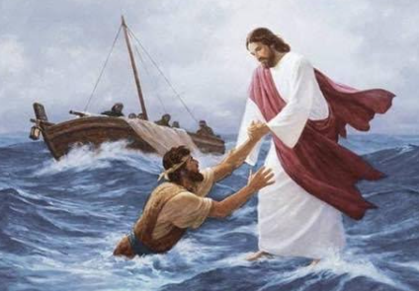
Anamehawikamek Welcome
ST. MICHAEL CATHOLIC CHURCH
PO Box 610, N816 State Highway 47-55,
Keshena, WI 54135 - Phone: 715-799-3811
Email: office@stmichaelkeshena.org
Website: stmichaelkeshena.com
Find us on Facebook: St. Michael’s Church

MISSION STATEMENT: St. Michael’s Christian Community, located on the Menominee Indian Reservation, is a diverse Christian community reaching out to all residents, learning, loving, sharing, and communicating with one another through the teachings and practices celebrated in the Mass & the Holy Sacraments of the Catholic Church by integrating sacred symbols and spiritual practices of the Menominee.
KNIGHTS OF COLUMBUS: Contact Grand Knight Paul Marroquin 715-853-2414.
HOLY HOUR: Every Friday after 8:00 am Mass.
ANOINTING OF THE SICK: Individual arrangements can be made through the Parish Office.
BAPTISM: Kindly contact parish office.
MARRIAGE: Make arrangements with the Priest, six months prior to desired date.
CONFIRMATION: Contact Deacon Mark Fuller for information via email mpfull7@gmail.com.

