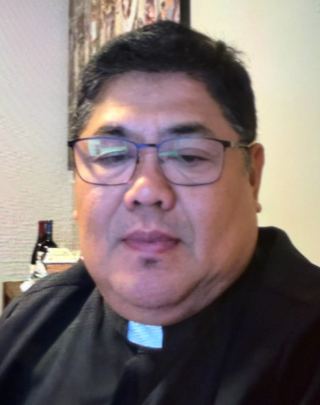 A Note from Father Juan
Reflection for the 20thSunday Ordinary time Yr A
Life in Christ is a Life of FAITH and PRACTICE.
The woman instantly pickup on this challenging nuance kneeling in deep humility she matches wits with Jesus even the households’ pets are insiders who belongs at the family feet eating the crumbs that drop from the master’s table. Jesus rejoices in her insight and exclaimed Woman great is your Faith! Let it be done for you as you wish.

Like of the Early disciples we are often tempted to decide who is In or who is Out we must therefore set no boundaries extending our radical compassion to our brothers and sister who is need.

We need to be persistent when God seems silent.
The Canaanite woman teaches us that delay is not denial It is an invitation to let our prayer shift from casual request to humble persistent of total reliance on Him.
Love of God knows no limit the driving force behind the woman boldness was a mother’s fierce sacrificial love for her child. We are called to pray hard for the healing of those around us.

Jesus reminds us two good things from PERSISTENT PRAYER AND HUMILITY Amen.

In Christ,
Fr. Juan C. Tejerero

MASS SCHEDULE &
INTENTIONS
08/15-5:00 pm…………….Parish Volunteers
08/16-9:00 am…………….Richard & Sylvia
Dodge
08/17………………………..No Mass
08/18-8:00 am…………….For families dealing
with cancer
08/19-8:00 am…………….Retired Religious
08/20-8:00 am…………….For leaders in this
community
08/21-8:00 am…………….For those who suffer
from temptation
08/22-5:00 pm…………….Back to school
students
08/23-9:00 am…………….Richard A Moses Sr.

Financial Blessings
August 8th & 9th

We are in need of Weekday Mass intentions. Mass intentions are $20.00 per Mass.

Envelope/Contributors | $2031.00
Loose Collection | $538.00
Thank you for supporting our Parish!
School Supplies Drive:
We are collecting school supplies for children in need in our community through the month of August. Donation bin is in the Church entrance. Suggested items include; pencils, crayons, Crayola markers, erasers, glue sticks, folders, scissors, pencil boxes/pouches, loose leaf paper, backpacks. Further items may be added as we get lists from the schools. Thank you for your generosity.

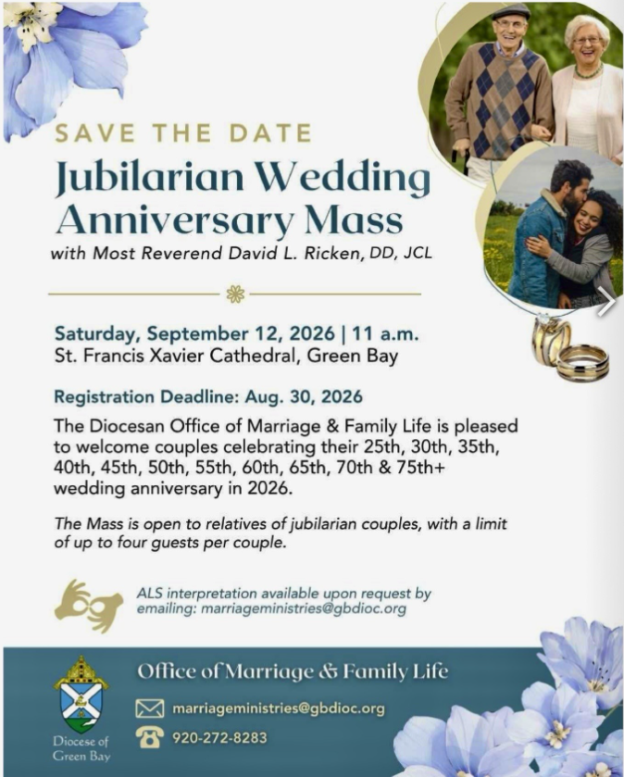
Food Pantry News:
The food pantry is in need of plastic and paper grocery bags. Donations of shampoo, body wash, bar soap and paper towel are greatly appreciated. The container is located in the main entrance of church.
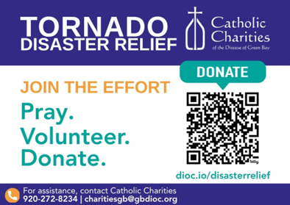
Faith Formation News:
Classes will be on Wednesday evenings from 6:00 – 7:15 pm. Classes begin with kick off on Wednesday September 16th. Returning students will receive registration packets in the mail. New students can contact Patty Fuller at faithformation@stmichaelkeshena.org. New catechists are welcome! If you are interested in teaching faith formation or even assisting in a classroom please contact Patty Fuller as indicated above.
EXTRAORDINARY MINISTER
OF HOLY COMMUNION &
LECTOR SCHEDULE

Saturday, August 15th, 5:00 p.m.
Lector: Rod Glauser
Eucharistic Minister: Karen Smart
Sunday, August 16th, 9:00 a.m.
Lector: Jacquie Braun
Eucharistic Minister: Anne Sulskis
Saturday, August 22nd, 5:00 p.m.
Lector: Mary Lewellin
Eucharistic Minister: Deacon Mark
Sunday, August 23rd, 9:00 a.m.
Lector: Ellie Sokoly
Eucharistic Minister: Deacon Mark
Saturday, August 29th, 5:00 p.m.
Lector: Larry Sikowski
Eucharistic Minister: Kevin Culhane
Sunday, August 30th, 9:00 a.m.
Lector: Jacquie Braun
Eucharistic Minister: Ellie Sokoly
Saturday, September 5th, 5:00 p.m.
Lector: Terri Glauser
Eucharistic Minister: Muffy Culhane
Sunday, September 6th, 9:00 a.m.
Lector: Ellie Sokoly
Eucharistic Minister: Gloria Gierach
Save the Date:
Welcome Fr. Juan Dinner:
Please join us on Saturday, August 22 following the 5:00 PM Mass to welcome Fr. Juan to our Parish and community. This will give Fr. Juan and our members an opportunity to enjoy a meal together and visit with one another. This will be a potluck dinner so we will provide the main menu items. We look forward to seeing everyone.

St. Michael Parish
Adult Confirmation News:
Deacon Mark is in the planning stages for an Adult Confirmation Class at St. Michael's starting this Fall. If you are interested in registering or just want some general information about the class, please contact Deacon Mark at the office number 715-799-3811 or by email mpfull7@gmail.com.
God’s Garden
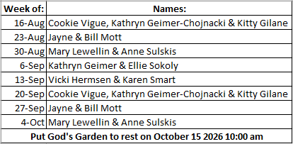



14109 County VV, Gillett, WI 54124


SUNDAY BRUNCH 9-12 PM.
CHICKEN DINNER ALL DAY.

Please pick up your pans, cookie sheets, and miscellaneous items left over from funerals and other church events in the Fr. Barrett Hall.
There will not be a Mass at St. Michael on Holy Saturday, March 26. Easter Vigil will be held at St. Francis in Gresham at 7 pm. Easter Sunday Mass will be at St. Michael and St. Anthony at 10:30 am.

Maintenance. Michael Catholic Parish in Keshena is seeking a part-time maintenance person. Responsible for light maintenance, cleaning the church, etc. Contact the parish office at telephone number 715-799-3811 for an application, and job.

Please pick up your pans, cookie sheets, and miscellaneous items left over from funerals and other church events in the Fr. Barrett Hall.
There will not be a Mass at St. Michael on Holy Saturday, March 26. Easter Vigil will be held at St. Francis in Gresham at 7 pm. Easter Sunday Mass will be at St. Michael and St. Anthony at 10:30 am.
PARISH STAFF
Parish Administrator
FR. JUAN TEJERERO JR.
Parish Office (715) 799-3811
father@stmichaelkeshena.org

DEACON MARK FULLER
(715) 201-2961
mpfull7@gmail.com

Parish Secretary
RICKIE DODGE
Parish Office (715) 799-3811
office@stmichaelkeshena.org

Faith Formation
PATTI FULLER
Parish Office (715) 799-3811
faithformation@stmichaelkeshena.org


PARISH TRUSTEES
KAREN SMART, Treasurer
VICKI HERMSEN, Secretary

Parish Council Chair
MARY LEWELLIN

Finance Council Chair
THERESE GLAUSER

Thrift N Gift Coordinator
COOKIE VIGUE

Food Pantry Coordinator

MASS SCHEDULE
Saturday: 5:00 pm Mass
4:30 pm Rosary & Confession
Sunday: 9:00 am Mass
8:30 am Rosary
Monday: No Mass Tuesday – Friday: 8:00 am Mass

PARISH OFFICE HOURS
Regular hours: Monday - Thursday
9:00 am – 2:00 pm
Hours may vary, please call before coming to the office.
SATURDAY MASS: 5:00 pm
SUNDAY MASS: 9:00 am
CONFESSION: Saturday 4:30 - 4:45pm
ROSARY: Saturday 3:40 pm Sunday 8:35 am
DAILY MASS: Chapel Southside of Church

P Parish Administrator, Fr. Nonito Barra - 715-799-3811 - pastor@livingwaterslivingfaith.org
Rectory – 715-994-1337
Parochial Vicar Fr. Joel Jores - 715-787-3377 frj@livingwaterslivingfaith.org
Deacon Mark Fuller 715-201-2961- deaconmark@livingwaterslivingfaith.org
Parish Secretary, Vicki Hermsen - 715-799-3811 - vicki@livingwaterslivingfaith.org
Religious Education Kathy King-Tucker - 715-799-3927 – ltucker@frontiernet.netmailto:maczuzak@frontiernet.net
Wednesday 6 – 7:30 pm September – May
Parish Administrator, Fr. Nonito Barra - 715-799-3811 - pastor@livingwaterslivingfaith.org
Rectory – 715-994-1337
Parochial Vicar Fr. Joel Jores - 715-787-3377 frj@livingwaterslivingfaith.org
Deacon Mark Fuller 715-201-2961- deaconmark@livingwaterslivingfaith.org
Parish Secretary, Vicki Hermsen - 715-799-3811 - vicki@livingwaterslivingfaith.org
Religious Education Kathy King-Tucker - 715-799-3927 – ltucker@frontiernet.netmailto:maczuzak@frontiernet.net
Wednesday 6 – 7:30 pm September – May
Parish Administrator, Fr. Nonito Barra - 715-799-3811 - pastor@livingwaterslivingfaith.org
Rectory – 715-994-1337
Parochial Vicar Fr. Joel Jores - 715-787-3377 frj@livingwaterslivingfaith.org
Deacon Mark Fuller 715-201-2961- deaconmark@livingwaterslivingfaith.org
Parish Secretary, Vicki Hermsen - 715-799-3811 - vicki@livingwaterslivingfaith.org
Religious Education Kathy King-Tucker - 715-799-3927 – ltucker@frontiernet.netmailto:maczuzak@frontiernet.net
Wednesday 6 – 7:30 pm September – May

St. Michael’s Calendar
08/18/2026 Thrift N Gift 11:00 am – 3:00 pm
08/18/2026 Food Pantry 12:30 – 3:00 pm
08/18/2026 Book Share 12:30 -3:00 pm
08/18/2026 Knights of Columbus meeting 7:00 pm
08/21/2026 Holy Hour after Mass
08/22/2026 Fr. Juan Welcome diner after Mass

MASS TIMES
St. Michael – Saturday: 5:00 pm, Sunday: 9:00 am
Monday: No Mass Tuesday - Friday: 8:00 am Mass
St. Anthony – Sunday: 10:30 am

Book Share
Will be open Tuesday August 18th from 12:30 – 3:00 pm. We have books for all ages! We will accept books in good shape, just no old magazines, text books or encyclopedias.

Food Pantry
Will be open Tuesday, August 18th from 12:30 - 3:00 pm. There will be drive up service only and food will be placed in your trunk. Please do not get out of your vehicle. Please save brown paper bags & plastic bags and please drop them off at the Parish office.

Thrift N Gift
Will be open Tuesday, August 18th from 11:00 am - 3:00 pm. We have an abundance of household items, clothes, and great gift items. Please reach out to Cookie if you need to, 920-216-9240.

We the Knights
We always ask God to bless our community members. If you or a family member need assistance to get to a doctor appointment, we may be able to help. Call Paul at 715-853-2414 or Todd 715-584-5885.

Kateri Prayer Circle
Never underestimate the power of prayer. Just one small prayer can change your life. If you or your family members need prayers for any reason, please call one of our Kateri Prayer Circle members, who will in turn call members of their group. Soon, many prayers will be offered for your specific prayer request. Please call:

Fay Waupochick: 715-799-3437
Jacqueline Braun: 715-701-4552

You can also call the Parish Office to leave a request.

Religious Education Calendar Up Coming Events:
Wednesday, November 30th –Classes Resume
Wednesday December 7th
Wednesday December 14th
Wednesday December 21st Birthday Party- Parents
Guardians invited
Wednesday December 28th No Class
Wednesday January 4th No Class
Wednesday January 11 Classes resume
August 16, 2026
20th Sunday in Ordinary Time
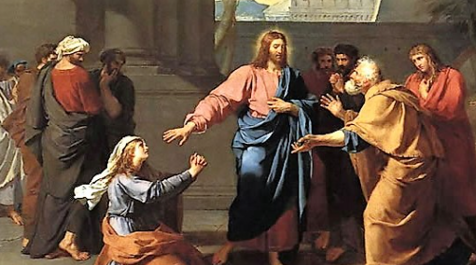
Anamehawikamek Welcome
ST. MICHAEL CATHOLIC CHURCH
PO Box 610, N816 State Highway 47-55,
Keshena, WI 54135 - Phone: 715-799-3811
Email: office@stmichaelkeshena.org
Website: stmichaelkeshena.com
Find us on Facebook: St. Michael’s Church

MISSION STATEMENT: St. Michael’s Christian Community, located on the Menominee Indian Reservation, is a diverse Christian community reaching out to all residents, learning, loving, sharing, and communicating with one another through the teachings and practices celebrated in the Mass & the Holy Sacraments of the Catholic Church by integrating sacred symbols and spiritual practices of the Menominee.
KNIGHTS OF COLUMBUS: Contact Grand Knight Paul Marroquin 715-853-2414.
HOLY HOUR: Every Friday after 8:00 am Mass.
ANOINTING OF THE SICK: Individual arrangements can be made through the Parish Office.
BAPTISM: Kindly contact parish office.
MARRIAGE: Make arrangements with the Priest, six months prior to desired date.
CONFIRMATION: Contact Deacon Mark Fuller for information via email mpfull7@gmail.com.

