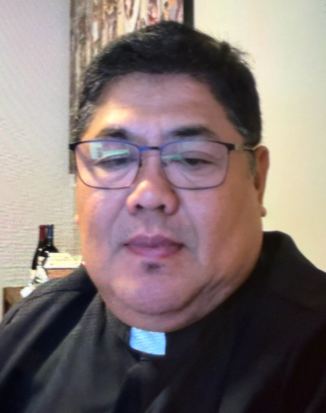 A Note from Father Juan
**Matthew 16:13–20**
In today’s Gospel, Jesus asks His disciples a very important question: **“Who do people say that the Son of Man is?”** Then He makes the question personal: **“But who do you say that I am?”**
This is not simply a question about what other people believe. Jesus wants each one of us to answer from our own heart: **Who is Jesus to me?**
Peter responds, **“You are the Christ, the Son of the living God.”** Peter recognizes Jesus not merely as a teacher or prophet, but as the Messiah and Son of God. Jesus tells Peter that this understanding is a gift from God, and then gives him a special mission: **“You are Peter, and upon this rock I will build my Church.”**
Peter was not perfect. He would later make mistakes and even deny Jesus. Yet Jesus chose him and entrusted him with leadership. This reminds us that God does not call perfect people; **God calls ordinary people and gives them grace to fulfill extraordinary missions.**
The Gospel also speaks to us about the Church. Jesus says, **“I will build my Church.”** The Church belongs to Christ. We are not simply members of an organization; we are part of a community founded by Jesus and called to continue His mission of love, forgiveness, service, and faith.
There is also a challenge in Jesus’ question: **“Who do you say that I am?”** It is easy to say that Jesus is the Son of God when we are in church. But our answer becomes real when we live according to His teachings—when we forgive someone who has hurt us, help someone in need, speak the truth, care for the lonely, and remain faithful during difficult moments.
Today, Jesus invites us to make Peter’s profession of faith our own:
**“Jesus, you are the Christ, the Son of the living God.”**

May this faith not remain only words on our lips. May it become the foundation of our lives. And like Peter, may we be willing to accept the mission Jesus gives us—to strengthen our families, serve our communities, and be faithful witnesses of the Gospel.
**Prayer:**
Lord Jesus, you are the Christ, the Son of the living God. Strengthen our faith so that we may know you, love you, and follow you more faithfully. Help us to be living stones of your Church and instruments of your love in the world. Amen.
In Christ, Fr. Juan C. Tejerero
MASS SCHEDULE &
INTENTIONS
08/22-5:00 pm…………….Back to school
students
08/23-9:00 am…………….Richard A Moses Sr.
08/24………………………..No Mass
08/25-8:00 am…………….Souls in purgatory
08/26-8:00 am…………….Military veterans
08/27-8:00 am…………….World peace
08/28-8:00 am…………….For all who are
persecuted
08/29-5:00 pm…………….Judy Blochowicz
08/30-9:00 am…………….Dean Schneider

Financial Blessings
August 15th & 16th

We are in need of Weekday Mass intentions. Mass intentions are $20.00 per Mass.

Envelope/Contributors | $1301.00
Loose Collection | $523.00
Thank you for supporting our Parish!
Food Pantry News:
The food pantry is in need of plastic and paper grocery bags. Donations of shampoo, body wash, bar soap and paper towel are greatly appreciated. The container is located in the main entrance of church.

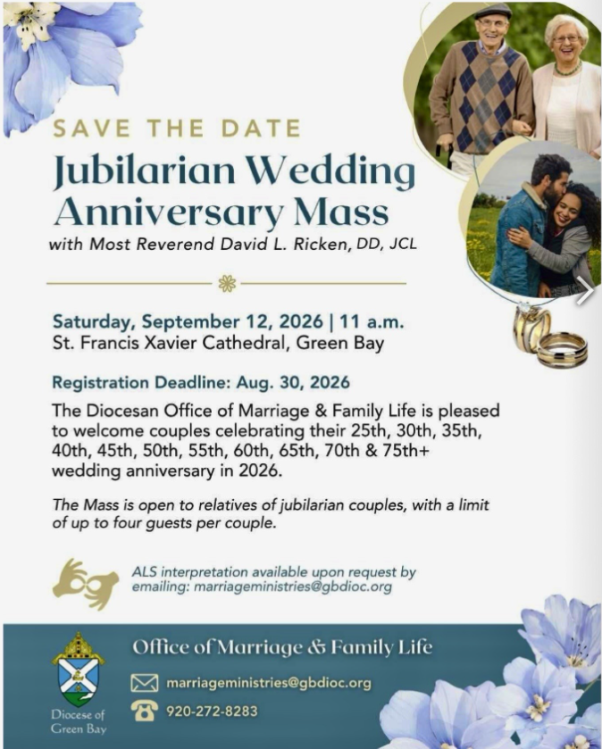

School Supplies Drive:
We are collecting school supplies for children in need in our community through the month of August. Donation bin is in the Church entrance. Suggested items include; pencils, crayons, Crayola markers, erasers, glue sticks, folders, scissors, pencil boxes/pouches, loose leaf paper, backpacks. Further items may be added as we get lists from the schools. Thank you for your generosity.

Faith Formation News:
Classes will be on Wednesday evenings from 6:00 – 7:15 pm. Classes begin with kick off on Wednesday September 16th. Returning students will receive registration packets in the mail. New students can contact Patty Fuller at faithformation@stmichaelkeshena.org.
New catechists are welcome! If you are interested in teaching faith formation or even assisting in a classroom please contact Patty Fuller as indicated above.
EXTRAORDINARY MINISTER
OF HOLY COMMUNION &
LECTOR SCHEDULE

Saturday, August 22nd, 5:00 p.m.
Lector: Mary Lewellin
Eucharistic Minister: Deacon Mark
Sunday, August 23rd, 9:00 a.m.
Lector: Ellie Sokoly
Eucharistic Minister: Deacon Mark
Saturday, August 29th, 5:00 p.m.
Lector: Larry Sikowski
Eucharistic Minister: Jim Gilane
Sunday, August 30th, 9:00 a.m.
Lector: Jacquie Braun
Eucharistic Minister: Ellie Sokoly
Saturday, September 5th, 5:00 p.m.
Lector: Terri Glauser
Eucharistic Minister: Muffy Culhane
Sunday, September 6th, 9:00 a.m.
Lector: Ellie Sokoly
Eucharistic Minister: Gloria Gierach
Saturday, September 12th, 5:00 p.m.
Lector: Kevin Culhane
Eucharistic Minister: Deacon Mark
Sunday, September 13th, 9:00 a.m.
Lector: Jacquie Braun
Eucharistic Minister: Deacon Mark

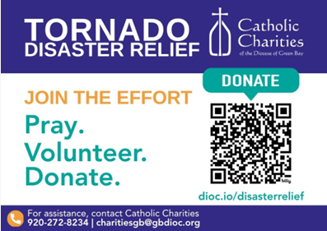

St. Michael Parish
Adult Confirmation News:
Deacon Mark is in the planning stages for an Adult Confirmation Class at St. Michael's starting this Fall. If you are interested in registering or just want some general information about the class, please contact Deacon Mark at the office number 715-799-3811 or by email mpfull7@gmail.com.
God’s Garden
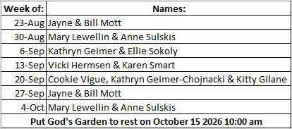



14109 County VV, Gillett, WI 54124


SUNDAY BRUNCH 9-12 PM.
CHICKEN DINNER ALL DAY.

Please pick up your pans, cookie sheets, and miscellaneous items left over from funerals and other church events in the Fr. Barrett Hall.
There will not be a Mass at St. Michael on Holy Saturday, March 26. Easter Vigil will be held at St. Francis in Gresham at 7 pm. Easter Sunday Mass will be at St. Michael and St. Anthony at 10:30 am.

Maintenance. Michael Catholic Parish in Keshena is seeking a part-time maintenance person. Responsible for light maintenance, cleaning the church, etc. Contact the parish office at telephone number 715-799-3811 for an application, and job.

Please pick up your pans, cookie sheets, and miscellaneous items left over from funerals and other church events in the Fr. Barrett Hall.
There will not be a Mass at St. Michael on Holy Saturday, March 26. Easter Vigil will be held at St. Francis in Gresham at 7 pm. Easter Sunday Mass will be at St. Michael and St. Anthony at 10:30 am.
PARISH STAFF
Parish Administrator
FR. JUAN TEJERERO JR.
Parish Office (715) 799-3811
father@stmichaelkeshena.org

DEACON MARK FULLER
(715) 201-2961
mpfull7@gmail.com

Parish Secretary
RICKIE DODGE
Parish Office (715) 799-3811
office@stmichaelkeshena.org

Faith Formation
PATTI FULLER
Parish Office (715) 799-3811
faithformation@stmichaelkeshena.org


PARISH TRUSTEES
KAREN SMART, Treasurer
VICKI HERMSEN, Secretary

Parish Council Chair
MARY LEWELLIN

Finance Council Chair
THERESE GLAUSER

Thrift N Gift Coordinator
COOKIE VIGUE

Food Pantry Coordinator

MASS SCHEDULE
Saturday: 5:00 pm Mass
4:30 pm Rosary & Confession
Sunday: 9:00 am Mass
8:30 am Rosary
Monday: No Mass Tuesday – Friday: 8:00 am Mass

PARISH OFFICE HOURS
Regular hours: Monday - Thursday
9:00 am – 2:00 pm
Hours may vary, please call before coming to the office.
SATURDAY MASS: 5:00 pm
SUNDAY MASS: 9:00 am
CONFESSION: Saturday 4:30 - 4:45pm
ROSARY: Saturday 3:40 pm Sunday 8:35 am
DAILY MASS: Chapel Southside of Church

P Parish Administrator, Fr. Nonito Barra - 715-799-3811 - pastor@livingwaterslivingfaith.org
Rectory – 715-994-1337
Parochial Vicar Fr. Joel Jores - 715-787-3377 frj@livingwaterslivingfaith.org
Deacon Mark Fuller 715-201-2961- deaconmark@livingwaterslivingfaith.org
Parish Secretary, Vicki Hermsen - 715-799-3811 - vicki@livingwaterslivingfaith.org
Religious Education Kathy King-Tucker - 715-799-3927 – ltucker@frontiernet.netmailto:maczuzak@frontiernet.net
Wednesday 6 – 7:30 pm September – May
Parish Administrator, Fr. Nonito Barra - 715-799-3811 - pastor@livingwaterslivingfaith.org
Rectory – 715-994-1337
Parochial Vicar Fr. Joel Jores - 715-787-3377 frj@livingwaterslivingfaith.org
Deacon Mark Fuller 715-201-2961- deaconmark@livingwaterslivingfaith.org
Parish Secretary, Vicki Hermsen - 715-799-3811 - vicki@livingwaterslivingfaith.org
Religious Education Kathy King-Tucker - 715-799-3927 – ltucker@frontiernet.netmailto:maczuzak@frontiernet.net
Wednesday 6 – 7:30 pm September – May
Parish Administrator, Fr. Nonito Barra - 715-799-3811 - pastor@livingwaterslivingfaith.org
Rectory – 715-994-1337
Parochial Vicar Fr. Joel Jores - 715-787-3377 frj@livingwaterslivingfaith.org
Deacon Mark Fuller 715-201-2961- deaconmark@livingwaterslivingfaith.org
Parish Secretary, Vicki Hermsen - 715-799-3811 - vicki@livingwaterslivingfaith.org
Religious Education Kathy King-Tucker - 715-799-3927 – ltucker@frontiernet.netmailto:maczuzak@frontiernet.net
Wednesday 6 – 7:30 pm September – May

St. Michael’s Calendar
08/22/2026 Food Pantry 2nd Collection
08/22/2026 Prayer Ministry after Mass
08/22/2026 Fr. Juan Welcome diner after Mass
08/23/2026 Food Pantry 2nd Collection
08/23/2026 Prayer Ministry after Mass
08/25/2026 United Way community Dinner 5:30 pm
08/28/2026 Holy Hour after Mass

MASS TIMES
St. Michael – Saturday: 5:00 pm, Sunday: 9:00 am
Monday: No Mass Tuesday - Friday: 8:00 am Mass
St. Anthony – Sunday: 10:30 am

Book Share
Will be open Tuesday September 1st from 12:30 – 3:00 pm. We have books for all ages! We will accept books in good shape, just no old magazines, text books or encyclopedias.

Food Pantry
Will be open Tuesday, September 1st from 12:30 - 3:00 pm. There will be drive up service only and food will be placed in your trunk. Please do not get out of your vehicle. Please save brown paper bags & plastic bags and please drop them off at the Parish office.

Thrift N Gift
Will be open Tuesday, September 1st from 11:00 am - 3:00 pm. We have an abundance of household items, clothes, and great gift items. Please reach out to Cookie if you need to, 920-216-9240.

We the Knights
We always ask God to bless our community members. If you or a family member need assistance to get to a doctor appointment, we may be able to help. Call Paul at 715-853-2414 or Todd 715-584-5885.

Kateri Prayer Circle
Never underestimate the power of prayer. Just one small prayer can change your life. If you or your family members need prayers for any reason, please call one of our Kateri Prayer Circle members, who will in turn call members of their group. Soon, many prayers will be offered for your specific prayer request. Please call:

Fay Waupochick: 715-799-3437
Jacqueline Braun: 715-701-4552

You can also call the Parish Office to leave a request.

Religious Education Calendar Up Coming Events:
Wednesday, November 30th –Classes Resume
Wednesday December 7th
Wednesday December 14th
Wednesday December 21st Birthday Party- Parents
Guardians invited
Wednesday December 28th No Class
Wednesday January 4th No Class
Wednesday January 11 Classes resume
August 23, 2026
21st Sunday in Ordinary Time
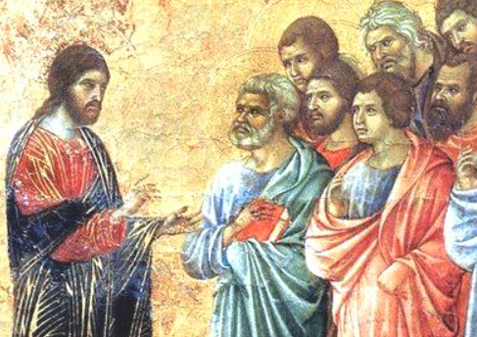
Anamehawikamek Welcome
ST. MICHAEL CATHOLIC CHURCH
PO Box 610, N816 State Highway 47-55,
Keshena, WI 54135 - Phone: 715-799-3811
Email: office@stmichaelkeshena.org
Website: stmichaelkeshena.com
Find us on Facebook: St. Michael’s Church

MISSION STATEMENT: St. Michael’s Christian Community, located on the Menominee Indian Reservation, is a diverse Christian community reaching out to all residents, learning, loving, sharing, and communicating with one another through the teachings and practices celebrated in the Mass & the Holy Sacraments of the Catholic Church by integrating sacred symbols and spiritual practices of the Menominee.
KNIGHTS OF COLUMBUS: Contact Grand Knight Paul Marroquin 715-853-2414.
HOLY HOUR: Every Friday after 8:00 am Mass.
ANOINTING OF THE SICK: Individual arrangements can be made through the Parish Office.
BAPTISM: Kindly contact parish office.
MARRIAGE: Make arrangements with the Priest, six months prior to desired date.
CONFIRMATION: Contact Deacon Mark Fuller for information via email mpfull7@gmail.com.

