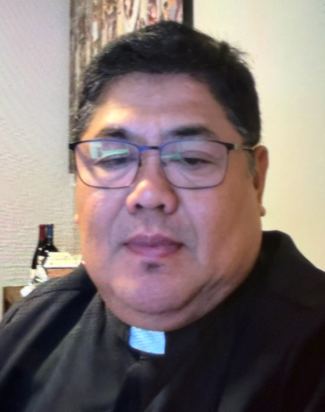 A Note from Father Juan
The Gospel presents a challenging message from Jesus: “Whoever wishes to come after me must deny himself, take up his cross, and follow me.”
Jesus had just revealed to His disciples that He would suffer, die, and rise again. Peter could not accept this. He wanted Jesus to avoid suffering. But Jesus teaches Peter—and all of us—that God’s way is often different from our human way of thinking.
1. Following Jesus involves the cross.
Christian discipleship is not always easy. There are moments of suffering, sacrifice, disappointment, and difficulty. Jesus does not promise that His followers will have no crosses. Instead, He promises to walk with us as we carry them.
Our crosses can be sickness, family problems, loneliness, financial difficulties, responsibilities, or simply the daily sacrifices we make for others. When we unite these struggles with Christ, they can become a path toward holiness.
2. We must not think only according to human standards.
Peter wanted a Messiah without suffering. Sometimes we also want Christianity without sacrifice—a faith that gives us blessings but asks little from us. Jesus reminds us: “You are thinking not as God does, but as human beings do.”
Faith calls us to trust God’s plan even when we do not understand it.
3. What does it mean to lose our life?
Jesus says, “Whoever wishes to save his life will lose it, but whoever loses his life for my sake will find it.”
This does not mean that we should neglect ourselves. It means that we should not make ourselves, our possessions, or our ambitions the center of our lives. True happiness comes when we give ourselves in love—especially through service, forgiveness, compassion, and generosity.
A question for us:
What cross am I carrying today? And am I carrying it alone, or am I allowing Jesus to walk with me?
The cross is not the end of the Christian story. Jesus carried His cross, died, and rose again. Therefore, whatever cross we carry with faith and love can lead us toward new life.
Prayer:
Lord Jesus, help us to follow You faithfully. When life becomes difficult, give us courage to carry our crosses without losing hope. Teach us to think as God thinks and to love as You love. May our sacrifices become acts of love and may our lives always lead others closer to You. Amen.
In Christ, Fr. Juan C. Tejerero
MASS SCHEDULE
INTENTIONS
08/29-5:00 pm…………….Judy Blochowicz
08/30-9:00 am…………….Dean Schneider
08/31………………………..No Mass
09/01-8:00 am…………….The homeless
09/02-8:00 am…………….For peace in Holy
Land
09/03-8:00 am…………….For all expectant
parents
09/04-8:00 am…………….Tribal Elders
09/05-5:00 pm…………….John & Marge
Glauser
09/06-9:00 am…………….Jim & Joleen
Kaquatosh & Kinsey
Financial Blessings
August 22th & 23th

Envelope/Contributors | $3409.00
Loose Collection | $451.00
We are in need of Weekday Mass intentions. Mass intentions are $20.00 per Mass.
Thank you for supporting our Parish!
Adult Confirmation News:
Deacon Mark is in the planning stages for an Adult Confirmation Class at St. Michael's starting this Fall. If you are interested in registering or just want some general information about the class, please contact Deacon Mark at the office number 715-799-3811 or by email mpfull7@gmail.com.

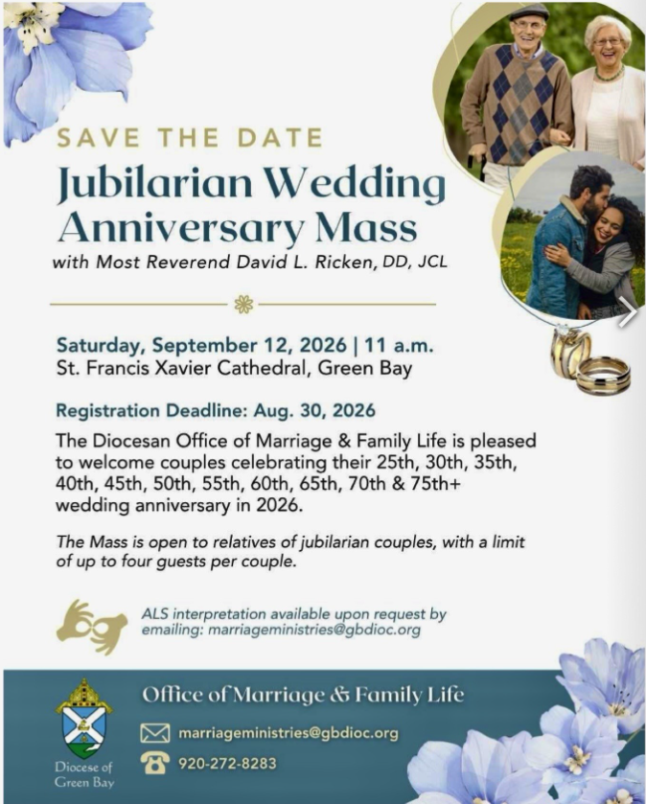
School Supplies Thank you:
Thank you for the generous donations of school supplies and backpacks for the community. The Eagle's Nest Homeless Shelter was very appreciative of the donations and will supply their school age residents, tiny homes and transition home children with the needed supplies. Clothing coupons were also given for Thrift and Gift for school clothes. Blessings on everyone who contributed.
Faith Formation News:
Classes for students in grades 1 through High School will begin on September 16, 2026. You may bring registration forms to the parish office or contact Patty or register on Sept. 16th. New and returning students are welcome! Join us for some fun for the Kickoff!
Food Pantry News:
In August the food pantry served 90 families with 427 members. The pantry is appreciative of your donations to sustain this mission. We welcome hygiene items donated and monetary donations that help us purchase needed food. The container for donations is in the church vestibule.
The food pantry is in need of plastic and paper grocery bags. Donations of shampoo, body wash, bar soap and paper towel are greatly appreciated. The container is located in the main entrance of church.

EXTRAORDINARY MINISTER
OF HOLY COMMUNION &
LECTOR SCHEDULE

Saturday, August 29th, 5:00 p.m.
Lector: Larry Sikowski
Eucharistic Minister: Jim Gilane
Sunday, August 30th, 9:00 a.m.
Lector: Jacquie Braun
Eucharistic Minister: Ellie Sokoly
Saturday, September 5th, 5:00 p.m.
Lector: Terri Glauser
Eucharistic Minister: Muffy Culhane
Sunday, September 6th, 9:00 a.m.
Lector: Ellie Sokoly
Eucharistic Minister: Gloria Gierach
Saturday, September 12th, 5:00 p.m.
Lector: Kevin Culhane
Eucharistic Minister: Deacon Mark
Sunday, September 13th, 9:00 a.m.
Lector: Jacquie Braun
Eucharistic Minister: Deacon Mark
Saturday, September 19th, 5:00 p.m.
Lector: Rod Glauser
Eucharistic Minister: Karen Smart
Sunday, September 20th, 9:00 a.m.
Lector: Ellie Sokoly
Eucharistic Minister: Anne Sulskis

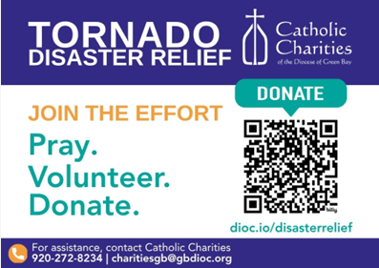

St. Michael Parish
God’s Garden
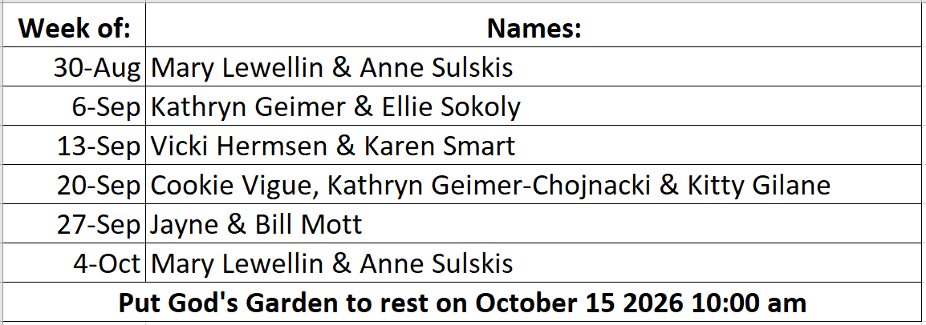


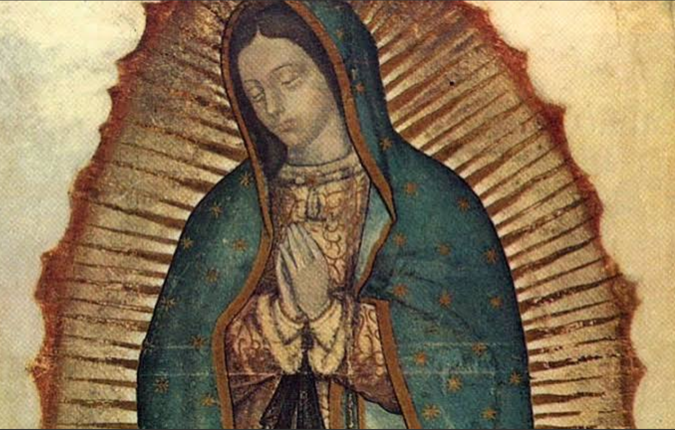St. Francis Solanus Church in Gresham is sponsoring a bus pilgrimage to Our Lady of Guadalupe Shrine in LaCrosse on Tuesday, September 29th. Deacon Mark is one of the leaders for this pilgrimage. There will likely be a few openings for this trip. If you have any interest in this opportunity to visit this beautiful shrine in the Lacrosse area, please contact Deacon Mark at 715-201-2961. Cost of the trip is only $40 dollars with a box lunch included.

14109 County VV, Gillett, WI 54124


SUNDAY BRUNCH 9-12 PM.
CHICKEN DINNER ALL DAY.

Please pick up your pans, cookie sheets, and miscellaneous items left over from funerals and other church events in the Fr. Barrett Hall.
There will not be a Mass at St. Michael on Holy Saturday, March 26. Easter Vigil will be held at St. Francis in Gresham at 7 pm. Easter Sunday Mass will be at St. Michael and St. Anthony at 10:30 am.

Maintenance. Michael Catholic Parish in Keshena is seeking a part-time maintenance person. Responsible for light maintenance, cleaning the church, etc. Contact the parish office at telephone number 715-799-3811 for an application, and job.

Please pick up your pans, cookie sheets, and miscellaneous items left over from funerals and other church events in the Fr. Barrett Hall.
There will not be a Mass at St. Michael on Holy Saturday, March 26. Easter Vigil will be held at St. Francis in Gresham at 7 pm. Easter Sunday Mass will be at St. Michael and St. Anthony at 10:30 am.
PARISH STAFF
Parish Administrator
FR. JUAN TEJERERO JR.
Parish Office (715) 799-3811
father@stmichaelkeshena.org

DEACON MARK FULLER
(715) 201-2961
mpfull7@gmail.com

Parish Secretary
RICKIE DODGE
Parish Office (715) 799-3811
office@stmichaelkeshena.org

Faith Formation
PATTI FULLER
Parish Office (715) 799-3811
faithformation@stmichaelkeshena.org


PARISH TRUSTEES
KAREN SMART, Treasurer
VICKI HERMSEN, Secretary

Parish Council Chair
MARY LEWELLIN

Finance Council Chair
THERESE GLAUSER

Thrift N Gift Coordinator
COOKIE VIGUE

Food Pantry Coordinator

MASS SCHEDULE
Saturday: 5:00 pm Mass
4:30 pm Rosary & Confession
Sunday: 9:00 am Mass
8:30 am Rosary
Monday: No Mass Tuesday – Friday: 8:00 am Mass

PARISH OFFICE HOURS
Regular hours: Monday - Thursday
9:00 am – 2:00 pm
Hours may vary, please call before coming to the office.
SATURDAY MASS: 5:00 pm
SUNDAY MASS: 9:00 am
CONFESSION: Saturday 4:30 - 4:45pm
ROSARY: Saturday 3:40 pm Sunday 8:35 am
DAILY MASS: Chapel Southside of Church

P Parish Administrator, Fr. Nonito Barra - 715-799-3811 - pastor@livingwaterslivingfaith.org
Rectory – 715-994-1337
Parochial Vicar Fr. Joel Jores - 715-787-3377 frj@livingwaterslivingfaith.org
Deacon Mark Fuller 715-201-2961- deaconmark@livingwaterslivingfaith.org
Parish Secretary, Vicki Hermsen - 715-799-3811 - vicki@livingwaterslivingfaith.org
Religious Education Kathy King-Tucker - 715-799-3927 – ltucker@frontiernet.netmailto:maczuzak@frontiernet.net
Wednesday 6 – 7:30 pm September – May
Parish Administrator, Fr. Nonito Barra - 715-799-3811 - pastor@livingwaterslivingfaith.org
Rectory – 715-994-1337
Parochial Vicar Fr. Joel Jores - 715-787-3377 frj@livingwaterslivingfaith.org
Deacon Mark Fuller 715-201-2961- deaconmark@livingwaterslivingfaith.org
Parish Secretary, Vicki Hermsen - 715-799-3811 - vicki@livingwaterslivingfaith.org
Religious Education Kathy King-Tucker - 715-799-3927 – ltucker@frontiernet.netmailto:maczuzak@frontiernet.net
Wednesday 6 – 7:30 pm September – May
Parish Administrator, Fr. Nonito Barra - 715-799-3811 - pastor@livingwaterslivingfaith.org
Rectory – 715-994-1337
Parochial Vicar Fr. Joel Jores - 715-787-3377 frj@livingwaterslivingfaith.org
Deacon Mark Fuller 715-201-2961- deaconmark@livingwaterslivingfaith.org
Parish Secretary, Vicki Hermsen - 715-799-3811 - vicki@livingwaterslivingfaith.org
Religious Education Kathy King-Tucker - 715-799-3927 – ltucker@frontiernet.netmailto:maczuzak@frontiernet.net
Wednesday 6 – 7:30 pm September – May

St. Michael’s Calendar
09/01/2026 Food Pantry 12:30 – 3pm
09/01/2026 Thrift N Gift 11 – 3pm
09/01/2026 Book Share 12:30 – 3pm
09/04/2026 Holy Hour after Mass
09/05/2026 B&G 2nd Collection
09/06/2026 B&G 2nd Collection

MASS TIMES
St. Michael – Saturday: 5:00 pm, Sunday: 9:00 am
Monday: No Mass Tuesday - Friday: 8:00 am Mass
St. Anthony – Sunday: 10:30 am

Book Share
Will be open Tuesday September 1st from 12:30 – 3:00 pm. We have books for all ages! We will accept books in good shape, just no old magazines, text books or encyclopedias.

Food Pantry
Will be open Tuesday, September 1st from 12:30 - 3:00 pm. There will be drive up service only and food will be placed in your trunk. Please do not get out of your vehicle. Please save brown paper bags & plastic bags and please drop them off at the Parish office.

Thrift N Gift
Will be open Tuesday, September 1st from 11:00 am - 3:00 pm. We have an abundance of household items, clothes, and great gift items. Please reach out to Cookie if you need to, 920-216-9240.

We the Knights
We always ask God to bless our community members. If you or a family member need assistance to get to a doctor appointment, we may be able to help. Call Paul at 715-853-2414 or Todd 715-584-5885.

Kateri Prayer Circle
Never underestimate the power of prayer. Just one small prayer can change your life. If you or your family members need prayers for any reason, please call one of our Kateri Prayer Circle members, who will in turn call members of their group. Soon, many prayers will be offered for your specific prayer request. Please call:

Fay Waupochick: 715-799-3437
Jacqueline Braun: 715-701-4552

You can also call the Parish Office to leave a request.

Religious Education Calendar Up Coming Events:
Wednesday, November 30th –Classes Resume
Wednesday December 7th
Wednesday December 14th
Wednesday December 21st Birthday Party- Parents
Guardians invited
Wednesday December 28th No Class
Wednesday January 4th No Class
Wednesday January 11 Classes resume
August 30, 2026
22nd Sunday in Ordinary Time
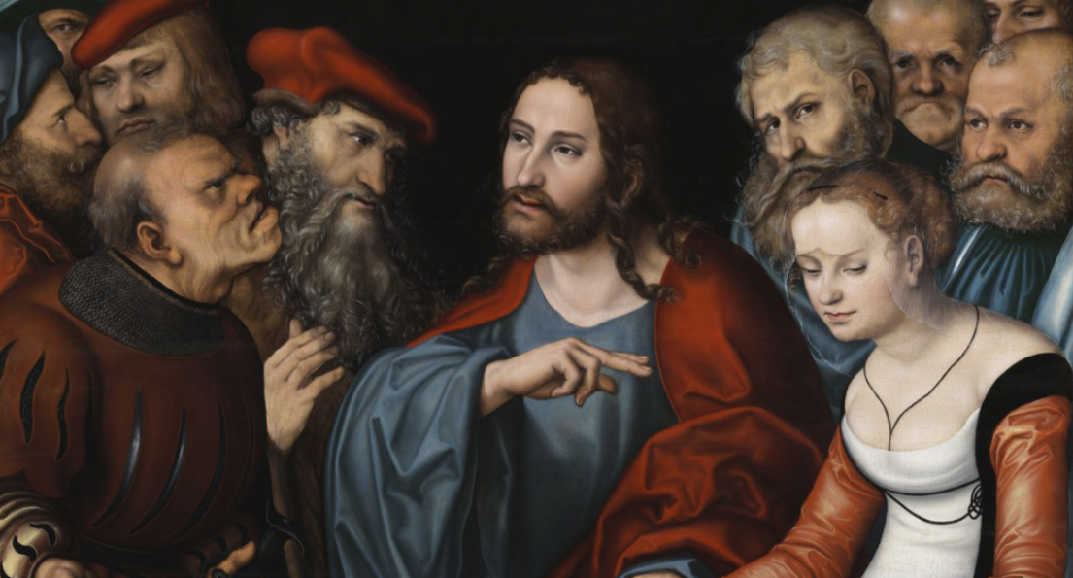
Anamehawikamek Welcome
ST. MICHAEL CATHOLIC CHURCH
PO Box 610, N816 State Highway 47-55,
Keshena, WI 54135 - Phone: 715-799-3811
Email: office@stmichaelkeshena.org
Website: stmichaelkeshena.com
Find us on Facebook: St. Michael’s Church

MISSION STATEMENT: St. Michael’s Christian Community, located on the Menominee Indian Reservation, is a diverse Christian community reaching out to all residents, learning, loving, sharing, and communicating with one another through the teachings and practices celebrated in the Mass & the Holy Sacraments of the Catholic Church by integrating sacred symbols and spiritual practices of the Menominee.
KNIGHTS OF COLUMBUS: Contact Grand Knight Paul Marroquin 715-853-2414.
HOLY HOUR: Every Friday after 8:00 am Mass.
ANOINTING OF THE SICK: Individual arrangements can be made through the Parish Office.
BAPTISM: Kindly contact parish office.
MARRIAGE: Make arrangements with the Priest, six months prior to desired date.
CONFIRMATION: Contact Deacon Mark Fuller for information via email mpfull7@gmail.com.

