A Sunday reflection
At the heart of Jesus’ frustration, and the anguish we hear from God in the reading from Isaiah, is of course their deep love for their people. Jesus isn’t angry because we’ve screwed up, he’s calling out the leaders God put in charge, the tenants who had agreed to care for the vineyard, who were leading from places of greed and selfishness. He’s singling them out for not practicing what they preach; instead of caring for the poor and the marginalized, they are caring about receiving praise and honors for themselves. Instead of joining Jesus in healing, they condemn him for breaking Sabbath laws. Instead of producing fruit that should be shared with those in need, they are hoarding those resources for their own benefit.
Jesus is not painting with a broad brush in today’s gospel, but that does not mean that we can sit back and relax. We still are invited to pay close attention to this scene, this riled-up Jesus and the trouble he’s causing in and for his religious leaders. We are being called to join God in God’s frustration.
Because sometimes our own leaders, civic and religious leaders, lose the plot. We can see it happen all around us: when our church leaders work harder to preserve their buildings and budgets than they do to serve the poor, or when our civic leaders make life-altering decisions that hurt the poorest among us the most. It’s happened over and over throughout the history of this church and this world, and God knows it will happen again.

MASS SCHEDULE INTENTIONS
10/03-5:00 pm……………..Joe Wilber
10/04-9:00 am……………..Kim Nacotee
10/05………………….……..No Mass
10/06………………………...No Mass
10/07…………………….…..No Mass
10/08-8:00 am………….….For the poor
10/09-8:00 am………….….Jimmy Laskey*
10/10-5:00 pm……………..David Wilber
10/11-9:00 am………….….Richard A Moses Sr.
We are in need of Weekday Mass intentions. Mass intentions are $20.00 per Mass.

WISH LIST 2026-2027
Lent Booklets……………....$ 75.00
Advent Booklets…………..$ 75.00
Paschal Candle…………...$ 250.00
Copy Paper………………..$ 300.00
Bulletin Paper………………$ 300.00
Altar Bread for 1 year…….$ 600.00
Missal/Song Books 1 year..$ 1800.00
Offset Monthly Utilities……$ 500.00
Church Envelopes……......$ 400.00
Concrete for sidewalks…..$ 10500.00
Bal of roof replacement....$ 3000.00
Update Sound System……. Waiting for
estimate
Financial Blessings
September 26th & 27th

Envelope/Contributors | $1078.00
Loose Collection | $357.00
Thank you for supporting our Parish!
Food Pantry News:
A big THANK YOU to Delta Dental of Wisconsin Foundation for the donation of a generous supply of toothbrushes, toothpaste and dental floss to be distributed to our food pantry recipients. We also thank the Elizabeth Street Business Complex in Shawano for the grant we received which will help us purchase food for our recipients.

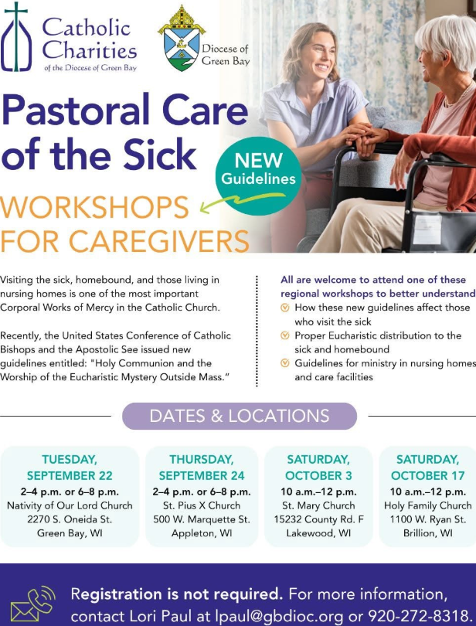
Faith Formation News:
Faith Formation Classes have begun! We welcome first grade through high school students to join us on Wednesdays 6-7:15 pm. To register please contact Patty at 715-799-3811 or register before the next Wednesday class. Mark your calendar for Wed Sept 30th – Children’s Mass and Class.

Bishop Occiano Visit:
Welcome Bishop Louisito Audal Occiano to St. Michael’s October 17th & 18th.

Bishop Occiano will celebrate Mass October 17th at 5:00 pm followed by a welcome dinner provided by the Parish. Desserts are needed. He will also celbrate Mass Sunday October 18th at 9:00 am and at St. Anthonys at 10:30 am.

Plan to join us to welcome Bishop Occiano!
EXTRAORDINARY MINISTER
OF HOLY COMMUNION &
LECTOR SCHEDULE

Saturday, October 3rd, 5:00 p.m.
Lector: Mary Lewellin

Eucharistic Minister: Jim Gilane
Sunday, October 4th, 9:00 a.m.
Lector: Ellie Sokoly

Eucharistic Minister: Gloria Gierach
Saturday, October 10th, 5:00 p.m.
Lector: Kevin Culhane

Eucharistic Minister: Muffy Culhane
Sunday, October 11th, 9:00 a.m.
Lector: Jacquie Braun

Eucharistic Minister: Karen Millet-Metzler
Saturday, October 17th, 5:00 p.m.
Lector: Terri Glauser

Eucharistic Minister: Karen Smart
Sunday, October 18th, 9:00 a.m.
Lector: Ellie Sokoly

Eucharistic Minister: Anne Sulskis

Save the dates
Saturday October 17th - Welcome dinner for Bishop Lousito Audal Occiano after 5:00 pm Mass. Desserts are needed.

Wednesday October 21st – Holiday Bazaar meeting 9:00 am. All are welcome, If you can’t make it and want to help please text Kathleen @ 920-858-6393.

Sunday October 25th - Annual Church Meeting after 9:00 am Mass.

Saturday November 7th - All Souls Supper after 5:00 pm Mass.

Saturday November 21st – Annual Holiday
Bazaar.

St. Michael Parish
God’s Garden
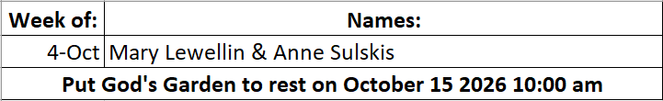

Thrift N Gift News:
Bring your Own Bag to fill for the month of October - 1 free bag per person.

World Mission Month Begins
One in Christ, United in Mission Each October, which is World Mission Month, the Church invites us to reflect upon our missionary vocation. This year’s theme, One in Christ, United in Mission, chosen by Pope Leo XIV, invites us to rediscover the profound unity we share in Christ through baptism and how our baptismal missionary identity overflows into the mission of the Church to bring all creatures into communion with God and us. The highlight of World Mission Month is the annual celebration of World Mission Sunday, which this year will take place on Oct. 18. Pope Leo XIV has stressed how important World Mission Sunday is for the Church. He spent a large part of his priestly ministry as a missionary in Peru and has noted how dependent he was on the prayers and financial support of the universal Church through World Mission Sunday. Let us pray this week for those missionaries who bring Christ’s love to far-off places, often at great personal cost and risk. And let us ask the Holy Spirit to rekindle a zeal in our own hearts, that we may also be missionaries, wherever we are


14109 County VV, Gillett, WI 54124

SUNDAY BRUNCH 9-12 PM.
CHICKEN DINNER ALL DAY.

Please pick up your pans, cookie sheets, and miscellaneous items left over from funerals and other church events in the Fr. Barrett Hall.
There will not be a Mass at St. Michael on Holy Saturday, March 26. Easter Vigil will be held at St. Francis in Gresham at 7 pm. Easter Sunday Mass will be at St. Michael and St. Anthony at 10:30 am.

Maintenance. Michael Catholic Parish in Keshena is seeking a part-time maintenance person. Responsible for light maintenance, cleaning the church, etc. Contact the parish office at telephone number 715-799-3811 for an application, and job.

Please pick up your pans, cookie sheets, and miscellaneous items left over from funerals and other church events in the Fr. Barrett Hall.
There will not be a Mass at St. Michael on Holy Saturday, March 26. Easter Vigil will be held at St. Francis in Gresham at 7 pm. Easter Sunday Mass will be at St. Michael and St. Anthony at 10:30 am.
PARISH STAFF
Parish Administrator
FR. JUAN TEJERERO JR.
Parish Office (715) 799-3811
Rectory 715-994-1337
father@stmichaelkeshena.org

DEACON MARK FULLER
(715) 201-2961
mpfull7@gmail.com

Parish Secretary
RICKIE DODGE
Parish Office (715) 799-3811
office@stmichaelkeshena.org

Faith Formation
PATTY FULLER
Parish Office (715) 799-3811
faithformation@stmichaelkeshena.org


PARISH TRUSTEES
KAREN SMART, Treasurer
VICKI HERMSEN, Secretary

Parish Council Chair
MARY LEWELLIN

Finance Council Chair
THERESE GLAUSER

Thrift N Gift Coordinator
COOKIE VIGUE

Food Pantry Coordinator

MASS SCHEDULE
Saturday: 5:00 pm Mass
4:30 pm Rosary & Confession
Sunday: 9:00 am Mass
8:30 am Rosary
Monday: No Mass Tuesday – Friday: 8:00 am Mass

PARISH OFFICE HOURS
Regular hours: Monday - Thursday
9:00 am – 2:00 pm
Hours may vary, please call first.
SATURDAY MASS: 5:00 pm
SUNDAY MASS: 9:00 am
CONFESSION: Saturday 4:30 - 4:45pm
ROSARY: Saturday 3:40 pm Sunday 8:35 am
DAILY MASS: Chapel Southside of Church

P Parish Administrator, Fr. Nonito Barra - 715-799-3811 - pastor@livingwaterslivingfaith.org
Rectory – 715-994-1337
Parochial Vicar Fr. Joel Jores - 715-787-3377 frj@livingwaterslivingfaith.org
Deacon Mark Fuller 715-201-2961- deaconmark@livingwaterslivingfaith.org
Parish Secretary, Vicki Hermsen - 715-799-3811 - vicki@livingwaterslivingfaith.org
Religious Education Kathy King-Tucker - 715-799-3927 – ltucker@frontiernet.netmailto:maczuzak@frontiernet.net
Wednesday 6 – 7:30 pm September – May
Parish Administrator, Fr. Nonito Barra - 715-799-3811 - pastor@livingwaterslivingfaith.org
Rectory – 715-994-1337
Parochial Vicar Fr. Joel Jores - 715-787-3377 frj@livingwaterslivingfaith.org
Deacon Mark Fuller 715-201-2961- deaconmark@livingwaterslivingfaith.org
Parish Secretary, Vicki Hermsen - 715-799-3811 - vicki@livingwaterslivingfaith.org
Religious Education Kathy King-Tucker - 715-799-3927 – ltucker@frontiernet.netmailto:maczuzak@frontiernet.net
Wednesday 6 – 7:30 pm September – May
Parish Administrator, Fr. Nonito Barra - 715-799-3811 - pastor@livingwaterslivingfaith.org
Rectory – 715-994-1337
Parochial Vicar Fr. Joel Jores - 715-787-3377 frj@livingwaterslivingfaith.org
Deacon Mark Fuller 715-201-2961- deaconmark@livingwaterslivingfaith.org
Parish Secretary, Vicki Hermsen - 715-799-3811 - vicki@livingwaterslivingfaith.org
Religious Education Kathy King-Tucker - 715-799-3927 – ltucker@frontiernet.netmailto:maczuzak@frontiernet.net
Wednesday 6 – 7:30 pm September – May

St. Michael’s Calendar
10/03/2026 Food Pantry 2nd Collection
10/04/2026 Food Pantry 2nd Collection
10/06/2026 Food Pantry 12:30 – 3pm
10/06/2026 Thrift N Gift 11 – 3pm
10/06/2026 Book Share 12:30 – 3pm
10/07/2026 Faith Formation Class 6:00 - 7:15pm
10/08/2026 Parish Finance Council meeting
10/09/2026 Holy Hour after Mass

MASS TIMES
St. Michael – Saturday: 5:00 pm, Sunday: 9:00 am
Monday: No Mass Tuesday - Friday: 8:00 am Mass
St. Anthony – Sunday: 10:30 am

Book Share
Will be open Tuesday October 6th from 12:30 – 3:00 pm. We have Fall & Halloween books! We will accept books in good shape, just no old magazines, text books or encyclopedias.

Food Pantry
Will be open Tuesday, October 6th from 12:30 - 3:00 pm. There will be drive up service only and food will be placed in your trunk. Please do not get out of your vehicle. Please save brown paper bags & plastic bags and please drop them off at the Parish office.

Thrift N Gift
Will be open Tuesday, October 6th from 11:00 am - 3:00 pm. We have an abundance of household items, clothes, and great gift items. Please reach out to Cookie if you need to, 920-216-9240.

We the Knights
We always ask God to bless our community members. If you or a family member need assistance to get to a doctor appointment, we may be able to help. Call Paul at 715-853-2414 or Todd 715-584-5885.

Kateri Prayer Circle
Never underestimate the power of prayer. Just one small prayer can change your life. If you or your family members need prayers for any reason, please call one of our Kateri Prayer Circle members, who will in turn call members of their group. Soon, many prayers will be offered for your specific prayer request. Please call:
Fay Waupochick: 715-799-3437
Jacqueline Braun: 715-701-4552
You can also call the Parish Office to leave a request.

Religious Education Calendar Up Coming Events:
Wednesday, November 30th –Classes Resume
Wednesday December 7th
Wednesday December 14th
Wednesday December 21st Birthday Party- Parents
Guardians invited
Wednesday December 28th No Class
Wednesday January 4th No Class
Wednesday January 11 Classes resume
October 4th, 2026
27th Sunday in Ordinary Time
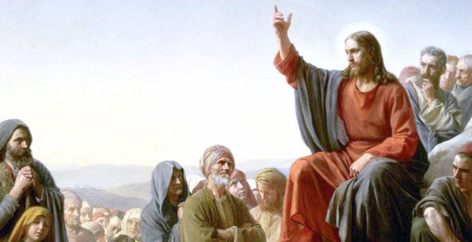
Anamehawikamek Welcome
ST. MICHAEL CATHOLIC CHURCH
PO Box 610, N816 State Highway 47-55,
Keshena, WI 54135 - Phone: 715-799-3811
Email: office@stmichaelkeshena.org
Website: stmichaelkeshena.com
Find us on Facebook: St. Michael’s Church

MISSION STATEMENT: St. Michael’s Christian Community, located on the Menominee Indian Reservation, is a diverse Christian community reaching out to all residents, learning, loving, sharing, and communicating with one another through the teachings and practices celebrated in the Mass & the Holy Sacraments of the Catholic Church by integrating sacred symbols and spiritual practices of the Menominee.
KNIGHTS OF COLUMBUS: Contact Grand Knight Paul Marroquin 715-853-2414.
HOLY HOUR: Every Friday after 8:00 am Mass.
ANOINTING OF THE SICK: Individual arrangements can be made through the Parish Office.
BAPTISM: Kindly contact parish office.
MARRIAGE: Make arrangements with the Priest, six months prior to desired date.
CONFIRMATION: Contact Deacon Mark Fuller for information via email mpfull7@gmail.com.

