THE LONDON SOFTWOOD CLUB
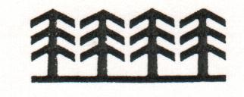

OCTOBER LUNCHEON MEETING
Thursday 8 October 2026 | 12.15 pm for 1.00 pm
THE BALLROOM, THE CLERMONT HOTEL (CHARING CROSS)  The Strand, London WC2N 5HX |  |  |  |  |  |  |  |  |  |  | TICKETS  £80
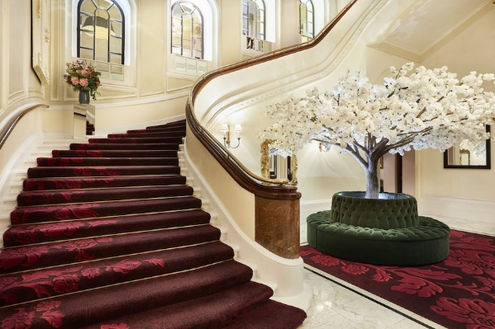 |  |  |  | 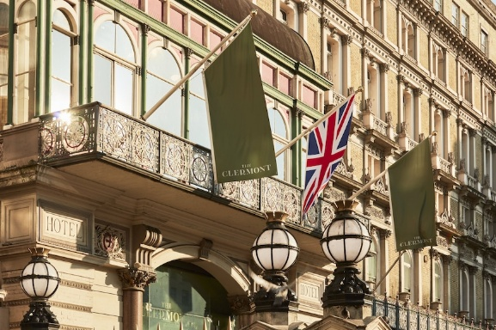 |  |  |  |  |  | 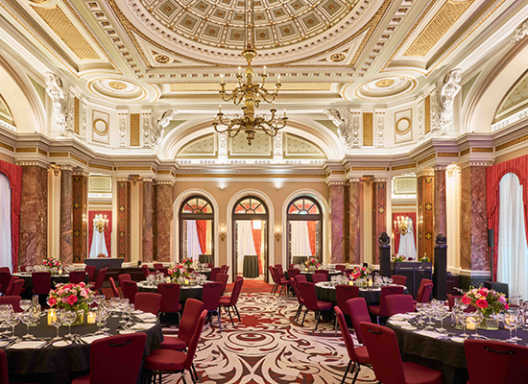
GUEST SPEAKER: MIKAEL ARVIDSSON
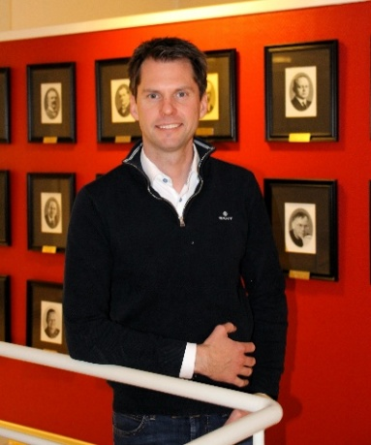 |  |  | Mikael Arvidsson is the founder and Group CEO of Amwood, as well as CEO and Head of Sales at Sweden Timber. With more than 18 years' experience in the wood industry, he has developed a business that began primarily in timber sales in 2013 into an international forest-products group spanning timber, paper, speciality pulp and bio-based composite materials. Sweden Timber operates sawmills and planing and processing mills across Malmback, Hjortkvarn, Skillingaryd and Mora. The wider Amwood group includes Hylte Paper, WoodComposite Sweden and Aspa Pulp, supplying customers in more than 50 countries.
BOOKING SLIP - MEMBER & CONTACT DETAILS (please confirm any dietary requirements)
Member / company | Click or tap to enter member / company name |  |  |  |  | Contact name |  | Click or tap to enter contact name
Email | Click or tap to enter email address |  |  |  |  | Telephone |  | Click or tap to enter telephone number
Number of places |  | Enter number of places |  |  | Total payment (£80 pp) |  |  |  | Enter total payment
PAYMENT: London Softwood Club  A/C 00071697 | Sort code 30-00-09 |  |  |  |  |  |  | EMAIL COMPLETED SLIP TO  jessica.vernon@timbergardenbuildings.co.uk  Copy: cindycrancherlsc@outlook.com
Places cannot be reserved until payment has been received. | Contacts: Cindy Crancher & Jessica Vernon

