**How to order a DECK kit – step by step**

1. Enter the English version site: <https://www.yigalzemachrelationshipscouncelling.co.il/t-en>
2. Choose the payment currency (currently only USD and ILS are available):



Click here

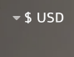

Click here

USD - $  
ILS – ש"ח

Choose here

Sometimes the currency refuses to switch (a problem in the site SW). Pressing the "refresh" button several times in a sequence, should solve the issue.

1. 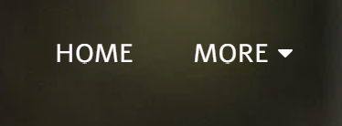

ABOUT ME  
COUNCELLING  
APPROACHES  
DECK  
ORDER DECK  
. . .

Bring cursor here

Click here

1. Click the picture (or the "DECK KIT" text):



Click here

1. Click the new picture:



Click here

1. Click "ADD TO CART":

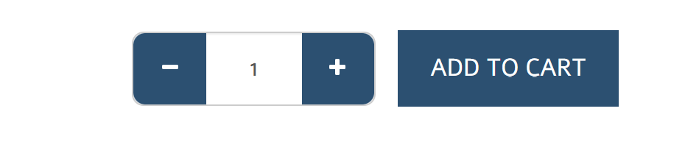

Click here

1. Click "MAKE AN ORDER":

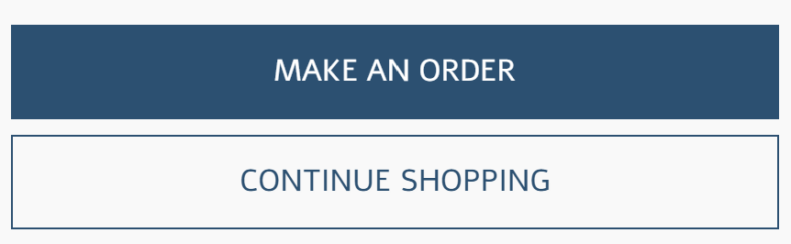

Click here

1. Fill your name, billing address, phone-number, e-mail, at the relevant slots
2. Fill your ID number
3. If the shipping address is not identical to the billing address, unmark the "My shipping … the same" box and fill the exact shipping address details.
4. Do not forget to mark the "I have read and I accept" box
5. Click "SAVE AND CONTINUE":

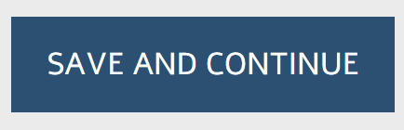

Click here

1. Once again, click "SAVE AND CONTINUE"
2. Choose (mark) either "Credit Card" or "Bank Transfer" as your payment method:

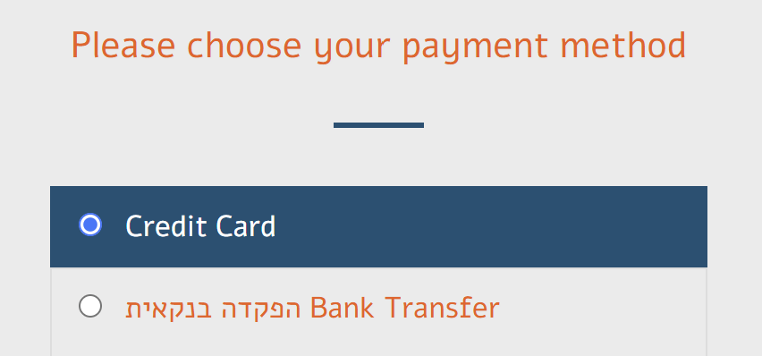

Mark here  
Or here

1. If you chose "Bank Transfer", a box now opens with the details of the billing account. Write them down, or perform the transaction now, since the details will disappear on the next click.
2. Click "PLACE ORDER":

Click here



1. Complete the payment and you are done.