**DECK = Depict Emotional Cycle Kit**

**A therapeutic-Cards-based kit supporting Emotional Work / Event Analysis**

**Designed for use in Emotionally Focused Therapy (EFT) with couples.**

**General**  
This brief document presents a product and proposes a method of use. The product is called DECK (Depict Emotional Cycle Kit), and it is intended to be a tool for therapists working within the framework of Emotionally-Focused Therapy (EFT). The document assumes that readers are familiar with the theory and practice of this approach, as described in extensive literature (see, for example: Johnson, 2019; Johnson et al., 1999).

The system is intended for use in a full 90-minute session. During the session, the couple brings a recent argument they experienced, and with the help of the tool, the therapist decodes the “cycle”[1] together with the couple, in an experiential and tangible manner. This allows them to recognize it, delve deeper, share their emotions, and undergo a corrective emotional experience.

**Materials**  
The kit includes: a set of therapeutic cards, a set of blank papers for writing, a “Cycle” board on which the cards and written papers are placed, and this instruction booklet (in English).

**Additionally required:** thin marker pen(s), a small table.

The card set contains open-ended drawings (subject to interpretation, ambiguous, and rich in detail). There are 60 double-sided cards, providing 120 images. Examples of cards are provided in Appendix B. Each card measures 7x10 cm.

The structure of the “Cycle” board is detailed in Appendix C. The size of the “Cycle” board is approximately 62x43 cm.[2]

The second set contains blank papers for recording text that relates to the interpretation of the card as provided by the client(s) with the therapist’s assistance. They are the same size as the cards (7x10 cm).

The marker pens are used to write short text on the blank papers. It is recommended to use different colors for each partner.

The table should be large enough to accommodate the “Cycle” board and 24 cards laid out. Therefore, a table size of 105x45 cm should suffice. Alternatively, two smaller tables can be used - one for the “Cycle” board and the other for the card layout.

**Therapeutic Work Options**

The couple chooses a recent argument they had, which will be analyzed together. At this stage, they provide only a title, enough to ensure they are both referring to the same event.

**Introduction (the therapist explains to the couple):**

We are analyzing an argument to clarify the patterns and dynamics at work within each of you, and between you as a couple. Emphasize that this is not about judgment but observation. We will be both within the situation and observing it from the outside.

It is essential to understand that if someone describes, for instance, a thought that crossed their mind during the argument, it does not necessarily mean they still think this way or that this is the only way to view reality. It is more like a snapshot of what was going on in their mind at that specific moment.

It is recommended to use guided imagery to help the couple evoke the emotions of the argument[3]. Each is asked to state when, for her/him, the argument began - the precise moment they first felt discomfort or an urge to respond (if they say something like, "It started when I said...", try to take a step back and check if that statement was actually a reaction to an earlier trigger). Identify the earliest event between the two, which will be referred to as the "trigger".

Lay out 18–24 cards for selection[4]. Explain that each card has two sides, but they will use only one side (avoid allowing them to flip and examine the other side during the selection process). Without talking to each other, each person selects three cards to represent:

1. The thoughts that arose in them.
2. The emotions they experienced.
3. The action they took (one card per description).

The instruction is: "Find *something* in the card that can describe the emotion / thought / action. It does not have to relate to everything on the card—it could even be a minor detail that, for you, symbolizes what was thought / felt/ done." Wait until both have made their selections.

Begin with the "trigger" event (the earlier of the two identified as the start of the argument - the trigger). Ask the person who reacted to the trigger to also select a card that represents the trigger itself. S/he places the trigger card in the corresponding board slot, and briefly explains her/his choice of card. The therapist explains that the board is divided into two parts - the left for one partner and the right for the other. In the first part of the session, the focus remains on the upper part of the board (from thoughts and up).

Continue with the same partner (the one triggered first), moving card by card through the cards chosen to represent their emotion, thought, and action[5]. Place each card in its corresponding slot on the board and ask the client to explain. The therapist slows down, reflects, validates, and emphasizes as needed, following standard EFT practice.

Focus on what seems significant or unclear, and strive to keep the emotion alive. Empathic conjectures may be raised, and bodily sensations or imagery may be requested (the card itself serves as imagery that can be utilized) - whatever seems appropriate. Together with the client, we write the relevant very brief text[6] on a blank paper dedicated to the relevant category (thought, emotion or action). We choose a different colored marker pen for each partner.

**When the explanation given for the emotion card aligns more with a thought, label the text as a thought** (on the sheet of paper dedicated to the thought category) **and prompt the expression of the appropriate emotion** (or any similar adjustment. We ensure that the content of the text aligns as closely as possible with the appropriate category). If a

primary emotion arises, open the "Deep Emotion" text sheet, write down the primary emotion, and save it for later work in the lower part of the board.

Place the text sheet next to the corresponding card and move on to the next card until the upper part of the board is completed for the first partner.

At this point, summarize the entire sequence of event, thought + emotion, and response. **Meta-processing:** How was this part for you? Did anything new come to light?

At this stage, there is an option to "fold" the text onto the card if the board seems too crowded (use the dashed lines for that). This is at the therapist’s discretion, though consulting the couple is also possible.

Switch to the second partner. ***How was it for you to hear this?*** If a new understanding emerges, enactment may be pursued. If there is resistance, address it accordingly.

Now perform the same EFT process with the second partner regarding their thoughts, emotions, and actions, as was done with the first partner, while remaining in the upper (explicit) part of the cycle board.

Try to connect the stories, observing how one partner's response becomes the other’s trigger, and what happens in between. Summarize, ask the second partner for reflection on the process, and finally return to the first partner to ask, ***How was it for you to hear this?***

At any stage, if an opportunity for enactment arises, use it.

This completes the **upper part of the cycle**[7]**.**

Add cards to replace the 7 that were used, so there are again 18-24 cards for selection. Each partner selects two new cards: one for an unmet need (what would have been fulfilled if things had gone the way you wanted?) and another for the deeper emotion (what truly occurred within you - emotions that may have already been touched upon and now need further exploration).

Once the cards are selected, return to the first partner and work on her/his unmet needs. **Deepening:** What would happen if...? What would happen if not...? Complete the text sheet and place the card and text in the appropriate slots on the cycle board. Finally, follow the same process for the deep (primary) emotion.

It is very possible that at the selection stage, they will struggle to identify primary emotions or basic needs. Leave the card as is but deepen the work as much as the client is capable of at the moment. It is also possible that during the deepening process, they may wish to replace their card. This is perfectly fine.

Repeat this work (in the **lower part of the cycle**) with the second partner. After each partner, conduct meta-processing with the option for enactment.

Now summarize the entire process - show the complete cycle in sequence: trigger, deep emotions and needs, secondary thoughts and emotions, and behavior that becomes the other’s trigger, ... It is recommended to highlight the commonalities between the partners. Taking a photo of the board is an option.

When discussing the cycle as a whole, it is important to normalize it and emphasize that the enemy of each one of them is not their partner but the cycle, which is their shared adversary. Sometimes here-and-now emotions related to the cycle itself will surface – this is an excellent opportunity to work with them.

If time and emotional capacity permit, continue discussing the action the first partner took after the second partner responded, showing how the cycle continues. In such cases, additional cards and text sheets may be layered over existing ones. Sometimes a card remains from one stage to the next - this is acceptable. Cards can also be recycled into other slots in a second cycle.

Option: Ask the couple to switch seats, so they sit in front of the partner's board side, and say something about what they see.

**It is important to exit the cycle in a positive state.** If an enactment took place at the end of the process, conclude through it. If not, allow each partner to express what moved them most in what they heard from the other, and attempt to create an enactment around this. Check if anything remains difficult for them and try to address it.

Make sure to acknowledge and thank them for the work they’ve done.

**Comparison to the Tango Work**[8]

The cycle process includes all the elements of the tango work, but the order of appearance and the dosage may differ.

For each card worked on, there will be reflection and validation. One challenge that may arise is that the emotion can relate to the original event but differ from the emotion felt in the present moment. It is advisable to address both.

The division into thought, emotion, and action naturally helps organizing experience and emotion. Empathic conjectures and evocative questions will deepen and refine the experience. The variety of cards naturally creates repetition. The visual nature of the cards invites image-based reflections, which can be further deepened.

At the beginning of the cycle, the process may be turbulent (as is common). The therapist will choose the right timing to slow down and speak in a soft tone to invite deeper work. Maintain focus on the specific event and avoid letting clients drift into general descriptions. Those are reserved for the stage when discussing the cycle as a whole.

Accordingly, some deepening is done while still in the **upper part** of the cycle. When moving to the **lower part**, the primary focus is on deepening, refining, and revealing primary emotions, which may feel alien, frightening and unacceptable.

Opportunities for enactment should be sought, and every completion of a “quarter board” (e.g., the upper part for Partner 1) is a natural point to initiate an enactment if appropriate.

The full cycle review provides a global organization of all that has been achieved in the session, akin to Stage 5 of the Tango. Meta-processing is conducted at the end of each “quarter board,” as previously explained.

**References**

Johnson, S. M. (2019). *Attachment theory in practice: Emotionally focused therapy (EFT) with individuals, couples, and families*. Guilford Publications.

Johnson, S. M., Hunsley, J., Greenberg, L., & Schindler, D. (1999). Emotionally focused couples therapy: Status and challenges. *Clinical psychology: Science and practice*, *6*(1), 67.

Woolley, S. R., & Johnson, S. M. (2005). Creating secure connections: Emotionally focused couples therapy. *Handbook of clinical family therapy*, 384-405.

**Acknowledgments and Gratitude**

* **EFT Theory and Practice:** **Leslie Greenberg, Susan Johnson**.
* **Visual Illustration of Couples' Infinite Loop:** **Scott Woolley**.
* **Card Illustrations:** **Yaya Raz**.
* **Development of DECK:** **Yigal Zemach**, 972-52-947525  
  [https://www.yigalzemachrelationshipscouncelling.co.il](https://www.yigalzemachrelationshipscouncelling.co.il/)
* Special thanks to several ICEEFT members for their feedback, particularly **Tal Padeh, Elena Katz, Leanne Campbell and Christian Fink-Jensen.**

**Appendix A – Text for Guided Imagery**

Sit comfortably on your chair and close your eyes. Place both feet on the ground. Notice the support of the chair and the backrest. Pay attention to the sounds you hear, the temperature in the room, the smell, and the taste in your mouth. Notice the sensations in your body right now: In the facial area... the jaw…the back of the neck…the neck… the shoulders… the arms…the fingers… Notice the sensations in your back…, your chest…, your abdomen…, and your pelvis… Pay attention to your legs… Feel the contact of your feet with the floor.

Take two long breaths. Inhale through your nose and exhale through your mouth. Notice how the air enters through your windpipe into your lungs and body. What is the air encountering right now? Notice how it leaves warmer than when it entered. Take two more breaths.

Now, recall the argument of <*the title they provided*>. Go back to it as if you are there right now. Try to bring up as many details as possible. If the details come in a jumble, try to make sense of the sequence. What thoughts come up during the argument? What emotions? Use your body to feel them. What do you sense? What do you do? What does the other person do? Stay with the situation as long as you need.

In a moment, when it feels right, open your eyes. When you are ready, each of you should state when, from your point of view, the argument begins - the first thing that caused discomfort or the need to respond. You may open your eyes when you’re ready.

**Appendix B – Card Examples**

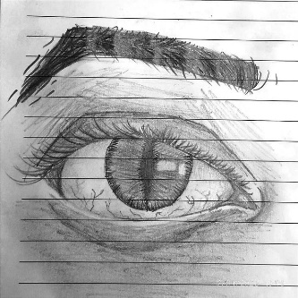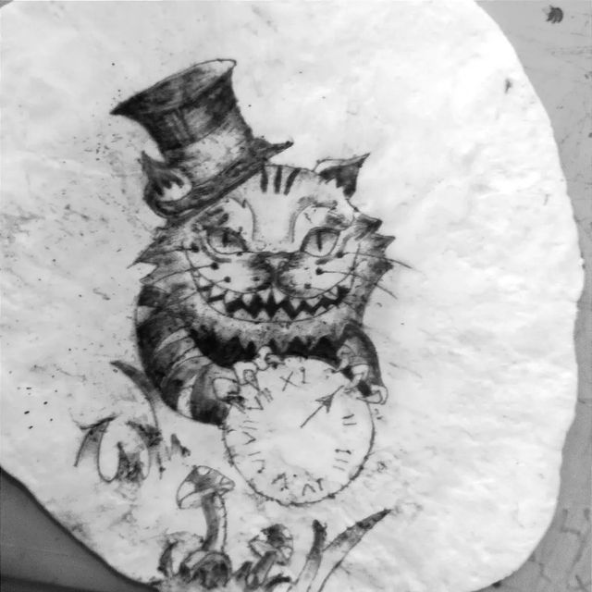

7 cm

10 cm

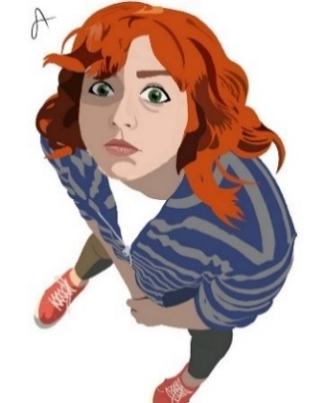

**Appendix C – Structure of the "Cycle" Board**

**Text**

**Card**

**Action**

**Card Text**

**Explicit Emotion**

**Thought**

**Card Text**

**Text**

**Card**

**Action**

**Text Card**

**Explicit Emotion**

**Thought**

**Text Card**

**Trigger**

**Need**

**Text Card**

**Deep Emotion**

**Text Card**

**Need**

**Card Text**

**Deep Emotion**

**Card Text**

**Card**

43 cm

62 cm



**The appearance of the board at the end – an illustration based on "The Little Prince" (and the rose):**

**טקסט**

**קלף**

**Action**

קלף טקסט

**Explicit Emotion**

**Thought**

**קלף טקסט**

**טקסט**

**קלף**

**Action**

**טקסט קלף**

**Explicit Emotion**

**Thought**

**טקסט קלף**

**Trigger**

**קלף**

**Need**

טקסט קלף

**Deep Emotion**

**טקסט קלף**

**Need**

**קלף טקסט**

**Deep Emotion**

**קלף טקסט**



She is beautiful and innocent;  
So why thorns?  
She invents non existing threats.   
I want to watch a sunset.

Wearing a mask.  
Factual:  
"No tigers here"  
"Tigers don't eat weed".

Anger, disappointment  
Heat, restlessness, fragmented breathing.  
Insult.

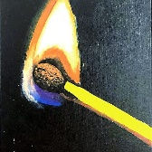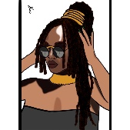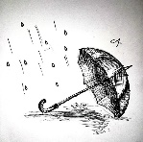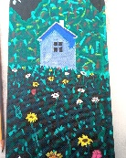

Keeps calm expression & intonation. Says "I'm not a weed" indifferently.  
Attacks: It's cold & unpleasant at your place. Bring me a screen.  
Entangled in an obvious lie. Coughing.

Humiliation, hurt pride. Insult.  
Anger, revenge wish. Wish he would atone.   
Body control, avoids showing weakness: no burst, no cry.

I'm a magnificent, gorgeous flower, not a weed.  
He deliberately calls me weed, to lower me.   
He throws me away and gives me up. Wasting my qualities.

Panic. Heart pounding, ragged breath.  
Disoriented, lost and helpless. Love that can't find itself. The blood drains from the face.

.

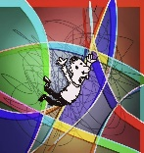

Connection, togetherness, belonging.  
Safety.  
Significance, value. That my value and effort will be seen and recognized.   
To be loved.

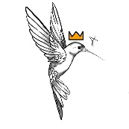

Fear.  
Sorrow ⬄ Loneliness  
Facial muscle tension, eye strain, hollow feeling in the stomach.

Freedom, Self-expression.  
Safety.  
Recognition and appreciation.  
Warmth, love; being desirable.

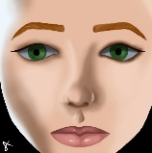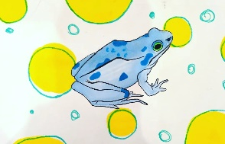

1. The description of the couple's pattern as an infinite loop or cycle is attributed to Dr. Wooley; see for example: Wooley & Johnson, 2005.
2. The board folds, so when folded, its size is approximately 22x31 cm, very close to an A4 sheet.
3. Possible text (for the guided imagery) is supplied in Appendix A
4. Use random choice to pick the 18-24 cards from the set of 60 cards. Alternatively, the therapist may prepare in advance cards they believe are suitable for the couple’s cycle based on prior sessions.
5. You may let them choose whether to start with emotion or thought. In any case, they are likely to describe them in a mixed manner, and one of our goals is to help them organize this description in a more distinct way. The action must be addressed last. A typical sequence would be: presenting a thought card – explanation – emotionally-focused processing – recording text; an emotion card – explanation – emotionally -focused processing – recording text; an action card – explanation – emotionally-focused processing – recording text; summary.
6. Typically, one word for an emotion, 2–3 words for a thought or action.
7. The assumption in the description is that the couple is in Stage 2. If the couple is only in Stage 1, the process does not delve into the deeper layers; at most, a few hints are provided.
8. See Johnson, 2019, pp. 54-67 for the description of the core EFT interventions as a Tango dance.