Friends of Garden Island Creek Landcare Group
First General Meeting
Minutes 17/4/21
Meeting Date: | 4/17/2021 | Meeting Time: | 10.00 am
Chair: | Kelsie Fractel | Meeting Location: | 14 Sunset Drive
Minute taker | Angela Bird | Next Meeting Date: | TBA
Meeting Attendees: | All attendees were required to sign in. This form and a Covid form were collected by Kimberley Mendonca
Apologies
Agenda | The agenda was published on the group’s Facebook page.  The Meeting was advertised on the Friends of Garden Island Creek Facebook page, the Cygnet Community Facebook page and flyers were distributed to some GIC residents.
Minutes
Topic | Discussion
Welcome | Welcome to Country  Introductions – the interim committee.  Guests:  - Paul Thomas from Friends of Randalls Bay (FORB)  - Rosalie Woodruff, Greens sitting member and candidate for Franklin  - Also in attendance Christine Campbell, member of the Huon Valley Council.  All attendees were given the opportunity to introduce themselves.  Points raised by residents during the introductions:  - Lack of ambulance in the area  - Lack of representation of long term residents and poor communication about the meeting being on.  - Making links with other local community organisations eg Cygnet community group.
Explanation  Why a Landcare Group. | - A Landcare Group will provide a formal, legal platform to bring forward community ideas, apply for funding and undertake community driven projects.  - The group will be inclusive of the whole of GIC – Sands, Creek, Bush  - Copies of the proposed constitution were circulated.
Governance  Voting in of the committee  Motions to formally establish the group  Election of a public officer | The group were informed that:  - Interested residents and friends are welcome to be part of the group and attend committee meetings whether financial or non-financial members.  - Membership fees are needed to cover registration of the group and other admin costs. If there are extra funds they will be used for community projects.  - Fees recommended by FORB are $10 for an individual & $20 for a family.  - Meetings could be bi monthly although this was up for further discussion.  Community members present at the meeting voted in a committee and passed a number of motions for the group to become incorporated.  The following were voted in by the community members present:  President: Kimberley Mendonca – Nominated self, Seconded by Ingrid Rahlen  Treasurer: Kelsie Fractal – Nominated self, Seconded by Ingrid Rahlen  Secretary: Angela Bird - Nominated self, Seconded by Kelsie Fractal  General Members:  Laura Pfundt Nominated self, Seconded Kelsie Fractal  Roslyn Astyn Nominated: self, Seconded: Kimberley Mendonca  Denise Wilcockson Nominated: self, Seconded Kimberley Mendonca  Maria Hunter Nominated: self, Seconded Laura Pfundt  Lucy StJack Nominated: self, Seconded Kelsie Fractal  Rob Miles Nominated: self, Seconded Kimberley Mendonca  Peter  The following motions were passed by those present at the meeting:  - I move that Friends of Garden Island Creek be formed, and that the Friends of Garden Island Creek constitution and rules be those circulated at this meeting.  Moved: Kelsie Fractal Seconded: Lukas Krosek  - I move that Friends of Garden Island Creek incorporate as an incorporated association under the provisions of the Associations Incorporations Act.  Moved: Angela Bird Seconded: Felix Fractal  - I move that Friends of Garden Island Creek be Friends of Garden Island Creek, or if that name is not approved Garden Island Creek Landcare, or if that name is not approved Garden Island Creek Land and Coast Care.  Moved: Kimberley Mendonca Seconded: Robbie Miles  - I move that Friends of Garden Island Creek open a not for profit everyday community sector banking account Bendigo Bank Cygnet.  Moved: Kelsie Fractal Seconded: Denise Wilcockson  - I move that Friends of Garden Island Creek obtain insurance that is provided by Landcare Australia, as a registered Landcare group.  Moved: Laura Pfundt Seconded: Lucy St Jack  When a group is incorporated, one member must be appointed as Public Officer.  The public officer is responsible for supplying the Commissioner of Corporate Affairs with an annual return on the prescribed form and informing the office:  - a change of Public Officer or a change of registered address  - a change of name  - the association becomes a trustee  - the association is winding up  Nomination: Angela Bird, nominated: self, Seconded: Pam ????  The nominee was elected.
Guest Speaker | Paul Thomas from Friends of Randalls Bay provided information about how their group functions. See attachment 1  Paul also provided a copy of the FORB brochure and access to a folder of other documents.
General discussion arising | - The importance of social gatherings. Attach a social gathering to a working bee.  - Make connections with council staff ie Amanda Blakely  - Budget submissions to council need to be made by May  - Important to lobby individual council members directly so they understand the issues.  - Suggested that all ‘Friends of’ groups join forces to lobby the government to address erosion issues being experienced by coastal communities and demand that a plan is in place.  - Other contacts the group needs to make – Ben ??? the local ranger, Ian Marmen, Jeremy Hood.  - Invite Jason Jacoby from PWS to attend a meeting  - Develop a communication strategy  - Be active in the local news ie Huon News, Classifieds, radio, Liv Smith Grape Vine. Clearly explain the issues.  - Bring all parties together for a meeting ie council, PWS for a conversation  - More letterbox drops to keep community informed.  - FORB have been very successful gaining grants each year. This has enabled the work on beach access and other works.  - PWS and Council are responsible for oversite and approvals.  - Paul Thomas and FORB is willing to assist the group in whatever way he/they can eg grant applications, processes.  - FOGIC were invited to attend the FORB winter dinner.
Meeting closed | While informal conversations and photos were taken it was decided to close the meeting at approximately 11.30 am.
Actions arising | What Who  Finalise the paper work required for the formal establishment of the group Kelsie Fractal  Complete meeting minutes and story for Huon News Angela Bird  Contact the committee and invite them to meet Kimberley Mendonca  Contact the local ranger to discuss beach access options eg beach ladder Angela Bird  Send information to Huon News supplied by Angela Kimberley Mendonca

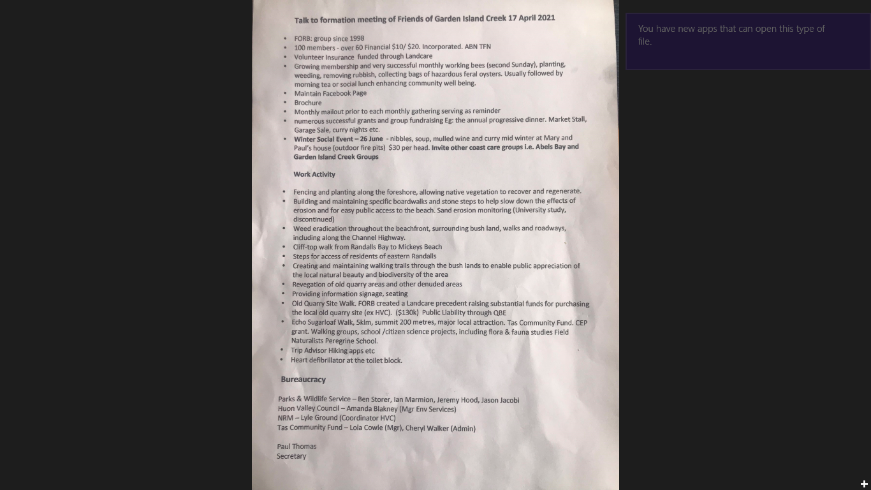
Attachment 1 Paul Thomas’ Notes

