Serenity Care Children’s Home
Statement of Purpose
Harplow
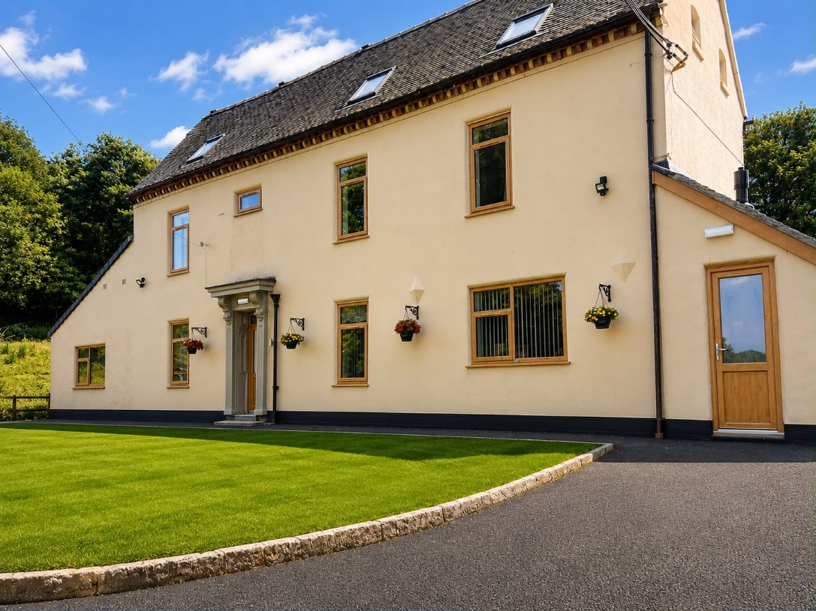

The Manager: Kelly Rushton-Martin
The Deputy Care Manager: Antony Light
Email info@serenitychildren.co.uk

Contents
QUALITY AND PURPOSE OF CARE
1. A statement of the range of needs of the children for whom it is intended that the children’s home is to provide care and accommodation.
2. Details of the home’s ethos, the outcomes that the home seeks to achieve and its approach to achieving them.
3. A description of the accommodation offered by the home, including:
(a) How accommodation has been adapted to the needs of children.
(b) The age range, number, and sex of children for whom it is intended that accommodation is to be provided; and
(c) The type of accommodation, including sleeping accommodation.
4. A description of the location of the home.
5. The arrangements for supporting the cultural, linguistic, and religious needs of children.
6. Details of who to contact if a person has a complaint about the home and how that person can access the home’s complaints policy.
7. Details of how a person, body or organisation involved in the care or protection of a child can access the home’s child protection policies or the behaviour management policy.

VIEWS, WISHES AND FEELINGS
8. A description of the home’s policy and approach to consulting children about the quality of their care.
9. A description of the home’s policy and approach in relation to:
(a) Anti‐discriminatory practice in respect of children and their families; and
(b) Children’s rights.

EDUCATION
10. Details of provision to support children with special educational needs.
11. If the home is not registered as a school, the arrangements for children to attend local schools and the provision made by the home to promote children’s educational achievement.

ENJOYMENT AND ACHIEVEMENT
12. The arrangements for enabling children to take part in and benefit from a variety of activities that meet their needs and develop and reflect their creative, intellectual, physical, and social interests and skills.

HEALTH
13. Details of Care provided, including:
(a) Details of the qualifications and professional supervision of the staff involved in providing the care; and
(b) Information about how the effectiveness of the care is measured, the evidence demonstrating its effectiveness and details of how the information, or the evidence can be accessed.

POSITIVE RELATIONSHIPS
14. The arrangements for promoting contact between children and their families and friends.

PROTECTION OF CHILDREN
15. A description of the home’s approach to the monitoring and surveillance of children.
16. Details of the home’s approach to behavioural support, including information about:
(a) The home’s approach to physical intervention in relation to children; and
(b) How persons working in the home are trained in physical intervention and how their competence is assessed.

LEADERSHIP AND MANAGEMENT
17. The name and work address of:
(a) The registered provider.
(b) The responsible individual; and
(c) The registered manager (if one is appointed).
18. Details of the experience and qualifications of staff, including any staff commissioned to provide care.
19. Details of the management and staffing structure of the home, including arrangements for the professional supervision of staff providing care.
20. If the staff are all of one sex, or mainly of one sex, a description of how the home promotes appropriate role models of both sexes.

CARE PLANNING
21. Any criteria used for the admission of children to the home, including any policies and procedures for emergency admission.
22. Management Profiles, Management flow chart and staff profiles.

Introduction
To comply with the Children’s Homes Regulations 2015, each home is required to have a Statement of Purpose. The Children’s Homes Regulations 2015 specifies that the Statement of Purpose is clear and available to staff and children. It is available to the responsible authority and any parent or person with parental responsibility. The standard also advises that the Statement of Purpose is child focussed and is updated along with the homes Children’s Guide every year in line with the Children’s Homes Regulations Schedule 1, which refers to Schedule 1 Matters to be included in the Statement of Purpose.
At Serenity Care Children’s Homes, our aim is to provide children and young people with stability of care with a view to help them to overcome traumatic life experiences, so that they can grow and learn to value themselves, fulfil their potential, and build and maintain positive relationships. Serenity Care Children’s Homes also aims to provide bespoke support packages for children with Emotional Behavioural Difficulties (EBD) and Learning Difficulties (LD).
Our main objective is to work towards meeting the holistic welfare needs of each child and young person. We will provide a child centred support that contributes to their overall personal, emotional, social, physical needs and preferences. We will work collaboratively with other services and professionals to help to maximise each person’s independence, health, and wellbeing. Staff will encourage where possible for the child or young person’s participation in the community, and to help them each achieve a full potential and positive outcomes.

Photographs of Harplow

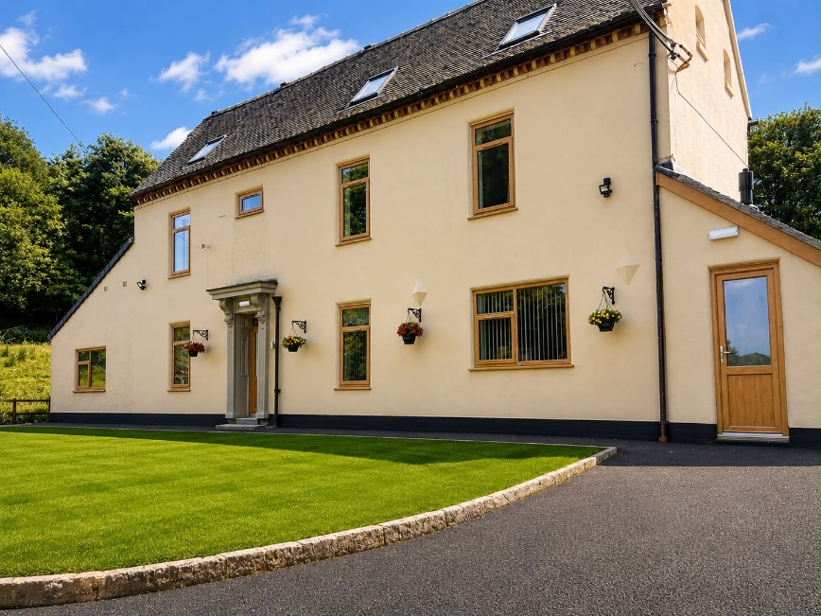
Front Elevation

Spacious Lounge Areas
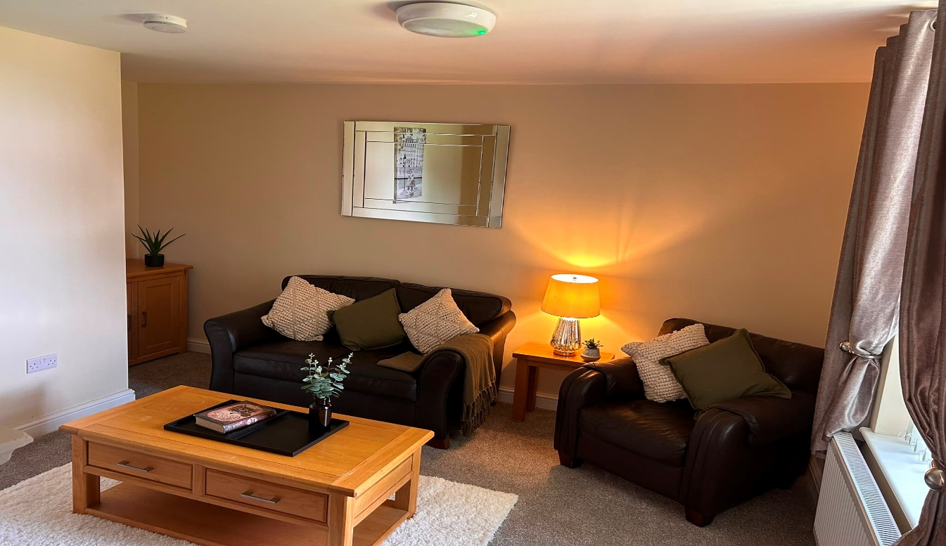
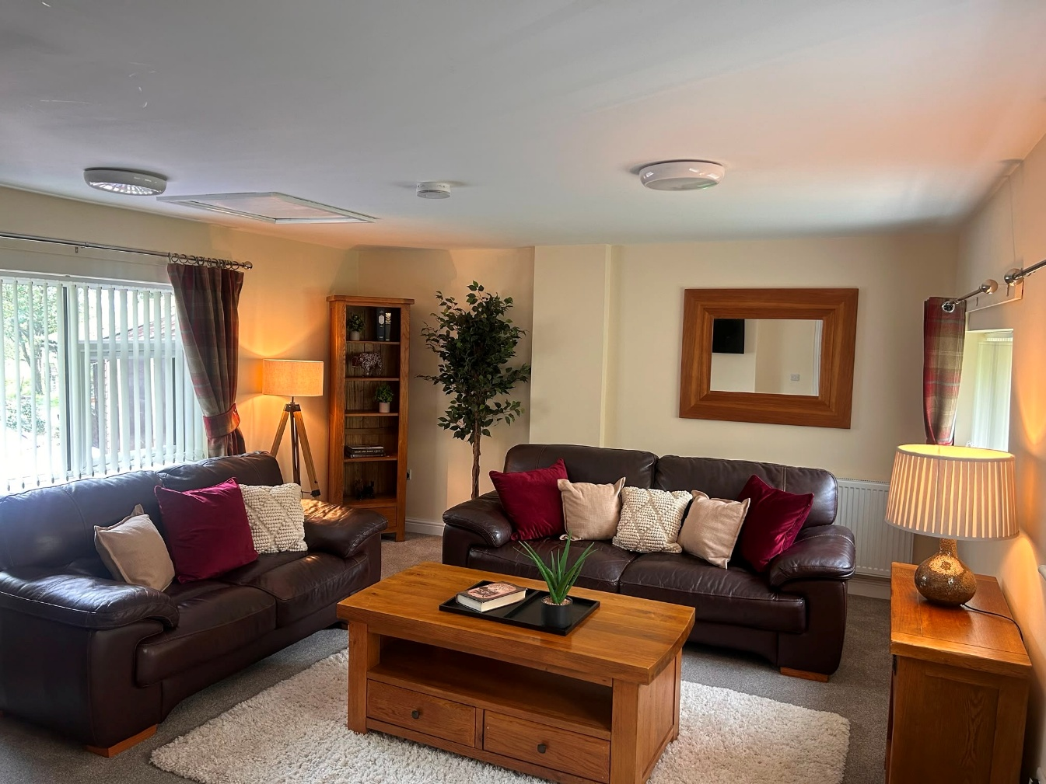
Two Spacious Lounge Areas for Relaxing and family Time

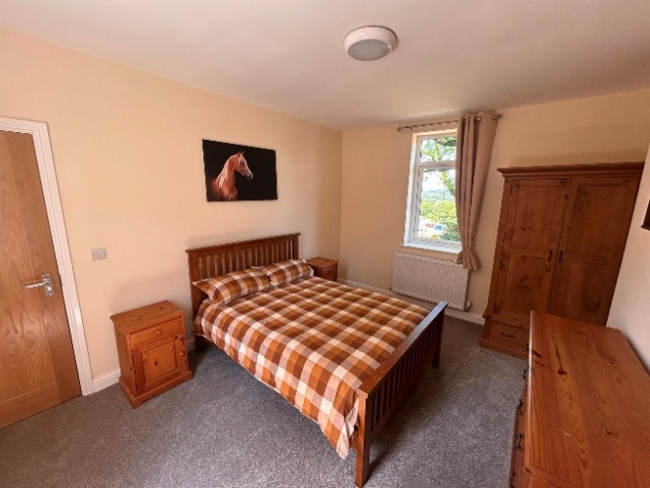
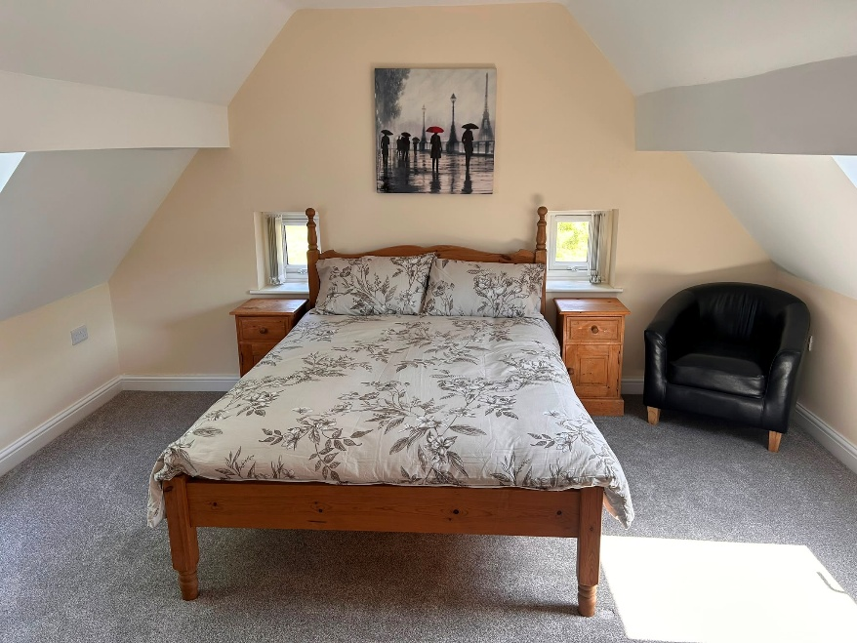
Six Spacious Bedrooms for Three Children & Three Staff (Children’s Bedrooms Pictured)

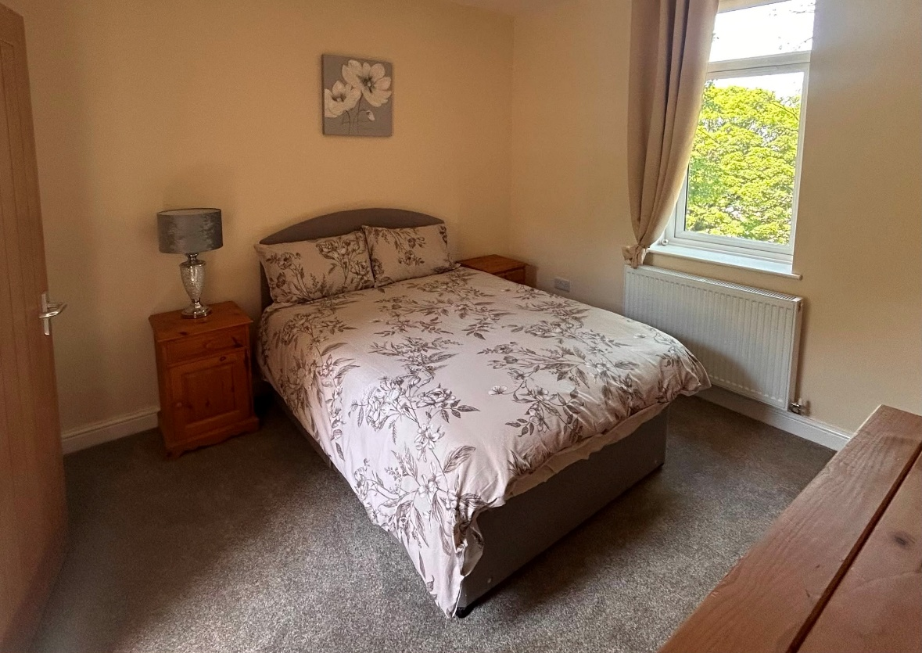

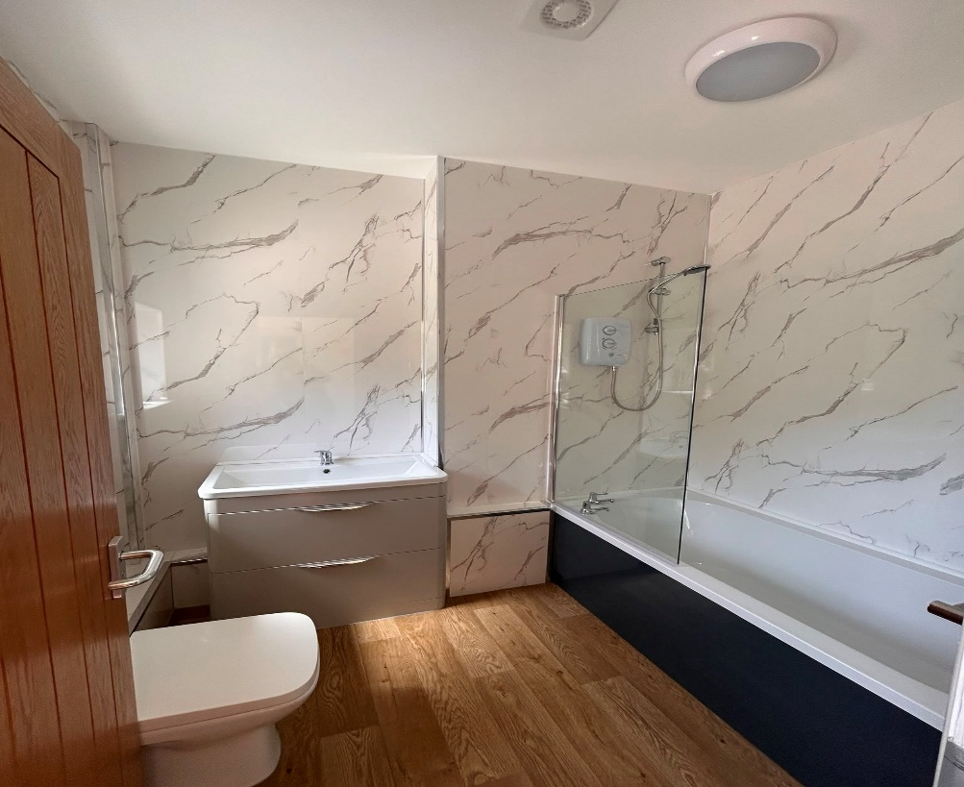
Family Bathroom

Kitchen
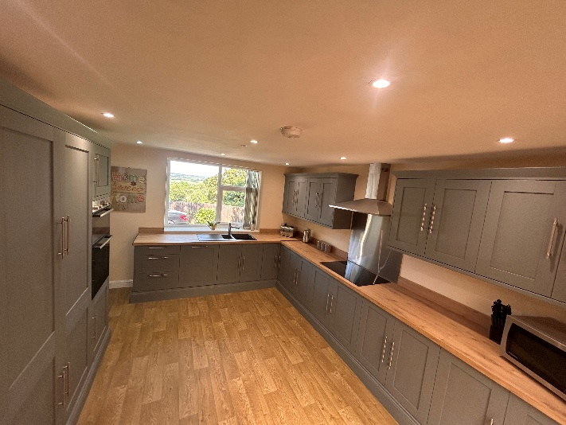
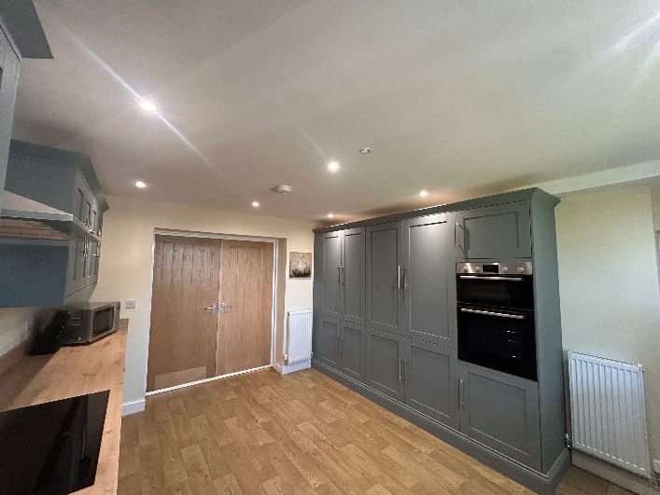

Large Bright Dining Area

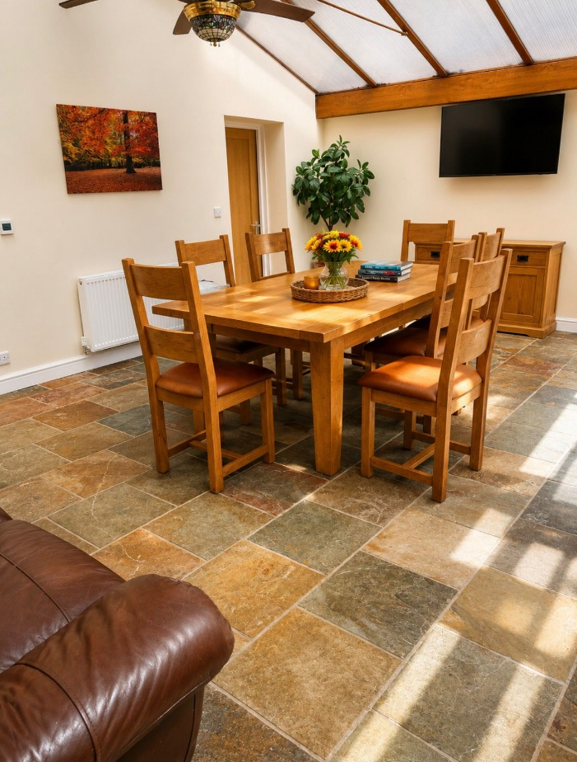

Quality and Purpose of Care
1. The range of needs of the children for whom it is intended that the children’s home is to provide care and accommodation
Serenity Care Children’s Home (Harplow) is applying to be a registered children’s home to provide care, accommodation, and education for a total of three children, male and female genders, aged 5- 17 years. We provide support for children who experience complex social, emotional and behavioural difficulties (EBD) and children with mild learning difficulties (LD).
Our home will not accommodate a new placement for an individual aged 18 years, however when placed before this age they are able to remain with us until they are 18 years.
We focus on values such as being non-judgemental, accepting each child as a unique individual providing care and empathy. We understand that to support the children in the best possible way; the needs of the child must be at the centre of everything we do.
Serenity Care Children’s Home (Harplow) provides a homely environment that is structured and caring. Staff will provide each child with daily support and will develop individual care plans to meet their unique needs. Children will be supported by the staffing team to achieve and develop themselves positively, with high expectations and valued for being themselves. The focus overall is to create the ideal conditions for a child to maximise their potential and prepare them for their adult life.
Serenity Care Children’s Homes (Harplow) recognise that children coming in to care are vulnerable and may have experienced disadvantages in their life. These disadvantages may have had a negative direct impact on their emotional and mental health and wellbeing. As a result of this they may be socially isolated or not engaged in education. Serenity Care Children’s Homes will provide support and educate in regard to an awareness of the risks in society around exploitation. We will support our children to gain their own coping mechanisms to support the prevention of exploitation.
Our approach encourages children to find their own self and identity, grow in confidence as they recognise themselves as being able to achieve, empowering their future self. Our approach supports children to heal and move forward from previously damaging and traumatic experiences.
Our staff work to build positive and meaningful relationships with our children, aiding them to support and contribute to manage their previous trauma and any associated behavioural challenges they may be facing. Our staff work together as a team providing consistency with the children and providing a family environment that is safe.
We are a positive choice for children for whom residential care is the preferred option, as most placements are offered on a long-term basis and therefore provide stability for the children and we can support children towards independent living, return to family and move towards foster placements.
Our children’s care and management plans are created in collaboration with the child and their team of professionals with a view to them being individual and person centred.

Children we care for
Our home provides residential care for up to 3 children of either male or female genders aged between 5 -17 years.
We care for children that have experienced past trauma and difficult childhood and as a result are no longer able to remain in their home with family. We support children with emotional and behavioural difficulties and also children with mild learning difficulties.
After careful consideration around matching to the area and that of the needs of other children in the home we can support children with the following range of needs:
Children’s range of needs we can support:
- Display behaviours that mean they can no longer be cared for in their family home.
- Global development delay
- Learning disabilities; Autism and ADHD.
- Difficulties in regulation skills needed for social relationships and learning.
- Sight & hearing impaired, corrected with visual or hearing aids (not deaf or blind)
- Attachment difficulties.
- Need therapeutic intervention to support in processing previous experiences
- Children that have suffered abuse and neglect.
- Struggle with living in a foster care setting
- Display behaviours that require a higher level of supervision to ensure their safety.
- Low level physical aggression
- Verbal aggression
- Self-harm
Children’s range of needs we cannot support:
- Fire setting.
- Complex Mental Health needs.
- Suicide risk.
- Knife risks or involvement with.
- Complex health care needs that cannot be managed by primary care team.
- Severe physical disabilities
- Severe Learning Difficulties

2. Our Ethos
We provide a legacy of excellence and actively listen to voices, advocating for the needs of the children. We endeavour to promote a culture based on empowerment, acceptance and learning.
All staff are supported to work together to translate our core principles into practice, assisted by high quality training. We believe that every young person should have a sense of hope, achievement, and aspiration for their future, as they may not have experienced this during early life. With a therapeutic and nurturing approach from the dedicated staffing team, we strive to reach positive outcomes and bring out the best in our children and young people.
This will be achieved by providing a warm and nurturing home offering stability and security with the overall goal in achieving permanence that allows the child to reach their full potential. Permanence may be different for each child; it might be a return to their family or a move to foster care. For this to be achieved we work towards outcomes of the child being able to understand themselves, their emotions, expressing themselves safely, developing independence skills, accessing education, building positive and meaningful relationships.
We utilise a child-centred approach, putting the child’s needs, wishes and feelings at the centre of everything we do.
We recognise that children placed with us may have recently experienced a crisis in their life, we will provide them with a feeling of safety to allow them to settle with us. In the child settling, having a sense of belonging and being provided with consistency that the nurturing environment can support them with the opportunity to explore and process their previous trauma. Serenity Care staff will seek to work with the child to understand their journey and how their experiences have impacted on their development. Using the training from our Psychology clinical team we will seek to address any of the essential building blocks that a child may have missed in their early life.
We believe that for some children residential care can be a positive choice, as some find biological family or foster placement difficult to cope with and cannot reach their full potential in these environments. In some instances, it may be more supportive to maintain family links from a residential base than from a foster home, and we will always promote family contact where this is beneficial for the child. Sibling placements together can be considered and if it is in the best interests of the children and as stipulated in their social care plan.
Serenity care can help break links with negative networks of previous abuse and neglect, whilst preserving, improving, and maintaining positive family links. Where children are placed away from their home area, we take particular care to ensure that they are made to feel safe and are supported.
One element of our ethos is that we treat crisis as an opportunity to effect lasting, positive change for our children and young people.
"During the period of crisis, a person is more susceptible to being influenced by others than at any other times of relative psychological equilibrium…this is a matter of supreme importance because by deploying helping services to deal with individuals in crisis, a small amount of effort leads to a maximum amount of lasting response.”
Gerald Caplan in “Prevention of Mental Health Disorders in young people”
Crisis is an opportunity for growth, and we endeavour to make the most of that opportunity to help the children and young people develop better, more constructive, effective coping skills and strategies.

3. Accommodation
Harplow is a 6-bedroom converted detached farmhouse set in its own large grounds with open spaces to enjoy some quiet time, play and sensory activities. Harplow has been specifically selected and adapted to meet the requirements for a residential children’s home.
Careful consideration has been given to the layout to give the children the opportunity for their choice of social interaction or own space and relaxation.
There are two lounges on the ground floor, one is a smaller, warm and inviting yet cosy lounge where social interactions can take place, or can be used for relaxation, TV and music. The second lounge is a larger space, again this lounge is warmly inviting and comfortable this can be used as a down time room, play area or communal lounge depending on the needs and wishes of the children. Both lounges are equipped with TV’s and audio equipment. The use of this equipment will be monitored for safety and to prevent access to inappropriate material unless educationally beneficial and age dependent.
Harplow has a large airy and a bright dining area that leads into the kitchen. The dining area is doubled as a communal space to relax as well as a dining room to share mealtime experiences as a family, maintaining, and encouraging sociability, building and maintaining relationships and encouraging reflective conversations on the day. The conservatory opens via double doors to the large spacious rear garden.
The home has a good sized, fully fitted kitchen with modern appliances.
The home will always be decorated and maintained to a high standard and will emit a comfortable and friendly atmosphere.
Harplow is a therapeutic, warm, and friendly environment, which cultivates children’s hopes for their future. Children will be provided opportunities through their education, therapy and daily care and support, to plan for a better future.
Children will be encouraged to have an input into decisions regarding décor and lay out of the home, with photographs of the children placed around the home to help to provide a sense of belonging, should they feel comfortable with their image being on display.
Each child will have their own bedroom, and children will be able to choose the layout of their bedroom and will be provided a personal budget for decorating the room, to support own personal identity, individuality personal and choice. The budget may be spent on individual items such as pictures, posters, personal possessions such as bedding etc.
All bedrooms are single occupancy and have comfortable furnishings, they are decorated to a high standard and include a television for each child if suitable for the child. Each child will be provided with a key to their room where age and need appropriate.

4. Location of the Home
The home is situated in a rural setting, just outside of the Historic Market Town of Cheadle, in Staffordshire. It’s located in the Staffordshire Moorlands District of Staffordshire. It is located between Uttoxeter, Leek, Ashbourne and Stoke-on-Trent.
Cheadle is a base for exploring the Peak District National Park area, which is popular with walkers and rock climbers. Surrounded by lofty hills, Cheadle is the gateway to the wooded Churnet Valley and is around 4 miles from the Alton Towers Resort.
Cecily Brook Local Nature Reserve is near to the centre of the town. Cheadle has fishing lakes at Hales Hall pool and Blakehall Fishery.
There are local leisure facilities at Cheadle Recreation Ground, hosting a skate park and close by South Moorlands Leisure Centre to enjoy swimming, gym, tennis, badminton, Zumba, exercise classes and much more. There are dance schools that can be enjoyed by children and young people in Cheadle town. there is a wider range of educational and entertainment facilities including cinemas, shopping centres, pool and snooker halls, go karting, swimming baths and other leisure centres in the surrounding cities and towns. Our children will be actively encouraged by our staff to take part in their local community.
There are local shops in Cheadle town for the children to access with the support of staff or independently if their care plan sets out they can have time in their local area unsupervised.
Harplow has one local residential property situated at the end of our driveway. There are bus stops in the main town which will help the young people progressing to semi-independency, using public transport, and travelling independently.

The nearest railway station is around 5 miles away at Blythe Bridge on the Crewe-Derby line. There are local bus services that can be found in the main town of Cheadle travelling to Hanley, Leek, Uttoxeter or Alton Towers.
Education provisions in the town and local nearby villages are plentiful:
Primary Schools
- Bishop Rawle C.E. (Aided) Primary School
- St Giles Roman Catholic Primary School
- Cheadle Primary School
- St Thomas’ Primary Catholic School (Tean)
- Great Wood Primary School (Tean)
High Schools
- Cheadle High School
- Painsley Catholic College
- Moorlands 6th Form College (in nearby Werrington)

Serenity Care Children’s Homes has developed good links with the local Police Community Support Officers as well as the local policing teams and Missing Persons Team. Serenity Care will liaise closely and proactively with the local police and encourage them to visit the home and speak with the children and young people to build positive relationships.
The staff team will work hard to build strong links between the local police, community support officers and the safeguarding team.
The staff team work hard to build strong and effective working relationships with local social networks, ensuring the same ethos is maintained when working with parents, relatives, and professionals.
These positive working relationships are made possible by our attitude towards safeguarding and not criminalising children and young people, ensuring that they are appropriately matched to our provision, and by encouraging engagement in lawful behaviours when away from the home.
Missing from care protocols have been adapted specific to our care home, and they incorporate robust risk management and proportionate responses to missing from home incidents.
We work in partnership to effectively liaise with external agencies such as the Youth Offending Team (YOT), Child and Adolescent Mental Health Services (CAMHS) and the Looked after children’s (LAC) team and other relevant health professionals.
Our well-staffed team and approach to risk management will reflect the child/young person’s ability and understanding of how to keep themselves safe. Therefore, our children/young people are kept safe, but also able to build trust through their behaviour, young people are also where it is appropriate encouraged to take therapeutic and acceptable risks with a view to learning and developing their life skills. The staff team ensures there is a high level of consultation work done with the young people on how to keep themselves safe.
Our team have cultivated strong links with the local area, we are aware of local hot spots where children and young people could be at risk, via our liaison with the local police. The children and young people in our care are therefore able to develop an understanding of the risks that they will face in the community when living independently as opposed to risk adverse measures.
Robust risk assessments and risk management plans are in place and reviewed and updated regularly to ensure that risk of all aspects is minimised, and remain at safe, manageable levels.
There are also a business continuity plan and an Emergency Evacuation plan in place should there be an emergency at the home to give staff guidance and support to make swift decisions and actions to keep everyone safe and notified.
Our Location Risk Assessment considers any local risks and how these are managed.

5. Cultural, Linguistic & Religious Needs
Recognising, respecting and learning about a child’s religion, culture, ethnicity and linguistic needs will be the role of every staff member caring for our children.
If a young person has cultural or linguistic needs or religious beliefs, and they wish to practice their beliefs or customs, it is important that they feel freely able to do so. The staff team will always actively support young people in pursuit of their beliefs, whether that is the provision of culturally appropriate of foods or assisting with traditional preparation of foods, or by ensuring that the young person has correct information and choice of attending their place of worship.
We encourage all children to form appropriate and safe connections with people with similar backgrounds via local amenities such as social groups or churches, mosques, temples etc. Further information regarding the diversity of faiths followed in the Staffordshire area can be obtained from the local council (www.staffordshire.gov.uk), which contains a directory of faith groups in the locality.
To meet the needs of our children and young people from diverse ethnic backgrounds, and to champion anti-racism within the home, will create a stable, accepting, caring environment, which will help to:
- Enhance the child/young person’s self-esteem.
- Create a climate where cultural and religious differences are acknowledged and valued, and discussion is actively encouraged to create better understanding and reduce prejudice.
- Allow visiting parents, relatives, and friends to feel comfortable in the home environment, and to be supported within contact with the child/young person, regardless of race, religion, or class differences.
- Provide a range of multi-cultural books, pictures, and magazines. Also, attention will be paid to meet choices of food, taste, and its preparation.
- Provide appropriate health and hygiene support and care when necessary.
- Young people will be supported to practice any religious faith or cultural norms they choose.
- Encourage acceptance of the child/young people’s race in a positive way and not to dismiss their race or cultural background as insignificant.
- Challenge racism in whatever form presented.

6. Complaints
Serenity Care recognises the vulnerability of children living away from home and how difficult it can be for them to make complaints, especially against those caring for them. The atmosphere in the home is conducive to children expressing their concerns, and staff validating their perspective, and they are committed to solving problems as they arise. If the child/young person agrees, comments and complaints can be made on their behalf, for instance by their independent visitor, Advocate, or via family members.
Serenity Care has a full written complaints procedure and representation procedure, which are shown and explained to every child on their admission. Our Children’s Guide gives the children the relevant information and contact details of who they can complain to (Child line support and advice to children and young people choosing to use this service, the telephone number is 0800 1111. In addition, any child/young person, parent or member of the public can make a complaint to: Ofsted, Piccadilly Gate, Store Street, Manchester, M1 2WD. Ofsted’s telephone number is 0300 123 1231 and email is enquiries@ofsted.gov.uk . NSPCC 0808 800 5000) Our children are subsequently reminded of their right to complain following any incidents. In most cases individual concerns can be resolved informally and so we would try to work to achieve the best outcome with the child/young person.
However, we support and encourage children to seek impartial support through the following means if they feel this is required; outside support from their families, referring social services department, the Ofsted inspector, Regulation 44 visitor, advocates or services such as ‘Childline’ if they have concerns, they wish to discuss.
There are child friendly comments/grumbles and complaints forms. Children do not have to put a complaint in writing although if they want to, they can speak to a member staff or the manager. Children are also able to voice their complaints either individually or by means of a group meeting.
All staff have training on how to deal with a complaint and who to report the complaint to. Staff are aware of the role of Ofsted and the Regulation 44 visitor.
There are procedures in place for addressing complaints made about the Manager, owners or family/friends in our Management of Allegations Policy and flowchart. A log is kept for all complaints made and is available for inspection by Ofsted, the Regulation 44 visitor and the children’s Social Workers. Our home manager reviews all complaints and records all outcomes. The child’s voice is always included, and they are kept updated throughout the process, and informed of the outcome.
A child can also make a complaint or raise any concerns with their Social Worker should they wish to do so. A Children’s Rights Officer can also be contacted if the child/young person feel that they have not been listened to. The nominated officer would then visit and speak to the young person and follow up with any subsequent actions.
All complaints are taken very seriously, and we will resolve them internally, within recognised time scales when and where appropriate.
Any person wishing to complain about the home should contact in the first instance the homes manager; Kelly Rushton-Martin or the RI Sandra Oulsnam.
Serenity care home’s complaints policy is made available to all children, parents (where appropriate) and the children’s social worker at the point of placement, and additionally on request.

7. Our Safeguarding and Behaviour Management Policies including Access to Our Policies
Serenity Care gives the highest priority to ensuring that the children and young people in our care are safe and to support this, we have a host of policies. These are available to all staff who can access these freely. Any of our policies are available upon request.
Serenity Care has rigorous safer recruitment procedures in place which are always followed during our recruitment process.
Staff are supervised, supported, and monitored accordingly. We have policies where there is a clear structure with flowcharts in place for lines of communication should any staff have any objections about any aspects of practice whether this be safeguarding or whistleblowing or allegations. Failing to report abuse or suspicions of abuse amounts to gross misconduct under our staff disciplinary procedure.
We believe in ‘no blame’ suspension of staff following the guidance in ‘Choosing with Care’.
All of our staff receive training in child protection procedures and whistleblowing during their robustly structured 2-week induction. There is a copy of the Staffordshire SCB procedures within the home, the most up to date copy of Working Together to Safeguard Children, and Serenity Cares Child Protection and Safeguarding Policy and Procedures.
Child protection concerns are reported to the Registered Manager, or the member of the management team that is the EPC, if the Manager is not available. It is the Manager’s responsibility to make a referral to Staffordshire’s Child Protection Team. The child’s Social Worker will also be informed, and a log is kept of any child protection referrals.
Our Safeguarding policy is available within the home, it is also sent out to professionals on commencement of placement, and during consultation over potential placements.

Views Wishes and Feelings
8. The home’s policy and approach to consulting children about the quality of their care.
The staff at Serenity Care are expected to work in partnership with children and young people to develop an ethos which balances each individual rights and needs, with the collective needs of the group. We believe that the more involved young people are in influencing the day to day running of the home, the more they will feel heard and respected, and experience greater benefits from their time at Serenity Care.
Children are encouraged to speak to management about staff. They have free access to their Social Worker and are encouraged to raise any concerns with the Regulation 44 Visitor.
Each child/young person is allocated a ‘Buddy’ who will be the child’s go to person. The ‘Buddy’ will ‘be there’ for the child to help them to remember important dates, to ensure that they have cards and gifts for family and friends, to help them shop for clothes and items they need to look after themselves. The ‘Buddy’ will support the child through informal conversations and educational conversation this will provide an opportunity for the child/young person to speak openly, in a private 1-1 setting, to discuss their views on how they are cared for or to express any other views, wishes or desires.
We support children with their individual needs, including learning and independence skills (age appropriate) these can be planned conversations or can happen organically and naturally.
A plan of learning and development sessions can be completed ahead as guidance for staff to follow however the topics are adaptable, to prioritise the need of the child at that present time.
All children and young people are involved and consulted in relation to all aspects of their lives, their community, their future and their role within family and society through:
- Involvement in meetings.
- Placement plans and Key work sessions.
- Menus and activity planning.
- Encouragement and support to have regular visits to their GP, dentist, opticians.
- Promotion of their right to follow their own religious beliefs and to attend a worship of their faith/practice.
- Each young person will have an individually focused Education Plan tailored to meet their academic needs.
- Each young person will be supported to contact the Children’s Rights Officer, IRO, Advocate or their social worker, as required.
- Young people will be encouraged to safely explore their own gender identity and sexual orientation.
As part of their arrival to our home and welcoming process, each child is given a Children’s Guide which contains the contact details of the Children’s Commissioner, and a copy of the Serenity care’s complaints policy child friendly version, will be provided and explained to them. They are encouraged to share any concerns which they may have within the home.
Children and young people in our care can have access to a phone to make private calls as required subject to their individual care plan.
Written consent is sought by the young people we support to ensure they give permission for any external visitors to inspect and access their care plans and care records as part of the Regulation 44 visiting process.
Organisational Advocacy
In line with our unique model of care, we are committed to hearing the children’s voice.
To do this Serenity Care provides a dedicated In House advocate who will work in the home developing meaningful and effective relationships with our children.
This is undertaken by engagement in activities of the child’s preference and provides protected time for our children to express their views wishes and feelings. This time being a forum to have conversations to share any worries or concerns they may have.
This is additionally an opportunity for feedback for improvements and change in practice.
The company advocate records this information and feeds back directly to the registered manager and relevant professionals.

9. A description of Serenity care’s policy and approach with regards to anti-discriminatory practice in respect of children and their families and Children’s Rights.
We are committed to providing a living environment in which children, young people and staff can realise their full potential, and make an equal contribution within our home, irrespective of their gender, race, disability, sexual orientation, marital status, age, religion or belief.
We value the differences that diversity brings to our home. All children and young people will be treated equally and with respect. In return, the staff group expect to be treated in the same way. We are an organisation that is committed to equal opportunities and anti-discriminatory practice, both in terms of the staff we employ and the children/young people we care for.
All our staff have equal access to training, supervision, support, and promotional opportunities. Prejudice attitudes and opinions in relation to age, gender, sexual orientation, and disability status will be actively challenged. Issues of individual difference will not affect an individual’s position within the home or their access to achievement.
Similarly, all children/young people within our care will have equal access to the benefits and opportunities available. We recognise that on occasions, children/young people will behave in a way that attracts consequences. When this happens, appropriate consequences will be applied consistently and fairly. Staff are clear that the purpose of consequences with children/young people is to promote change rather than to punish. Should restorative justice be an option we feel this is a better route to follow along with reparation work completed if able to do so.
We believe that all colleagues, children, young people, and visitors should be treated with respect. Disruptive or offensive behaviour will not be tolerated and will always be challenged. When children/young people perpetrate such incidents, this will be managed in a way that promotes better understanding and encourages a change in attitude and behaviour. If children are subjected to discrimination, they will be offered protection, comfort and support.
We believe that all children are equally entitled to have their needs met and to be free from abuse and exploitation.
Each child/young person will have a ‘Buddy’ who will explain to them their rights as a looked after child and will consistently ensure that these are being met.
Children’s Rights are paramount within residential care. The rights of children to be treated with respect, to be asked for their views and to be listened to and involved in decisions about their future and their care are fundamental to a positive experience in residential care.
Serenity Care Children’s Homes will ensure that the staff do not feel disempowered by this concept of children’s rights, but actively encourage children to:
- Have their wishes and feelings considered in respect of their care
- Express what they think and feel
- To be consulted
- To have access to information
- To not be unjustly punished
- To be protected from abuse
- To have personal privacy
- Access to health care
- Access to education
- Access to leisure activities
- Make a complaint
- Have or refuse family time/visits
Our staffing team have a clear understanding encouraging children’s rights, whilst having a responsibility to protect children from taking on too much responsibility at a young age. It is our belief that good parenting skills will support children to make more decisions for themselves.
Staff working with our children will, if requested or feel it is appropriate support the children in seeking the support of an independent advocate to allow them to have their views heard without prejudice.

Education
10. Provision to support children with special educational needs (SEN)
All staff at Serenity Care are committed to preparing children and young people for a successful life, by promoting and making the most of the opportunities available for them.
We know that working with children who have special educational needs (SEN) requires a multi-agency approach with close working relationships to ensure a consistency from all to meet the child’s needs.
At Serenity care we have a host of resources available to us, such as PECS, communication cards and now and next boards in order to support children with SEN. We have various rewards systems in place where children can be rewarded for their achievements to support their engagement and encourage them to strive to reach their potential.
If there is a situation where the educational needs and /or abilities of a child coming to Serenity Care have not been fully assessed or have previously been afforded a lesser priority due to their life experiences, we will work closely with the multi-agency professional teams to support the children to have these educational assessments and needs met.
We aim to provide each individual child or young person with the specific help and encouragement they require to achieve their full educational potential, equipping them with the essential skills needed for adult life.
We understand that children and young people in care have often suffered from lack of continuity in their education, and the difficulties and disruptions in their earlier life make them vulnerable to underachievement.
They often suffer from low self-esteem and may have struggled academically. It is our aim to give every child/young person as many opportunities to succeed as possible.
Our staff team can offer a wide range of skills and opportunities to the children we care for. Every child/young person’s Placement and Education Plan is developed from learning experiences that reflect that individual’s needs. Keyworkers are identified to support each child; this will include attending meetings with teachers to discuss their development within the school.
There are a variety of schools in the local vicinity along with specialised schools to meet special educational needs.
11. If the home is not registered as a school, the arrangements for children to attend local school and the provision made by the home to promote children’s education achievement.
At Serenity Care Children’s Homes, all children will access education via a provision that meets their individual and unique needs. Where children are out of an individual programme of education, we will work closely with the local authority to support them into education.
We are not a registered school or education provision. Should tuition at our home be required, we have facilities such as Twinkl and can source online activities (guided by the local authority) to support the children to continue learning whilst sourcing a school placement.
The resources available at Serenity Care aim to help a child who does not attend school for whatever reason as an interim measure using alternative educational services. We aim to maximise the use of our own resources and those available locally (such as libraries). The children will be encouraged to form links with the local community by joining local clubs and libraries and helping with local community projects. The opportunity to pursue personal hobbies and interests is actively encouraged.
There are educational visits to museums and galleries within the local areas within Staffordshire and Stoke-on-Trent.
We have access to two ponies which are linked to EAL (Equine Assisted Learning) with available staff daily that have completed EAL and courses.

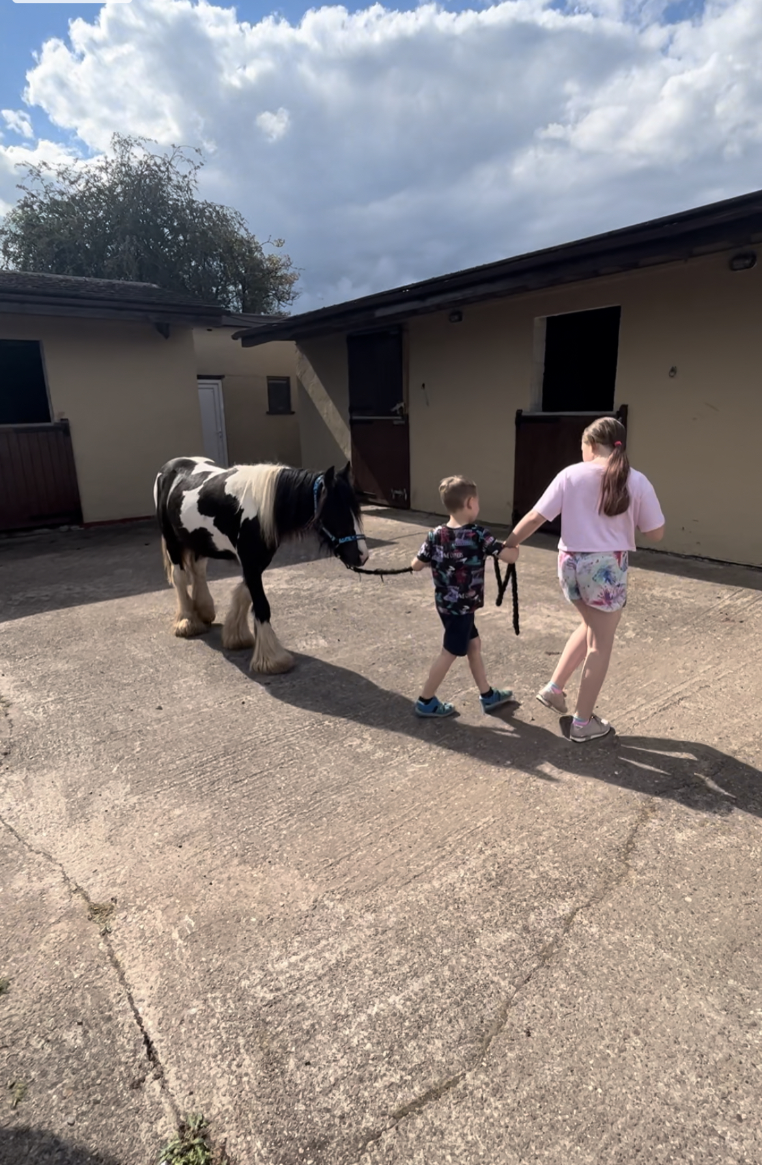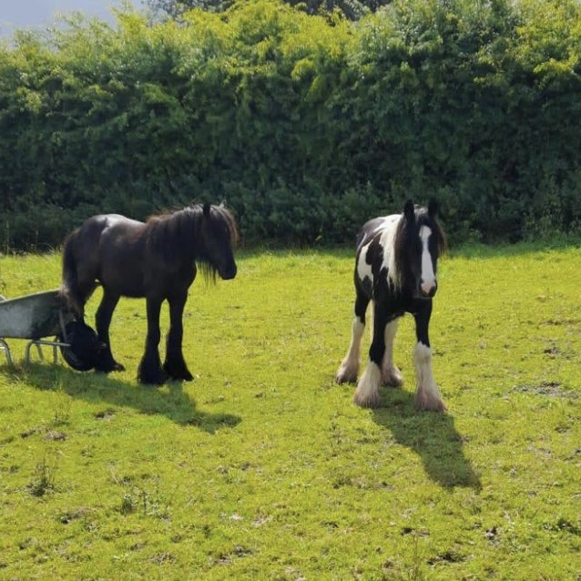

12. Enjoyment and Achievement
Activities are provided as an integral part of our educational program as well as provided during leisure time. It is important to us that we establish the children’s needs, likes and dislikes so that we may support them in the most child centred way to reflect their own creative, intellectual, physical and social interest and skills.
We will endeavour to seek as much information at the point of referral to ensure that we can match the child’s needs, likes and interests from the resources in our local area. If a child is well matched and placed with us, we will continue to support them in building on their repertoire of activities and associated learning, social skills and creativity. To achieve this, we will involve the child in completing their weekly activity planner.
We will take time to go out into the local area and explore the options available. Where required we will look further afield geographically to support the child to take part and benefit from social activities. Serenity Care staff will join in (where the child wishes) to assist them in building confidence and resilience towards their independence in these activities where appropriate.
There are lots of community resources in the local area for activities including leisure centres, activity clubs and classes, youth clubs and volunteer organisations. Other activities that are available include swimming, badminton, squash, tennis, football, cycling, walking, local parks and countryside, Alton Towers theme park, Go Ape, Segway, ice skating, horse riding, water sports, gym sessions, climbing clubs and dance lessons. Children and young people are encouraged to join in community activities such as Army and Navy Cadets, Scouts, Brownies and Girl Guides and other interest/social groups.
There are a variety of in-house activities made available by the staffing team for the young people to partake in and experience group living and social interaction where they can have pamper nights, games nights, have their hair styled and style each other’s, film night, play board games, bake, make up applied and generally chill and chat together.
The young people can have planned access to the ponies, to enjoy and experience the benefits to life that the ponies can bring. They can enjoy them as part of an activity and complete tasks that involve looking after the ponies such as grooming, feeding, walking and petting.
Risk Assessments are carried out for high-risk activities. We have stringent procedures in place relating to safety arrangements for children, young people and staff which includes staff leaving details of whereabouts, intended destinations and locations, times of return, amendments to any change of plans and reporting in and after activity.

13. Health
All children at Serenity Care will be registered with a local GP surgery who will complete an initial health assessment and regular check-ups. Children will also be registered with a local dentist and optician who will carry out checks for any treatment they need. All children are encouraged to attend and engage in their appointments. Whilst respecting a child’s rights to privacy, they are supported to seek advice or assistance with any health concern.
We promote a culture of health and wellbeing, encouraging healthy eating and access to physical activity. Children are encouraged to support in the completion of the weekly menu, this gives them the opportunity to express their views on the menu and to contribute to it.
Our Staffing team are trained in medications management, emergency first aid, food hygiene, health and safety and any additional training as required or identified as necessary.
Homely remedies are kept in the home for use when required and prescribed medication is held and administered in line with health practitioner directions and our policy.
We actively discourage children from smoking and vaping. We have a policy where staff are not to smoke or vape in front of the children.
Monthly consultation sessions are available with The Child Psychology Services (TCPS). Following consultation, staff receive a written report the following day to read to provide guidance of working as a team and supporting the young people in the most therapeutic way for them at that time.
The staffing team are trained to apply PACE –Playfulness, Acceptance, Curiosity and Empathy.
Residential Psychology Therapy Input
Serenity Care employs The Child Psychology Service (TCPS) which is a Social Enterprise based in the Midlands and are mostly made up of Clinical/Counselling Psychologists, Therapists and two Specialist Occupational Therapists. They have expertise working with children and families who have experienced developmental trauma and all of their work is grounded in attachment theory, to aid the understanding and support of young people who present with trauma-related behaviour.

TCPS’ Ethos and Approach:
Children who have experienced abuse and neglect have a complex range of difficulties which inhibit their ability to capitalise on the love and care provided by their carers. They are likely to have deep-seated difficulties with trust which can make it hard for them to see their carers’ positive intentions. These issues with trust are also likely to manifest in other relationships with adults including relatives, teachers and professionals.

Ultimately, as residential staff will be having more regular contact with the young people, we want to be able to strengthen this relationship and scaffold a trusting relationship with them and individual work with a therapist is often not the best way to facilitate this. Therefore, our relational approach is about working with the systems around the young people, this is done via training and psychological consultations and working with the network around a child. We primarily draw upon the Empathic Behaviour Management (EBM) and Dyadic Developmental Psychotherapy (DDP) models.
Serenity Care works with a qualified Psychologist who supports our home. This professional has completed an undergraduate degree in psychology and further studies at doctorate level, which involves working clinically across placements and completing a research thesis to build theory-practice links. Each clinician is registered with the Health and Care Professions Council (HCPC), is DBS checked and has completed Level 1 and Level 2 training in DDP. They also have access to high quality supervision.
The qualified Psychologist has facilitated EBM training with Serenity Care Staff which focuses on the impact of developmental trauma on identity, cognitive, social and emotional development. The residential team learn about therapeutic re-parenting approaches and to further embed these ideas, staff consultations are offered monthly. These meetings provide psychological insight into children’s needs and allow a reflective space for the team.

What are TCPS’ Psychological Consultations?
Consultations aim to support residential staff to understand and connect emotionally with the young people in their care using a psychologically informed approach. We work together to develop knowledge, skills and confidence in therapeutic care, to define the features of a care environment that allows a child to feel safe enough to begin to heal, and to help the team respond to specific challenges the young people may be facing.

What type of things can we talk about?
- The emotional impact of supporting traumatised young people and staff well-being.
- Updates on the young people, including risky and complex behaviours that feel challenging to manage.
- Creating psychological and trauma-informed explanations to understand behaviours.
- Exploring what these behaviours might be communicating.
- Attachment/relationship issues.
- Exploring ideas for key work sessions.
- Highlighting progress and celebrating successes.
- Team dynamics.
- Ways in which we can improve communication and consistency in the team.
- The impact of organisational changes.

What are the benefits for the team and for the young people?
- Increased consistency in the staff team’s approach and reflective practice.
- Opportunities to embed therapeutic care principles at the heart of the work.
- Helping the team to be empathic and understanding when faced with behaviours that challenge.
- Improving team cohesion, resilience and work satisfaction to increase staff retention. This in turn, improves containment and consistency for the young people.
- Developing a deeper understanding of attachment and the impact of trauma.
- Improved connections with young people.
- To continue to nurture a thriving and therapeutic team environment built upon PACE (playfulness, acceptance, curiosity and empathy).

In addition to the TCPS we use our ponies to complete weekly Equine Assisted Therapy (EAT) with trained staff members. Our vision here is to engage the children to connect with the ponies and carryout activities/games where the child is exploring their emotions, this may be naming an emotion at a particular time in their life and working with this. There are many more activities that we carry out using this approach. The feedback we get from the children after completing these activities is fantastic.

14. Positive Relationships
The importance of contact between children and their parents, relatives, friends, and significant others is acknowledged, and maintained by working in partnership with relevant parties. Serenity Care supports the principles within the Children’s Act 1989 that such contact should be promoted. These principles are further endorsed by the Patterns & Outcomes in the Child Placement which says:
“Policies and practice need to take seriously the now well-established research finding that visiting is the key to discharge. Contact enhances the welfare of placed children and does not increase the risk of breakdown”.
Within the legislative framework, decisions about contact will be made by the placing authority, subject of course to any order of the court.
Nevertheless, Serenity Care has a significant role to play in making contact arrangements work; in assisting the Local Authority to come to informed decisions about contact; and in facilitating informal contact between the child and significant others.
Where the child is placed outside of their home area, there is specific focus on practical arrangements that need to be put in place to ensure that they maintain supportive contact with their social workers, their families and friends, and connection to their home area.
Arrangements for contact, and any restrictions in contact, will be agreed with the Local Authority prior to admission. We will record details of the contact visit in accordance with the regulations; these will form part of the case record and be available to the local authority. We will keep the Local Authority updated of our views on the contact arrangements.
Where restrictions have been agreed (e.g that contact should be supervised), Serenity Care will provide the necessary staff and facilities if suitable to do so after appropriate risk management.
There are ample facilities within the home to make contact arrangements work, ranging from accommodating private contact within the child’s own space to supervised contact. Parents, family, and friends etc are welcome to share meals and visit the home if it does not conflict with contact arrangements or impede the smooth running of the home.
Serenity Care aims to ensure a welcoming and friendly setting is available for all.
The home has a landline where the children can make and receive calls in private. The names and numbers of Childline, Children’s Commissioner and Ofsted are printed in the Children’s welcome brochure.
There are facilities to monitor the calls however this is only done with the prior approval of the child’s social worker and as part of the child’s agreed Placement Plan, and the children/young people are always informed.
If the child has a mobile phone a contract will be drawn up regarding its use; if the child is unable to adhere to the agreement the details may be changed, or the phone withdrawn, or its use supervised according to need.
In the event of it being required the home has individualised written agreements in place specifically surrounding the use of electronic monitoring in place for mobile phone devices, the home can use with the consent of the local authority or parent, to further support the young person’s safety and planning as part of a reduction of risk as to support the young people to become more independent with an additional level of care and proactive risk management.
Where a young person refuses contact, we will discuss this with them and offer counselling support, and we will not facilitate contact against their expressed wishes. The placing authority will always be informed of this.
Positive relationships with influence-the adult as a role model
The relationship between staff and children/young people plays a crucial role in the effectiveness of our work.
At all times staff are engaged in their efforts to help children to explore and understand their experiences and feelings, and then to move forward. This involves breaking the momentum of the crisis cycle, modelling alternative ways of reacting, rather than allowing cycles of maladaptive coping to manifest.
Our staff will not negatively react to children/young people’s destructive behaviours in a way that the young person fears and expects. Our staff will use a therapeutic approach to support our children.
Our practice encourages mature strength, teaching the child better ways of coping with difficult feelings and situations.
Protection of Children
15. Monitoring & Surveillance
We respect the child’s right to privacy and dignity and do not constantly watch children, without good reason and giving due regard to their age and vulnerability. However, children living at Harplow may require an agreed level of supervision to keep them safe and others safe; this will be determined by the child’s behaviour and needs. At the point of referral this will be agreed, and the child will be made aware of how we will keep them and others safe.
If a child requires 1:1 supervision this will be agreed by the manager and the placing authority, a plan will be implemented to show how the 1:1 supervision might be reduced in accordance with the risk assessment.
The home will be staffed 24 hours a day, 7 days a week and there will be sufficient staff to provide adequate care to the children.
Should the placing authority require any additional safety measures it will be agreed with the home manager at the point of referral.
Sections of the premises may be protected by security sensors and alarms. The intention is to deter intruders, or alert to their presence. Staff vehicles on the premises may also be protected by alarms.
The home does not use as standard electronic door alarms on bedroom doors for the young person’s residing in the home, however, with express permission from the placing authority the home can fit discrete electronic door alarms if required to support the young persons in the home for a short period of time.
If required and agreed with the placing authority children’s bedroom doors may be fitted with sensors that alert staff if the door is opened.
Reasons for use include:
- A non-instructive way of monitoring that no-one (staff or child) enters the child’s bedroom at night (this removes the need for visual checks by staff which can be disturbing for the child).
- The child feels safer: staff will know if anyone enters their bedroom.
- The child will not need to approach staff sleep-in accommodation if they need assistance at night. Staff will automatically be alerted by the sensor and will get dressed and attend to the child’s needs.

16. Details of the homes approach to behavioural support, including information about the homes approach in relation to children and how persons working in the home are trained in physical intervention and how their competence is assessed.
Serenity Care Children’s Homes aims to provide a high standard of individualised behaviour support within all homes. Our children are encouraged to participate with their behaviour support plans.
Positive behaviours occur in situations with a high-quality care provision, with good relationships between staff and children. This includes creating a pleasant physical environment, providing structure, discipline, and supervision, and creating opportunities for experiential learning and success.
Serenity Care implement a range of appropriate and proportionate natural consequences. This approach reflects positive behaviours, rewards and support for the children alongside positive intervention strategies which work for the individual child. Intervention from the youth justice team will be a part of this if appropriate for the child.
Good behaviour and achievements are given positive reinforcements. There is a behaviour reward chart where children can work towards specific goals. Children can earn additional rewards through positive behaviours to encourage future positive behaviours occurring.
Unacceptable behaviours are discouraged. In most circumstances verbal disapproval or restorative work are sufficient to support the children and discourage a repeat of the negative behaviour. When natural consequences are used, it is important to us that they are appropriate, proportionate, and relevant. For example, if a child deliberately breaks a window, contributing towards the cost of the repair helps them to understand the consequences of their actions along with the cost of items which are to be replaced. Where Restorative practice can be applied reparation will be used to prevent the child from building up a debt of funds along with learning practical skills for independent life. For example, should they break a picture, and it is repairable staff will work with the child to restore it to its original state.
Other consequences could be loss of privileges or treats, restriction of leisure activities, additional chores, or increased supervision. In all cases where consequences are used, they are recorded in the log and approved by the senior member of staff on duty. The Manager frequently reviews the consequences log.
When supporting children, there are occasions where extreme behaviours may be exhibited by children which poses as a risk to themselves or others around them, at these times staff may use physical intervention as a last resort. (see PPR below)
Serenity care also employs external therapy psychologists (TCPS) for advice and guidance as well as demonstrating a commitment to holistic work practice and ensuring any consequence a child receives are in line with the child’s developmental learning curve.
Serenity Care use an emphasis on communication, distraction and de-escalation. During the four-day course, staff training of EBM (Empathic Behaviour Management), staff are taught to look beyond the behaviour and see the child and their past trauma as to try and explore the reasons why this behaviour is being exhibited and work on this with the child through link works and keywork sessions whether this be formal or informal.
A holistic care plan addresses individual needs which are developed, encompassing educational planning, identifying therapy goals, recreational activities, direct work required, group work, and supporting contact with families and friends.
Our routines ensure safety, consistency, boundaries and expectations of conduct, whilst promoting positive experiences, new achievable challenges, success, positive reinforcement and building and maintain relationships for each child in our care.
At Serenity Care we recognise that moments of crisis provide both danger and opportunity. By appropriately managing the danger we create an opportunity for growth. We help the child through the crisis in a way that restores the status quo, balance or order and we teach the child more constructive, effective ways of dealing with stress or painful feelings.
We define crisis as a time when a child/young person has run out of or has never learned effective, rational, constructive ways of coping with interpersonal problems and difficulties.

Preventing Protecting and Restoring (PPR)
Serenity Care follows the Preventing, Protecting, and Restoring (PPR) intervention by BTC. This is a Crisis Prevention and management system that uses ‘reasonable force’ in ‘last resort’ with an ‘honest held belief’ circumstances to prevent crime, danger and injury. Situations of ‘last resort’ are often misunderstood. PPR believes it may be necessary to intervene at the start to prevent a “greater harm from occurring” PPR is a crisis prevention and management strategy, designed to reduce the need to rely on high-risk interventions.
The program provides a structure to help make sense of a child’s difficult behaviour. Staff are taught specific techniques appropriate for each child to prevent and manage crisis situations, this includes understanding situational and maturational crisis and the use of a variety of intervention approaches and specific behaviour management techniques (e.g. caring gesture, prompting, active listening, planned ignoring, and positive attention).
PPR also teaches a range of safety interventions, including release and physical restraint.
Physical interventions rest on the principles of a maximum number of caring gestures, with a minimum amount of force, and the goal of de-escalating the situation by reducing stimulation. Staff are continually observed and assessed on the course and in practice. All parties play an active role in including reflective practice in real life situations, this ensures that staff remain vigilant and can analyse their own skills and practice and appraise the staffing wider team on how best to manage conflict situations.
Supervision and monitoring arrangements for PPR.
Written records are made of all physical interventions. The Manger reviews and countersigns all incident reports involving a physical intervention being required.
All staff are trained in PPR techniques and receive annual refresher courses, unless staff require and interim support. Any concerns about practice are initially overseen and addressed by the homes Manager or the Deputy Manager.
The Behaviour Management policy is made available to professionals, and young people on commencement of their placement, and is regularly consulted upon. This policy is also available on request.
Safeguarding overview
The primary concern for all those working at Serenity Care is the welfare and safety of all the children residing there, a robust Safeguarding policy is in place to assist with this. All carers undergo training on safeguarding so they can deal with any allegations and can identify and address any causes for concern. They are trained to be aware that abuse can take place anywhere and by anyone.
When a child moves into Harplow, we discuss with them how we would take care of them should they make a disclosure or allegation. The carer will make them aware that as part of safeguarding we share this information with those who need to know and will discuss with the child who this might include.
Any carer who believes that a child is at risk or who have received a disclosure/allegation from a child, will report it immediately to a member of the management team in line with safeguarding procedures. It will be reported immediately to the child’s social worker, designated safeguarding lead and where appropriate the police. If the incident relates to abuse from one child to another both placing authorities will be made aware. From this point all actions required to ensure the child is safe will be followed and the home with liaise closely with the professionals involved to ensure any advice given will be actioned and adhered too.
If any member of staff suspects any other staff member including the manager, they should follow the Whistle Blowing policy. Any allegations made about a staff member at Serenity Care will be reported to the referring authority, designated safeguarding lead, and Ofsted. The manager will follow Serenity Cares safeguarding flowchart to ensure that all actions are completed, fully documented, and evidenced. The manager will ensure that they take any agreed action to keep all children/adults safe. In line with safeguarding procedure and in agreement with the designated officer Serenity Care will initiate its own investigation procedures to discover if there has been any misconduct on the part of a staff member, further detail is contained within the Safeguarding policy. The police will manage the investigation should a crime have been committed.
The Registered Manager is the designated senior person at Harplow for managing allegations and ensuring the subject of the allegation is kept informed during and after the investigation. Sandra Oulsnam (Responsible Individual) will also be aware and in the event of the managers absence would take the lead. All those involved in an investigation will be supported by the manager; this includes the child, their family and the person who is the subject of the allegation. Serenity Care will ensure that the process will be transparent and non-judgmental. It will ensure that the child’s needs are paramount, and that children’s safety and wellbeing is the priority.
Serenity Care gives the highest priority to ensuring that the children and young people in our care are safe. We operate within the Arena of Safety and Aware Culture, and rigorous recruitment procedures are followed. Staff are supervised, supported, and monitored. One to one working is agreed with the placing authority and regularly reviewed. There are clear lines of communication should staff have any misgivings about any aspects of practice.
There is provision for ‘no fault’ suspension of staff following the guidance ‘Choosing with Care’.
All staff receive training in child protection procedures and whistleblowing upon induction. There is a copy of Staffordshire LSCB procedures within the home, the most up to date copy of Working Together to Safeguard Children and the homes own Child Protection Policy and Procedures.
The safeguarding/child protection policy is available within the home, sent out to parents and professionals on commencement of placement and for consultation.
The organisation has an appointed DSL who can be contacted at any time from the homes staff. In the event you would like to contact the organisation’s designated safeguarding lead please email: info@serenitychildren.co.uk.
Culture of Safety through Awareness
Serenity Care must be a safe, non-abusive environment for children and staff.
All staff are supervised, supported, and trained to ensure they always operate with in the arena of safety.
Creating and maintaining a safe environment and emotional safe base for children and young people is of upmost importance.
This is the starting point for all staff recruitment and operational practices and engenders our policies and procedures.

17. Leadership and Management
The registered provider is:
Serenity Care Children’s Homes LTD

The Responsible Individual is:
Sandra Oulsnam (Sandra.oulsnam@serenitychildren.co.uk )

The Registering Manager is:
Kelly Rushton-Martin ( Kelly.rushton-martin@serenitychildren.co.uk )

18. Details of the experience and qualifications of staff working at the children’s home, including any staff working at the education and health care.
Our dedicated management team brings to the organisation vast experiences from different backgrounds and theoretical perspectives. The team values diversity, inclusion and equality and are enthusiastic and committed to their service delivery.
Our staffing team will have acquired skills from a wide variety of training and benefit from ongoing professional support in applying this information in a practical way. Our staff are recruited based on their previous skills, life experiences and their personal, emotional and temperament as suitable to the role.
Our collective experiences and a shared commitment to our children will assist us to continually review and develop our service for the benefit of our children at Serenity Care.
The quality and reliability of our staff is paramount to the success of Serenity Care Children’s Homes. The minimum standard for a Registered Manager at the home is a Level 5 or equivalent. For residential staff the Level 3 Diploma as a minimum qualification. To achieve both standards we actively support our staff through our inhouse competency framework and a personal development plan. The management team ensures that both formal (structured) and informal supervision (meetings, training sessions, one to one discussion, reflective practice) of each staff member takes place with group supervision within team meetings are undertaken.
The staff have access to ongoing training and development internally and by agreement externally. Serenity Care are committed to training their staff to the highest standard in line with best practice. All training courses are current and meet relevant legislation and regulatory requirements.
Our training is bespoke to meet the needs of Serenity Care and the children and young people. Serenity Care support staff via a 4-week induction programme. The initial 2 weeks staff will be introduced to the home, team and children. They will complete mandatory training, read and sign policies and the plans in place for each child. Each new staff member will have a competent mentor from who they can learn.
A list of our mandatory and additional training courses can be provided upon request.
All staff will be enrolled onto the Level 4 Diploma for Residential Childcare, if they are working well towards a successful probationary period, we will look to enrol staff at the half way point which is 12 weeks. Staff are expected to have achieved this qualification within 2 years of employment in line with the Children’s Homes Regulations 2015.
Responsible Individual: Sandra Oulsnam
Sandra has worked with a large range of children with complex needs such as Learning Disabilities, Sexually Harmful Behaviours, Autism, Emotional and Behavioural Difficulties, Self-Harm and Suicidal Ideation working with both male and females for 16 years and has gained a wealth of knowledge and experience in these sectors. Sandra has completed Level 3 in Health and Social Care Working with Children and Young People and Level 4 in Health and Social Care Working with Children and Young People, along with completing a Leadership and Management Level 2 course in and again in 2022. During this time Sandra has completed a vast amount and variety of training. Sandra has had numerous positions and experiences in Key Working, Lead Mentoring, Senior Practitioner and Deputy Care Manger. Sandra has completed courses in EBM and PACE therapeutic training. Sandra has enjoyed working with the young people and supporting them through their daily challenges. Sandra has worked in the role of the responsible Individual since opening Serenity Care and is progressing well. Sandra is also the homes DDSL in the absence and the RM.

Registering Manager: Kelly Rushton-Martin

Kelly identifies herself as a someone who has a nice balance between her mind and heart and has a solid foundation of transferable knowledge.
Kelly has a mixed background of working with children, young adults and older people all from varying backgrounds, with complex needs (learning disabilities and autism), challenging behaviours and deafblind, sight/hearing impaired. Experience of working in a multi bedded home for children with CSE & EBD. House Manager of a solo placement for care leavers and then managed a 3-bed provision for care leavers. Currently Registered Manager for a 2 bed children’s home, in preparedness for Serenity’s next 3 bed home (Harplow) of which has just completed her FPI and is awaiting the outcome of this along with the homes registration outcome. Kelly also has experience in LD and MH young adults.
Kelly holds a Level 3 Diploma in Lead Adult Care and is a Level 3 OCN qualified Deafblind Assessor. Other qualifications held are NCFE Level 2 Health & safety and counselling therapies. Kelly is also a Reiki Practitioner, using mindfulness and other complimentary therapies to support wellbeing. Kelly holds a Level 5 Diploma in Leadership and Management for Children and Young People.
Kelly is familiar with EBM & PACE models to support young people. In 2014 Kelly completed a Counselling course to further develop her knowledge and skills in theoretical and supportive communication.
For 16 years Kelly worked in the NHS, and Local Authority; some of this time spent as a Deputy Manager in a Domiciliary Care registered service and for 9 years Kelly worked in adult Social Work, following this she spent a short time as a Registered Home Manager of a 64 bed Residential Care Home under the CQC.
Kelly’s knowledge, experience, ethics and values ensure that she always strives for the highest care/support standards and aims as a minimum to meet, exceeding where possible the standards/regulations as set out by governing bodies.
Kelly continues to build and progress her working knowledge of relevant children’s legislation. Has a good understanding of the Children’s Homes Regulations and Quality Standards along with the Care Standards Act 2000 and the Social Care Common Inspection Framework.
Kelly has a thorough working knowledge of the Health and Social Care Act 2008/Regulations 2014, CQC Fundamental Standards, The Care Act 2014, Safeguarding, Mental Capacity Act 2007, Human Rights Act, Equality Act 2010, Homelessness Reduction Act 2017 and other relevant legislations.

Deputy Manager: Antony Light
Antony joined Serenity in June 2024 as a bank worker. Antony’s previous experience in management and team leadership skills supported him in the role and quickly progressed to a full-time role as Senior Practitioner. During this time Antony acquired the relevant skills and knowledge to give the young people the best start to their journey at Serenity care.
Antony has years of personal relevant and transferrable experience in supporting young children with challenging behaviours and more recently a child diagnosed with ADHD.
Antony has a well-balanced approach in behaviour management and is confident in implementing boundaries as he knows firsthand how this can help to develop the child’s thinking in relation to their behaviours.
Antony has completed EBM and PACE training and is currently working towards the Diploma Level 4 Children, Young People and Family Practitioner. Antony will undertake and work towards the Level 5 Diploma Leadership and Management in children’s, young people and family’s qualification. In the interim Antony has been supported to enrol onto a Management Development Programme relevant to Children’s homes, which will support his ongoing development regarding his knowledge and practice in an Ofsted regulated management role.

19. Details of the Management and staffing structure of the children’s home, including arrangements for professional supervisions of staff employed at the children’s home, including staff that provide education or health care.
Harplow will be staffed as follows when occupancy is full: 1 Registered Manager, 1 Deputy Manager, 3 Seniors (minimum) and 6 Residential Practitioners. This model provides 3 staff on shift per day to support the children in placement.
The team looks at a balance of both sexes where possible helping to give the children positive role models to assist their growth via nurturing, positive interaction and care.
At Serenity Care we believe that our children and young people need a consistent approach and therefore reflect this continuity in our rota system. Our staff are on duty between 08:00 – 23:00 and then sleep in.
Each shift will have 3 staff on duty at any one time. The staffing ratio may change to reflect the needs of our children. Each fulltime staff member will work a minimum of 160 hours in the home per month. The rota will reflect this. This allows the children to develop meaningful relationships with each staff member. In addition to this the manager and deputy manager are present during the day Mon-Fri, and part of the management team are contactable out of hours via our Emergency Point of Contact support service on a rota basis.
To enable us to manage staffing shortfalls in the rota, such as pre booked annual leave or training events we have a team of bank staff that support the home, this ensures that the rota staffing allocation does not fall below the minimum staffing levels.
Immediate shortfalls such as short-term sickness are covered by the following:
- Our pool of Bank Staff who have completed a full induction and training plan with relevant safer recruitment and safeguarding checks already completed. We endeavour to maintain a good number of bank staff in the pool at all times. If a bank staff takes on a full or part time role, we will recruit to the bank staff pool.
- Overtime where part shifts can be offered out to the team, alternatively the same offer can be presented to staff working in other Serenity homes and effective temporary relocation of staff from homes is an effective way of meeting emergency shortfalls as well as longer term vacancies or absences.

All of our staff, prior to employment are subject to and extensive selection and vetting process. Checks are carried out with the Disclosure and Barring Service and previous employers to ensure that there are no aspects of their background that would make them unsuitable for working with children.
Our staff receive professional support and supervision. For staff in their probationary period, they receive supervision every 2-3 weeks which can include practical work-based learning. Upon completion of their probationary period Serenity Care will provide a minimum of one hour’s supervision regularly.
Supervisors and Line Managers are competent in delivering high quality supervisions following a thorough in-house training session. Feedback is sought following this training to identify any additional support required.
The TCPS Therapist is supervised by the Clinical Psychologist, whom in turn receives professional supervision independently.
Regulation 44 visits
Regulation 44 visits are carried out by an external independent person that is impartial and independent of the organisation. The reports are available for reading by all staff, social workers, and inspectors. The inspector has extensive residential experience and aims to at every visit; interview with their consent and in private, children accommodated at the home, their parents, relatives, and staff working within the home along with any other people they feel relevant such as social workers or advocates.
The premises are also inspected on every visit along with records of the home apart from any case recordings, unless it has been agreed by the child or the placing authority.

20. If the staff working at the children’s home are all of one sex, or mainly one sex, a description of how the children’s home promotes appropriate roles models of both sexes.
The home has both male and female staff of varying ages, culture and background which provides positive role models for the children. Although the gender is balanced there may be times where it is predominantly male/female. Gender roles are not stereotyped, and all tasks are completed by male and female staff to promote equality and reduce the typical stereotype of an historical traditional household.

Care Planning
21. Any criteria used for the admission of children to the home, including policies and procedures for emergency admission
Serenity Care has a clear referrals and admissions process and briefly outlined below:
Our home provides residential care for up to 3 children of either male or female genders aged between 5 -17 years.
We care for children that have experienced past trauma and difficult childhood and as a result are no longer able to remain in their home with family. We support children with emotional and behavioural difficulties and children with mild learning difficulties.
After careful consideration around matching to the area and that of the needs of other children in the home we can support children with the following range of needs:
Children’s range of needs we can support:
- Display behaviours that mean they can no longer be cared for in their family home.
- Global development delay
- Mild Learning Disabilities
- Autism and ADHD.
- Difficulties in regulation skills needed for social relationships and learning.
- Sight & hearing impaired, corrected with visual or hearing aids (not deaf or blind)
- Attachment difficulties.
- Need therapeutic intervention to support in processing previous experiences
- Children that have suffered abuse and neglect.
- Struggle with living in a foster care setting
- Display behaviours that require a higher level of supervision to ensure their safety.
- Low level physical aggression
- Verbal aggression
- Self-harm
Children’s range of needs we cannot support:
- Fire setting.
- Complex Mental Health needs.
- Significant Knife risks or involvement with.
- Complex health care needs that cannot be managed by primary care team.
- Severe physical Disabilities.
- Severe Learning Difficulties.
Planned Admission Procedure:
- Enquiry
- Referral details and any additional information
- Impact assessment completed and agreed
- Discussion with team and young people
- Initial assessment visit to child
- Placement Agreement meeting
- Visit to the home which can include an overnight stay
- Second visit to the child or activity with child
- Room prepared to individual wishes
- Admission
All consents and agreements inclusive of admission documentation must be received before the placement of the child commences, if this is not the case the placement will not commence in line with organisational admission policies.

Emergency Admission Procedure:
It is anticipated that some placements will be emergency admissions, however this will be avoided where possible. In these circumstances the manager will obtain the most comprehensive information available from the referrer to allow a decision to be made and to ensure that the following conditions are agreed/met.
- Emergency admissions may be assessed for the suitability for placement based on suitable matching.
- Planning meeting arranged within 72 hours
- There must be a named Social Worker with case responsibility
- All appropriate paperwork is provided along with a comprehensive and full history
- Impact assessment completed and agreed between Manager and Local Authority
- Initial Assessment
All consents and agreements inclusive of admission documentation must be received before the placement of the child commences, if this is not the case the placement will not commence in line with organisational admission policies.
When considering the admission of a child, attention will be paid both to their needs and to those of the children already residing within the home. Children and young people of any ethnic origin or religion may be admitted to the home.
Children and young people may either be accommodated by a Local Authority under section 20 of the Children’s Act 1989 or subject to a full care order (FCO) section 31. There may be times where an interim care order is applied. Young people can be placed by Voluntary Organisations and others.
- The Placing authority must be supportive of the objectives of Serenity Care.
- The Placing authority must be supportive of Preventing Protecting and Restoring.
- The child (and parents where appropriate) must be consulted about the placement.
- At serenity care we strive to ensure that a transition is completed to support the young people who reside at the home however we are aware that this may not always be suitable to the needs of the young people and their current circumstances and will always ensure that the young people are supported to the highest levels where this may not be a suitable option.

On arrival, each child receives a Children’s Guide. This includes everything they need to know about the home and their rights whilst in care. They also receive a welcome pack, a small package to welcome the child.
We aim to consult with our children about any new young people that may be joining us, however, there are times where we may take emergency placements, and this does not always afford us the opportunity to consult with the children. Where this occurs the staffing team will complete 1:1 work with our children to explain the reasons this has not taken place. A house meeting will be completed with the new child and our current children with a view to welcome and get to know each other.
At Serenity Care, preparation for future independence begins at the point of admission. During their time with Serenity Care, staff will support them in learning life skills and planning for their future via an independence plan. This will enable the young person to feel somewhat equipped to join the world of independence.
In preparation for moving on, Pathway plans can be devised where appropriate, and young people helped through that process.
An End of placement report will be completed at the end of each child’s stay along with memorabilia to commemorate their stay along with a gift from everyone at the home. Follow up work can be offered and undertaken as necessary.
The children will be offered opportunities to go on holiday and have short breaks away from the home.
At Serenity care we believe that each child needs a sense of routine, consistency and boundaries in their life, and a caring and nurturing system of support to encourage, develop and maintain pride, self-discipline, self-esteem, confidence to establish trust and respect for themselves and others.
Our staff team are motivated, experienced, and committed to working with children and young people. Staff will encourage children to self-express positively, assisting them in overcoming emotional expressions of past trauma, positively impacting well-being and nurturing resilience.

Contracting:
Where we are providing care on behalf of the child’s local authority, it is our policy to have clear contractual agreements which reflect our partnership. In the absence of block purchasing agreements, the following will set out the basis of any partnership between Serenity Care Children’s Homes and the referring agency:
- A completed referral
- Signed financial agreement
- Individual care Plan
- Individual Placement Plan
From the outset, we need to be clear that a management decision has been made supporting the appropriateness of an approach to Serenity Care Children’s Homes. A signed financial agreement is the only notification of such a decision we can accept, as it informs us that the referral to Serenity Care Children’s Homes is one which has been carefully thought out and has everything in place for the application to progress without delay. We believe this to be good practice and in the best interest of all concerned. All applications received without a financial agreement are placed on our waiting list at the request of the referring authority.

Staffing Compliment
Harplow

Staffing, Skills and Experience
The home is staffed by a team who have, or are supported to develop, the knowledge, skills and experience required to meet the individual needs of children and young people with learning disabilities.
Staff receive training and ongoing professional development appropriate to the needs of the children living at the home. This includes learning disability awareness and, where relevant to the children we support, autism and neurodiversity, communication needs, sensory needs, positive behaviour support and understanding behaviour as a form of communication.
Staff are supported to adapt their approach to each child's individual level of understanding and preferred method of communication. This may include the use of visual information, simplified language, additional processing time, social stories or other individual communication strategies identified within the child's care plan.
The staff team promotes children's independence, choice and participation and supports children to develop their daily living, social and communication skills in accordance with their individual abilities and plans.
Training needs are reviewed through induction, supervision, appraisal and the home's workforce development arrangements. Where a child has a specific or more complex learning disability or associated need, additional child-specific training, guidance or professional support will be obtained where required before and during the placement.
The Registered Manager considers the skills, experience and training of the staff team when assessing whether the home can safely and effectively meet the needs of a child prior to admission.

Responsible individual - Sandra Oulsnam,
Sandra has worked with a large range of children with complex needs such as Learning Disabilities, Sexually Harmful Behaviours, Autism, Emotional and Behavioural Difficulties, Self-Harm and Suicidal Ideation working with both male and females for nearly 20 years and has gained a wealth of knowledge and experience in these sectors. Sandra has completed Level 3 in Health and Social Care Working with Children and Young People and Level 4 in Health and Social Care Working with Children and Young People, along with completing a Leadership and Management Level 2 course in and again in 2022. During this time Sandra has completed a vast amount and variety of training. Sandra has had numerous positions and experiences in Key Working, Lead Mentoring, Senior Practitioner and Deputy Care Manger. Sandra has completed courses in EBM and PACE therapeutic training. Sandra has enjoyed working with the young people and supporting them through their daily challenges.
Sandra has worked in the role of the responsible Individual since opening Serenity Care Children’s Homes. Sandra is also the homes DDSL in the absence and the registered manager.
Standards and other relevant legislation.
Kelly Rushton-Martin, Registering Manager

Kelly identifies herself as a someone who has a nice balance between her mind and heart and has a solid foundation of transferable knowledge.
Kelly has a mixed background of working with children, young adults and older people all from varying backgrounds, with complex needs; learning disabilities, autism, mental health concerns, physical disabilities, challenging behaviours and communication barriers such as nonverbal, deafblind, sight/hearing impaired. Kelly has a broad knowledge of communication strategies and methods to support those with different communication needs to ensure they feel included and that they matter.
Prior to working with Serenity Care, Kelly has experience of working in a multi bedded home for children with ASD, ADHD, LD, & EBD. Kelly spent a period of time as a House Manager in a solo placement for care leavers, supporting them in building skills to take them into independence. Kelly went on to manage a 3-bed provision for care leavers, again supporting the younger people with social, life and independence skills to support them moving forward into adulthood.
Kelly commenced her employment with Serenity Care Children’s Homes in October 2023. During this time Kelly has been the Registered Manager for a 2 bed LD/EBD children’s home showing excellence in leadership and management balanced with a child focused approach.
Kelly is qualified, having completed her Level 5 Diploma in Leadership and Management for Children and Young People. In addition to this Kelly holds a Level 3 Diploma in Lead Adult Care and is a Level 3 OCN qualified Deafblind Assessor, has a certificate in basic counselling skills and NCFE In Health & safety at Work.
Kelly is familiar with Empathic Behaviour Management (EBM) & PACE models to support young people. The Counselling course further developed knowledge and skills in theoretical and supportive communication.
For 16 years Kelly worked in the NHS, and Local Authority; some of this time spent as a Deputy Manager in a Domiciliary Care registered service and for 9 years Kelly worked in adult Social Work, following this she spent a short time as a Registered Home Manager of a 64 bed Residential Care Home under the CQC.
Kelly’s knowledge, experience, ethics and values ensure that she always strives for the highest care/support standards and meets/exceeds the standards/regulations as set out by governing bodies.
Kelly has a thorough working knowledge of the Health and Social Care Act 2008/Regulations 2014, The Care Act 2014, Safeguarding, Mental Capacity Act 2007, Human Rights Act. Kelly continues to build and progress her working knowledge of relevant children’s legislation. Has a good understanding of the Children’s Homes Regulations and Quality Standards.
Deputy Care Manager – Antony Light

Antony joined Serenity in June 2024. Since this time Antony has worked in a Senior Residential Practitioner role.
Antony has personal previous and current relevant experience in supporting young children with challenging behaviours and more recently a child diagnosed with ADHD. Antony has shown high levels of awareness and understanding with young people with additional needs as well as empathetic approaches and therapeutic understanding.
Antony has a well-balanced approach in behaviour management and is not afraid to implement boundaries as he knows firsthand how this can help to develop the child’s thinking in relation to their behaviours.
Antony has completed EBM and PACE training and is qualified, holding a Diploma Level 4 Children, Young People and Family Practitioner. Antony will be enrolled onto his L5 Diploma in Leadership and management.
Ellie Scifo, Senior RCP

Ellie holds a BTEC Level three national Diploma in Children’s Play, Learning and Development. Ellie completed this achieving grade of D*D*D but also acquired so much more knowledge along the way. Ellie had the opportunity to train in Paediatric first aid, British sign language and food hygiene displaying that she thrives upon challenges and meeting expectations.
Working on a Level 3 qualification enabled her to reflect on skills already possessed, including organisation skills, patience, and a positive work attitude.
Ellie completed a placement with the age range of 0-7years, a focus on early years. The placement enabled Ellie to gain hands-on experience and insights into her capabilities as a role model, teacher, and advisor. Ellie says that she was able to demonstrate her planning skills, patience and time management when she worked through the daily running of the classroom.
Ellie has experience as a home-based child minder giving a different insight into working hands on with children. Ellie feels this developed her ability to manage activities and tasks designed to help children meet their milestones.
Ellie took an opportunity to study an undergraduate degree in Psychology and Counselling at Keele university.
Upon graduation in 2025 Ellie aims to continue onto a master’s degree in counselling which will incorporate her skills and personal traits of empathy and tenderness towards everyone she meets. Ellie describes herself as having an infectious enthusiasm and perseverance, allowing her to flourish, stand out and succeed.
Ellie has progressed within the company and has been promoted to a Senior position and has commenced the Diploma Level 4 Children Young People and Families Practitioner (RCC).
Jamie Troth, Senior RCP
I have worked in a residential position looking after children and young people in single, dual and multi occupancy homes for twenty-four years.
Within this role I have been expected to provide care and support to a range of young people who have come from unprivileged backgrounds. Due to their poor experiences of life and often coming from some form of abused background it has meant I have had to deal with crisis situations where the young person. It is therefore responsible and challenging work as it may take a considerable length of time to form a strong rapport with the young person.
However with patience, resilience, being empathetic and having a caring personality it is possible to achieve this. I feel that I have a sensitive and understanding approach, being fair and consistent with maintaining boundaries and encouraging the young people who I have looked after to achieve and self-develop. I have always tried to maintain a professional attitude towards my duties and been focused towards understanding all relevant legislation, company policies and procedures to ensure a high level of quality care provision. I would describe myself as hardworking and have a liking for working with young people and children. I am educated to degree level and committed to furthering my qualifications by undertaking any courses related towards this profession

Tina Cartwright, RCP (part time)
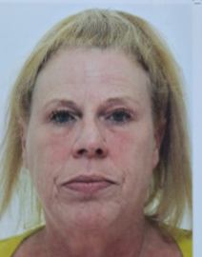
Tina joined ourselves in 2025 and has worked in all the serenity homes with a wide range of young people tina my hobbies are cooking, walking and days out with my grandchildren. Holidays and short breaks. I spend a lot of time with my dog going for walks and enjoying activities
I have previously worked for nursing companies for many years as well as with a man with a brain injury and taken training in peg feeding, medication, epilepsy and NVQ2.
I am a happy, kind and patient person, with a good heart. True and honest. I love my family and enjoy spending time with them.
Annie Ridgway, RCP
Annie joined Serenity in 2025, has previous experience of working with children and young adults who present with behaviours that challenge. Annie has other valuable transferable skills and has gained experience in her current role as a Residential Children’s Practitioner. Annie has worked well towards the company competency framework.
Annie will be enrolling onto her Level 4 diploma upon successful completion of her probationary period.
Sarah McCylmont RCP (Part Time)

Sarah is employed as a bank Residential Care Practitioner. Sarah loves working with people to help enhance their quality of life. Sarah is a trauma healer and spiritual mentor that helps people to let go of negative patterns and move to a happier state of being. Sarah especially loves working with young people as small positive influences can have a massive impact on their future. Sarah has volunteered at Caudwell Children, supporting children with autism in the admissions department and also working directly with the children on short breaks and summer holiday club.

The home currently is planned to support 1 child at this time, and the staffing team reflects this upon the initial child settling additional staff will be added to the homes staffing compliment when deemed suitable for further admittances.

Louise Heaton, Company Advocate
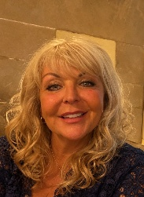
Louise has 7 years’ experience of working in a Residential Children’s Home as an RCW and as a Senior Practitioner. Louise looked after young females with a diverse range of traumatic experiences from sexualised behaviours, emotional and behavioural difficulties, self-harm, and suicidal Ideation.
Louise has completed training in Non-Violent Resistance training (NVR), EBM and PACE therapeutic training and regularly applies EBM and PACE in her daily practice.
Louise has completed the Level 4 Children and Young Peoples Family Practitioner qualification. Louise has experience in Key working the young people and building and maintaining positive relationships.
Louise was initially working in role as a Senior Practitioner however has chosen to take the role of our Companies Advocate due to having a natural way of working with young people using skills such as Active Listening, Walking the Middle Line, applying PACE and being the voice for them to ensure their views, wishes and feelings are heard.
In times of need Louise is permitted to complete working alongside the young people within the home on a need basis to support individual children residing in the organisation.

Bank workers
Jordan Mallinder, RCP/Senior (Bank)
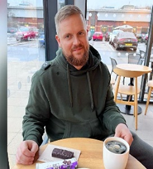
Jordan has been working with children and young adults and joined Serenity Care in 2023.
Jordan has experience of working with young adults in the Care Leaving sector. Jordan worked in a 3-bed supported accommodation house with young care leavers. Jordan supported the young people to work towards their independence in readiness for them leaving supported accommodation. To support Jordan in this it was important to him that he built positive relationships. Jordan has worked with a variety of young people with challenging behaviours. Jordan has already commenced his level 4 diploma programme and will continue this with us. Jordan has completed numerous training aspects relating to supporting children and young people.

Scott Beech, RCP (Bank)
Scott Joined Serenity in June 2024 as a bank worker with a view to taking on a full-time role as one becomes available. Scott is currently in the Armed Forces and has recently been supporting persons seeking Asylum. Scott has completed his mandatory training and will be supported to complete our EBM and PACE training courses to support him in delivering care in a therapeutic manner. Scott will be given the opportunity to take up a relevant diploma.
Nathan Steedman, RCP (Bank)
Nathan has firsthand knowledge with conditions like epilepsy, developmental delay, and autism, looking after a sibling as their main carer. Nathan previously worked as a Prison Officer frequently looking after 120 convicts. Nathan has the capacity to diffuse situations before they escalate. Nathan has completed level 3 emergency first aid along all mandatory training required for working with young people and children. Nathan gained a grade C in math, science, extra science, philosophy, and ethics. also achieved a grade C in public service.

Additional Workers (Support cover)

Christie Fresson, Senior Practitioner

Christie loves nothing more than trying to make days as fun as possible by making sure that activities are planned for the young people to enjoy! Christie loves camping and playing games and being a fun kind of silly. Christie holds a Level 4 qualification in Education and Training which she is always happy to put into action when completing children’s education either that being home tutoring or helping with schoolwork. Christie is also a qualified Dental Nurse and will always promote the correct oral hygiene within our home. In her free time Christie loves to travel and will often be at a football game with her partner. Christie’s main priority is to make sure everyone in my care feels comfortable, respected, and relaxed. Christie has completed all of the relevant training during her time at Serenity including EBM & PACE, along with PPR and First Aid. Christie has a good knowledge and understanding of Safeguarding having previously completed advanced courses as part of her Dental Nurse role.

Sarah Hope, Senior Practitioner

Sarah is a fun, outgoing, bubbly person and is extremely passionate about her role in supporting all children and families a like. Sarah loves playing football and loves watching others play football. Sarah is such a fun person and loves being out doing things.
Sarah has worked previously with children between the ages of 6 months and 10 years of age, including those with additional needs. Sarah was previously a Third in charge of a private day nursery prior to joining Serenity Care. Sarah has 6 years of experience working with children and families. She’s gained many skills over the years and is looking to develop her skills and knowledge further.

Sarah holds a Level 3 Qualification in Childcare & Education and is due to start her Level 4 Qualification in Residential Care in due course. Sarah has many transferable skills and a vast amount of knowledge to help her succeed in her role as a senior.

She’s extremely excited to work with the children, families, staff, and other professionals. Sarah is also hoping to progress here at Serenity Care in the near future.

Jodi Kavanagh, Senior Practitioner
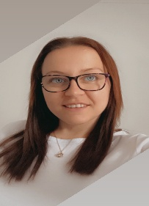
Jodi has 9 years’ experience working between care and education, with children, young people and adults. Jodi first started her career in care and completed the Care Certificate whilst working in a day service. Jodi moved into working in education with young adults with complex needs such as autism, down syndrome, social emotional mental health needs.
Jodi has senior experience within a day service. Jodi’s qualifications are around education & care, other qualifications that Jodi completed at school & local college including public services and beauty therapy. Jodi enjoys spending time with her two young children, and like to stay active by going swimming, on walks and bike rides, having fun together! Spending quality time together as a family is important to Jodi.
Katie Stevenson, RCP

Katie joined Serenity in 2025, has valuable transferable skills and has gained experience in her current role as a Residential Children’s Practitioner. Katie has worked well towards the company competency framework and wishes to develop as a Senior over the coming months. Katie will be enrolling onto her Level 4 diploma upon successful completion of her probationary period.

Laura Smith, RCP
Laura is a new staff member with Serenity and recently completed her induction. Profile information requested from Laura. Laura will be enrolled onto her Level 4 diploma upon successful completion of her probationary period.
Debbie Scifo, Senior Coordinator Practitioner
Debbie Scifo has worked in children’s residential care for 5 years. Debbie’s background previously has been working as a childminder, working with Early Years in a school setting, volunteering at Victim Support, gaining level 3 in counselling, Foundation degree in Early Years, BA Hons in Education, Level 4 in Children, young people and family’s practitioner and Level 5 in Leadership and Management.
Debbie is a director and works on shift as a senior co-ordinator at Serenity and supports the management with the running of the home, ensuring new employees complete their induction to a high standard and delivers training such as PPR, Key-working, day to day on the job training and supporting staff to complete their medication workbook.
Debbie supervises several staff members, and ensures the home continues to deliver high quality care to our young people.

Craig Ellison Senior Practitioner

Craig is a Senior Childcare Practitioner that is super enthusiastic when it comes to playing racket sports outdoors. Tennis and Badminton are Craigs golden sports which he excels in, Craig puts this down to his height advantage, but in general Craig will get involved in majority of sports. Craig says he is an approachable dude that has the time of day for people. He understands that being able to relate with people of various walks in life is a great attribute to attain in life which he believes he can do quite well. Craig enjoys trying to share transferable life skills to people to help them realise and achieve their best version of themselves and that in life it is key to work hard and the results will surely pay off. Craig loves being outdoors and out in nature and going on hikes etc. Recently found a new love for bike riding.
Craig also tries to remain healthy; he likes trying out new recipes when it comes to smoothies and learning about how the human body functions to help himself where he can. Craig looks forward to the time he will spend together with the children at Serenity Care and hopes his and the children’s characters will vibe and create many fun and fond memories. Craig has a very chilled persona which helps people to feel relaxed around him and get on with him very easily.
Declan Sims, Senior RCP
Prior coming to Serenity Declan worked in a residential children’s home for 2 years. Declan gained experience in therapeutic care in an all-girls setting. Later Declan had the opportunity to gain experience in shift leading over a period of 12 months, alongside a key working role to the young people in his care. Declan was able to gain a working knowledge, build relationships and support the young people. Declan has 8 years’ experience supporting a friend who is a foster carer, frequently looking after the children. Declan also provides respite care for children on a voluntary basis for families in need. Declan has been part of the Royal air force cadets since 2009.
Declan has experience in a senior position since commencing employment. Declan has completed courses in EBM and PACE therapeutic training along with completing a Diploma Level 4 Children Young People and Families Practitioner since commencing employment. Declan has since enrolled on to the Level 5 management and leadership in children and families.

Sean Casey, Senior RCP
Sean is a driven, versatile, and responsible individual who wanted to advance his career in a new direction. Sean describes his ability as being able to work well in a team but also his ability to work equally well alone, having a rational approach to problem solving and the motivation to see things through to completion. Sean's knowledge and skills have expanded as a result of the training he has completed, and this has made it easier for him to interact with people from all different backgrounds.
Sean has finished his first aid training for emergencies, food safety, PPR training, and other related training. Sean's education includes level 3 public services, English, arithmetic, psychology, including a background in food technology, and R.E. Sean is working towards his Diploma Level 4 Children Young People and Families Practitioner (RCC).
Connor Allcock Senior RCP

Connor has recently completed studying sport and exercise therapy at the University of Wolverhampton. The course investigated the biopsychosocial model and how sport can be used as a form of therapy which, he finds ties in quite nicely to the work being done with the children at Serenity. Connor enjoys challenging himself to push beyond his targets and will try his hand at anything to achieve that.
Outside of a working environment, Connor is massively into sports, primarily football, as well as basketball, golf and Formula 1. He lives with his fiancé, their dog Alfie and a rescue cat Luna; so being kept on his toes is something that doesn’t just stop when he leaves work. In his free time if not out watching the football, Connor enjoys going to the cinema or going for food – Connor doesn’t have many off days as he says he enjoys being active!
Connor is working towards the Diploma Level 4 in Children Young People and Families Practitioner.
Grace Watkin, RCP & relief Shift Leader
Grace joined Serenity in December 2023 and comes from a primary education background. Grace holds a level 3 health and social care as well as an A level in sociology.
Grace obtained 9 GCSE at A-C grade and is completing training within the organization and shows herself to be a quick and proactive learner to the role and has previously had experience in equine working.
Grace is working towards the Diploma Level 4 Children Young People and Families Practitioner.

Paula Ridgway, RCP
Paula has experience dealing with both elderly and young children. She is very devoted, hardworking, and always eager to go above and beyond. Paula has worked in residential care for many years and has developed good ties and built positive relationships with the young people she has worked with.
Paula is looking forward to expanding her expertise after she has completed her NVQ.
Paula has completed the following training: PPR, health and hygiene, first aid, and EBM training.
Paula is working towards her Diploma Level 4 Children Young People and Families Practitioner (RCC).

*******END******

