Business Plan Template

Prepared for you by

The Virtual Bookkeeper

Dave Murphy, CPA, PLC



www.VirtualBookkeeper.us

DaveMurphyCPA@gmail.com

434-515-2774

How to Use This Template

Use this template as a jumping off point for your company’s business plan.

I have included sections common in most business plans, as well as prompts for you to fill out your company’s information. Included in this template are two sections:

- A template for you to completely customize, and
- An example plan for you to see what yours might look like when finished.

When you finish your business plan you can share it with potential investors, company leadership, or whomever you see fit.

This template is designed to be completely customized. It is presented as an MS Word document so that you can edit it and save it with your own file name. You should delete the first to pages so that your business plan begins on the next page

When you finish it should be your business plan. Please omit sections that you feel don’t apply to your business, add sections that you feel are missing and make as many changes as you feel are necessary to make it yours.

Company Name

Business Plan

Date

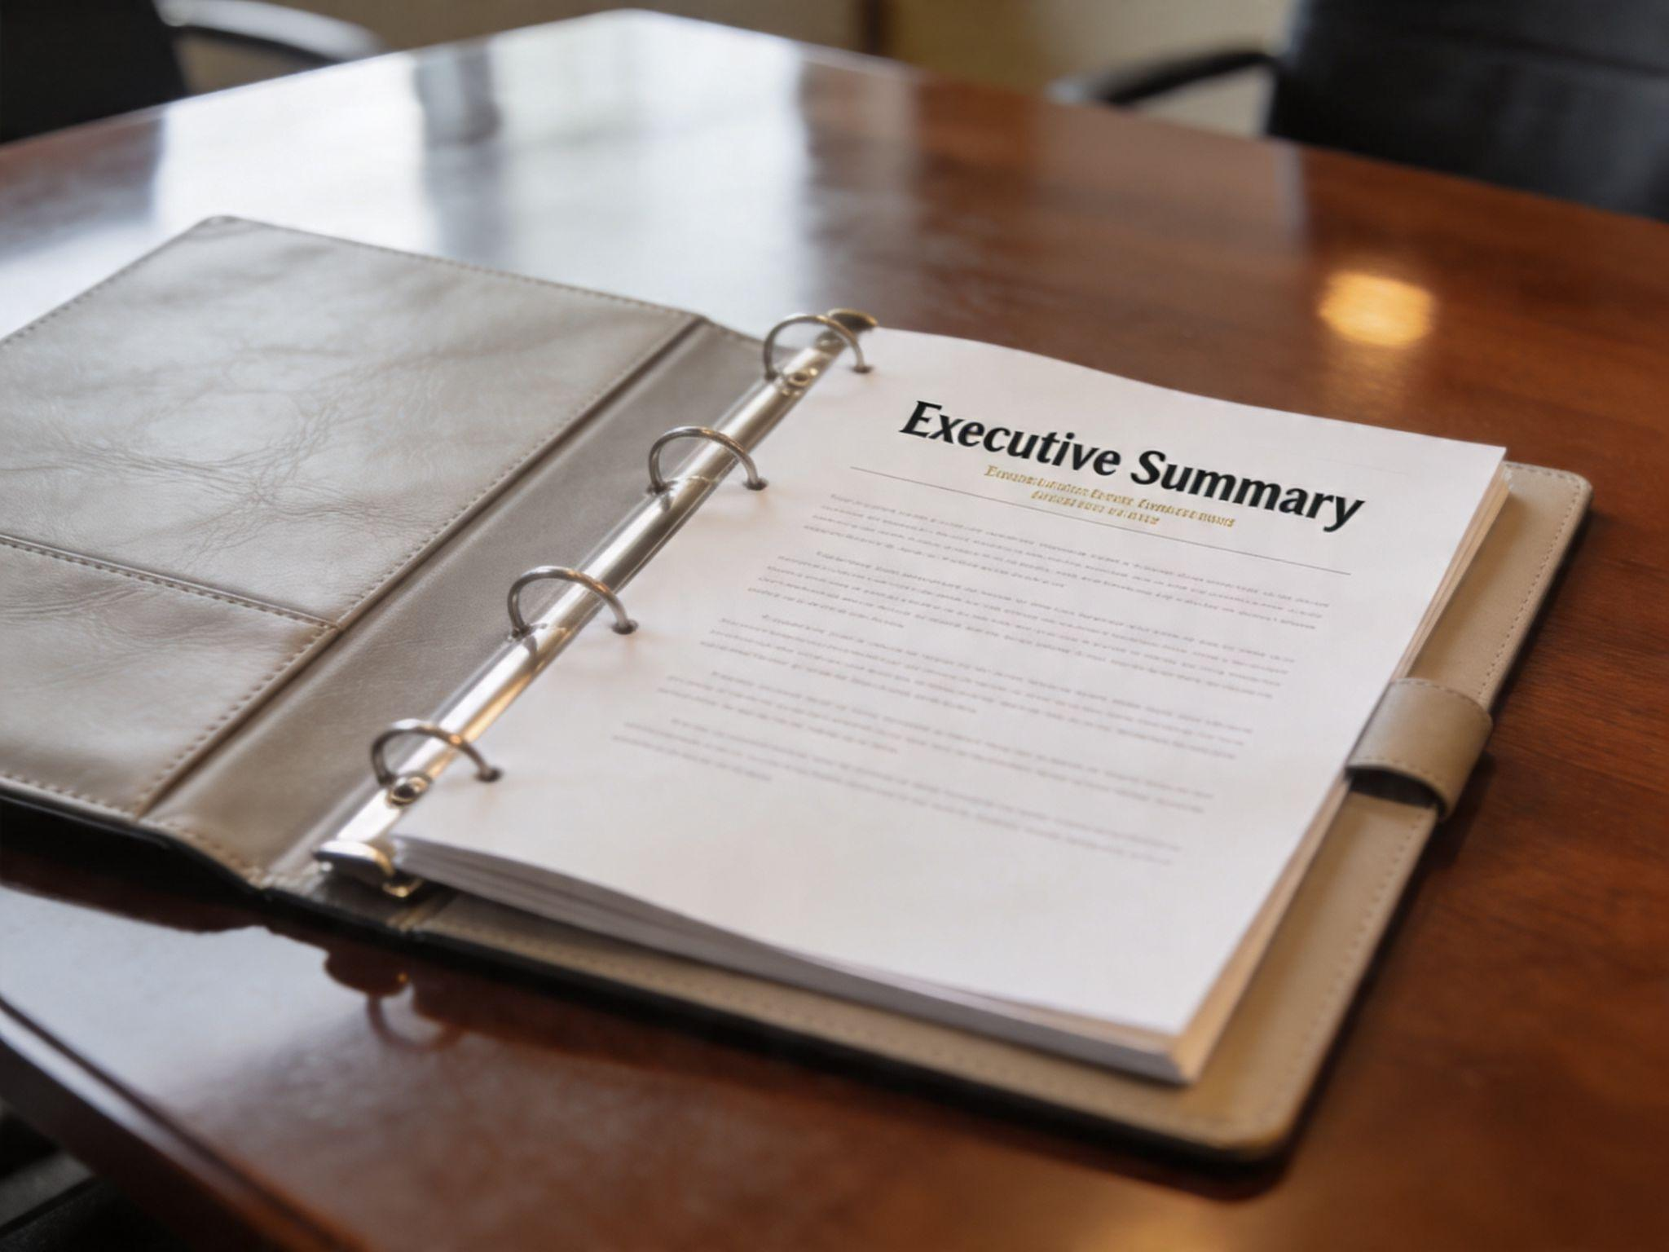

Table of Contents | Executive Summary | #
Table of Contents | Company & Business Description | #
Table of Contents | Product & Services Line | #
Table of Contents | Market Analysis | #
Table of Contents | Marketing Plan | #
Table of Contents | Sales Plan | #
Table of Contents | Legal Notes | #
Table of Contents | Financial Considerations | #
Table of Contents | Appendix | #

Executive Summary

Pro Tip: Wait until you’ve finished your business plan before writing this section. That way you can summarize what you have already written.

Provide a one-two page overview of the business and highlight the most crucial pieces of information for readers. Typically, this brief executive summary includes:

- A Mission Statement
- The Company History and Leadership Model
- An Overview of Competitive Advantage(s)
- Financial Projections
- Company Goals
- An Ask From Potential Investors

[Enter Executive Summary Here]

Company & Business Description

Company Purpose

Provide a 1-2 paragraph description of what your business does. Focus specifically on the types of products/services you will provide, who your target market is, and why you think you’ll succeed with your current business plan.

[Enter Company Description Here]

Mission and Vision Statements

Pro Tip: Your Mission statement should describe why your business exists. Your vision statement, on the other hand, describes where you see your business going . . . what will it look like in 10 years. If you have never written a mission statement and a vision statement then you might want to check out my YouTube video about writing mission and vision statements.

[Enter Mission/Vision Statement Here]

Core Values

Your company’s core values define your purpose. List out your core values, why they were chosen, and how your company embodies them. The help you get started, here is a short list of common corporate core values:
A few examples of company values include:
- Accountability
- Boldness
- Collaboration
- Continuous improvement
- Curiosity
- Customer commitment
- Diversity
- Honesty
- Humility
- Inclusion
- Innovation
- Integrity
- Making a difference
- Passion
- Persistence
- Self-improvement
- Sustainability
- Teamwork
- Transparency
- Trust
- Vulnerability
[Enter Core Values Here. You might start with “At _____ we value:” and list our core values].

Team & Org Structure

Pro Tip: Watch my short video on YouTube about organizational structures.

Provide an overview of your company. Identify the key management position and the individuals who will fill those positions. A good way to summarize this is with an organizational chart. Below the chart you might want to provide short bios of the employees in key leadership roles and the experience they will bring.

[Enter Org Structure Here]

Products and Services Line

Product Offering(s)

Describe your product line in more detail, if applicable. List each product and its functionality.

[Enter Product Offering(s) Here]

Service Offering(s)
Describe your service line in more detail, if applicable. List each service and why you’re offering it.
[Enter Service Offering(s) Here]

Pricing Model

What will you charge for each of your products and services? What will your markups be and why?

[Enter Pricing Model Here]

Market Analysis

Target Market

Outline the market you’re targeting and why you’re doing so. Highlight the demographics, psychographics, and size of your total addressable market.

[Enter Target Market Here]

Buyer Personas
Who is your target market? How well do you know them? Can you get inside their heads and think like them? A buyer personas is a semi-fictional representations of your ideal customer based on market research and real data about your existing customer.

Pro Tip: Watch my YouTube video about developing buyer personas.

[Enter Buyer Persona(s) Here]

Persona | Demographics | Communication
Give the persona a name and basic descriptor here.  Basic needs that are unmet. | Gender:  Age:  Marital Status:  Educational Level:  Income Level:  And anything else that is relevant | With whom does this person communicate?  How do they communicate?  Preferred communication media:
Personal Goals | Professional Goals | Personality Traits

Location Analysis

Explain why you’ve chosen your (proposed) location and what benefits you expect to see from it. Your location may be a physical, brick a mortar business or it may be online. The three keys to retail marketing have often been identified as location-location-location. A retail business needs to be located with the business persona will find it. The same is true of online businesses. Locate and advertise your business where your target market will find you . . . where they are . . . whether your business is physical or online.

[Enter Location Analysis Here]

Competitor Analysis

Explain the state of competition in your industry. You might want to include an analysis of your strengths, weaknesses, opportunities and threats (SWOT analysis) or use Porter’s Five Forces analysis (competition, potential of new entrants, power of suppliers, power of customers, and threat of substitute products or services.
Here is a template for doing a SWOT analysis:

Strengths | Weakness
What are we good at?  What’s working well?  What do our customers like about us? | What do we need to improve?  What do we need to strengthen?  How can we become more efficient?
Opportunities | Threats
What else could we be good at?  What makes a difference from the competition?  What are unfulfilled needs in the market? | Who could take our customers?  What could hinder our growth?  What is going on in the economy that might affect us?  What technological and industry trends could hurt us?

To summarize this info, list your top competitors as well as the following information for each competitor:

- Comparative Strength – What are your company’s assets that this competitor does not have?
- Comparative Weakness – In what areas or attributes do your competitors outperform you?
- Counterpoints – If a comparative weakness is mentioned in a sales presentation, which counterpoints can be used to address those weaknesses?

[Enter Competitor Analysis Below]

Competitors | Our Comparative Strength(s) | Our Comparative Weakness(es) | Counterpoint(s)

Marketing Plan

Positioning Strategy

Why are potential buyers going to be interested in your product or services? How will you address your buyer persona’s biggest challenges and goals? How will you use a website to your advantage?

[Enter Positioning Strategy Here]

Acquisition Channels
What are your main customer acquisition channels (e.g., search engine marketing, event marketing, blogging, co-marketing, paid, etc.) and what do you plan to prioritize this year?
[Enter Acquisition Channels Here]

Tools and Technology

What systems will you equip your marketing team with? Will you use a CMS, marketing automation software, or blogging software? If so, list it here.

[Enter Tools and Technology Here]

Sales Plan

Sales Methodology

How will you reach and engage with new leads? Are you pursuing an inbound or outbound sales strategy? Why does your prospecting strategy make sense for your business?

[Enter Sales Methodology Here]

Sales Organization Structure
Who will be in charge of selling your products and/or services? How will sales and marketing work together? How will the breakdown of roles look?
[Enter Sales Organization Structure Here]

Sales Channels
What will you utilize to sell your products? Will you sell online, in stores, or through sales reps? Are you going to sell at your own store or distribute to other stores?
[Enter Sales Channels Here]

Tools and Technology

Describe the sales tools you will use – for example live chat, website and ecommerce sales integrations, your CRM software, and call software – and how they will help you hit your goal.

[Enter Tools and Technology Here]

Legal Notes

Legal Structure

What type of legal structure will your business be?
If you are not sure, then watch my videos on business entity types and check out this IRS Resource.

[Enter Legal Structure Here]

Legal Considerations

What legal considerations does your business need to keep in mind for its core operating procedures? List all government registrations, permits, health codes, insurance requirements, and zoning laws you need to address and how you have addressed/will address them.

Here is an incomplete list, incomplete because requirements differ by type of business and jurisdiction):

- Basic business license from the city in which your business will operate, or from the local county (if the business will be operated outside of any city's limits).
- Federal employer identification number (EIN), also called a tax identification number (required for almost all types of businesses). Note: your business may also need to acquire a similar tax identification number from your state's department of revenue or taxation.
- Fictitious business name permit (also called "dba" or "doing business as" permit; required for almost all types of businesses).
- Zoning and land use permits, especially for new manufacturing businesses and certain home-based business operations.
- Health department permits, especially if your business involves the preparation and/or sale of food.
- Sales tax license for the selling of almost all products and services. If you are selling products online in different states you may be required to collect and remit sales tax in the states where your customers reside.
- Fire department permits, especially for businesses that will attract large numbers of customers (i.e. nightclubs and bars).
- Special state-issued business license or permits, if your business will involve the sale of the following types of products:
  - Liquor
  - Lottery tickets
  - Gasoline
  - Firearms
- Special state-issued occupational / professional licenses, if you and/or your employees will be offering a state-regulated services, including:
  - Attorney
  - Auto repair
  - Cosmetology
  - CPA
  - Insurance sales
  - Investment advisor
  - Medical care
  - Mortgage broker
  - Real estate sales
  - Tax services
- Special federal business license or permits, if your business involves the following (contact the agency identified in parentheses):
  - Broadcasting (Federal Communications Commission)
  - Drug manufacturing (U.S. Food and Drug Administration)
  - Ground transportation, i.e. trucking (U.S. Department of Transportation)
  - Investment advising (Securities & Exchange Commission)
  - Manufacturing tobacco, alcohol, or firearms; or selling firearms (U.S. Bureau of Alcohol, Tobacco, and Firearms)
  - Preparation of meat products (U.S. Food and Drug Administration)

[Enter Legal Considerations Here]

Financial Considerations

Startup Costs

Outline each of your startup costs as a line item, followed by a total cost. You may also want to provide a more detailed list of.

[Enter Startup Costs Here]

Description | Cost
Marketing
Real Estate and Storage
Inventory
Delivery Trucks
Hiring Costs
Total

Sales Forecasts

Provide your sales forecasts for the next several quarters or years. You may want to summarize the forecasts and point to a bottom-line metric, then point to a more detailed spreadsheet in your appendix.

[Enter Sales Forecasts Here]

Break-Even Analysis

Share at which point in time and after how many dollars/units in sales are reached before you break even. You may want to attach a more in-depth break-even analysis in the appendix if this section gets too convoluted.

Break-even Units = Total Fixed Cost / (Unit Selling Price – Unit Variable Cost)

[Enter Break Even Analysis Here]

Projected P&L

Explain your profit and loss projections for at least one year. If you’re expected to turn a profit shortly after one year, include that date in this section.

[Enter Projected P&L Here]

Funding Requirements

What funding will you need in the immediate future to make your business a success?

[Enter Funding Requirements Here]

Appendix

The following sections are each optional – feel free to include, exclude, or add any charts or information you think is appropriate.

- Floor plans
- Patents
- Org chart
- Financial charts

[Enter Appendix Here]

Anything Else?

Add another section here if you need it.

